Machine learning for early prediction of subsequent stage 2–3 acute kidney injury in critically ill adults: hospital-disjoint internal-external validation
Cagdas YILMAZ¹ · Ali AKDAGLI¹*
¹ Mersin University, Faculty of Engineering, Department of Electrical and Electronics Engineering, Mersin, Türkiye
ORCID: Cagdas YILMAZ, 0000-0001-6373-2768; Ali AKDAGLI, 0000-0003-3312-992X
* Corresponding author: Ali AKDAGLI, akdagli@mersin.edu.tr
Article type: Article
Article section: General Nephrology
Running title: Early prediction of subsequent stage 2–3 AKI

Abstract
Purpose: To develop machine-learning models to predict subsequent serum-creatinine-defined KDIGO stage 2–3 acute kidney injury (AKI) after a 12-hour landmark in critically ill adults.
Methods: We performed a retrospective eICU-CRD study. Adults meeting the landmark without prior stage 2–3 AKI or acute renal replacement therapy, and with sufficient observation to ascertain outcome, were included. The outcome was incident or progressive stage 2–3 AKI from >12 to 72 hours. We evaluated 159 predictors using five-fold hospital-disjoint internal-external cross-validation and fold-specific Platt calibration.
Results: Among 58,491 patients from 198 hospitals, 3,032 (5.18%) developed the outcome. Calibrated XGBoost achieved an area under the receiver operating characteristic curve (AUROC) of 0.876 (95% confidence interval 0.868–0.883), an area under the precision-recall curve (AUPRC) of 0.399 (0.375–0.423), and a Brier score of 0.038. Calibration intercept and slope were 0.002 and 1.005. Relative to the strongest parsimonious renal-status comparator, XGBoost improved AUROC from 0.834 to 0.876 and AUPRC from 0.288 to 0.399. At approximately matched alert burden, it identified 2,247 events versus 2,069 with the prespecified creatinine-trajectory comparator. With minimum 12- and 24-hour warning intervals, AUROC was 0.842 and 0.795.
Conclusion: Models using routinely recorded data assigned to the first 12 hours by source timestamps showed strong discrimination and good pooled calibration for subsequent stage 2–3 AKI across held-out hospitals. Independent external and prospective evaluation remain necessary before clinical deployment.
Keywords: Acute kidney injury; Critical illness; Machine learning; Clinical prediction; Internal-external validation; Decision curve analysis

Introduction
Acute kidney injury (AKI) is a common and heterogeneous complication of critical illness. In the multinational AKI-EPI study, 1,032 of 1,802 patients admitted to 97 intensive care units (ICUs) in 33 countries developed AKI during the first ICU week when complete Kidney Disease: Improving Global Outcomes (KDIGO) serum-creatinine and urine-output criteria were applied, and short-term outcomes worsened with each increase in AKI stage [1]. Serum creatinine and urine output nonetheless remain delayed and imperfect functional markers that respond to nonrenal factors, and patients with mild early abnormalities can follow very different courses [2, 3].
Electronic health records make it possible, in principle, to flag patients before stage 2–3 AKI develops. The prediction literature that has grown around this idea is methodologically uneven. Reviews of adult ICU studies describe frequent risk of bias, inconsistent calibration reporting, little external validation, and reliance on a handful of reusable databases [4–6], and across ICU prediction research more broadly, performance tends to fall when a model is moved to a new setting [7]. For rare or moderately imbalanced outcomes, the area under the receiver operating characteristic curve (AUROC) alone can also hide alert burden and positive predictive value, so the area under the precision-recall curve (AUPRC) is a useful complement [8].
Published AKI models address distinct clinical questions: incident AKI, KDIGO stage 2–3, persistent severe AKI, transient-versus-persistent phenotypes, and progression among patients who already meet AKI criteria [9–15]. Several have been evaluated externally or prospectively [11, 13, 14], but their prediction landmarks, horizons, baseline definitions, and outcome components differ enough that ranking their performance directly is not meaningful. A fixed-landmark design that uses only information available before the prediction time, evaluated across held-out hospitals, offers a more direct way to assess early risk of subsequent stage 2–3 AKI.
We therefore developed and evaluated models that estimate the probability of subsequent serum-creatinine-defined KDIGO stage 2–3 AKI after a 12-hour ICU landmark and through 72 hours. The framework combined nested hospital-disjoint internal-external cross-validation, training-only preprocessing, fold-specific calibration, hospital-cluster bootstrap uncertainty, and decision-curve analysis over a predefined threshold range. Secondary analyses examined selection, robustness to missingness, incremental value beyond parsimonious renal information, alarm burden, hospital heterogeneity, and exploratory subgroup performance.

Methods

Study design and data source
This retrospective multivariable prediction-model study used version 2.0 of the eICU Collaborative Research Database (eICU-CRD), a deidentified multicenter database of United States ICU admissions collected during 2014–2015. The database was accessed through PhysioNet under credentialing and data-use requirements [16, 17]. We designed and reported the study with reference to TRIPOD+AI and TRIPOD-Cluster because the data were clustered across multiple hospitals [18, 19].

Participants and analytical landmark
Adult ICU stays lasting at least 12 hours were considered. To avoid correlated repeated observations, a single deterministic eligible ICU stay per patient was retained. The prediction landmark was fixed at 12 hours after ICU admission. Patients were excluded from the primary cohort when a qualifying early reference creatinine was unavailable, chronic dialysis or end-stage kidney disease was identified, KDIGO stage 2–3 or acute renal replacement therapy had occurred by the landmark, or outcome status could not be determined because of early death, inadequate follow-up, or absent post-landmark creatinine measurements. The analytic cohort was conditional on the prespecified creatinine outcome-observability rule: an observed post-landmark stage 2–3 event established positivity, whereas a negative label required the frozen follow-up or recent-pre-discharge creatinine criteria; therefore, the estimand does not represent unobserved biological AKI incidence in all patients present at 12 hours. No formal prospective sample-size calculation was performed because this retrospective study used all 58,491 patients with 3,032 events from 198 hospitals who met the eligibility and outcome-observability criteria; nested hospital-disjoint folds preserved cluster separation.

Reference creatinine and outcome
The operational reference creatinine was the earliest selected creatinine in the prespecified source-specific reference window. That window extended from the later of hospital admission or 24 hours before ICU admission to 6 hours after ICU admission; no reference value occurred after the 12-hour landmark. The primary outcome was incident or progressive serum-creatinine-defined KDIGO stage 2 or 3 occurring >12–72 hours after ICU admission. Acute renal replacement therapy (RRT) at or before the 12-hour landmark was an exclusion. RRT initiated after the landmark was not itself a primary outcome component; creatinine measurements were not censored at post-landmark RRT initiation and could contribute to creatinine-based stage ascertainment. Urine-output criteria were not used. This was a study-specific decision: the available eICU inputs were not considered suitable for hourly urine-output ascertainment, which does not imply that eICU urine-output records are unreliable in general. Earlier work on creatinine-based staging and reference-creatinine surrogates [3, 20, 21] informed this choice but does not bear on the eICU-specific decision.

Predictors and data preparation
The model used 159 source predictors selected before outer-test evaluation. Predictors were constructed from routinely recorded variables using prespecified source-specific timestamp rules at or before the 12-hour landmark; the available source fields do not establish the time at which a laboratory result first became visible to clinicians. Variables included demographics, admission context, previous history, laboratory measurements, vital-sign summaries, respiratory support, medication or infusion indicators, and early renal state. Data cleaning, feature construction, and temporal eligibility rules were specified before outer-test evaluation. Numeric imputation values and missingness indicators were learned within each training partition; categorical variables used an explicit missing category and one-hot encoding. Scaling was applied only for algorithms that required it. Preprocessing objects learned from training hospitals were applied unchanged to the corresponding held-out hospitals. Exact technical locators are sql/06_feature_static.sql through sql/10_feature_matrix_and_model_view.sql, sql/14_modeling_view.sql, code/05_AKI_V2_MODEL_DEVELOPMENT_SOURCE.ipynb, locked protocols in protocols/, docs/SOFTWARE_ENVIRONMENT.md, and checklists/REPRODUCIBILITY_CHECKLIST.md.

Model development and hospital-disjoint validation
Five outer folds were defined at the hospital level so that no hospital contributed patients to both development and evaluation in the same fold. Within each outer-training set, five additional hospital-disjoint inner folds were used for candidate selection. Candidate models were ranked by pooled inner out-of-fold AUPRC, with AUROC and Brier score as predefined tie-breakers. The outer-test fold was used only once for diagnostic evaluation and never for tuning. Elastic-net logistic regression and XGBoost comprised the original model set; random forest and CatBoost were additional post-hoc benchmarks, and a parsimonious clinical logistic model was an exploratory clinical comparator.

Calibration and performance measures
For each model family and outer fold, Platt calibration was fitted only to the selected candidate’s pooled inner out-of-fold prediction scores and then applied to that model’s untouched outer-test predictions. The five-model comparison therefore used fold-specific Platt-calibrated held-out probabilities for each model family. Performance was summarized from the pooled outer-test predictions using AUROC, AUPRC, Brier score, log loss, calibration intercept, calibration slope, and calibration by risk decile. AUPRC was interpreted relative to the observed event prevalence. Uncertainty was estimated using 2,000 hospital-cluster bootstrap replicates. Model comparisons used paired hospital resampling and are described as nominal exploratory comparisons when they were not specified before performance review [8].

Clinical utility and operating points
Decision-curve analysis compared the calibrated XGBoost model with the parsimonious clinical comparator, treat-all, and treat-none strategies. The primary threshold range of 1–10% in 0.5-percentage-point increments and the sensitivity range of 0.5–15% were specified before the decision-curve results were examined. No threshold was selected because it maximized observed net benefit. Scenario thresholds of 1%, 2%, 3%, 5%, 7.5%, and 10% were used to quantify sensitivity, specificity, predictive values, F1 score, and alerts per 100 patients [22].

Explainability, sensitivity, and secondary analyses
Native XGBoost TreeSHAP values were calculated for held-out patients, aggregated to source-predictor level, and interpreted as non-causal raw-margin attribution. Secondary strengthening analyses evaluated alternative reference-creatinine rules, landmark selection, and hospital heterogeneity. Robustness analyses repeated the locked hospital-disjoint workflow after removing source predictors with at least 50% missingness within each outer-training partition and, separately, after omitting explicit numeric missingness indicators; indicator attribution was also quantified from held-out TreeSHAP values. Renal comparators included the strongest parsimonious renal-status comparator (Comparator 1) and a creatinine-trajectory logistic comparator specified before performance review (Comparator 2), with complete Comparator 0–3 definitions in Online Resource 1. The exploratory parsimonious clinical comparator reported in Table 3 was a separate model from this Comparator 0–3 renal set. Incremental performance, decision curves, and matched alert burden were evaluated.
Exploratory subgroup performance across sex, age, and recorded race/ethnicity used the original held-out probabilities without subgroup refitting or recalibration. Paired uncertainty used 2,000 hospital-cluster bootstrap replicates where applicable. Actionable lead-time sensitivity progressively excluded events occurring within 6, 12, or 24 hours after the landmark, without relabeling them as non-events; alternative outcome windows assessed horizon dependence. Hospital-specific performance used untouched calibrated outer-test predictions, with a descriptive tier requiring at least 20 events and 20 non-events and no hospital-specific fitting, recalibration, or threshold optimization.

Ethics and software
The source database was deidentified to meet the HIPAA Safe Harbor provision and was accessed through PhysioNet by a credentialed investigator after completion of the required human-subjects research training and acceptance of the applicable PhysioNet Data Use Agreement [16, 17]. The investigators analyzed only the deidentified eICU-CRD, had no access to direct patient identifiers, had no contact with participants, and did not intervene in care. Analyses were performed in Google Colab with Python 3.12.13, pandas 2.2.2, NumPy 2.0.2, scikit-learn 1.6.1, XGBoost 3.3.0, imbalanced-learn 0.14.2, SHAP 0.52.0, google-cloud-bigquery 3.42.2, and google-cloud-bigquery-storage 2.39.0.
Generative artificial intelligence tools were used during manuscript preparation. OpenAI ChatGPT assisted with code review, literature organization, and language editing. Anthropic Claude assisted with figure creation. The authors independently verified all analytical decisions, database queries, model outputs, numerical results, citations, and the final manuscript text, and take full responsibility for the work. No identifiable patient-level information was provided to these tools.

Results

Cohort and outcome
Of 172,392 adult ICU stays lasting at least 12 hours, 58,491 patients from 198 hospitals remained after the repeated-stay, reference-creatinine, pre-existing renal-state, landmark, and outcome-observability criteria were applied (Fig. 1; Table 2). The outcome occurred in 3,032 patients (5.18%). Compared with the remaining patients, those who developed the outcome had higher body mass index, higher reference and last pre-landmark creatinine, higher blood urea nitrogen, heart rate, and respiratory rate, a higher prevalence of KDIGO stage 1 at the landmark, and lower systolic blood pressure (Table 1). The five outer folds contained 39–40 hospitals each, with nearly identical event prevalence. Mutually exclusive landmark inclusion and exclusion groups are reported in Online Resource 1.
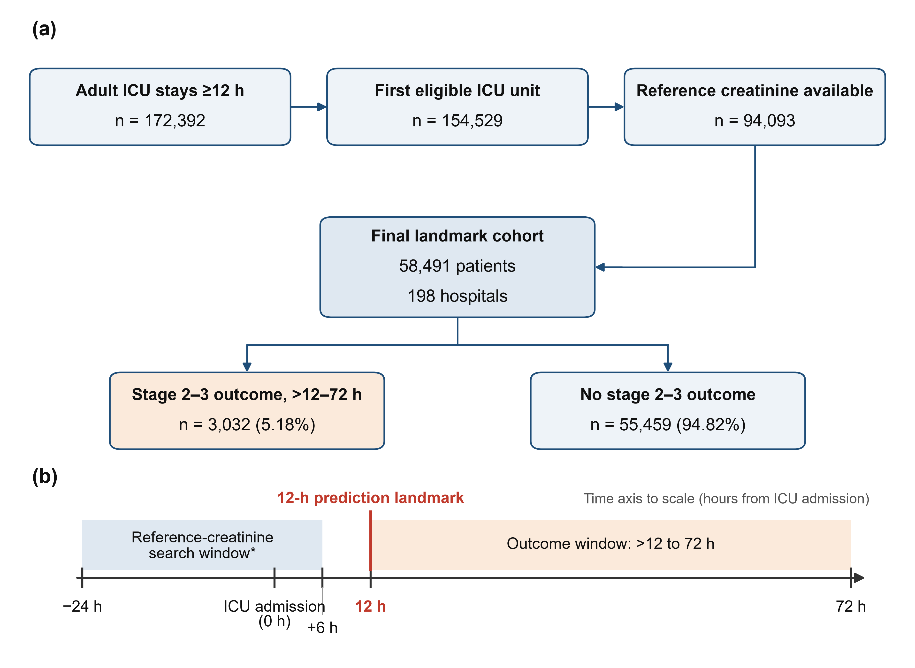
Fig. 1 Cohort flow and temporal design. (a) Cohort flow from eligible adult ICU stays to the final landmark cohort and outcome groups. (b) Fixed temporal design showing the reference-creatinine search window, 12-h prediction landmark, and >12- to 72-h outcome window; the time axis is drawn to scale. *Reference creatinine was the earliest selected value in the prespecified window from the later of hospital admission or 24 hours before ICU admission to 6 hours after ICU admission

Discrimination, calibration, and model comparison
All five model-comparison estimates in Table 3 and Fig. 2a,b derive from fold-specific Platt-calibrated held-out probabilities. XGBoost reached a pooled AUROC of 0.876 (95% confidence interval (CI) 0.868–0.883), an AUPRC of 0.399 (0.375–0.423), a Brier score of 0.038 (0.036–0.040), and a log loss of 0.142, with a calibration intercept of 0.002 and a calibration slope of 1.005 (Fig. 2c). Across the outer folds, AUROC ranged from 0.862 to 0.884 and AUPRC from 0.340 to 0.429. CatBoost (AUROC 0.871; AUPRC 0.393) and random forest (0.868; 0.389) were close behind, so the three nonlinear models formed a single performance cluster within which XGBoost was numerically strongest. Logistic regression reached AUROC 0.848 and AUPRC 0.315, and the exploratory parsimonious clinical comparator 0.815 and 0.262. Relative to that comparator, XGBoost improved AUROC by 0.061 (nominal 95% CI 0.054–0.069) and AUPRC by 0.136 (0.120–0.155).
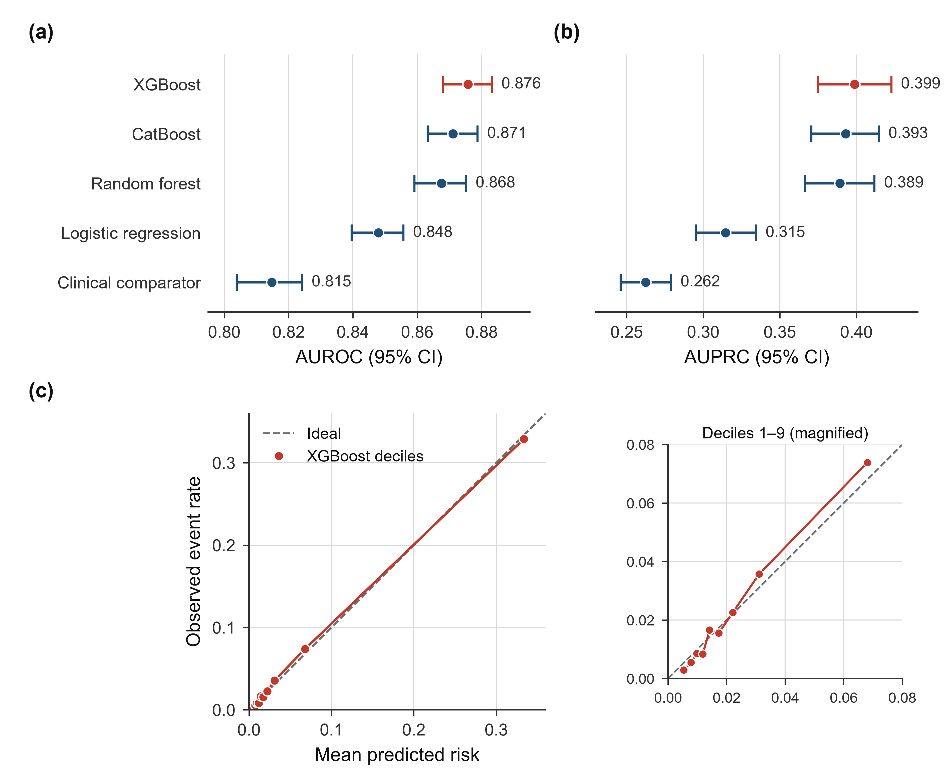
Fig. 2 Discrimination and calibration. (a) Pooled held-out AUROC with 95% percentile confidence intervals from 2,000 hospital-cluster bootstrap samples for the clinical comparator and four model families. (b) Corresponding pooled held-out AUPRC with 95% percentile confidence intervals. (c) Pooled held-out calibration for fold-specific Platt-calibrated XGBoost predictions, showing observed event rate versus mean predicted risk across prediction deciles; the dashed diagonal denotes ideal calibration and the inset magnifies the nine lowest-risk deciles. Fold- and hospital-level calibration heterogeneity are reported in Online Resource 1

Clinical utility and feature attribution
XGBoost showed positive estimated net benefit at all 19 thresholds between 1% and 10% and exceeded the clinical comparator at each of them (Fig. 3a). At the 5%, 7.5%, and 10% thresholds, sensitivity was 74.1%, 69.5%, and 66.4%, positive predictive value was 22.9%, 27.0%, and 30.1%, and the model generated 16.8, 13.3, and 11.4 alerts per 100 patients (Table 4). These operating points are scenarios, not an optimized deployment threshold. Early reference creatinine, the last pre-landmark creatinine, and KDIGO stage 1 status at the landmark led the pooled mean absolute grouped TreeSHAP ranking, followed by oxygenation and vital-sign summaries, admission source, blood urea nitrogen, body mass index, and blood-pressure measures (Fig. 3b). Spearman correlations of source-predictor ranks between pairs of outer folds ranged from 0.819 to 0.890, so the global attribution pattern was broadly stable across held-out hospital groups.
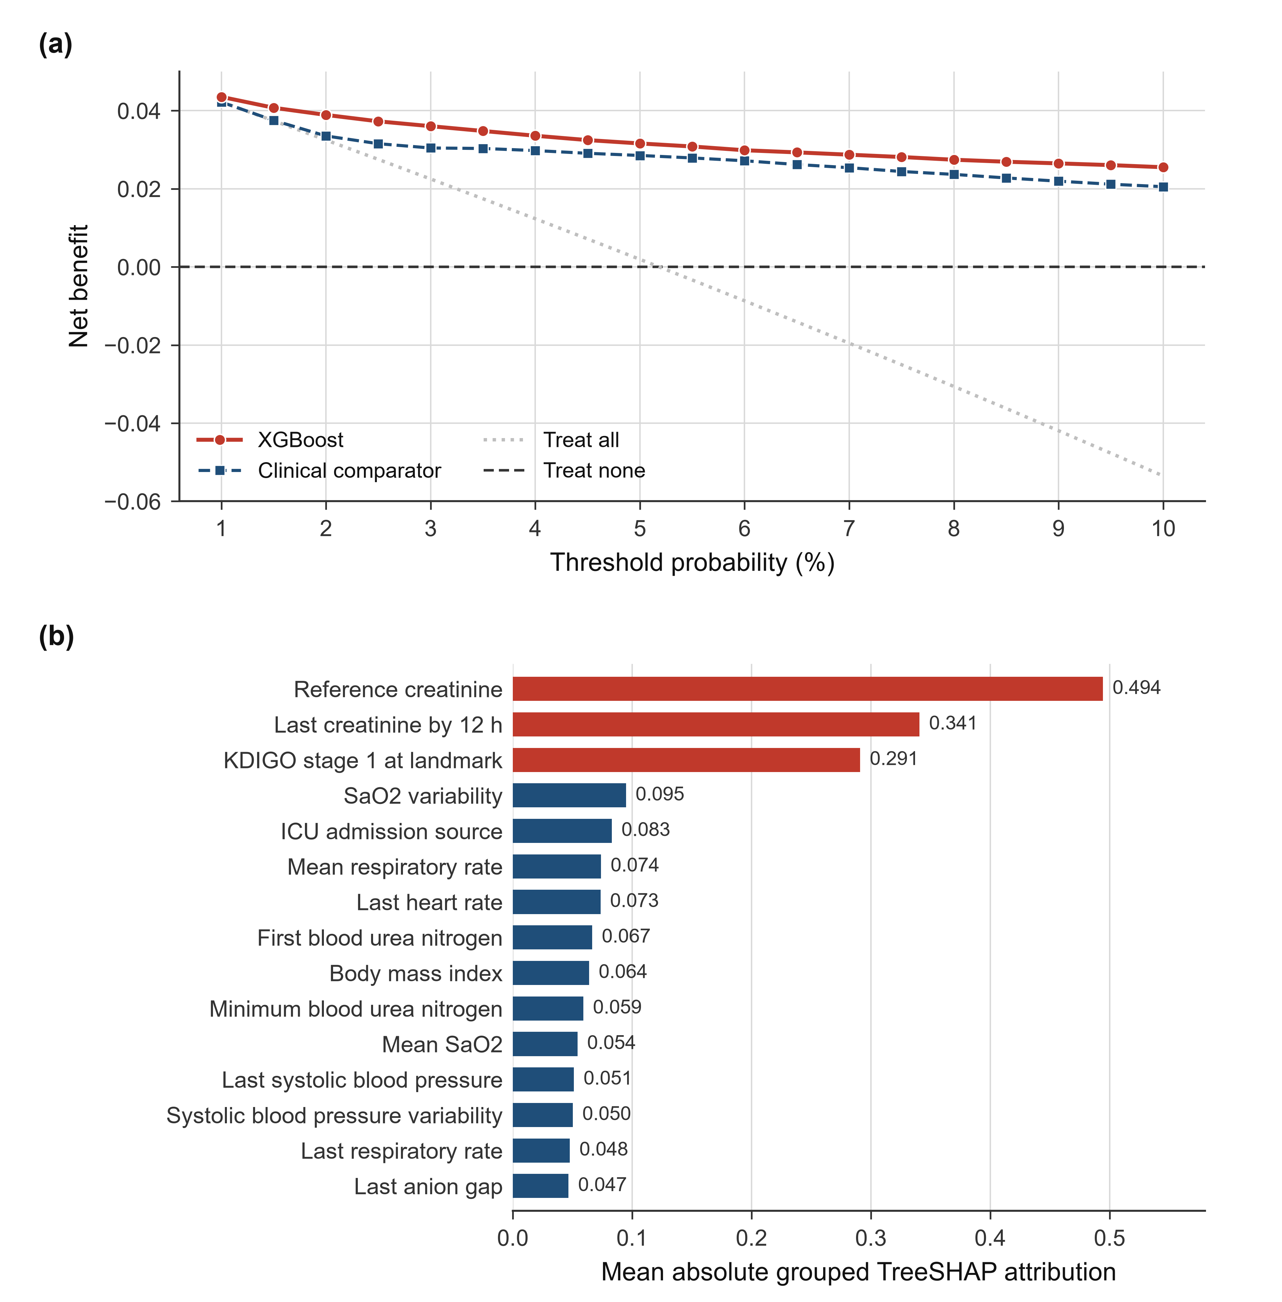
Fig. 3 Clinical utility and feature attribution. (a) Decision-curve analysis across the 1–10% threshold range for calibrated XGBoost, the parsimonious clinical comparator, treat-all, and treat-none strategies. (b) Top 15 source predictors ranked by pooled mean absolute grouped TreeSHAP attribution; the three renal-state predictors are shown in red. SHAP values are non-causal model attributions

Sensitivity, comparator, and subgroup analyses
Removing eight predefined renal-state predictors reduced calibrated XGBoost to AUROC 0.786 and AUPRC 0.209. In the direct renal comparisons, the full model (AUROC 0.876; AUPRC 0.399) outperformed Comparator 1, the strongest parsimonious renal-status comparator (0.834; 0.288). Comparator 2, which added creatinine trajectory and was specified before its performance was reviewed, reached only 0.784 and 0.251, below Comparator 1; creatinine slope was unavailable in 71.8% of patients. At 16.78 alerts per 100 admissions, XGBoost identified 2,247 events against 2,069 for Comparator 2, that is, 178 additional patients with subsequent stage 2–3 AKI at essentially the same alert burden, and its estimated net benefit exceeded that of Comparator 2 at every threshold from 1% to 10%.
Performance did not change when predictors with at least 50% missingness in each outer-training partition were removed (AUROC/AUPRC 0.876/0.399 in both cases). The 153 explicit numeric missingness indicators accounted for 1.89% of total absolute held-out TreeSHAP attribution, and omitting them left performance essentially unchanged (AUROC 0.877; AUPRC 0.401). Selection characterization showed observable differences between included and excluded patients in early support, monitoring, and admission context, together with between-hospital variation in reference-creatinine availability. In the exploratory subgroup analyses, discrimination was lower among patients aged at least 80 years (AUROC 0.830), although calibration remained close to ideal, and recorded African American patients had an observed risk of 8.34% against a mean predicted risk of 7.34%, a modest underprediction despite preserved discrimination (AUROC 0.889). These were the most notable signals in the systematic sex, age, and recorded race/ethnicity summaries; complete subgroup estimates, group sizes, and uncertainty are given in Online Resource 1, Tables S5–S14 and Figs. S6–S10.
The median interval from the landmark to the first qualifying stage 2–3 event was 18.3 hours. Discrimination attenuated as the required warning interval lengthened but remained informative: with at least 12 and 24 hours of warning, AUROC/AUPRC were 0.842/0.252 and 0.795/0.134, and for the >12–48-hour outcome window they were 0.897/0.382 (Online Resource 1, Tables S15–S16; Fig. S11). Among the 51 held-out hospitals with at least 20 events and 20 non-events, median AUROC was 0.878 (IQR 0.856–0.899; 10th percentile 0.827; minimum 0.730); 47 of 51 hospitals had AUROC ≥0.80 and none fell below 0.70. The calibration intercept varied more (median 0.073, IQR −0.145 to 0.319; 28 of 51 with an absolute intercept >0.25), whereas the calibration slope was 1.012 (IQR 0.952–1.097). In the stricter 29-hospital subset, median and minimum AUROC were 0.883 and 0.823, and removing the 10 highest-AUROC hospitals moved the pooled AUROC from 0.876 to 0.870 (Online Resource 1, Tables S17–S18; Fig. S12).

Discussion
Routinely collected data available by 12 hours after ICU admission supported strong discrimination and good pooled calibration for subsequent serum-creatinine-defined KDIGO stage 2–3 AKI through 72 hours, and every patient was scored by a model trained without data from that patient’s hospital. Discrimination was consistent across outer folds; calibration-in-the-large varied more across adequately sized hospitals. These findings apply to held-out hospitals within eICU, not to independent external or prospective validation.
The question addressed here is narrower than general incident-AKI prediction: which patients still eligible at a fixed 12-hour landmark will develop stage 2–3 creatinine-defined AKI during the following 60 hours? Existing progression and severe-AKI studies use heterogeneous index times, populations, prediction horizons, and outcome definitions. Wei and colleagues modeled progression after early AKI in MIMIC-III [9], You and colleagues recently evaluated sepsis-associated progression to stage 3 across several datasets [10], and persistent severe-AKI [11, 23] and continuous incident-AKI models [13] have undergone external or prospective evaluation. These studies show how far the field has moved, but their tasks and temporal alignment differ from ours, so their performance figures are not direct benchmarks.
Hospital-disjoint internal-external validation is the main methodological strength of this work. Hospital separation was maintained throughout model selection and evaluation, preprocessing and calibration were learned only from development data, and AUPRC, hospital-cluster bootstrap uncertainty, and source-level TreeSHAP were reported with post-hoc and exploratory analyses labeled as such. Together these choices limit the usual sources of optimism, temporal leakage and test-set tuning among them. Discrimination held across adequately sized held-out hospitals and was not carried by a small subset of high-performing centers, although calibration-in-the-large showed more between-center heterogeneity. All hospitals nevertheless came from the same eICU data ecosystem, so these results do not constitute independent external validation or universal transportability, and they argue for local calibration assessment before deployment [7, 15, 19, 24].
Clinical usefulness depends on what a risk estimate triggers. Performance declined as the required warning interval lengthened (AUROC 0.842 with at least 12 hours of warning and 0.795 with at least 24 hours), which points to near-term rather than long-horizon use. Decision curves showed positive estimated net benefit across the predefined 1–10% range [22], but the threshold that matters in practice depends on intervention burden and workflow. A high-risk estimate could prompt clinician-led review of renal-function and urine-output surveillance, nephrotoxic or renally cleared medications, hemodynamics, and volume status, with nephrology consultation where appropriate [25, 26]. We did not test such a protocol, and this study does not show that model-guided care improves outcomes.
Renal-state variables dominated global attribution, as expected for an outcome defined by subsequent creatinine-based AKI, and the renal-marker ablation confirmed that legitimate pre-landmark renal state carried much of the prognostic information. The direct comparisons nonetheless showed added predictive value beyond parsimonious renal information: Comparator 1, the strongest renal-status comparator, outperformed the creatinine-trajectory Comparator 2, and both remained below the full model. Creatinine slope was unavailable in 71.8% of patients, which limits trajectory-only baselines in this dataset. The matched-alert and decision-curve analyses favored the full model at the evaluated thresholds; they do not establish clinical superiority or benefit to patients.
The limitations are substantial. The analysis rests on a single United States multicenter database from 2014–2015, uses serum creatinine without urine-output criteria, and relies on an early-admission operational reference that may not reflect stable premorbid renal function. RRT timing and indication were documentation-dependent and post-RRT creatinine values were not censored, so the creatinine-defined phenotype should not be read as a complete KDIGO stage 3 phenotype that incorporates RRT. The recorded laboratory sampling and revision timestamps do not establish when results first became clinically available, so strict real-time availability of predictors at 12 hours was not verified. Outcome ascertainment required post-landmark observation, which makes the analytic cohort conditional on future observability, and the robustness analyses do not remove selection and measurement-process concerns. The subgroup findings were exploratory rather than a formal fairness assessment and need confirmatory evaluation. Future work should test a refitted and locked model in independent contemporary cohorts, evaluate complete creatinine-plus-urine-output phenotypes where reliable data exist, prospectively assess workflow and patient impact, and examine the translation of explainable AKI prediction models in its own right [27]. Until then, independent contemporary validation, prospective impact studies, and local calibration assessment stand between these results and implementation.

Conclusion
With a fixed 12-hour landmark and hospital-disjoint internal-external validation, routinely recorded ICU data assigned to the pre-landmark window supported strong discrimination and good pooled calibration for early prediction of subsequent serum-creatinine-defined KDIGO stage 2–3 AKI. The model added information beyond parsimonious renal-status and creatinine-trajectory comparators. Independent external validation, confirmatory subgroup analysis, and prospective impact evaluation remain necessary before implementation.

Statements and Declarations

Ethics approval
This study was a secondary analysis of the deidentified eICU Collaborative Research Database (eICU-CRD). The database was deidentified to meet the HIPAA Safe Harbor provision before release [16, 17]. Access was granted through PhysioNet after researcher credentialing, completion of the required human-subjects research training, and acceptance of the applicable PhysioNet Data Use Agreement [17]. The investigators analyzed only the deidentified database, had no access to direct patient identifiers, did not recruit or contact participants, and did not intervene in care.

Consent to participate
Not applicable to the authors’ secondary analysis; the investigators did not recruit or contact participants and analyzed only the deidentified eICU-CRD available under PhysioNet credentialed access.

Consent for publication
Not applicable.

Funding
This research received no specific grant from any funding agency in the public, commercial, or not-for-profit sectors.

Competing interests
The authors have no relevant financial or non-financial interests to disclose.

Author contributions
Cagdas YILMAZ: Conceptualization (supporting), Data curation (lead), Formal analysis (lead), Investigation (lead), Methodology (supporting), Software (lead), Validation (lead), Visualization (lead), Literature and evidence synthesis (lead), Writing – original draft (lead), and Writing – review and editing (equal). Ali AKDAGLI: Conceptualization (lead), Methodology (lead), Supervision (lead), Project administration (lead), Resources (lead), Validation (supporting), and Writing – review and editing (equal). Both authors approved the final manuscript and agree to be accountable for the integrity and accuracy of the work.

Data availability
The eICU Collaborative Research Database (version 2.0) is available through PhysioNet at https://doi.org/10.13026/C2WM1R to credentialed users who complete the required human-subjects research training and accept the applicable Data Use Agreement [17, 28, 29]. No patient-level derivative dataset is publicly redistributed by the authors.

Code availability
Source-only reproducibility materials are publicly available at https://github.com/originalprojects-code/aki-progression-hospital-iec/tree/v1.2.2-submission and are archived in Zenodo as version 1.2.2-submission at https://doi.org/10.5281/zenodo.24058816. The archive includes code, parameterized SQL query templates, predefined model specifications, aggregate outputs, software-environment files, and reproduction instructions. No patient-level data or Data Use Agreement-restricted derivatives are redistributed. No single production-ready final model was trained or released; reported performance came from held-out predictions within the hospital-disjoint validation framework. Clinical implementation would require refitting and locking a final model, followed by independent and prospective evaluation.

Supplementary information
Online Resource 1 contains Supplementary Methods and Results, Tables S1–S18, and Figs. S1–S12 covering operating points, reference-creatinine sensitivity, landmark selection, missingness robustness, renal comparators, exploratory subgroups, actionable lead time, outcome-window sensitivity, and hospital-level discrimination and calibration heterogeneity.

Registration
This retrospective secondary analysis was not prospectively registered.

Patient and public involvement
Patients and members of the public were not involved in the design, conduct, reporting, or dissemination planning of this retrospective secondary analysis.

References
1. Hoste EAJ, Bagshaw SM, Bellomo R, Cely CM, Colman R, Cruz DN, Edipidis K, Forni LG, Gomersall CD, Govil D, Honoré PM, Joannes-Boyau O, Joannidis M, Korhonen A-M, Lavrentieva A, Mehta RL, Palevsky P, Roessler E, Ronco C, Uchino S, Vazquez JA, Vidal Andrade E, Webb S, Kellum JA (2015) Epidemiology of acute kidney injury in critically ill patients: the multinational AKI-EPI study. Intensive Care Med 41:1411-1423. https://doi.org/10.1007/s00134-015-3934-7
2. Pickkers P, Darmon M, Hoste E, Joannidis M, Legrand M, Ostermann M, Prowle JR, Schneider A, Schetz M (2021) Acute kidney injury in the critically ill: an updated review on pathophysiology and management. Intensive Care Med 47:835-850. https://doi.org/10.1007/s00134-021-06454-7
3. Kellum JA, Sileanu FE, Murugan R, Lucko N, Shaw AD, Clermont G (2015) Classifying AKI by urine output versus serum creatinine level. J Am Soc Nephrol 26:2231-2238. https://doi.org/10.1681/ASN.2014070724
4. Shi T, Lin Y, Zhao H, Kong G (2025) Artificial intelligence models for predicting acute kidney injury in the intensive care unit: a systematic review of modeling methods, data utilization, and clinical applicability. JAMIA Open 8(4):ooaf065. https://doi.org/10.1093/jamiaopen/ooaf065
5. Vagliano I, Chesnaye NC, Leopold JH, Jager KJ, Abu-Hanna A, Schut MC (2022) Machine learning models for predicting acute kidney injury: a systematic review and critical appraisal. Clin Kidney J 15(12):2266-2280. https://doi.org/10.1093/ckj/sfac181
6. Feng Y, Wang AY, Jun M, Pu L, Weisbord SD, Bellomo R, Hong D, Gallagher M (2023) Characterization of risk prediction models for acute kidney injury: a systematic review and meta-analysis. JAMA Netw Open 6(5):e2313359. https://doi.org/10.1001/jamanetworkopen.2023.13359
7. Rockenschaub P, Akay EM, Carlisle BG, Hilbert A, Wendland J, Meyer-Eschenbach F, Näher A-F, Frey D, Madai VI (2025) External validation of AI-based scoring systems in the ICU: a systematic review and meta-analysis. BMC Med Inform Decis Mak 25:5. https://doi.org/10.1186/s12911-024-02830-7
8. Saito T, Rehmsmeier M (2015) The precision-recall plot is more informative than the ROC plot when evaluating binary classifiers on imbalanced datasets. PLoS ONE 10:e0118432. https://doi.org/10.1371/journal.pone.0118432
9. Wei C, Zhang L, Feng Y, Ma A, Kang Y (2022) Machine learning model for predicting acute kidney injury progression in critically ill patients. BMC Med Inform Decis Mak 22:17. https://doi.org/10.1186/s12911-021-01740-2
10. You X, Chen Y, Chen J, Mao X, Wang Y, Zhang Z, Zhou Z, Li W, Mei Y, Zhu Y, Huang P, Chen X (2026) Early identification of acute kidney injury progression in critically ill patients with sepsis: interpretable machine learning approach. Clin Kidney J 19(8):sfag216. https://doi.org/10.1093/ckj/sfag216
11. Zappalà S, Alfieri F, Ancona A, Taccone FS, Maviglia R, Cauda V, Finazzi S, Dell’Anna AM (2024) Development and external validation of a machine learning model for the prediction of persistent acute kidney injury stage 3 in multi-centric, multi-national intensive care cohorts. Crit Care 28:189. https://doi.org/10.1186/s13054-024-04954-8
12. Jiang W, Zhang Y, Weng J, Song L, Liu S, Li X, Xu S, Shi K, Li L, Zhang C, Wang J, Yuan Q, Zhang Y, Shao J, Yu J, Zheng R (2025) Explainable machine learning model for predicting persistent sepsis-associated acute kidney injury: development and validation study. J Med Internet Res 27:e62932. https://doi.org/10.2196/62932
13. Alfieri F, Zappalà S, Bacci A, Cauda V, Basso M, Musso G, Cochelli L, Votta CD, Mariconti L, Maderna L, Russo G, Gomez J, Esteban-Reboll F, Gilavert Cuevas MC, Bodì M, Finazzi S, Kashani K, Ancona A (2026) Prospective and external evaluation of an AI model for continuous and early prediction of moderate and severe AKI in critically ill patients. Intensive Care Med Exp 14:71. https://doi.org/10.1186/s40635-026-00928-y
14. Jonkers J, Rouzé A, Verhaeghe J, Van Biesen W, De Waele J, Duchateau L, Van Wallendael G, Hoste E, Van Hoecke S (2026) Beyond binary AKI classification: development and external validation of a distributional model predicting serum creatinine and urine output trajectories in ICU patients. Crit Care 30:249. https://doi.org/10.1186/s13054-026-06017-6
15. Hourani AZ, Jakubowska Z, Malyszko J (2026) Forecasting ICU acute kidney injury with actionable lead time using interpretable machine learning: development and multi-center validation. J Clin Med 15(3):1191. https://doi.org/10.3390/jcm15031191
16. Pollard TJ, Johnson AEW, Raffa JD, Celi LA, Mark RG, Badawi O (2018) The eICU Collaborative Research Database, a freely available multi-center database for critical care research. Sci Data 5:180178. https://doi.org/10.1038/sdata.2018.178
17. Pollard T, Johnson A, Raffa J, Celi LA, Badawi O, Mark R (2019) eICU Collaborative Research Database (version 2.0). PhysioNet. https://doi.org/10.13026/C2WM1R
18. Collins GS, Moons KGM, Dhiman P, Riley RD, Beam AL, Van Calster B, Ghassemi M, Liu X, Reitsma JB, van Smeden M, Boulesteix A-L, Camaradou JC, Celi LA, Denaxas S, Denniston AK, Glocker B, Golub RM, Harvey H, Heinze G, Hoffman MM, Kengne AP, Lam E, Lee N, Loder EW, Maier-Hein L, Mateen BA, McCradden MD, Oakden-Rayner L, Ordish J, Parnell R, Rose S, Singh K, Wynants L, Logullo P (2024) TRIPOD+AI statement: updated guidance for reporting clinical prediction models that use regression or machine learning methods. BMJ 385:e078378. https://doi.org/10.1136/bmj-2023-078378
19. Debray TPA, Collins GS, Riley RD, Snell KIE, Van Calster B, Reitsma JB, Moons KGM (2023) Transparent reporting of multivariable prediction models developed or validated using clustered data: TRIPOD-Cluster checklist. BMJ 380:e071018. https://doi.org/10.1136/bmj-2022-071018
20. Siew ED, Matheny ME, Ikizler TA, Lewis JB, Miller RA, Waitman LR, Go AS, Parikh CR, Peterson JF (2010) Commonly used surrogates for baseline renal function affect the classification and prognosis of acute kidney injury. Kidney Int 77:536-542. https://doi.org/10.1038/ki.2009.479
21. Rahimi AK, Ghadimi M, van der Vegt AH, Canfell OJ, Pole JD, Sullivan C, Shrapnel S (2023) Machine learning clinical prediction models for acute kidney injury: the impact of baseline creatinine on prediction efficacy. BMC Med Inform Decis Mak 23:207. https://doi.org/10.1186/s12911-023-02306-0
22. Vickers AJ, Holland F (2021) Decision curve analysis to evaluate the clinical benefit of prediction models. Spine J 21(10):1643-1648. https://doi.org/10.1016/j.spinee.2021.02.024
23. Zappala S, Alfieri F, Ancona A, Dell Anna AM, Kashani KB (2025) External validation of persistent severe acute kidney injury prediction with machine learning model. Mayo Clin Proc Digit Health 3(2):100200. https://doi.org/10.1016/j.mcpdig.2025.100200
24. Sun H, Depraetere K, Meesseman L, Cabanillas Silva P, Szymanowsky R, Fliegenschmidt J, Hulde N, von Dossow V, Vanbiervliet M, De Baerdemaeker J, Roccaro-Waldmeyer DM, Stieg J, Domínguez Hidalgo M, Dahlweid FM (2022) Machine learning-based prediction models for different clinical risks in different hospitals: evaluation of live performance. J Med Internet Res 24:e34295. https://doi.org/10.2196/34295
25. Flechet M, Falini S, Bonetti C, Güiza F, Schetz M, Van den Berghe G, Meyfroidt G (2019) Machine learning versus physicians’ prediction of acute kidney injury in critically ill adults: a prospective evaluation of the AKIpredictor. Crit Care 23:282. https://doi.org/10.1186/s13054-019-2563-x
26. Kashani KB, Awdishu L, Bagshaw SM, Barreto EF, Claure-Del Granado R, Evans BJ, Forni LG, Ghosh E, Goldstein SL, Kane-Gill SL, Koola J, Koyner JL, Liu M, Murugan R, Nadkarni GN, Neyra JA, Ninan J, Ostermann M, Pannu N, Rashidi P, Ronco C, Rosner MH, Selby NM, Shickel B, Singh K, Soranno DE, Sutherland SM, Bihorac A, Mehta RL (2023) Digital health and acute kidney injury: consensus report of the 27th Acute Disease Quality Initiative workgroup. Nat Rev Nephrol 19:807-818. https://doi.org/10.1038/s41581-023-00744-7
27. Lin W-L, Fang S-S, Chen S-H (2026) From black box to glass box: explainable artificial intelligence for acute kidney injury prediction-a scoping review and the GLASS-AKI translational framework proposal. Int Urol Nephrol 58(11):4611-4624. https://doi.org/10.1007/s11255-026-05241-x
28. Pollard T, Moody BE, Lehman L-WH, Gow BJ, Fernandes C, Xie C, Johnson A, Mark RG, Heldt T (2026) PhysioNet as a global platform for biomedical research. Nature Health 1(8):792-795. https://doi.org/10.1038/s44360-026-00096-z
29. Goldberger AL, Amaral LAN, Glass L, Hausdorff JM, Ivanov PC, Mark RG, Mietus JE, Moody GB, Peng C-K, Stanley HE (2000) PhysioBank, PhysioToolkit, and PhysioNet: components of a new research resource for complex physiologic signals. Circulation 101:e215-e220. https://doi.org/10.1161/01.CIR.101.23.e215

Tables
Table 1 Baseline characteristics by outcome group
Characteristic | Overall  (n = 58,491) | No stage 2–3 outcome  (n = 55,459) | Stage 2–3 outcome  (n = 3,032) | Missing overall,  n (%)
Age, years | 65.0 (53.0–76.0) | 65.0 (53.0–77.0) | 65.0 (54.0–75.0) | 0 (0.0%)
Body mass index, kg/m² | 27.6 (23.6–32.9) | 27.5 (23.6–32.8) | 28.9 (24.4–34.6) | 1,393 (2.4%)
Reference creatinine, mg/dL | 1.0 (0.8–1.5) | 1.0 (0.8–1.5) | 2.1 (1.0–4.5) | 0 (0.0%)
Last creatinine by 12 h, mg/dL | 1.0 (0.8–1.5) | 1.0 (0.7–1.5) | 2.5 (1.3–4.1) | 12,777 (21.8%)
Last blood urea nitrogen by 12 h, mg/dL | 19.0 (13.0–32.0) | 19.0 (12.0–31.0) | 32.0 (20.0–53.0) | 13,018 (22.3%)
Last heart rate by 12 h, beats/min | 84.0 (72.0–97.0) | 83.0 (72.0–96.0) | 89.0 (75.0–104.0) | 898 (1.5%)
Last noninvasive systolic blood pressure by 12 h, mmHg | 116.0 (103.0–133.0) | 116.0 (103.0–133.0) | 112.0 (98.0–129.0) | 3,377 (5.8%)
Last respiratory rate by 12 h, breaths/min | 18.0 (15.0–22.0) | 18.0 (15.0–22.0) | 20.0 (16.0–25.0) | 5,185 (8.9%)
Last temperature by 12 h, °C | 37.2 (36.7–37.7) | 37.2 (36.8–37.7) | 37.0 (36.2–37.7) | 51,414 (87.9%)
Female sex | 26,304 (45.0%) | 25,054 (45.2%) | 1,250 (41.2%) | —
Male sex | 32,179 (55.0%) | 30,397 (54.8%) | 1,782 (58.8%) | —
Other/missing sex | 8 (0.0%) | 8 (0.0%) | 0 (0.0%) | —
KDIGO stage 1 at the 12-h landmark | 2,949 (5.0%) | 2,168 (3.9%) | 781 (25.8%) | 0 (0.0%)
Values are median (interquartile range) for continuous variables and n (%) for categorical variables. Descriptive summaries for variables with missing data are based on observed values; no between-group hypothesis tests were performed. Temperature was available for 7,077 of 58,491 patients (12.1%) and should therefore be interpreted cautiously. Systolic blood pressure is the noninvasive measurement used as a model predictor; Online Resource 1, Table S5 summarizes the periodic systemic systolic record and therefore reports different missingness. KDIGO, Kidney Disease: Improving Global Outcomes.
Table 2 Cohort construction and analytical population
Cohort step | Number
Adult ICU stays lasting ≥12 h | 172,392
First eligible ICU unit per hospital stay | 154,529
Reference creatinine available | 94,093
Final primary cohort | 58,491
Stage 2–3 events >12–72 h | 3,032 (5.18%)
Non-events | 55,459
Additional mutually exclusive landmark selection and exclusion groups are provided in Online Resource 1. Counts in the supplementary landmark groups are defined within the landmark candidate set and should not be interpreted as a single subtraction sequence from the initial ICU-stay count.
Table 3 Pooled held-out performance after fold-specific Platt calibration
Model | AUROC (95% CI) | AUPRC (95% CI) | Brier (95% CI) | Calibration slope
XGBoost | 0.876 (0.868–0.883) | 0.399 (0.375–0.423) | 0.038 (0.036–0.040) | 1.005
CatBoost | 0.871 (0.863–0.879) | 0.393 (0.371–0.415) | 0.038 (0.036–0.040) | 0.994
Random forest | 0.868 (0.859–0.875) | 0.389 (0.367–0.412) | 0.038 (0.036–0.040) | 0.998
Logistic regression | 0.848 (0.840–0.856) | 0.315 (0.295–0.334) | 0.042 (0.040–0.044) | 1.010
Clinical comparator | 0.815 (0.804–0.824) | 0.262 (0.246–0.279) | 0.044 (0.042–0.046) | 1.000
All estimates use fold-specific Platt-calibrated outer-test predictions. Confidence intervals are percentile intervals from 2,000 hospital-cluster bootstrap samples. XGBoost and logistic regression were original candidate families; random forest and CatBoost were additional post-hoc benchmarks; the parsimonious clinical logistic model was an exploratory post-hoc comparator.
Table 4 Selected operating-point scenarios for calibrated XGBoost
Threshold | Sensitivity | Specificity | PPV | NPV | F1 | Alerts per 100 patients
5% | 74.1% | 86.4% | 22.9% | 98.4% | 0.350 | 16.8
7.5% | 69.5% | 89.7% | 27.0% | 98.2% | 0.389 | 13.3
10% | 66.4% | 91.6% | 30.1% | 98.0% | 0.414 | 11.4
Thresholds were scenario values fixed before decision-curve results were examined and were not selected to maximize observed performance. PPV, positive predictive value; NPV, negative predictive value; F1, harmonic mean of precision and recall.

