**Task-2:**

1. **Create a custom role using Az-CLI**
2. **vi ReaderSupportRole.json** (Creating a json File)

{

"Name": "",

"IsCustom": true,

"Description": "",

"Actions": [],

"NotActions": [],

"DataActions": [],

"NotDataActions": [],

"AssignableScopes": [

"/subscriptions/{subscriptionId1}"

]

}

* Add the following operations to the Actions property. These actions allow the user to view everything in the subscription and create support tickets.

"*/read",

"Microsoft.Support/*"

1. **vi ReaderSupportRole.json**

{

"Name": "",

"IsCustom": true,

"Description": "",

"Actions": [

"*/read",

"Microsoft.Support/*"

],

"NotActions": [],

"DataActions": [],

"NotDataActions": [],

"AssignableScopes": [

"/subscriptions/{subscriptionId1}"

]

}

1. **az login** (Login to your azure portal account)
2. **az account list --output table**
3. **vi** **ReaderSupportRole.json**

{

"Name": "Reader Support Tickets",

"IsCustom": true,

"Description": "View everything in the subscription and also open support tickets.",

"Actions": [

"*/read",

"Microsoft.Support/*"

],

"NotActions": [],

"DataActions": [],

"NotDataActions": [],

"AssignableScopes": [

"/subscriptions/00000000-0000-0000-0000-000000000000"

]

}

**** In AssignableScopes, replace {subscriptionId1} with your subscription ID.******

1. **az role definition create --role-definition ReaderSupportRole.json** (Path of the json file)
2. **az role definition list --custom-role-only true**
3. 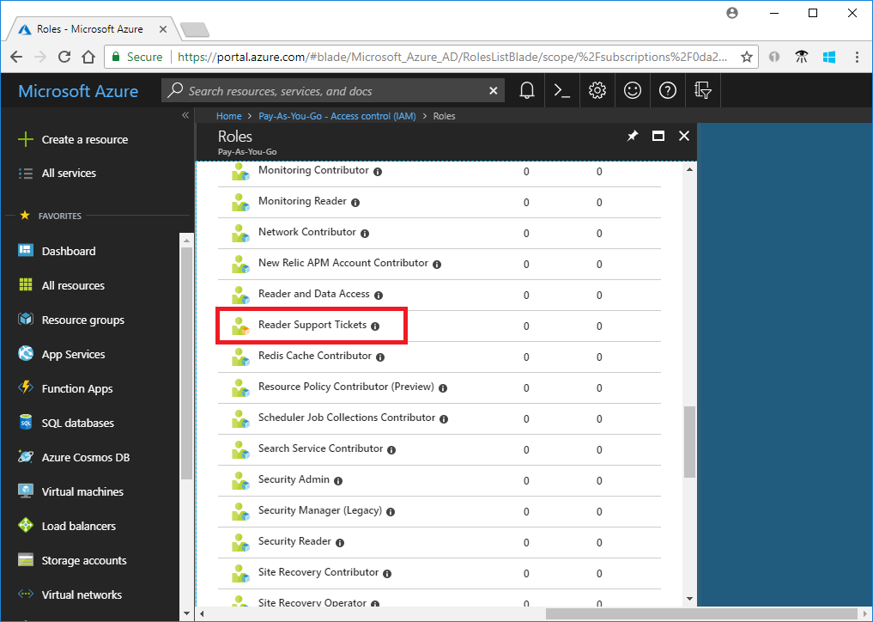

You can also see the custom role in the Azure portal.

1. **Assigning Roles to User**

**az role assignment create --role "Reader Support Tickets" --assignee** [**admin@bhadra982gmailcom.onmicrosoft.com**](mailto:admin@bhadra982gmailcom.onmicrosoft.com)

* Here [admin@bhadra982gmailcom.onmicrosoft.com](mailto:admin@bhadra982gmailcom.onmicrosoft.com) comes from the following steps:

Login to your Azure Portal and

Home 🡪 Azure AD 🡪 More info 🡪 Profile 🡪 Member

* You can confirm that this Role is assigned to the User by going to any of the Resource Group 🡪 IAM 🡪 Role Assignments and you can see the Role is assigned over there.

1. **Delete Roles**

**az role assignment delete --assignee dcadc05b-8292-4428-8488-2eb2e90da9a3 --role "Reader Support Tickets"**

Here “dcadc05b-8292-4428-8488-2eb2e90da9a3” comes from Home 🡪 Azure AD 🡪 More info 🡪 Profile 🡪 Object ID