Screenshots from test cases for the Homework 5

Below are screenshots from the 8 tests cases for the first part, and 5 test cases for the second part.

1)

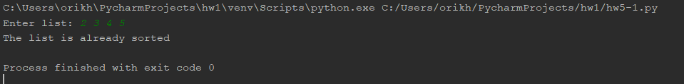

2)

