Accuracy : 0.4743

Macro F1 : 0.4753

Micro F1 : 0.4743

Macro ROC-AUC : 0.8117

precision recall f1-score support

0 0.81 0.29 0.42 89802

1 0.35 0.70 0.47 28218

2 0.58 0.48 0.52 60214

3 0.35 0.77 0.48 33853

accuracy 0.47 212087

macro avg 0.52 0.56 0.48 212087

weighted avg 0.61 0.47 0.47 212087

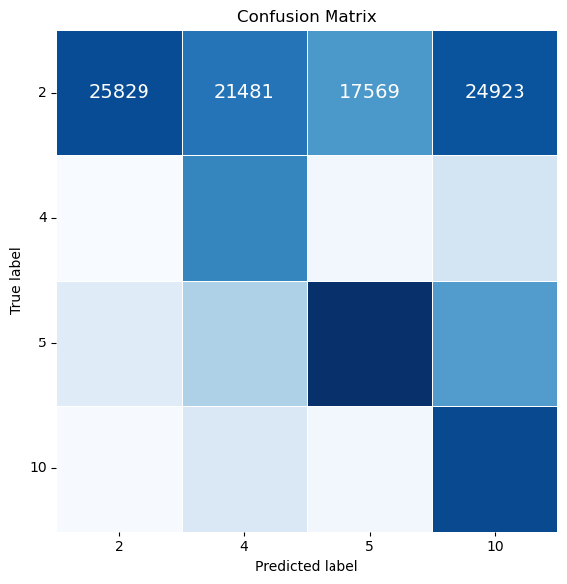

|  | **feature** | **drop_in_macro_f1** |
| --- | --- | --- |
| **0** | AGE | 0.097548 |
| **8** | STFIPS | 0.058512 |
| **2** | RACE | 0.043875 |
| **4** | EDUC | 0.017768 |
| **5** | EMPLOY | 0.015735 |

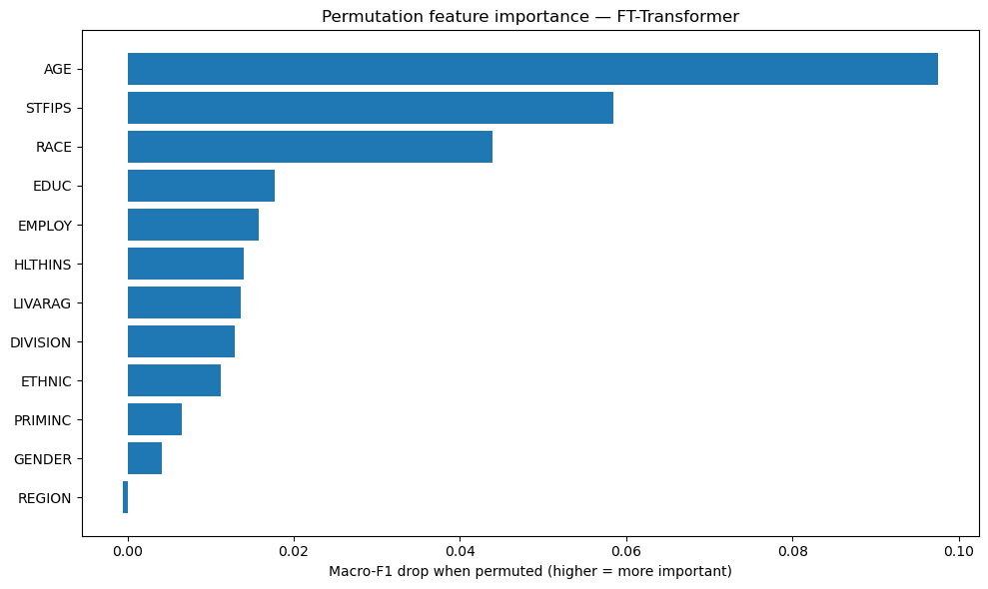

[6]:

|  | **feature** | **drop_in_macro_f1** |
| --- | --- | --- |
| **0** | AGE | 0.097548 |
| **8** | STFIPS | 0.058512 |
| **2** | RACE | 0.043875 |
| **4** | EDUC | 0.017768 |
| **5** | EMPLOY | 0.015735 |