**Answers**:

**Contextlib** – a module that provides utilities for working with context managers, which are used to manage resources, such as files or network connections, ensuring they are properly cleaned up after use. The most common use case of a context manager is with the 'with' statement, like when opening a file, and so in this case the 'with' automatically handles closing the file after it's done being used.

**'enter', 'exit' -** These are special methods that you can define in your own classes to make them context managers. The 'enter' method is executed when the 'with' block is entered, and its return value is assigned to the variable after 'as' in the 'with' statement (if used). The 'exit' method is executed when the 'with' block is exited, whether it exits normally or via an exception, It takes three arguments related to exceptions: exc_type, exc_value, and traceback - These are 'None' if no exception occurred.

**Create a custom context manager of my own –**

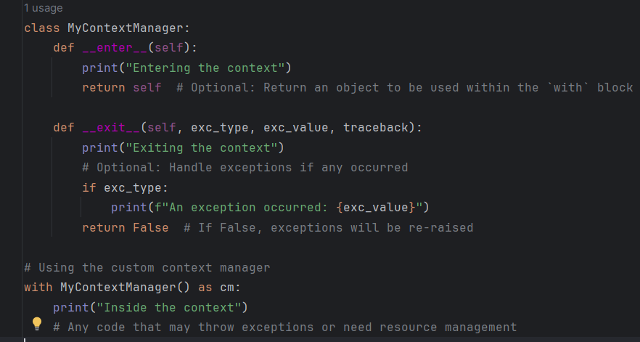You need to define a class and implement the _enter_ and _exit_ methids in it:

**Options for logging -**

Standard library – 'logging': Python’s built-in logging library provides a flexible framework for emitting log messages from Python programs. It supports different log levels (DEBUG, INFO, WARNING, ERROR, CRITICAL) and can output logs to various destinations (console, files, remote servers). Libraries like 'structlog' and 'loguru' offer more advanced logging capabilities, including structured logging.

Logging middlewares – In web frameworks like Flask or Django, middleware can be used to log HTTP requests and responses, errors, and other relevant data.

**Exceptions and warnings -**

Exceptions used to handle errors that occur during execution, typically stop the program unless caught using 'try' and 'except'.

Warnings used for non-critical issues, which don’t necessarily stop the execution of the program but signal that something might need attention. Python’s warnings module allows you to issue warnings and control how they are displayed.

**Typing** - Introduces type hints into Python, allowing you to specify the expected types of function arguments, return values, and variables. It improves code readability and helps catch type-related errors during development. Commonly used type hints include List, Dict, Optional, Union, and Any.

**Itertools -** A standard library module that provides a collection of fast, memory-efficient tools for creating and using iterators. Commonly used functions include count, cycle, permutations, combinations, chain, and groupby. Useful for looping over data in complex ways, such as generating combinations, permutations, or infinite sequences.

**operator + Operator Overloading –**

operator module provides functions corresponding to Python’s basic operations, like addition, subtraction, multiplication, and more complex operations like item getting and setting. Its often used in functional programming or as a more readable alternative to lambda functions.

Operator overloading allows you to define how operators like +, -, *, etc., behave for instances of your own classes. It is Implemented by defining special methods like __add__, __sub__, __mul__, etc.

**Threading -** A module for creating and managing threads in Python, allowing for concurrent execution of code. Useful for I/O-bound tasks like reading from a file or making network requests. Common functions include Thread, Lock, Event, and Semaphore. Threading introduces complexity, particularly with shared state, so careful synchronization is required.

**Inspect** - provides several useful functions to help you get information about live objects, such as modules, classes, methods, functions, and even the call stack. Commonly used to retrieve function signatures, source code, or to introspect the current execution frame.

**Abc** – abstract base classes – the abc module is used to define abstract base classes in Python, which are classes that cannot be instantiated and often define a set of methods that must be implemented by any concrete subclass. It is commonly used in situations where you want to enforce a certain interface across multiple classes.

**Pickle** – the pickle module is used to serialize and deserialize Python objects into a byte stream and vice versa.

**Pydantic**- a data validation and settings management library using Python type annotations. Commonly used in FastAPI and other projects where data validation and parsing are critical. automatically validates data and converts it to the specified types, providing helpful error messages when data is invalid.

**Pathlib** - a modern library for working with file system paths in an object-oriented way. Replaces older modules like os.path with a more intuitive and flexible API. Supports operations like joining paths, reading/writing files, and navigating directories.

**Posix** - refers to the POSIX (Portable Operating System Interface) standard for Unix-like systems. The posixpath module is part of the os module and handles path manipulations in a way that is compliant with POSIX standards.

**Functools** - a module for higher-order functions that act on or return other functions. These utilities can help with tasks like function composition, caching, and method wrapping, making it easier to work with functions in a more functional programming style.

**Decorators** - Functions that modify the behavior of other functions or methods. Commonly used for logging, access control, memoization, and more. Created using the '@decorator_name' syntax and can be stacked.