EXECUTIVE ASSISTANT ASSESSMENT

Candidate: Glaiza P. Oringot
Date: August 26, 2026
Position: Executive Assistant / Virtual Assistant

SECTION 1: CALENDAR CONFLICT RESOLUTION

Executive Summary
Conflict Identified: Two high-priority meetings scheduled simultaneously
- Meeting A: Investor Meeting (External, High Stakes)
- Meeting B: Key Partner Meeting (External, Ongoing Relationship)

Decision Made
Action | Decision
Keep | Investor Meeting
Reschedule | Key Partner Meeting
New Time | Proposed within 24 hours

Decision Rationale
Factor | Investor Meeting | Partner Meeting
Schedule Flexibility | ❌ Rigid, limited availability | ✅ More flexible
Financial Impact | 🔴 Critical (funding decisions) | 🔴 Important but non-urgent
Rescheduling Cost | High (weeks of delay) | Low (days)
Decision Urgency | High (deadline-driven) | Medium
Relationship Impact | Minimal with proper communication | Manageable

Communication Drafts

📧 EMAIL 1: To Key Partner

To: [Partner Name]
CC: [Executive Name]
Subject: Request to Reschedule - [Meeting Topic]
Dear [Partner Name],
I hope you're having a productive morning.
Due to an unforeseen and urgent scheduling conflict, I respectfully request to reschedule our meeting originally set for [Time] today.
I sincerely apologize for any inconvenience this may cause.

Proposed Alternative Times
Option | Date | Time | Duration
Option 1 | Tomorrow, [Date] | 10:00 AM - 11:00 AM | 1 hour
Option 2 | [Next Day], [Date] | 2:00 PM - 3:00 PM | 1 hour
Option 3 | [Day After], [Date] | 9:30 AM - 10:30 AM | 1 hour

Please let me know which time works best for you, or if you have an alternative suggestion. I sincerely apologize for any inconvenience this may cause.
I've already prepared the discussion materials and will ensure they are ready for our rescheduled meeting. Please feel free to call or email me if you need anything in the meantime.
Thank you for your understanding.
Warm regards,
Glaiza Oringot
Executive Assistant to [Executive Name]
📞 09097696160
📧 oringotglaiza611@gmail.com

📧 EMAIL 2: To Executive (Approval Request)

To: [Executive Name]
Subject: ⚠️ URGENT: Calendar Conflict - Your Approval Needed
Hi [Executive Name],
I've identified a scheduling conflict for [Time] today:
Meeting | Attendees | Status
Investor Meeting | [Investor Name] | 🔴Waiting for approval
Partner Meeting | [Partner Name] | 🔴Waiting for approval

My Recommendation
Keep the Investor Meeting | Reschedule the Partner Meeting
Reasoning:
- The investor meeting is critical for securing funding
- Key partners are generally more accommodating with schedule changes
I've drafted a rescheduling request to the key partner. Please review and approve so I can send it promptly.
Next Steps:
- If approved, I'll send the reschedule request immediately
- I'll confirm the new time and update your calendar
- I'll ensure all meeting materials are prepared for both
Awaiting your approval.
Best,
Glaiza Oringot

SECTION 2: INBOX ORGANIZATION SYSTEM

Email Triage Framework
Priority Matrix
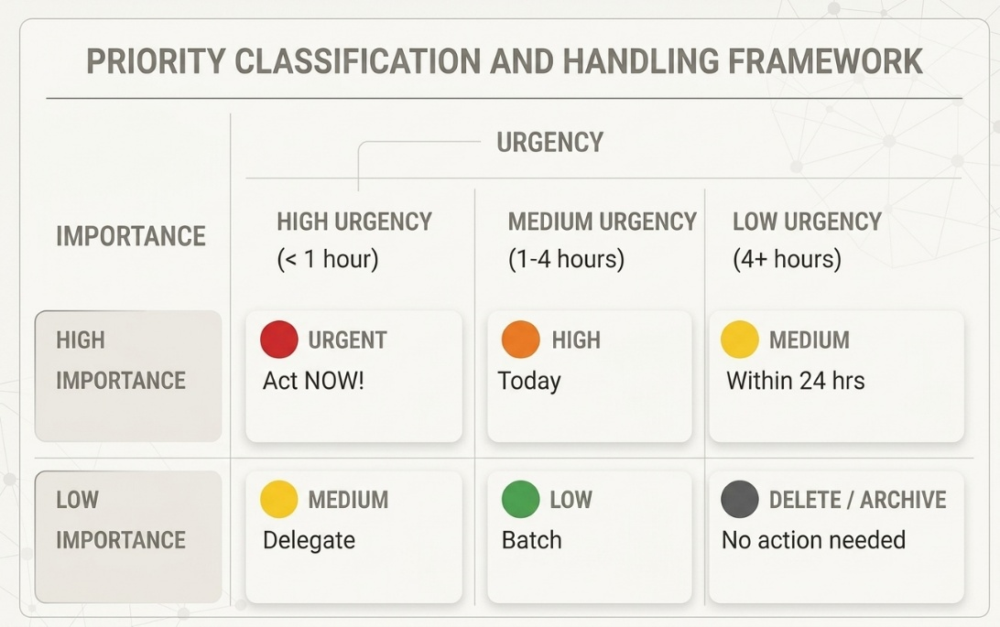
Email Categories

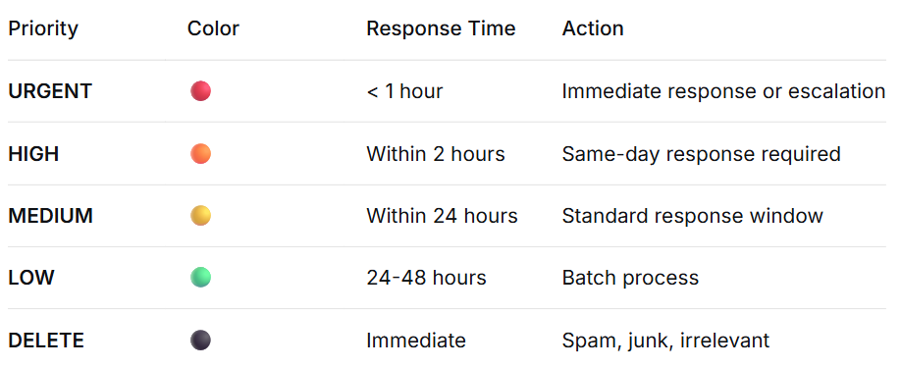
120+ Email Processing Strategy
10-Minute Triage Process
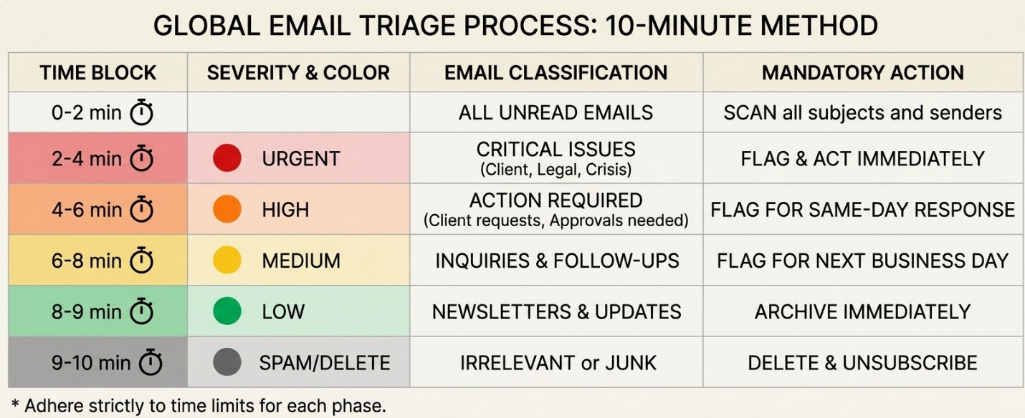

Draft Responses for 3 Key Emails

📧 EMAIL 1: URGENT - Contract Issue

From: [Client Name]
Subject: ⚠️ URGENT: Contract Clause Discrepancy - Legal Risk

Draft Response:
To: [Client Name]
CC: [Legal Team], [Executive Name]
Subject: RE: ⚠️ URGENT: Contract Clause Discrepancy - IMMEDIATE ACTION
Dear [Client Name],
Thank you for flagging this critical issue immediately.

Immediate Action Plan
Step | Action | Owner | Timeline
1 | Review the specific clause | Legal Team | 20 minutes
2 | Assess legal implications | Legal Team | 30 minutes
3 | Draft revised language | Legal Team | 1 hour
4 | Present to Executive | Myself | 1 hour
5 | Submit to Client | Myself | End of day

What I Need from You
- Can you please specify the exact section causing concern?
- Do you have a preferred timeline for the revised draft?
I will follow up personally within 1 hour with an update. Please don't hesitate to reach out directly at [Your Phone Number] if you need immediate clarification.
I apologize for any inconvenience and appreciate your patience.
Best regards,
Glaiza Oringot
Executive Assistant to [Executive Name]
📞 09097696160
📧 oringotglaiza611@gmail.com

📧 EMAIL 2: HIGH - Budget Approval

From: [Marketing Director]
Subject: Q3 Budget Approval Required by 3 PM TODAY

Draft Response:
To: [Executive Name]
Subject: 🚨 APPROVAL NEEDED: Q3 Marketing Budget - Deadline TODAY 3 PM
Hi [Executive Name],
The marketing team needs your approval on the Q3 budget of $75,000 by 3:00 PM today to secure early bird rates for ad placements.
Budget Summary
Category | Amount | Justification
Digital Advertising | $35,000 | Early bid rates expire today
Social Media Campaign | $20,000 | Q3 campaign launch
Content Production | $20,000 | Video, graphics, copy
TOTAL | $75,000

Quick Decision Options
Option | Action | What You Need to Do
A | Approved in full | Reply: “APPROVED”
B | Approved with conditions | Reply: ‘’APPROVED if [condition]
C | Schedule 5-min call | Reply: “CALL”

Documents Attached
- 📄 Full budget breakdown (PDF)
- 📊 ROI projections (Excel)
- 📝 Campaign timeline (Google Doc)

I will follow up in 2 hours if I haven't heard back.
Best,
Glaiza Oringot

📧 EMAIL 3: MEDIUM - New Vendor Inquiry

From: [Vendor Name]
Subject: Partnership Proposal - [Company Name] Collaboration

Draft Response:

To: [Vendor Name]
Subject: RE: Partnership Proposal - [Company Name]
Dear [Vendor Name],
Thank you for sharing your proposal with us. I appreciate your interest in partnering with [Company Name].

Current Status
Item | Status
Proposal Received | ✅ Yes
Executive Review | 🔄 In Queue
Vendor Evaluation | 📅 Scheduled for Q4
Next Steps | 📋 Defined

What I've Done
- ✅ Forwarded to [Executive Name] for review
- ✅ Saved in Vendor Folder for Q4 Evaluation
- ✅ Added to our partnership consideration list
- ✅ Sent to [Department Head] for preliminary assessment

Timeline
Milestone | Expected Date
Executive Review | Within 2 weeks
Vendor Shortlist Selection | End of Q3
Final Decision | Beginning of Q4

Please feel free to send:
- Client testimonials or case studies
- Product/service demo links
- Reference contacts

I will be your main point of contact. Please direct all future communications to me.
Thank you for your interest.
Best regards,
Glaiza Oringot
Executive Assistant to [Executive Name]
📞 09097696160
📧 oringotglaiza611@gmail.com

SECTION 3: REVISED TRAVEL PLAN

Situation Overview
Item | Details
Original Flight | [Flight Number] –[Airline]
Scheduled Date | Tomorrow, [Date]
Scheduled Time | [Time]
Status | ❌CANCELLED
Event | [Event Name], [Location]
Executive’s Role | [Speaker/ Attendee]

Primary Travel Solution
Option 1: Direct Flight (RECOMMENDED)
Detail | Information
Airline | [Alternative Airline]
Flight Number | [Flight Number]
Departure | [Time] (1 hour earlier than original)
Arrival | [Time]
Travel Time | [X hours]
Class | Business (as preferred)
Seat | ][Seat Preference]
Cost | [$X,XXX

✅ Pros:
- Fastest option
- Minimal disruption
- Arrives with buffer time

Backup Travel Solutions
Option 2: Connecting Flight
Detail | Information
Airline | [Alternative Airline]
Flight 1 | [City A]- [City B]- [Time]
Layover | [X hours]
Flight 2 | [City B]- [Destination]- [Time]
Total Duration | [X hours]
Cost | [$X,XXX]
🔄 Backup if Option 1 fills up

Contingency Plan Matrix
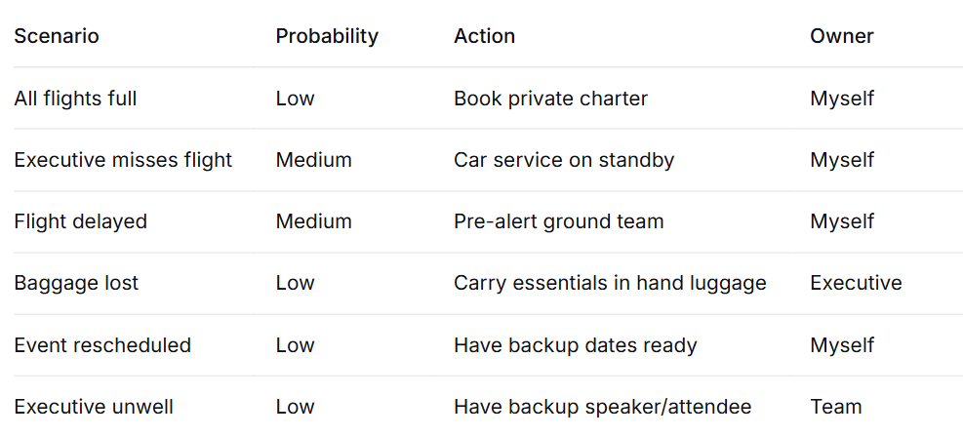

Revised Travel Itinerary
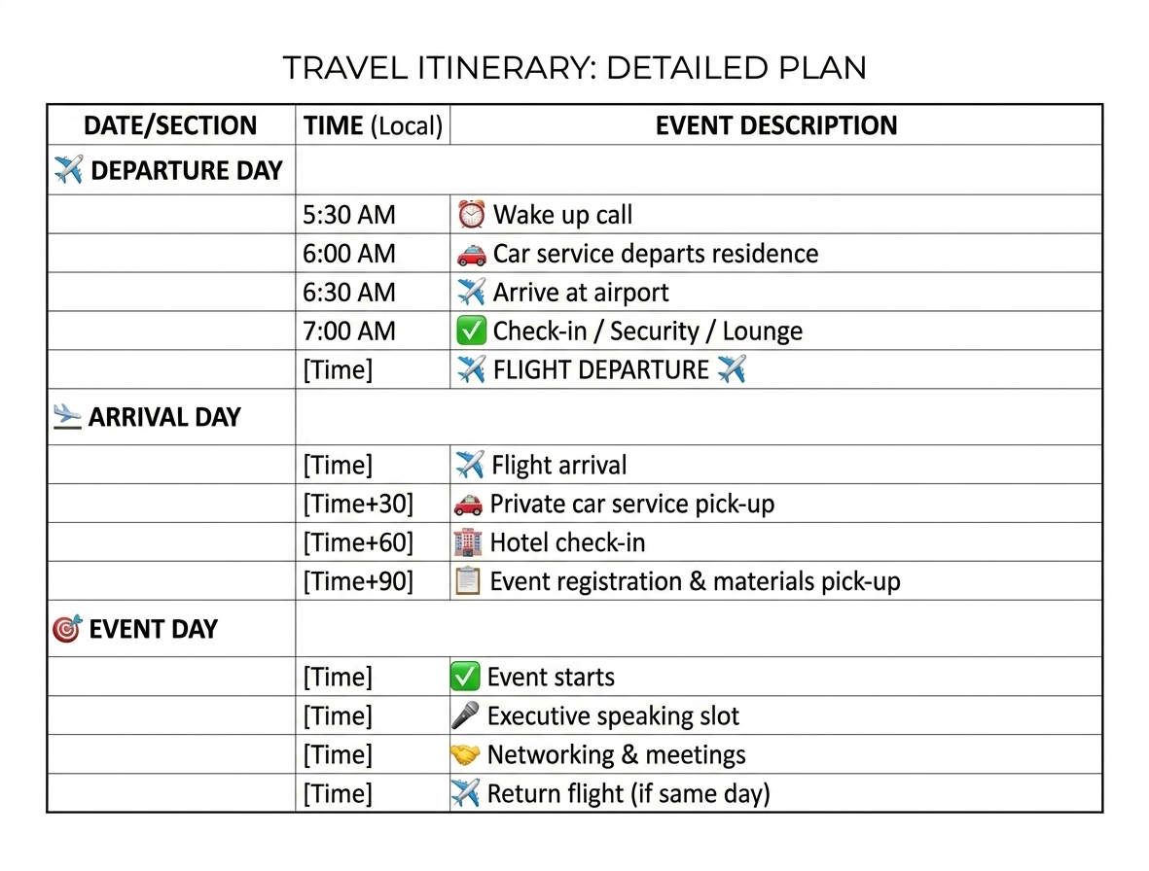
Communication to Executive

To: [Executive Name]
Subject: 🛫 FLIGHT CANCELED - 3 Alternatives Ready
Hi [Executive Name],
Your original flight has been canceled.

Quick Options
Option | Airline | Departure | Arrival | Recommendation
1 | [Airline A] | [Time] (1 hour earlier) | [Time] | ✅ BEST - earliest arrival
2 | [Airline B] | [Time] | [Time] | 🔄 Backup - connecting flight

My Recommendation
OPTION 1 - Direct flight with earliest arrival
Why:
- ✅ Arrives with 3-hour buffer
- ✅ Business class available
- ✅ No layovers or connections
- ✅ Same airline (for loyalty points)

Action Required
Please reply with:
- "1" for Option 1
- "2" for Option 2
I will book immediately and confirm.
Deadline: 30 minutes (to secure booking)

Already Handled
- ✅ Hotel confirmed (keeping original booking)
- ✅ Ground transport arranged (updated for new time)
- ✅ Event registration confirmed
- ✅ Speaking slot confirmed (no changes)

Please confirm so I can finalize everything.
Best,
Glaiza Oringot

SECTION 4: DAILY WORKFLOW SYSTEM

Complete Daily Operating System

🕐 Morning Routine (7:00 AM - 9:00 AM)
Time | Task | Tool | Outcome
7:00 | Scan all channels | Slack, SMS, WhatsApp | Identify emergencies
7:15 | Calendar review | Google Calendar | Know today's schedule
7:30 | Email triage | Email Platform | Prioritize 120+ emails
8:00 | Executive priorities | Notion | Define day's focus
8:15 | Prepare morning brief | Google Docs | Executive-ready summary
8:30 | Daily stand-up | Slack | Team alignment
8:45 | Final preparation | All tools | Ready to execute

🔄 Midday Routine (10:00 AM - 4:00 PM)
Time | Task | Tool | Outcome
10:00 | 5-min check-in | Slack/Call | Executive alignment
11:00 | Process HIGH emails | Email Platform | Clear priority items
12:00 | Morning review | Google Docs | Track progress
1:00 | Process MEDIUM emails | Email Platform | Respond within 24 hrs
2:00 | Meeting preparation | Calendar/Tools | Ensure readiness
3:00 | Meeting follow-ups | Email Platform | Action item tracking
4:00 | Calendar planning | Google Calendar | Set tomorrow's schedule

🌙 Evening Routine (4:00 PM - 6:00 PM)
Time | Task | Tool | Outcome
4:30 | Unread email sweep | Email Platform | Inbox Zero
5:00 | End-of-day brief | Google Docs | Executive summary
5:15 | Review pending items | Notion | Identify blockers
5:30 | Prepare tomorrow | Calendar/Tasks | Set up for success
5:45 | Final communication | Slack/Email | Team updates
6:00 | Shut down | All tools | Work-life balance

Tool Stack
Purpose | Tool | Why
Calendar | Google Calendar | Color coding, buffers, sharing
Email | Gmail/Outlook | Rules, labels, filters
Tasks | Notion | Centralized, flexible, transparent
Communication | Slack | Quick, organized channels
Documents | Google Drive | Real-time collaboration
Notes | Google Docs | Executive summaries, templates

Automation Setup
Email Rules & Filters
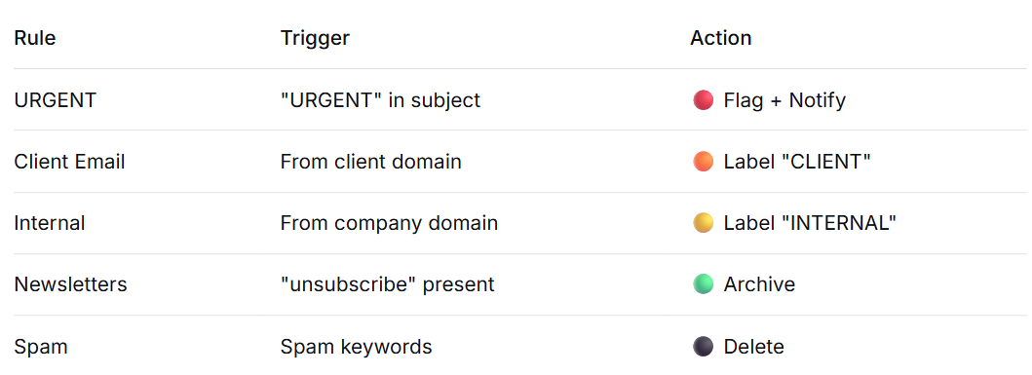

Calendar Rules
Rule | Action
New Meeting Invite | Auto-add with 15-min buffer
External Meeting | Color code ORANGE
Internal Meeting | Color code BLUE
Focus Time | Auto-block 2 hours daily

Prevent Overload - The 5-Pillar System

Executive Summary
This system prevents overload by creating structure, automation, and clear boundaries. Each pillar addresses a specific overload risk and provides actionable solutions.

The 5 Pillars at a Glance
Pillar | Focus | Overload Risk Addressed
1. Inbox Zero | Email Management | Email overwhelm
2. Calendar Buffers | Time Management | Back-to-back meetings
3. Priority Matrix | Task Prioritization | Unclear priorities
4. Weekly Review | Reflection & Planning | Reactive work
5. Communication Protocols | Response Standards | Constant interruptions

PILLAR 1: INBOX ZERO
🎯 Goal: Never have more than 20 emails in your inbox
The 4 Email Rules
Rule | Action | Example
Batch Processing | Check email 4x daily only | 8 AM, 11 AM, 2 PM, 5 PM
2-Minute Rule | If <2 min, do it immediately | Quick reply, forward, delete
One-Touch Rule | Touch each email only once | Read, decide, act, file
Unsubscribe | Unsubscribe weekly from irrelevant lists | Every Friday

Daily Email Schedule
Time |  | Duration | Task
8:00 AM |  | 20 min | Process overnight emails
11:00 AM |  | 20 min | Process morning emails
2:00 PM |  | 20 min | Process afternoon emails
5:00 PM |  | 20 min | Final sweep to Inbox Zero

Folder System
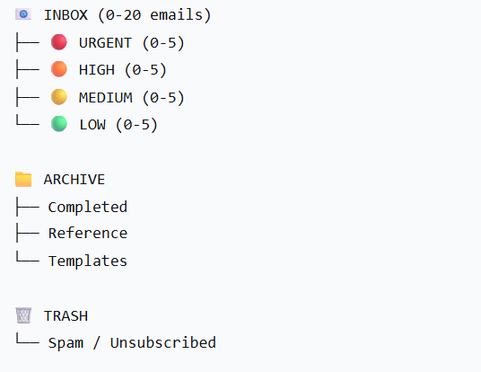
Inbox Zero Checklist
✅ | Action
□ | Every email has been read
□ | Every email has been acted on or filed
□ | Every email has a follow-up date (if needed)
□ | Inbox is clean at end of day

PILLAR 2: CALENDAR BUFFERS
🎯 Goal: Never have back-to-back meetings
The 3 Buffer Rules
Rule | Purpose
Between Meetings | Prep, notes, bathroom, transition
Focus Time | Deep work, NO meetings
Prep Time | Review materials, set agenda

Calendar Structure

Buffer Rules Checklist
✅ | Action
□ | 30-min buffer after EVERY meeting
□ | 2-hour Focus Time blocked daily
□ | 15-min prep before each external meeting
□ | Lunch break is ALWAYS protected

PILLAR 3: PRIORITY MATRIX
🎯 Goal: Always know what to do next
The Matrix Framework
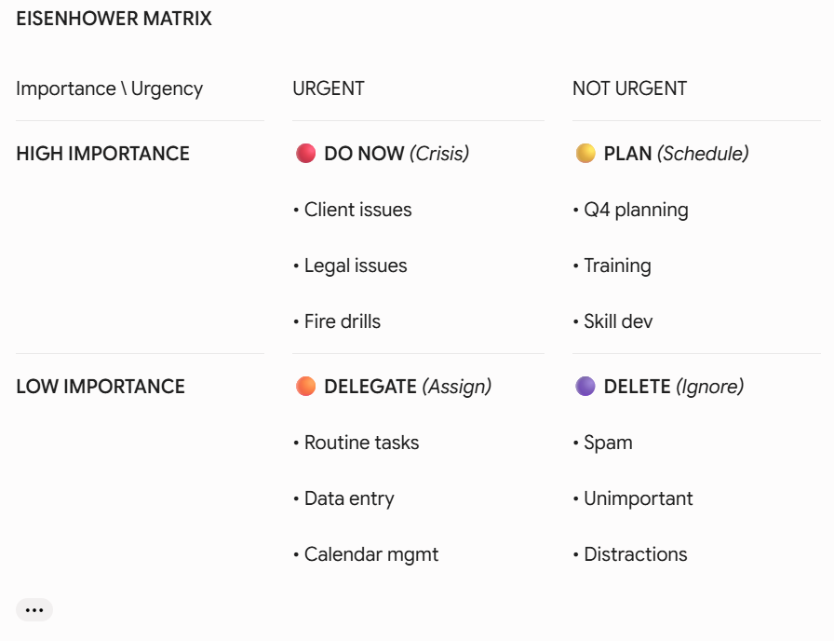

Daily Decision Process

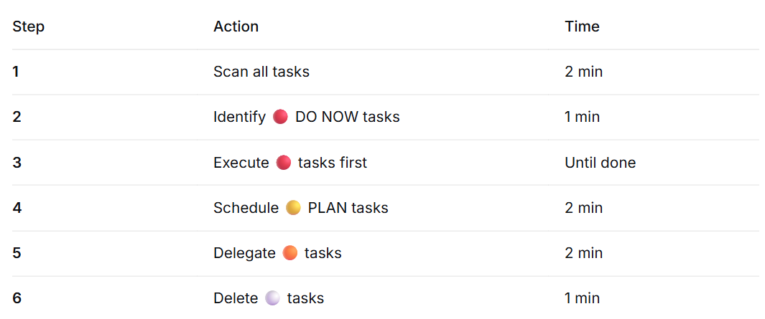

Priority Rules

Rule | Explanation
Urgent + Important | DO NOW. Cannot wait.
Urgent + Unimportant | DELEGATE. Someone else can do it.
Not Urgent + Important | PLAN. Schedule it before it becomes urgent.
Not Urgent + Unimportant | DELETE. Does not matter.

PILLAR 4: WEEKLY REVIEW
🎯 Goal: Stay proactive, not reactive
Weekly Review Schedule
Friday Afternoon: 30 minutes (4:00 PM - 4:30 PM)
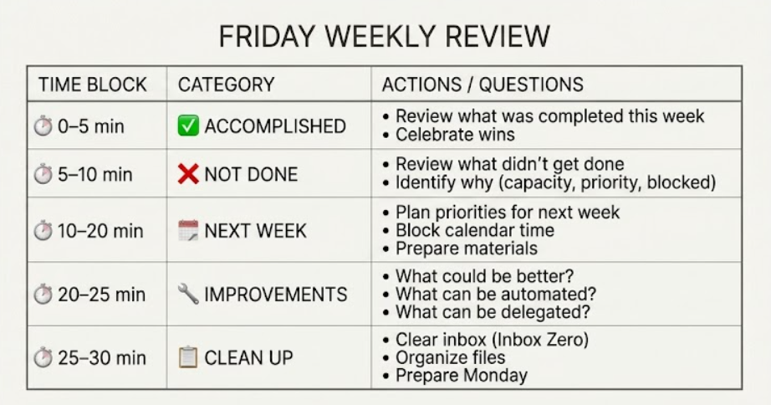

Weekly Review Checklist
✅ | Area | Questions
□ | Tasks | Are all tasks up to date? Pending items followed up?
□ | Calendar | Is next week fully scheduled? Any conflicts?
□ | Emails | Is inbox clean? Any urgent emails missed?
□ | Projects | Are all projects on track? Any blockers?
□ | Goals | Are we meeting weekly goals?
□ | Improvements | What can I do better next week?

Monthly Review (1st Friday of Month)
✅ | Focus | Questions
□ | Big Picture | Am I aligned with executive priorities?
□ | Metrics | Am I meeting performance goals?
□ | Feedback | Have I asked for feedback?
□ | Development | Have I learned something new?
□ | Automation | What can I automate further?

PILLAR 5: COMMUNICATION PROTOCOLS
🎯 Goal: Stop constant interruptions
Response Time Standards
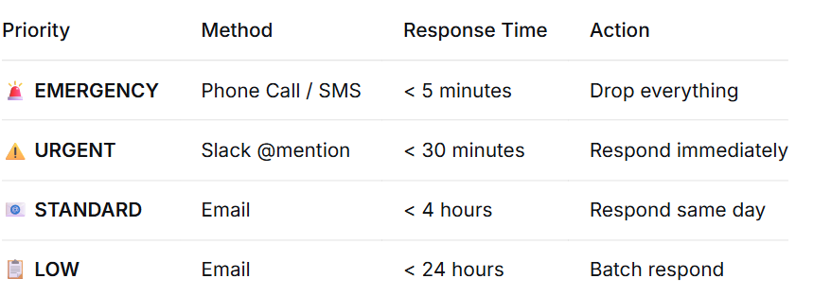
Communication Channels
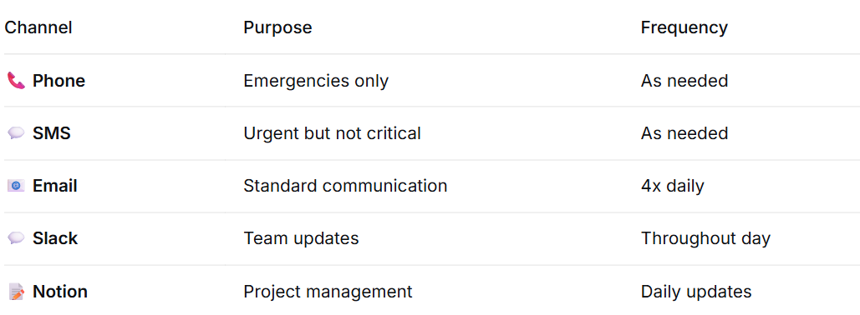

The Interruption Prevention Rule
DON’T BREAK MY FOCUS
Rule: During Focus Time (2 hours), I do NOT respond to:

❌ Slack messages
❌ Email notifications
❌ Non-urgent phone calls
❌ In-person interruptions

✅ Only respond to: EMERGENCIES (phone call)

Why? It takes an average of 23 minutes to refocus after interruption.

Communication Preferences Template
To fill with Executive:
Question | Executive's Answer
How do you prefer to be contacted for emergencies?
How do you prefer to be contacted for urgent matters?
How often do you want email updates?
What times are you unavailable?
Do you prefer summaries or full details?
Any communication you DON'T want to receive?

Summary: The 5-Pillar System
COMPLETE OVERLOAD PREVENTION
Pillar | Strategy/ Action
PILLAR 1: INBOX ZERO | Batch process, 2- Minute Rule
PILLAR 2: CALENDAR BUFFERS | 30-min buffers, 2- hours focus
PILLAR 3: PRIORITY MATRIX | Eisenhower Matrix (4 quadrants)
PILLAR 4: WEEKLY REVIEW | 30-minutes Friday Review
PILLAR 5: COMMUNICATION | Response standards, channel
RESULT: ✅ Zero overload, ✅ Maximum productivity, ✅ Always ahead

Quick Reference Card
OVERLOAD PREVENTION CHEAT SHEET
Category | Rules & Guidelines
📧 EMAIL | Process 4x daily | 2-Minute Rule | Inbox < 20
📅 CALENDAR | 30-min buffers | 2-hr focus time | 15-min prep
🎯 PRIORITY | DO NOW > PLAN > DELEGATE > DELETE
📋 WEEKLY | Friday 4:00 PM - 30-min review
💬 COMMUNICATION | Emergency (Call) < 5 min | Email < 4 hrs
⚠️ REMEMBER: Check email at 8AM, 11AM, 2PM, 5PM ONLY
⚠️ REMEMBER: No interruptions during Focus Time
⚠️ REMEMBER: If < 2 minutes, DO IT NOW

Why This System Works
Why | Explanation
Predictable | You know exactly what to do and when
Proactive | Weekly reviews prevent surprises
Protected | Focus time and buffers protect your energy
Prioritized | You always work on what matters most
Peaceful | No more feeling overwhelmed

Final Thought
"The goal is not to do more. The goal is to do what matters, without stress, and with excellence."

SECTION 6: BONUS CHALLENGE RESPONSE

Executive Frustration Scenario
"The executive later expresses frustration that you rescheduled the 'wrong' meeting."

Brief Justification
I prioritized the investor meeting because investors operate with rigid schedules, strict funding deadlines, and limited availability. Rescheduling investors often delays capital deployment by weeks or months, directly impacting our Q3 cash flow. The partner meeting, while important, was focused on progress review - not time-sensitive deliverables.
My decision was based on: (1) investors are harder to reschedule than partners, (2) partners have more flexibility in their calendars, and (3) the investor meeting had immediate financial implications.
However, I acknowledge that the executive has deeper context about relationship dynamics that I may not fully understand. Moving forward, I will proactively confirm meeting priorities before any rescheduling decisions.

Improvement to Executive Preferences
🔧 One Improvement: "Executive Priority Matrix"
Create a documented Decision Framework aligned with executive preferences:
Preference Category | Questions to Ask | Result
Stakeholder Priority | Rank: Investors? Partners? Internal? | Priority ranking
Meeting Protection | Which meetings are NEVER rescheduled? | Protected list
Decision Speed | Speed vs. consultation? | Decision style
Communication | When to text vs. email? | Protocol
Risk Tolerance | Conservative vs. aggressive? | Approach

Implementation Plan
Step | Action | Timeline
1 | Create 5-min "Executive Preference Form" | Day 1
2 | Present to executive for review | Day 1-2
3 | Populate and confirm | Day 2-3
4 | Use as decision guide for ALL scheduling | Ongoing
5 | Quarterly review and update | Quarterly

Expected Outcome
- ✅ 100% alignment on scheduling decisions
- ✅ Zero frustration on rescheduling choices
- ✅ Faster decision-making with clear priorities
- ✅ Stronger trust between executive and assistant
- ✅ Reduced need for executive input on minor decisions

"Wrong Meeting" Resolution Script
If the executive says: "You rescheduled the wrong meeting!"
My Response:
"I understand your frustration, and I apologize for the inconvenience. I made the decision based on investor scheduling rigidity and financial impact, but I clearly didn't have full context about the partner relationship.
I've already created a Priority Decision Framework to prevent this from happening again. It documents your preferences on:
- Which stakeholders are non-negotiable
- Which meetings are always protected
- How you prefer decisions to be made
Can I take 2 minutes to review this with you now? I want to ensure we're 100% aligned going forward.
In the meantime, I've already reached out to the partner to reschedule for tomorrow at 11:00 AM and confirmed their availability."

