1. customers spent an [average of 46 seconds waiting for call centers](https://ozonetel.com/campaigns/call-center-metrics-2022/).
2. 28% of these callers disconnected before they could speak to a business representative.
3. The Average Wait Time within contact centers was 46 seconds (2021).
4. 34% of callers who hang up are never called back - increasing the abandonment rate.
5. Average cost of an employee to his employer for an hour is 30$.
6. [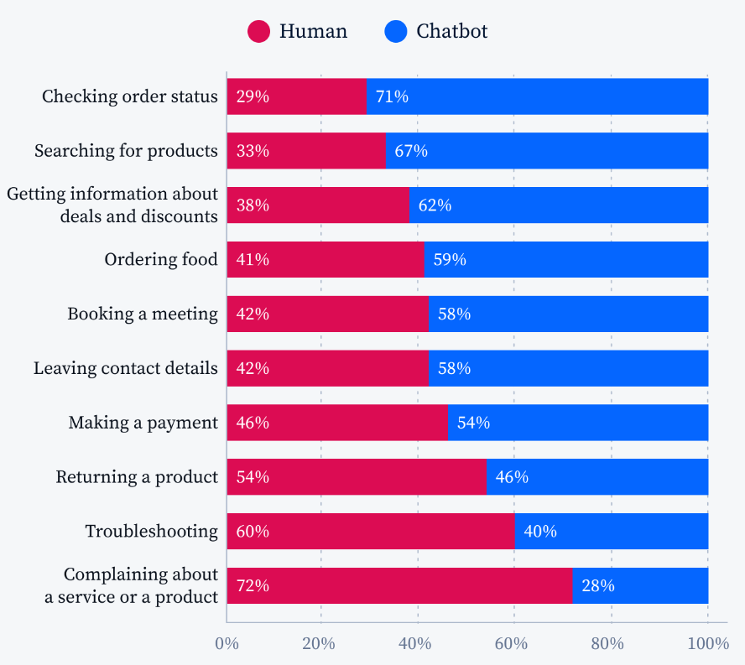](https://www.tidio.com/blog/chatbot-vs-live-chat/)