Design Thinking Block Course

270220

SS2014

Syllabus @CITEC-Bielefed

Berengueres & Eyssel

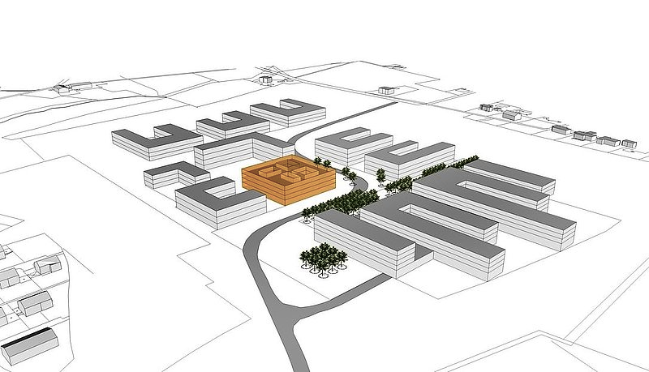

What is Design Thinking?
While Design Thinking has many interpretations, in this course we will consider it from a process management point of view - a skill that can be used to optimise the creative output of your team. Design Thinking is particularly effective when applied to complex projects such as: innovating or designing a new product. It will give you tools to manage the creative workflow and to avoid corporate traps such as the so called: Death by Committee and Group Thinking. Originated at Stanford in 2004, and with a school funded by Hasso Plattner (see: http://www.hpi.uni-potsdam.de/willkommen.html), today Design Thinking impacts design processes, engineering practice, and education across disciplines.

Goals
The goal of this course is to acquire Design Thinking skills. Rather than using the traditional MBA case study method, this is a workshop-based course where students learn by doing. At each step, a thinking tool will be introduced and practiced.
Outcomes
By the end of the course the student is expected to:
(1) Have a sense of self-efficacy & creative confidence
(2) Know how to manage a Design Thinking workshop: Layout roles, times and process.
(3) Effectively use thinking tools: (a) A3 / PDCA, (b) Root cause analysis, (c) Kaizen / 5S

Course Outline July 2014
Module | Key concepts / Learning Goals | Release time  10 - 16h
0. Introduction  1. Psychology of Team Work | - Overview of the course. Wicked Problems. Process vs. Product. (20’)  - The Marshmallow workshop (20’), video (20’), discussion, Group IQ (Vosmek)  - Alex Ferguson Case (20’) (Elberse 2013) Visualisation, special purpose trainings, step-back  - ideo (2h)  -Life of David Kelley – the man, DIY culture, unhappiness (20’)  - The Shopping Cart Workshop (20’)  Roles, Use of deadlines, Space & behavior, Preparation, diversity, learn by doing  go  - Workshop time (1h)  Iterative prototyping, Layout, Empathic observation | Friday July 4th  Room 2.015  CITEC Building
2. Empathy  3. Toyota | - Developing Empathy skills: d.gift workshop (2h)  - Toyota historical perspective (20’)  - Tools to see better (2h)  - 7 Waste  Added Value vs. Non Added Value mapping  Crossfunctional teams Nissan case (Magee)  - A3 Toyota reporting with PDCA & Value Stream Maps  - The Five Why’s method (Aspirin)  - Kaizen / 5S - The incomplete Japanese temple (switchable to next session) | Wed. July 9th  Room 1.015 CITEC Building
4. Product Innovation Matrix  5. Creativity I | - Product innovation Matrix (Tchirsky 2006) (20’)  - Microwave workshop (2h)  - Tina Seelig’s Five Dollar Workshop.(4h)  - Comfort Zones  - Failed resume | Friday July 11th  Room 2.015  CITEC Building
6. Creativity II  7. Boosting R&D | - Reflection Time (5 Dollar Workshop)  - Don Norman / Happy Brain  - Paula Scher Serious vs. Solemn/ Virgin America vs. Emirates safety flight video  - Case study: applying 5 Why to R&D | Monday July 14th  Room: 1.015  CITEC Building
8. Total Design Thinking | - Real-time workshop: (3h) with case study: Vibrasol Inc, case study CITEC robots (Mario/Cornula).  - The War-Room method  - Concluding remarks  - Diploma certificates | Wed July 16th  Room 1.015  CITEC Building

Textbooks & Media

Ideo / Riverdale (2012) Design Thinking for Educators (open source). Version 2.
http://www.designthinkingforeducators.com/toolkit

Berengueres, J. (2013) The Brown Book of Design Thinking, ISBN 978-1-63041-059-9. UAE University College. (iBooks/ Free)

More materials and pdf version available at: http://faculty.uaeu.ac.ae/jose/designthinking/

Grading Policy
Each student's final numerical score for this course is based on the following items and weights:
  - Design Workshop outcome (50%)
  - Creativity Workshop outcome (50%)
I will add up the points from these grading ingredients to compute a total score. According to the scores you achieved, you qualify for the following badges of achievement:
Certificate | How it is earned | What you get
Course completed | Obtain 70% or more | Statement of accomplishment
Design Thinking Expert | Obtain 90% or more | Statement of accomplishment
Excellence Award | Top 1% in total score | Potential invitation to collaborate on future course development

Credits will be provided according to regulations at University of Bielefeld.


Office hours
Office hours : by appointment via email jose@uaeu.ac.ae
Whatsapp : +971.553.519.573
Office : CITEC-2.045

Created Mon 25 Jun 2012 10:48:56 AM PDT
Last Modified Fri 20 Jun 2014 3:48:12 PM PST

