

Dr. John Runciman,

50 Stone Rd E,

Guelph, ON

N1G 2W1

Dear Dr. Runciman,

Please find attached the proposal “FSAE Rim Design”. The project will begin November 2, 2018 and end March 31, 2019. We have selected you as faculty advisor for this project because of your extensive experience in project management and your knowledge of manufacturing. Should you have any questions regarding this proposal, please contact us by email at [millero@uoguelph.ca](mailto:millero@uoguelph.ca). If you choose to accept this proposal, please send us a response at the email above.

Sincerely,

Nicolas Bessay-Torfs

Orion Miller

Andrew Roberts

Nicole Smith



**FSAE Rim Design**

Advisor: Dr. John Runciman, Ph.D, P.Eng

November 2, 2018

Group #26

Nicolas Bessay-Torfs - 0667788

Orion Miller - 0939412

Andrew Roberts - 0945811

Nicole Smith - 0947043

**Executive Summary:**

The proposed project is being done as a capstone engineering project at the University of Guelph. This project must be completed by every student in their fourth year of study in order to satisfy the requirements for graduation. In order to meet this requirement, our group of four mechanical engineering students will work together to develop, build, and validate a new carbon fibre rim design for the University of Guelph’s Formula SAE racecars.

Creating carbon fibre components is a highly specialized, time intensive process that has been used in the automotive world for around 20 years by those seeking to push the limits of performance. When well-made, carbon fibre parts have an unmatched combination of low density and high strength. The rims of the FSAE car are a prime candidate to take advantage of this technology. The performance of the car could be significantly improved by the development of a lighter and stiffer rim.

A complex manufacturing project like this one has many aspects that must be considered. For this reason, the scope will be broad and include:

* Investigation into the forces encountered by a racing rim, quantifying their magnitudes.
* Determination of the material type and manufacturing process best suited to the needs of the race team and considering the available facilities and tools.
* Finite Element Analysis of traditional aluminum rims to gain insight that will improve preliminary design and understanding of the project.
* Design of a carbon fibre rim that uses a two-piece carbon shell with an aluminum center. This will be done with consideration for the layering and orientation of the carbon throughout the part, as well as the logistics of bonding and clamping the assembly together.
* Production of carbon test pieces. This will occur throughout the project to gain experience in the manufacturing method and verify the material properties. These pieces may range from simple carbon plates to full-size rims.
* Design and manufacturing of the necessary molds using CNC machining.
* Finally, if all of these goals can be met, a complete set of carbon fibre rims will be made for the 2019 season.

This project will be an excellent learning experience for four engineering students who wish to further develop their mechanical design and project management skills as they prepare themselves for their future careers. The far-reaching scope of this project will provide a wide range of opportunities for group members with different interests. The members will also benefit from the process of testing and validating their design, a very important of aspect of engineering that cannot always be experienced to the same degree in projects that do not include a physical execution of the plan. The project will also benefit the Gryphon Racing Formula SAE team. By laying the groundwork for a transition to this technology, the ongoing success of a club that supports student’s efforts to learn engineering skills can be improved.

**Background:**

4100 design projects are completed by all U of G engineering undergrads in their final semester. The projects are meant to challenge students with open ended design problems and expose students to project planning and management similar to what will be encountered in industry. The projects allow students to cap their undergraduate degree by bringing together and applying a wide variety of materials, tools, and techniques picked up throughout their studies. The 4100 design project is also an opportunity to look forward to the types of careers students wish to pursue. Projects are an opportunity to gear studies towards fields of interest and learn from working engineers right before graduation.

For our 4100 design project, we chose to design and manufacture a set of carbon fibre rims for the Gryphon Racing team. This project will require us to apply our knowledge of finite element analysis, materials science, and mechanics. We will also learn new skills related to the manufacturing process, including laying-up carbon fibre and vacuum bagging. Looking ahead, carbon fibre manufacturing is well established in southern Ontario, and engineers with experience in the field are sought after.

By manufacturing rims from carbon fibre, we hope to reduce their weight and improve performance significantly. In a racecar, the performance of the vehicle is limited by the weight of the rims as heavier rims are more difficult to control. This is because they have higher rotational inertia and increase how much mass the suspension must act upon. A major weight reduction would improve these characteristics, as well as causing a significant reduction in total vehicle weight; the rims currently make up around eight percent of the car’s weight. We estimate that by making rims out of carbon fibre, the weight can be reduced by approximately 50% [1]. It is important to also consider that, as the part which transfers all forces between the car and the road, rims are both highly loaded and the main source of suspension compliance. When designing a car, it is important to minimize suspension compliance as it causes the tires to deviate unpredictably from their intended orientation and range of motion. It follows that implementation of rims that are both lighter and stiffer would result in major performance improvements to the FSAE car.

When designing rims, it is important to take into account the various loads that will be exerted on them. In this way one can ensure that the final rim design will be able to meet all requirements without malfunction. The coordinate axes defining the forces on a rim are shown below in Figure 1. Longitudinal forces (X-Direction) are caused by the driving and braking torques. They will put a torsional load on the rim about the center axis of the spindle. Lateral forces (Y-Direction) are caused by cornering forces and will put a bending load on the rim. Normal forces (Z-Direction) are caused by the weight distribution in the vehicle at a given instant as well as bumps from road irregularities. This force puts a radial load on the tire. Because much of the tire’s stiffness comes from the pressure of the air inside, a large proportion of these loads are transferred to the rim as a uniform compression on the entire outside face of the wheel shell. The remainder of the force is transferred to the underside of the rim’s tire bead surface through the tire sidewalls.

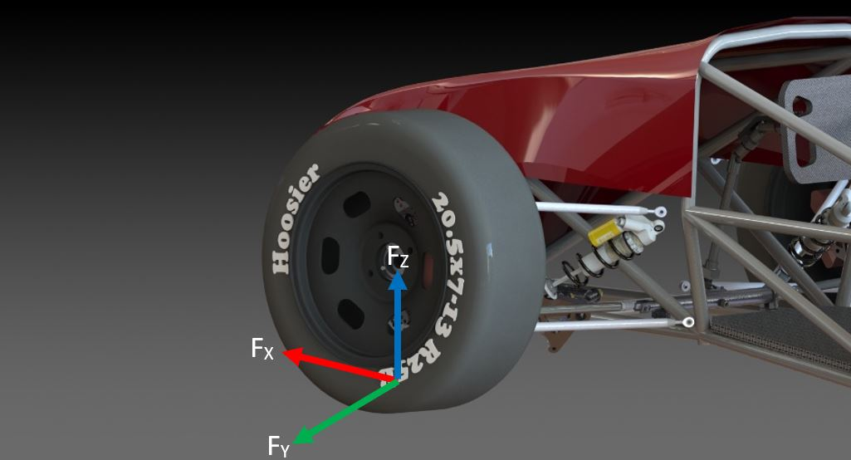

**Figure 1: Standard Convention for Forces Acting on a Wheel**

The application of these three forces makes up the different loading cases used in the rim design. Vehicle dynamics analysis will be performed to determine the appropriate magnitudes. The rim and wheel assembly will be considered as fixed at the hub mounting surface.

The unique properties of carbon fibre present many potential advantages for rim design of the car over the traditional aluminum design. Mainly, carbon fibre has much higher values of strength-to-weight and stiffness-to-weight when loaded in its direction of strength. However, because it is an anisotropic material, special care will have to be taken that the layers are oriented suitably to bear the stresses

**Scope:**

The project will focus on the creation of carbon fibre rims. It will begin with a force analyses of the previous aluminum wheel rims using ANSYS in order to determine the required stiffness of the carbon fibre rims in order to prevent deformation. The rim will then be redesigned in SolidWorks, substituting carbon fibre for the material. The new design will focus on matching the stiffness of the aluminum rims while reducing weight. Using the Advanced Manufacturing Lab CNC, aluminum molds will be machined. Prototyping of the carbon fibre rim will then be carried out. Four or more rims will be manufactured by hand laying CF weave onto the 2 molds, using a vacuum bag to apply pressure and set the laminated layers. The rims will then be finished (trimmed, cemented, and drilled) and tested to verify that they meet the required stiffness and strength properties. Afterwards, further performance testing with the FSAE car will be performed to ensure proper functioning under racing conditions.

**Proposed Work:**

The project has several main parts that must be taken into consideration before the final product can be made. Material selection, CAD modelling, CNC machining, and carbon fibre manufacturing are just some of the tasks that will be during this project. By completing all these steps, the team plans to create four functional rims for the race car.

Load cases for the design will be determined using a tire test data processing program that has already been developed for this project in Matlab, as well as the FSAE team’s suspension design spreadsheet. Using this data, a force analysis of the previously used aluminum rims will be conducted, which will inform the design of the carbon fibre rim. The rims will be designed to be interchangeable with the current aluminum rims, with comparable stiffness and reduced mass. CAD modeling of the rim and hub design and molds will be done in Solidworks. An ANSYS analysis will determine the amount and thickness of carbon fibre required to meet design constraints, as well as identify any areas that require reinforcement.

For manufacturing, CNC code will be written in Mastercam. The Advanced Manufacturing CNC will be used to machine the required aluminum molds and aluminum hub. The design of the carbon fibre rim calls for two molds. Carbon fibre parts will be manufactured by hand laying CF mats onto the molds and laminating using a vacuum bag to apply pressure. Once manufactured, the two halves of the rim will be cemented together, drilled, and mated to the aluminum hubs.

In order to become skilled at the hand layup and vacuum bagging process, a series of smaller sample molds and parts will be manufactured initially. Testing will be performed on these material samples to ensure that the expected stiffness and strength properties are met. Testing of methods for cementing and drilling CF parts will also occur with these samples. Tests will be performed in the material sciences lab at the University of Guelph.

Testing of the rims will begin once a prototype becomes available. Before mounting to the FSAE car, the stiffness of the rims will be tested in order to ensure that it meets the design constraints. If problems are encountered the design may be altered, including changes to the amount of carbon fibre used in the rim, the location of reinforcements, the type of weave used in the carbon fibre cloth, the vacuum bagging step, and part geometries.

The team will first produce a test rim to validate the design and the manufacturing process. This will allow the opportunity to revise the design or process if necessary, before a full production set is made. If the final carbon fibre rims are deemed unsuited for use with the FSAE car, backup aluminum rims will instead be used. Force analyses will still be performed on the manufactured rims and the purchased rims and methods to improve the carbon fibre design and manufacturing process may be investigated. The project will then be considered to include only the design process for the wheels and the building and testing of the test model.

**Team:**

The team primarily consists of four mechanical engineering students. The team will meet often to discuss findings and ensure deliverables are completed on time. Nicole and Andrew will conduct the evaluation and selection of materials and the manufacturing of the carbon fibre parts, as well as FEA analysis to validate the CF part design. As the suspension lead of the race team, Orion is the link between this project and the Gryphon race team; he will determine the loading cases to design for and will program the CNC machining of the molds. Orion will also design the aluminum wheel center. Nicolas will be responsible for leading material testing and product validation, because of his experience working in these areas.

The team also anticipates the assistance of additional University of Guelph faculty, staff, and students:

* Ken Graham and David Wright, University of Guelph machine shop - will provide guidance when machining sundry parts.
* Barry Verspagen, University of Guelph Advanced Materials Lab - will be asked for assistance when machining the aluminum molds with the CNC.
* Anthony Meola, University of Guelph Student - Design Captain of Gryphon Racing, will also be consulted throughout the process.
* John Runciman, University of Guelph – Faculty advisor

**Schedule:**

The Gantt chart below maps out the anticipated progress of this project. This schedule is meant as a starting point and is subject to change. Tasks will become further subdivided into smaller tasks as the project progresses.

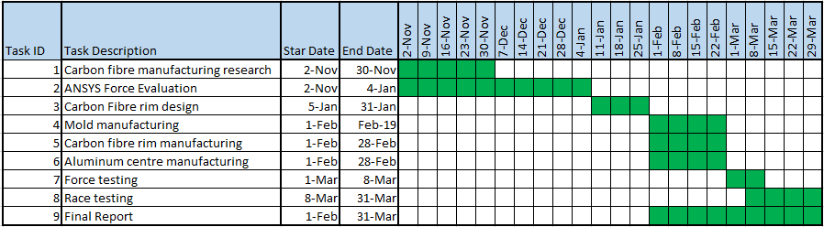

**Figure 2: Project Schedule**

The team feels that a sturdy foundation of research has already been conducted into loading cases (research began in the summer of 2018); the next steps will be conducting a review of carbon fibre manufacturing methods and an ANSYS analysis of the CF rim. Force analysis and solid modelling are expected to begin in November in order to allow the maximum amount of time for manufacturing and testing. Design of the production rim, molds, and centres will be completed in January and will also require the use of ANSYS and SolidWorks. Manufacturing of molds will begin in February. Completed rims should become available before March. Following this, testing and modifications to the design will be the focus of the team until April.

**Resources:**

Many of the resources that will be used in this project have already been purchased by the race team. This includes materials such as the aluminum needed to create the molds, the carbon fibre mats to make the rims, and some of the epoxy to laminate the mats (Additional epoxy is expected to be purchased by the race team this year). To ensure that we have enough for all test pieces and final products, we will also purchase our own supply of epoxy (roughly 5kg with a cost of $100). The team is also expecting to require the use of the Advanced Manufacturing Laboratory in the Thornborough Building for a relatively extensive amount of time to machine the molds. The team anticipates the purchase of multiple cutting tools to use with the CNC. The cost per cutting tool was found to be $46 [2]. All carbon fiber work will occur in the Gryphon Racing workshop.

**Sponsors, Ownership, & Intellectual Property:**

The team does not anticipate the need to make use of outside sources to complete this project. The final product of this project will belong to the FSAE race team as they will be the people who will be using the rims on their car.

**Constraints and Criteria:**

The project has many different segments that all need to be completed in order to obtain the final product. However, the team has a small budget and only a handful of months to work on it. Following the intended schedule is very important to ensure all deadlines are met and the work submitted is high quality.

The success of the carbon fibre rims will be measured by:

* Adherence to the designed stiffness
* Weight reduction achieved
* Strength and resistance to plastic deformation over time
* Adherence to designed dimensions

The overall success of this project will be measured by progress towards a reliable process for performing carbon fibre manufacturing using the facilities and knowledge available to the Gryphon race team. Our team recognizes that the production of a complete set of suitable racing rims is a lofty goal and may require the efforts of future students to complete our work. In view of this, attention must be paid to documentation and reproducibility of our manufacturing methods, so that the project may continue and produce carbon fibre rims for a future Guelph racing team.

**References:**

[1] A. Ressa, “Development of a carbon Fiber Wheel Rim,” U.S. thesis, Ohio State University, Columbus, OH, 2013.

[2] Tools Today. Available: <https://www.toolstoday.com/solid-carbide-cnc-spiral-o-flute-aluminum-cutting-up-cut-router-bits.html> [Accessed on November 1, 2018].