**Microtube Heat Exchanger for Solid-Oxide Fuel Cell Vehicles**

*Orion Miller, Chase Ambeau, Mike Bos, Jameson Bonnett, Ian Censner*

The purpose of this project is to design a heat exchanger for a Solid-Oxide Fuel Cell system. The general idea behind applying a solid oxide fuel cell system to the automotive industry is to provide a meaningful solution to address the shortcomings of internal combustion engines (ICE), as well as emerging electric vehicle technology (EV). ICE vehicles have a very low overall efficiency and are a large contributing factor to the world's pollution. EV’s have a critical drawback in the way they store energy; lithium ion batteries have very low mass and volume energy densities compared to liquid fuel, and require significant amounts of natural resources to produce. A solid oxide fuel cell system would take advantage of the efficiency of electric drivetrains while avoiding the battery issue by generating electricity as needed.

To maintain the high operating temperature required for SOFC’s, a need arises to exchange heat from the hot exhaust gases to the cold fuel and air on their way in to the system. Heat exchanger design for the anode branch of the system is the focus of this project. Constraints and criteria include needing a compact form factor, resistance to corrosion and temperatures of 1300 K, and ease of manufacturing.

The team determined that a microchannel heat exchanger fits these constraints best. This heat exchanger maximizes heat transfer area, is efficient and can operate at extreme temperatures. The material used is Inconel 625 (an alloy of Nickel, Copper, and Iron), due to its high thermal conductivity and melting point. Manufacturing will be accomplished by making the unit as a set of individual plates which are photochemically etched with channel patterns, and then joining them together through diffusion bonding.

Keywords: Fuel Cells, Heat Exchanger, Automotive, Thermodynamics.

System Heat Transfer Diagram

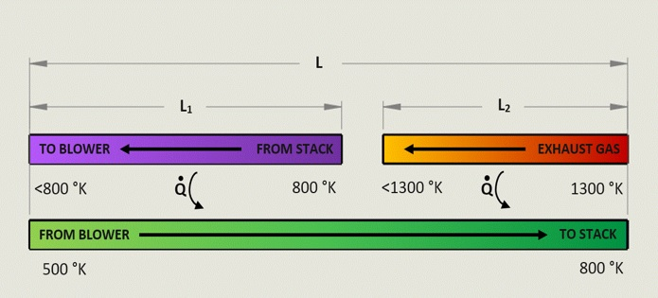

Isometric View

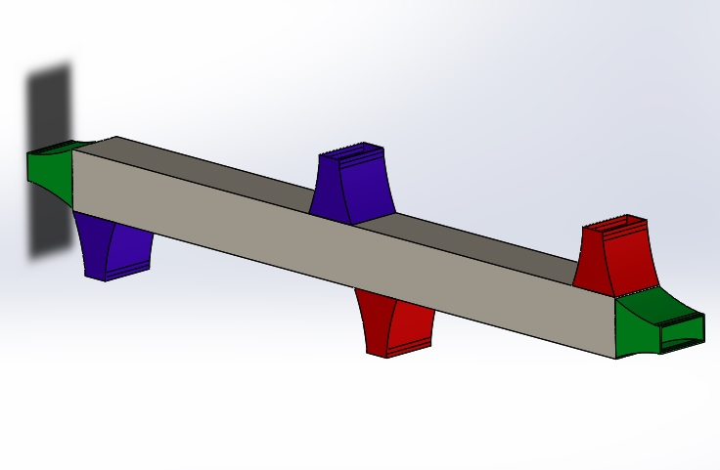

Closeups of Channel Geometry

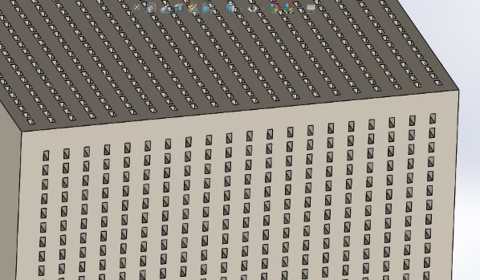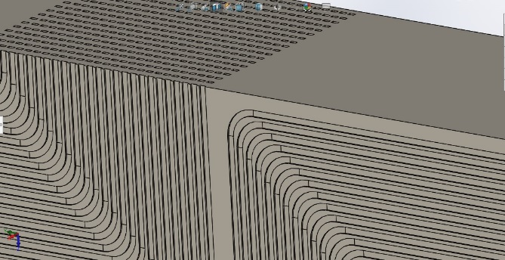

Mesh of Subsection for CFD Simulation

