* Put in actual doc with other two diagrams I made

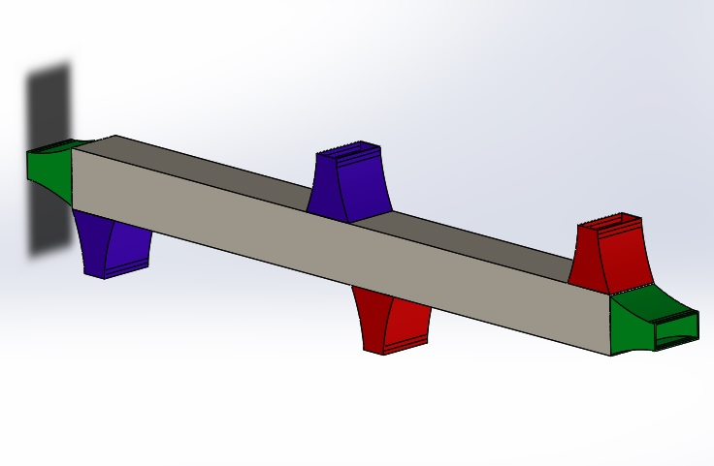

Figure _: Isometric View of Model

* For Appendix

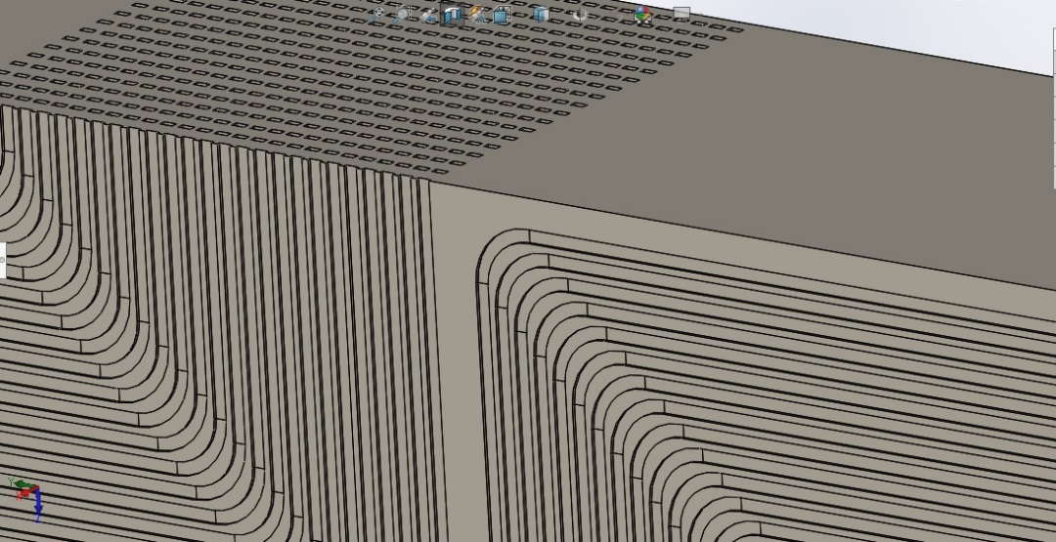

Figure _: Section View 1 (Purple + Red Passages)

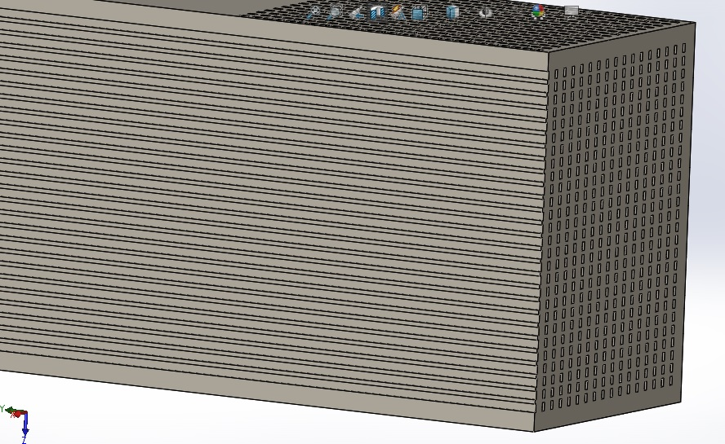

Figure _: Section View 2 (Green Passages)

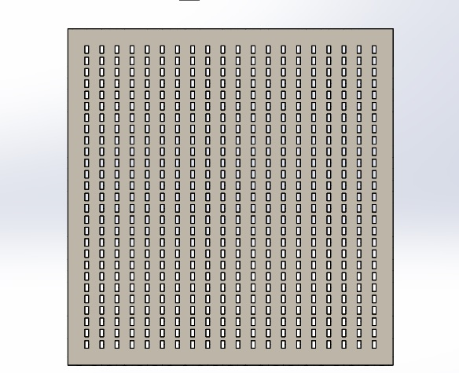

Figure _: Cross Sectional View