AIR UNIVERSITY, ISLAMABAD
Department of Software Engineering
FINAL PROJECT DOCUMENTATION
FitTrack: Gym Fitness and Workout Progress Tracking Portal
Course: Introduction to Software Engineering (SE-101 / SEC-301)
Submitted To: Sir Zulfiqar Ali
Submitted By:
Muhammad Hamza Khan — Registration No. 2502941
Muhammad Awais Bajwa — Registration No. 2502857
Class / Section: BSSE-II-A
Degree: Bachelor of Science in Software Engineering (2025–2029)
Date of Submission: June 5, 2026

ACKNOWLEDGEMENT
We would like to express our sincere gratitude to Sir Zulfiqar Ali, our course supervisor, for his invaluable guidance, continuous support, and constructive feedback throughout the development of this project. His expertise in software engineering and dedication to student learning have been instrumental in shaping this documentation and the underlying system.
We extend our appreciation to Air University, Islamabad, and the Department of Software Engineering for providing an academic environment that encourages practical learning and project-based development.
We are also grateful to the local gym managers and fitness enthusiasts who participated in our requirement-gathering interviews and surveys. Their insights helped us understand real-world fitness management challenges and design a system that addresses genuine user needs.
Finally, we thank our families and classmates for their moral support and encouragement during this journey.

ABSTRACT
The FitTrack Gym Fitness and Workout Progress Tracking Portal is a web-based application designed to help users manage their fitness routines in a structured and efficient manner. Many individuals face challenges related to improper workout techniques, absence of systematic progress tracking, and limited communication with professional fitness trainers. This system addresses these problems through an integrated platform that combines workout plan management, BMI and calorie tracking, exercise tutorial videos, trainer-client communication, and visual progress reporting.
This documentation presents the complete software engineering lifecycle of the FitTrack system, from initial project proposal and feasibility analysis through requirements specification, system design, and implementation. The system was developed following Agile methodology and Object-Oriented Design (OOD) principles, utilizing HTML5, CSS3, JavaScript, React.js, Node.js, and MySQL as the core technology stack.
The system incorporates six major functional modules: User Management, Workout Management, Progress Tracking and Data Visualization, Nutrition and Diet Tracking, Trainer-Client Communication, and an Exercise Tutorial System. The implementation includes a fully designed Figma prototype with eleven screens, a functional dashboard with interactive charts, a BMI calculator, a nutrition tracker, and a real-time trainer-client messaging interface.
The FitTrack portal provides a convenient digital platform for gym members, trainers, and administrators, promoting healthier lifestyles and improving fitness outcomes through data-driven tracking and professional guidance.
Keywords: Fitness Tracking, Web Application, BMI Calculator, Workout Management, Agile Development, Object-Oriented Design, MySQL, Node.js, React.js

ACKNOWLEDGEMENT 2
ABSTRACT 3
LIST OF FIGURES 7
LIST OF TABLES 9
CHAPTER 1: INTRODUCTION 10
1.1 Background 10
1.2 Problem Statement 10
1.3 Motivation 10
1.4 Objectives 11
1.5 Scope of Project 11
1.6 Project Overview 11
CHAPTER 2: PROJECT PROPOSAL 13
2.1 Proposed Solution 13
2.2 Feasibility Analysis 13
Technical Feasibility 13
Operational Feasibility 14
Economic Feasibility 14
2.3 Project Planning 14
2.4 Technology Stack 15
2.5 Team Responsibilities 15
2.6 Expected Outcomes 15
CHAPTER 3: SOFTWARE REQUIREMENT SPECIFICATION (SRS) 17
3.1 Introduction 17
3.2 Purpose 17
3.3 Scope 17
3.4 Stakeholders 17
3.5 User Classes and Characteristics 18
3.6 Functional Requirements 18
3.7 Non-Functional Requirements 19
3.7.1 Reliability 19
3.7.2 Usability 19
3.7.3 Performance 19
3.7.4 Security 19
3.8 Use Cases 20
Module 1: User Management 20
Module 2: Workout Management 20
Module 3: Progress Tracking 20
Module 4: Nutrition Tracking 21
Module 5: Communication 21
Module 6: Exercise Tutorial 21
3.9 Use Case Diagrams 21
3.10 Use Case Tabular Details 24
Use Case UM-UC1: Register New Account 24
Use Case TC-UC1: Send Message to Trainer 25
3.11 System Constraints 25
3.12 Assumptions and Dependencies 25
CHAPTER 4: SOFTWARE DESIGN SPECIFICATION (SDS) 27
4.1 Design Overview 27
4.2 System Architecture 27
4.3 UML Diagrams 27
4.3.1 Activity Diagrams 27
4.3.2 Class Diagram 34
4.3.3 Sequence Diagrams 35
4.4 Database Design 43
4.5 ER Diagram 43
4.6 Data Dictionary 44
4.7 Module Design 45
4.7.1 BMI Calculator Algorithm 45
4.7.2 Nutrition Tracking Algorithm 46
4.7.3 Workout Plan and History Algorithm 46
4.8 User Interface Design 46
Module View Screens 47
CHAPTER 5: IMPLEMENTATION 49
5.1 Development Environment 49
5.2 Technology Stack 49
5.3 Database Implementation 49
5.4 Backend Implementation 49
5.5 Frontend Implementation 49
5.6 Authentication and Security 50
5.7 Major Features Implemented 50
5.7.1 Major Module: Dashboard, Nutrition, and BMI Calculator 50
5.7.2 Minor Module: Trainer-Client Communication and Progress Recording 50
5.8 UI Screenshots – Figma Prototype 50
5.9 Setup and Installation Guidelines 54
5.10 Demo Resources 54
CHAPTER 6: RESULTS AND DISCUSSION 56
6.1 System Evaluation 56
6.2 Achievements 56
6.3 Challenges Faced 56
6.4 Performance Analysis 56
6.5 Limitations 57
CHAPTER 7: CONCLUSION AND FUTURE WORK 58
7.1 Conclusion 58
7.2 Future Enhancements 58
REFERENCES 60
APPENDICES 61
Appendix A: GitHub Repository 61
Appendix B: Figma Prototype Link 61
Appendix C: Demo Video 61
Appendix D: Additional Module Views 61
Appendix E: Presentation Slides (Key Extracts) 63

LIST OF FIGURES
Figure 1.1: Project Title Slide – FitTrack Gym Fitness and Tracker Portal
Figure 1.2: Project Category and System Type
Figure 2.1: Problem Statement – Key Challenges in Fitness Management
Figure 2.2: Proposed Solution Overview
Figure 2.3: Related Systems Analysis (Competitive Analysis)
Figure 3.1: Client Use Case Diagram
Figure 3.2: Trainer Use Case Diagram
Figure 3.3: Admin Use Case Diagram
Figure 4.1: Three-Layer System Architecture
Figure 4.2: Activity Diagram – Module 1: Registration and Login
Figure 4.3: Activity Diagram – Module 2: Create Workout Plan
Figure 4.4: Activity Diagram – Module 3: Progress Tracking
Figure 4.5: Activity Diagram – Module 4: Send Message to Trainer
Figure 4.6: Activity Diagram – Module 4: Receive Feedback
Figure 4.7: Activity Diagram – Module 5: Nutrition Tracking
Figure 4.8: Activity Diagram – Module 6: Browse Exercise Tutorial
Figure 4.9: Class Diagram – Overall System
Figure 4.10: Sequence Diagram – Registration
Figure 4.11: Sequence Diagram – BMI Calculation
Figure 4.12: Entity-Relationship (ER) Diagram
Figure 4.13: Module View – Dashboard
Figure 4.14: Module View – BMI Calculator
Figure 4.15: Module View – Workout Plan
Figure 4.16: Module View – Nutrition
Figure 4.17: Module View – Progress
Figure 4.18: Module View – Trainer Chat
Figure 5.1: Figma UI Design – Main Dashboard
Figure 5.2: Figma UI Design – BMI Calculator
Figure 5.3: Figma UI Design – Workout Plan (Weekly Schedule)
Figure 5.4: Figma UI Design – Workout Plan (Exercise List)
Figure 5.5: Figma UI Design – Nutrition Meal Log
Figure 5.6: Figma UI Design – Nutrition Macronutrient Breakdown
Figure 5.7: Figma UI Design – Fitness Progress Tracking
Figure 5.8: Figma UI Design – Progress Weekly Charts
Figure 5.9: Figma UI Design – Trainer Chat Interface
Figure 5.10: Figma UI Design – Exercise Tutorial Library
Figure 5.11: Figma UI Design – Exercise Library Tutorial Cards

LIST OF TABLES
Table 2.1: Tools and Technologies Used
Table 2.2: Team Responsibilities Division
Table 2.3: Competing Systems Comparison
Table 3.1: User Classes and Characteristics
Table 3.2: Operating Environment Constraints
Table 3.3: Design and Implementation Constraints
Table 3.4: Use Case List – Module 1: User Management
Table 3.5: Use Case List – Module 2: Workout Management
Table 3.6: Use Case List – Module 3: Progress Tracking
Table 3.7: Use Case List – Module 4: Nutrition Tracking
Table 3.8: Use Case List – Module 5: Communication
Table 3.9: Use Case List – Module 6: Exercise Tutorial
Table 3.10: Use Case Detail – Register New Account (UM-UC1)
Table 3.11: Use Case Detail – Send Message to Trainer (TC-UC1)
Table 3.12: Functional Requirements
Table 4.1: Data Dictionary

CHAPTER 1: INTRODUCTION

1.1 Background
The fitness industry has witnessed a significant transformation with the advancement of digital technology. Traditional gym management methods, which relied on paper-based records, verbal communication between trainers and clients, and manual tracking of fitness metrics, are increasingly being replaced by sophisticated digital platforms. These platforms offer centralized management of workout plans, nutritional data, progress metrics, and communication channels.
Despite the existence of several fitness tracking applications such as MyFitnessPal, JEFIT, and Fitbod, a comprehensive gap remains in providing an integrated solution that combines workout management, real-time trainer-client communication, nutrition tracking, and progress visualization within a single, user-friendly web-based platform. Most existing tools are either too specialized, too complex for beginner users, or lack direct trainer interaction capabilities.
The FitTrack Gym Fitness and Workout Progress Tracking Portal is developed as an academic project at Air University, Islamabad, under the supervision of Sir Zulfiqar Ali. The system is designed to serve the local gym community while embodying best practices in full-stack web development, database management, and software engineering methodology.

1.2 Problem Statement
Users of fitness applications and gym members face several interconnected challenges that impede their fitness journeys:
- Clients cannot easily communicate with trainers for guidance, tips, and exercise corrections in real time.
- When attempting dietary discipline, users fail to accurately calculate calorie intake, protein requirements, and balanced macronutrients.
- Without proper demonstration and supervision, users perform workouts incorrectly, significantly increasing the risk of injury.
- Most individuals do not have a clearly defined fitness goal, leading to confusion and slow progress.
- Exercising without visual progress tracking and encouragement leads to loss of commitment and motivation over time.
- Many users track only weight, ignoring body fat percentage, muscle mass, and other important health indicators.
- Fitness data such as BMI, calorie intake, workouts, and progress are tracked using separate tools, making comprehensive analysis difficult.
- Users receive no feedback on performance improvement, workout intensity, or goal achievement rate.

1.3 Motivation
The motivation behind developing FitTrack stems from the observed gap between the growing demand for personalized fitness guidance and the limitations of existing digital solutions. Local gym managers consulted during the requirement-gathering phase highlighted the need for a system that bridges the communication divide between trainers and clients while providing meaningful, data-driven insights to users. The project also serves as a significant learning opportunity for the development team to acquire practical experience in full-stack web development, database design, API integration, and UI/UX design principles.

1.4 Objectives
The primary objectives of the FitTrack Gym Fitness and Workout Progress Tracking Portal are:
- To develop a web-based centralized platform that integrates all aspects of gym fitness management.
- To enable real-time communication between clients and trainers through a dedicated messaging module.
- To provide accurate BMI calculation and calorie tracking with personalized health category feedback.
- To offer visual progress monitoring through interactive charts and performance reports.
- To deliver a library of exercise tutorial videos that guide users in correct workout techniques.
- To support administrators in managing users, trainers, memberships, and system content.
- To implement secure authentication and role-based access control for all user categories.
- To ensure a responsive, accessible interface compatible with desktops, tablets, and mobile devices.

1.5 Scope of Project
The scope of the FitTrack Portal encompasses the design and development of a centralized fitness management system that integrates multiple functionalities. The system is targeted at three primary user roles: Clients (gym members), Trainers (fitness professionals), and Administrators. The system operates as a web application accessible through modern browsers on all device types.
The system includes six core functional modules: User Management, Workout Management, Progress Tracking and Data Visualization, Nutrition and Diet Tracking, Trainer-Client Communication, and an Exercise Tutorial System. The scope explicitly excludes live video streaming, live payment gateway integration (a simulated checkout is used), and AI-based posture correction features.

1.6 Project Overview
FitTrack is classified as a web-based application system developed using an Agile process model and Object-Oriented Design methodology. The frontend is built with HTML5, CSS3, JavaScript (ES6), and Bootstrap 5, with React.js for interactive components. The backend uses Node.js with Express, and data is persisted in a MySQL relational database. The user interface was prototyped in Figma prior to implementation. The project was collaboratively developed by Muhammad Hamza Khan (frontend and UI) and Muhammad Awais Bajwa (backend and database), with the source code hosted on GitHub.
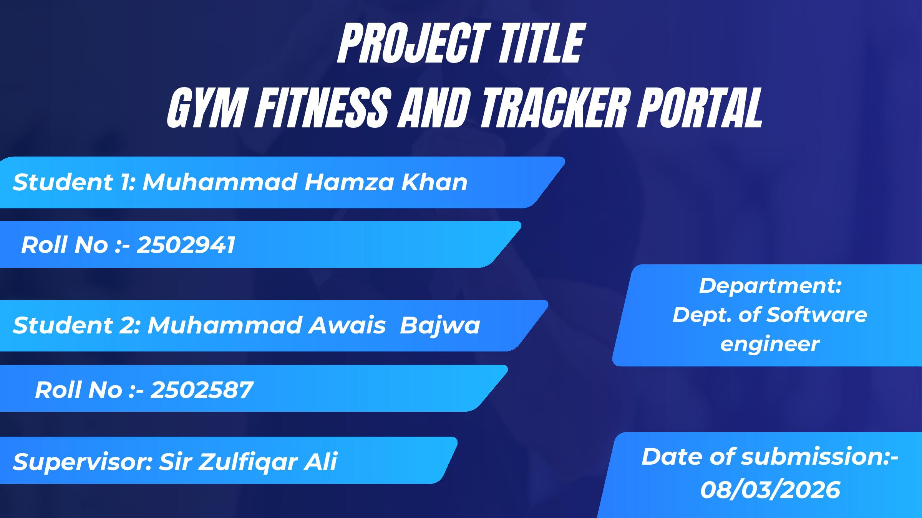
Figure 1.1: Project Title Slide – FitTrack Gym Fitness and Tracker Portal

CHAPTER 2: PROJECT PROPOSAL

2.1 Proposed Solution
The FitTrack system proposes a comprehensive, centralized web-based platform that addresses all identified fitness management challenges through a cohesive set of modules:
- A direct trainer-client communication system where clients can interact with trainers for guidance, tips, and workout corrections.
- A diet and nutrition tracking module that automatically calculates calorie intake, protein requirements, and macronutrient balances.
- A visual progress tracking system with graphs and reports to maintain user motivation.
- A goal-setting framework allowing users to define specific targets such as weight loss, muscle gain, or endurance improvement.
- A centralized data repository storing BMI records, calorie logs, workout history, and progress metrics in a single system.
- A trainer monitoring panel enabling fitness professionals to track client progress and adjust workout plans accordingly.
- A multi-indicator health monitoring dashboard covering BMI, body fat percentage, weight, and workout performance.
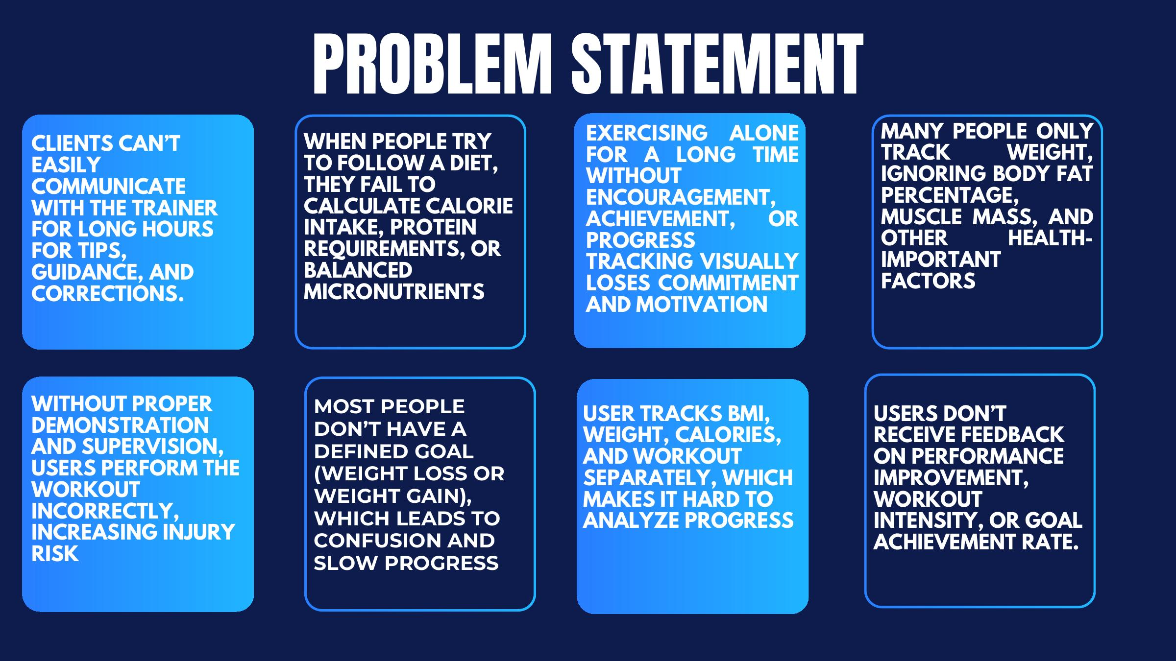
Figure 2.2: Proposed Solution Overview

2.2 Feasibility Analysis

Technical Feasibility
The project utilizes well-established, open-source technologies including HTML5, CSS3, JavaScript, Bootstrap 5, Node.js, and MySQL. All team members have sufficient knowledge of these technologies through coursework and self-directed learning. Development tools such as Visual Studio Code, Figma, and Draw.io are freely available. The project is technically feasible within the allocated academic timeline.

Operational Feasibility
The system is designed with a focus on usability. New users can complete registration within three minutes, and all major features are accessible within three interface clicks. The responsive design ensures accessibility on all device categories. The system is operationally feasible for both technical and non-technical users.

Economic Feasibility
As an academic project, the system uses free and open-source tools and hosting environments. No commercial licensing or paid APIs are required in the current version. The simulated payment module avoids the need for a live banking API, making the project fully feasible within a zero-budget academic context.

2.3 Project Planning
The project follows the Agile process model with iterative delivery of modules. The system was developed in phases: (1) requirement gathering and documentation, (2) UI design in Figma, (3) database schema design and setup, (4) backend API development, (5) frontend implementation, and (6) integration, testing, and documentation. Object-Oriented Design guided the modular architecture, ensuring each module operates independently while sharing common data entities.
Requirement gathering was conducted through three methods: targeted interviews with local gym managers to understand membership and trainer-client workflows; a Google Forms survey among fitness enthusiasts to prioritize features; and competitive analysis of existing platforms including MyFitnessPal, Fitbod, and JEFIT to identify capability gaps.
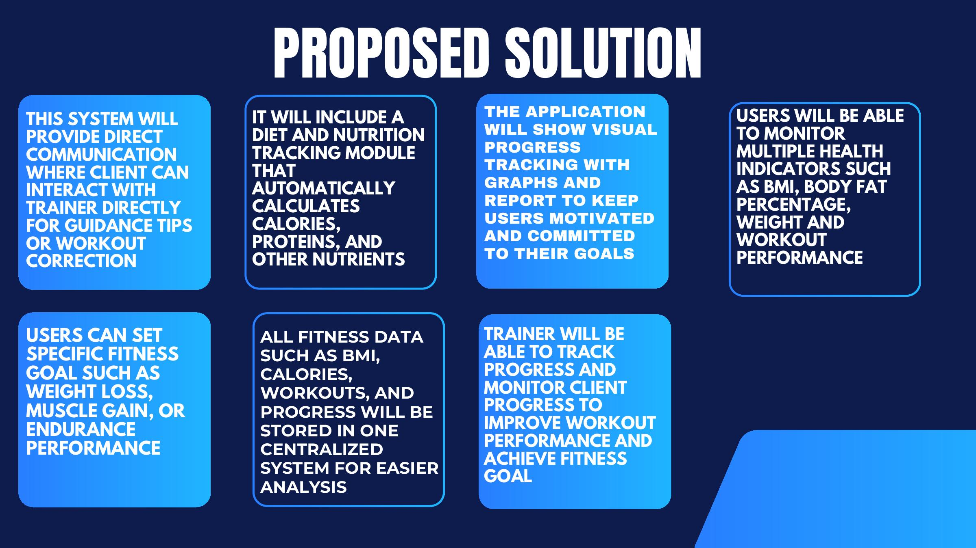
Figure 2.3: Related Systems Analysis (Competitive Analysis)

2.4 Technology Stack
Tool / Technology | Version | Purpose
Visual Studio Code | Latest | Integrated Development Environment
HTML5 | 5 | Webpage Structure
CSS3 | 3 | Webpage Styling
JavaScript | ES6 | Interactive Web Functionality
Bootstrap | 5 | Responsive UI Framework
React.js | Latest | Frontend Component Framework
Node.js / Express | Latest | Backend API Server
MySQL | Latest | Relational Database Management System
Figma | Latest | UI/UX Design and Prototyping
Draw.io | Latest | UML and System Diagrams
Canva | Latest | Design and Presentation Graphics
MS Word | 2019/365 | Technical Documentation
Table 2.1: Tools and Technologies Used

2.5 Team Responsibilities
Student Name | Registration No. | Responsibilities
Muhammad Hamza Khan | 2502941 | Frontend UI design (Dashboard, Login/Signup, Workout Tracking); Responsive layouts (HTML, CSS, Bootstrap); Chart and graph integration; User input forms
Muhammad Awais Bajwa | 2502857 | Database setup (Users, Workouts, Progress); Backend APIs for login, registration, and CRUD; BMI/calorie calculation logic; Data validation and security
Table 2.2: Team Responsibilities Division

2.6 Expected Outcomes
- A fully functional web-based fitness management portal accessible on all modern browsers and devices.
- A Figma prototype covering all eleven major screens of the application.
- A functional implementation of the Dashboard, BMI Calculator, Nutrition Tracker, and Trainer-Client Communication modules.
- A complete MySQL database schema with normalized tables and referential integrity.
- Practical experience in full-stack web development, database management, API integration, and UI/UX design.

CHAPTER 3: SOFTWARE REQUIREMENT SPECIFICATION (SRS)

3.1 Introduction
This chapter presents the Software Requirements Specification (SRS) for the FitTrack Gym Fitness and Tracker Portal. The SRS defines the functional and non-functional requirements, use cases, constraints, and assumptions that govern the development of the system.

3.2 Purpose
The purpose of this SRS document is to define the requirements of the FitTrack Gym Fitness and Tracker Portal for multiple stakeholder groups:
- For Developers: This document serves as a guide for understanding features and functionalities requiring implementation, providing use cases and technical specifications for coding and system design.
- For Trainers and End Users: It explains what the system offers and how users can leverage it to achieve their fitness goals.
- For Documentation Writers: It serves as a reference for creating user manuals and system guides.
- For Project Supervisors: It provides a formal record of agreed system capabilities for academic evaluation.

3.3 Scope
The FitTrack Gym Fitness and Tracker Portal is a web-based application that helps users manage their fitness routine. The system solves problems including poor trainer-client communication, inability to accurately track calorie and protein intake, absence of visual progress tracking, risk of incorrect workout execution, lack of defined fitness goals, fragmented fitness data management, and absence of performance feedback mechanisms.

3.4 Stakeholders
Stakeholder | Role / Interest
Air University, Islamabad | Project Sponsor and Academic Authority
Sir Zulfiqar Ali | Project Supervisor – provides technical oversight and validates system architecture
Gym Members (Clients) | Primary end users – track workouts, diet plans, and fitness progress
Fitness Trainers | Content creators and coaches – create workout plans and guide clients
System Administrators | Manage memberships, trainers, and gym resources
Development Team | Responsible for requirement analysis, full-stack development, and testing
Table 3.1: Project Stakeholders

3.5 User Classes and Characteristics
User Class | Description
Client | Gym member who tracks workouts, diet, and progress. Requires a simple, intuitive interface. Interacts primarily with workout tracking, nutrition logging, and progress charts.
Trainer | Fitness professional who creates and assigns workout plans and guides clients. Needs to manage multiple client profiles simultaneously.
Admin | Manages user accounts, trainer assignments, system content, and membership records. Requires elevated access privileges.
Table 3.2: User Classes and Characteristics

3.6 Functional Requirements
ID | Title | Requirement Description | Priority
FR-1 | User Registration | System shall allow users to register with name, email, password, age, weight, height, and fitness goals. | High
FR-2 | BMI Calculation | System shall calculate BMI using the formula BMI = weight(kg) / height(m)² and display the corresponding health category. | High
FR-3 | Workout Tracking | System shall track completed exercises, sets, repetitions, and weight used per session. | High
FR-4 | Messaging | System shall provide a bi-directional messaging interface between clients and their assigned trainers. | Medium
FR-5 | Calorie Tracking | System shall track daily calorie and macronutrient intake and compare totals against user-defined goals. | Medium
FR-6 | Tutorial Videos | System shall provide exercise tutorial videos with step-by-step instructions and equipment guidance. | Medium
FR-7 | Progress Charts | System shall display fitness progress through interactive charts and statistical graphs. | Medium
FR-8 | Goal Setting | System shall allow users to define and track specific fitness goals (weight loss, muscle gain, endurance). | Medium
FR-9 | Admin Dashboard | System shall provide an administrative interface for managing users, trainers, and system content. | Low
Table 3.3: Functional Requirements

3.7 Non-Functional Requirements

3.7.1 Reliability
- System shall maintain 99% uptime during peak hours (6:00 AM – 10:00 PM).
- Daily automated database backups shall be maintained, restorable within two hours.
- System shall support up to 500 concurrent users without performance degradation.
- All user inputs shall be validated to prevent data corruption.

3.7.2 Usability
- New users shall be able to complete registration within three minutes.
- All core system functions shall be accessible within three interface clicks.
- Error messages shall be written in plain, non-technical language.
- The interface shall be fully responsive across desktops, tablets, and mobile devices.
- Consistent color coding shall be applied: green for completed actions, yellow for warnings, red for errors, and blue for interactive elements.

3.7.3 Performance
- 95% of all pages shall load within three seconds under standard network conditions.
- Database queries shall execute within 500 milliseconds.
- Progress charts shall be generated within two seconds of user request.
- Messages shall be delivered within two seconds in the trainer-client chat.
- Search results shall be returned within one second.

3.7.4 Security
- All user passwords shall be hashed using bcrypt encryption.
- Passwords shall require a minimum of eight characters including uppercase, lowercase, numeric, and special characters.
- User sessions shall timeout after 30 minutes of inactivity.
- Role-based access control (RBAC) shall restrict system features by user type.
- All communications shall be encrypted using HTTPS with TLS 1.2 or higher.
- The system shall implement protections against SQL injection, Cross-Site Scripting (XSS), and Cross-Site Request Forgery (CSRF).
- Five consecutive failed login attempts shall trigger a 30-minute account lockout.

3.8 Use Cases

Module 1: User Management
ID | Use Case Name
UM-UC1 | Register New Account
UM-UC2 | Log in to System
UM-UC3 | Update Profile
UM-UC4 | Change Password
UM-UC5 | Recover Password
UM-UC6 | View Profile
UM-UC7 | Logout
Table 3.4: Use Case List – Module 1: User Management

Module 2: Workout Management
ID | Use Case Name
WM-UC1 | Create Workout Plan
WM-UC2 | Assign Plan to Client
WM-UC3 | View Assigned Plan
WM-UC4 | Mark Exercise Complete
WM-UC5 | Track Workout History
WM-UC6 | Update Workout Plan
WM-UC7 | Delete Workout Plan
Table 3.5: Use Case List – Module 2: Workout Management

Module 3: Progress Tracking
ID | Use Case Name
PT-UC1 | Log Body Measurements
PT-UC2 | Calculate BMI
PT-UC3 | View Weight Chart
PT-UC4 | View BMI History
PT-UC5 | View Performance Graph
PT-UC6 | Generate Progress Report
Table 3.6: Use Case List – Module 3: Progress Tracking

Module 4: Nutrition Tracking
ID | Use Case Name
NT-UC1 | Log Daily Food Intake
NT-UC2 | Track Calories
NT-UC3 | Track Protein
NT-UC4 | Track Macronutrients
NT-UC5 | View Nutrition Summary
NT-UC6 | Get Diet Recommendations
Table 3.7: Use Case List – Module 4: Nutrition Tracking

Module 5: Communication
ID | Use Case Name
TC-UC1 | Send Message to Trainer
TC-UC2 | Send Message to Client
TC-UC3 | View Message History
TC-UC4 | Provide Feedback
TC-UC5 | Receive Guidance
TC-UC6 | Share Progress with Trainer
Table 3.8: Use Case List – Module 5: Trainer-Client Communication

Module 6: Exercise Tutorial
ID | Use Case Name
ET-UC1 | Browse Tutorials
ET-UC2 | Search by Category
ET-UC3 | View Tutorial Video
ET-UC4 | Read Instructions
ET-UC5 | View Equipment Requirements
ET-UC6 | Save Favourite Tutorials
Table 3.9: Use Case List – Module 6: Exercise Tutorial

3.9 Use Case Diagrams
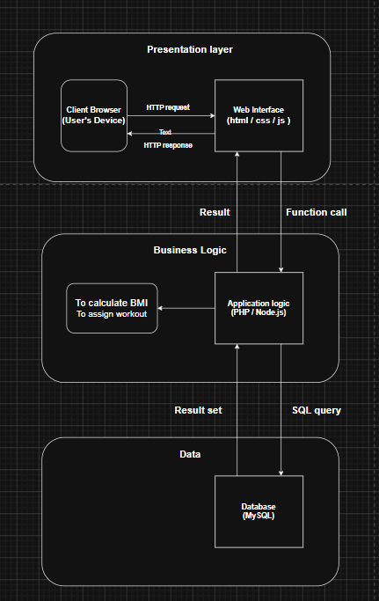
Figure 3.1: Client Use Case Diagram
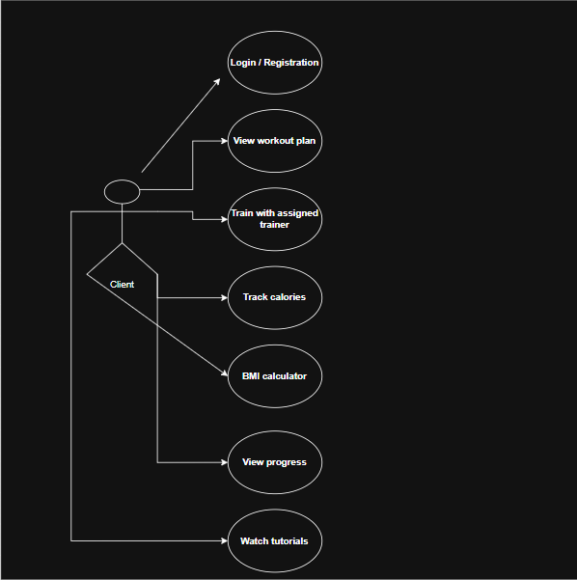
Figure 3.2: Trainer Use Case Diagram
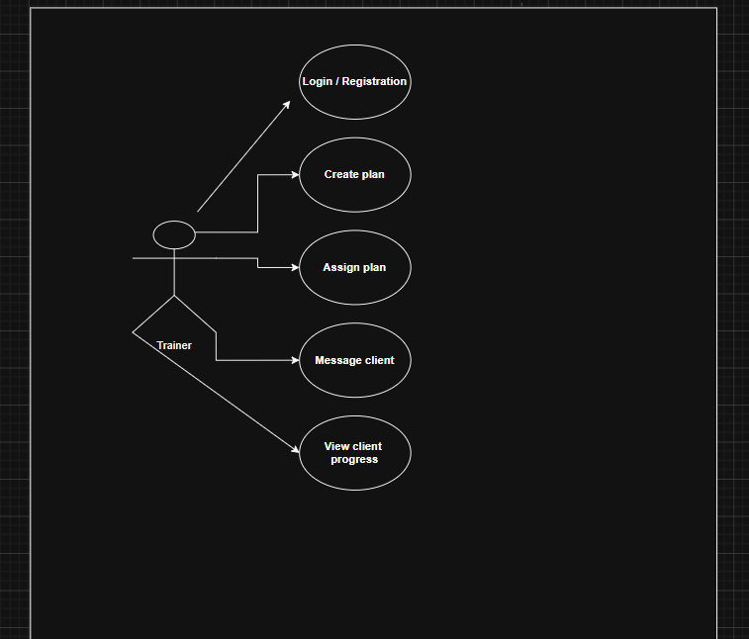
Figure 3.3: Admin Use Case Diagram

3.10 Use Case Tabular Details

Use Case UM-UC1: Register New Account
Field | Description
Use Case ID | UM-UC1
Name | Register New Account
Actors | Client, Trainer, Admin
Description | User creates an account by providing name, email, password, age, weight, height, and fitness goals.
Trigger | User clicks the "Sign Up" button.
Preconditions | User has internet access and a valid email address.
Postconditions | Account is created; user is logged in; a welcome email is sent.
Normal Flow | 1. User clicks Sign Up 2. System displays registration form 3. User fills in all required fields 4. System validates input 5. System checks for duplicate email 6. System encrypts password 7. System creates account 8. User is redirected to the dashboard
Alternate Flow | If registering as a Trainer, additional certification fields are displayed.
Exceptions | Email already exists; passwords do not match; password does not meet strength criteria.
Table 3.10: Use Case Detail – Register New Account (UM-UC1)

Use Case TC-UC1: Send Message to Trainer
Field | Description
Use Case ID | TC-UC1
Name | Send Message to Trainer
Actors | Client, Trainer
Description | Client sends a message to their assigned trainer for guidance or questions.
Trigger | Client clicks the "Message Trainer" button.
Preconditions | Client is logged in and has an assigned trainer.
Postconditions | Message is saved in the database; trainer receives a notification.
Normal Flow | 1. Client opens the messages section 2. Types the message 3. Clicks Send 4. System saves the message 5. Trainer receives notification
Exceptions | Empty message submitted; attachment file size exceeds limit.
Table 3.11: Use Case Detail – Send Message to Trainer (TC-UC1)

3.11 System Constraints
ID | Constraint Description
CON-1 | Web-based application using HTML5, CSS3, and JavaScript.
CON-2 | Uses Bootstrap 5 for responsive design across all devices.
CON-3 | Backend implemented in PHP or Node.js with MySQL database.
CON-4 | SQL used for all database query operations.
CON-5 | User passwords encrypted using bcrypt hashing algorithm.
CON-6 | Payment processing is simulated; no live banking API is integrated.
CON-7 | Tutorial videos are stored locally; external streaming platforms are not used.
CON-8 | Agile methodology governs the development process.
CON-9 | Object-Oriented Design ensures modular, maintainable architecture.
Table 3.12: Design and Implementation Constraints

3.12 Assumptions and Dependencies
- Users are assumed to have access to a stable internet connection for real-time messaging and progress synchronization.
- The system relies on self-reported workout data; physical verification of workout completion is outside system scope.
- Tutorial video content is assumed to be pre-uploaded by administrators and does not support live streaming.
- The project depends on open-source frameworks (React.js, Bootstrap, Node.js) and MySQL remaining freely available.
- Email notification functionality assumes availability of an SMTP service for sending system emails.

CHAPTER 4: SOFTWARE DESIGN SPECIFICATION (SDS)

4.1 Design Overview
This chapter presents the software design specification for the FitTrack system. The system was designed using Object-Oriented Design (OOD) methodology, which organizes the system around distinct entities such as User, Trainer, WorkoutPlan, NutritionLog, ProgressRecord, Message, and Tutorial. The modular architecture ensures that each module operates independently while sharing a common data layer, facilitating easier maintenance and future extensibility.

4.2 System Architecture
The FitTrack system follows a three-layer architectural model:
- Presentation Layer (UI): Handles all graphical user interface components that interact directly with users. Implemented using HTML5, CSS3, JavaScript, Bootstrap 5, and React.js. Responsible for form rendering, chart display, and navigation.
- Business Logic Layer (Backend): Processes incoming requests such as BMI calculations, workout assignments, calorie summations, and message routing. Implemented using Node.js with the Express framework.
- Data Layer: Manages a MySQL relational database that stores all user data, fitness records, messages, and system content. Communicates with the business logic layer through SQL queries via a data access object pattern.
The client browser sends an HTTP/HTTPS request to the web interface, which forwards the request to the application logic layer for processing. Computed results are retrieved from or persisted to the MySQL database, and the response propagates back to the user's browser.

4.3 UML Diagrams

4.3.1 Activity Diagrams
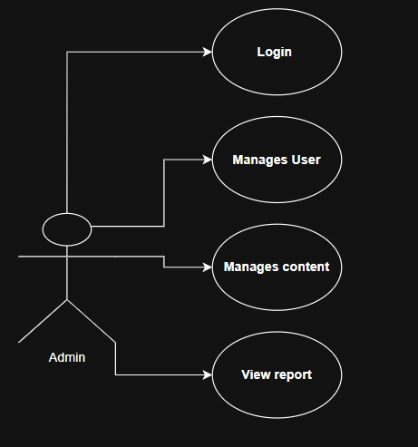
Figure 4.2: Activity Diagram – Module 1: User Registration and Login
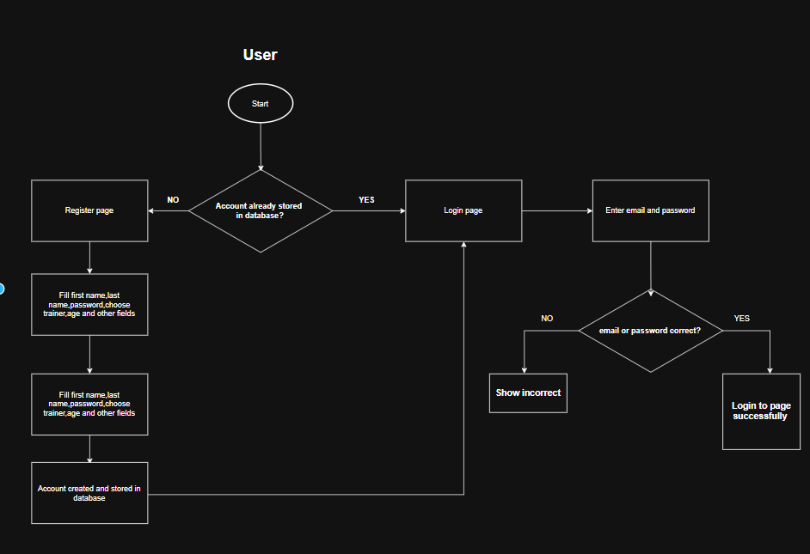
Figure 4.3: Activity Diagram – Module 2: Create Workout Plan and Mark Exercise Complete
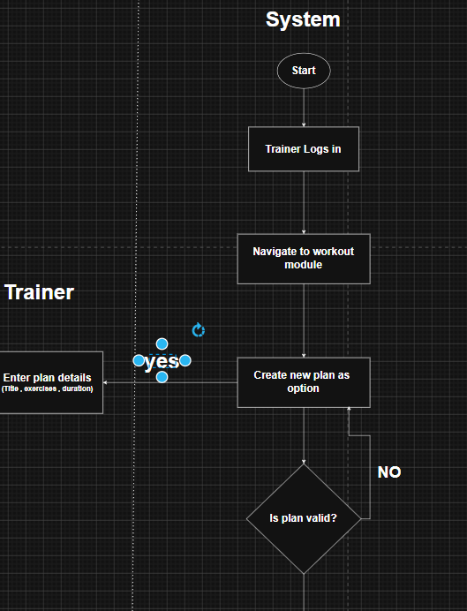
Figure 4.4: Activity Diagram – Module 3: Log Body Measurement and Progress Tracking
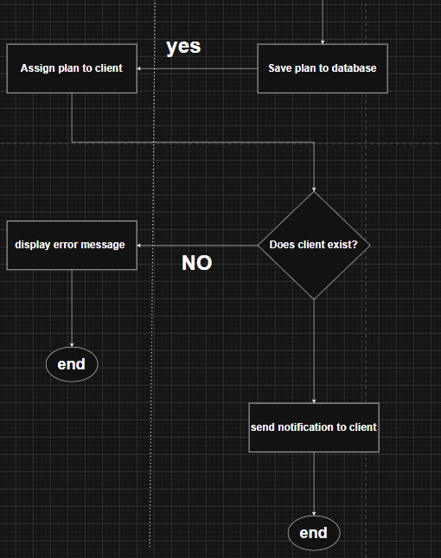
Figure 4.5: Activity Diagram – Module 4: Send Message to Trainer
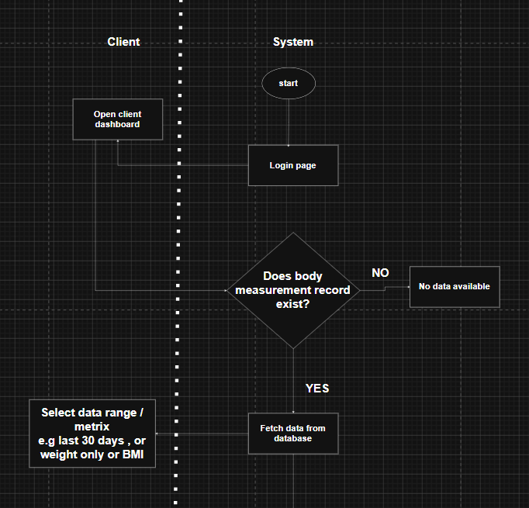
Figure 4.6: Activity Diagram – Module 4: Receive Feedback from Trainer
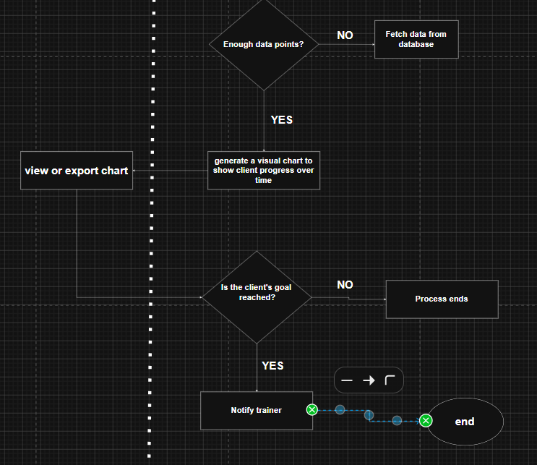
Figure 4.7: Activity Diagram – Module 5: Log Daily Food Intake and Calorie Tracker
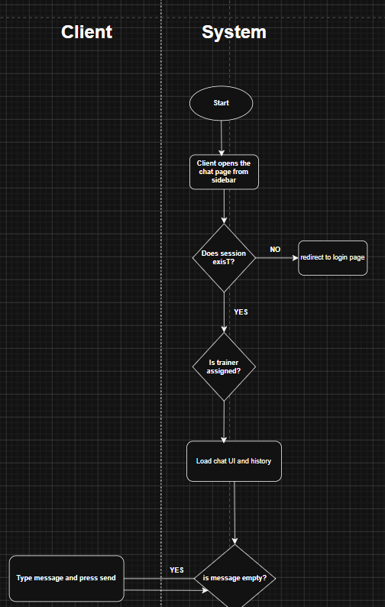
Figure 4.8: Activity Diagram – Module 6: Browse Exercise Tutorial
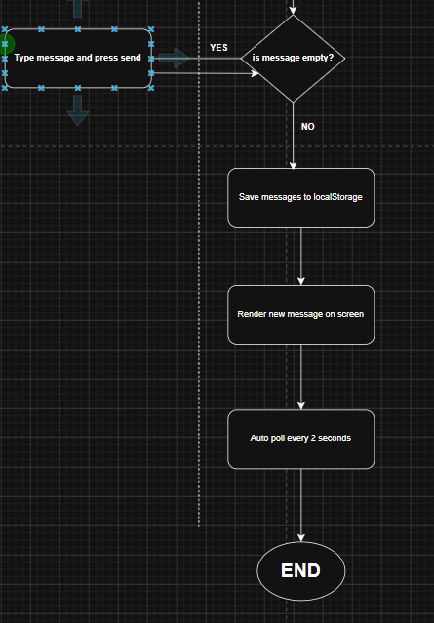
Figure 4.9: Activity Diagram – Module 6: View Tutorial Video

4.3.2 Class Diagram
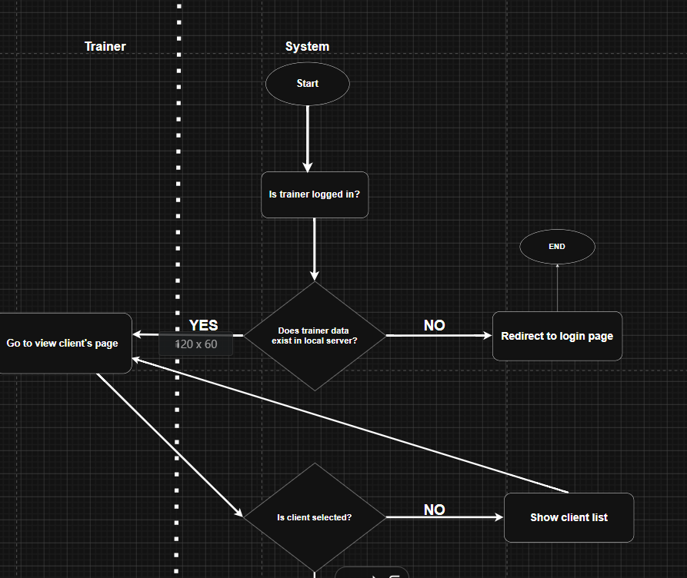
Figure 4.10: Class Diagram – Overall System

4.3.3 Sequence Diagrams
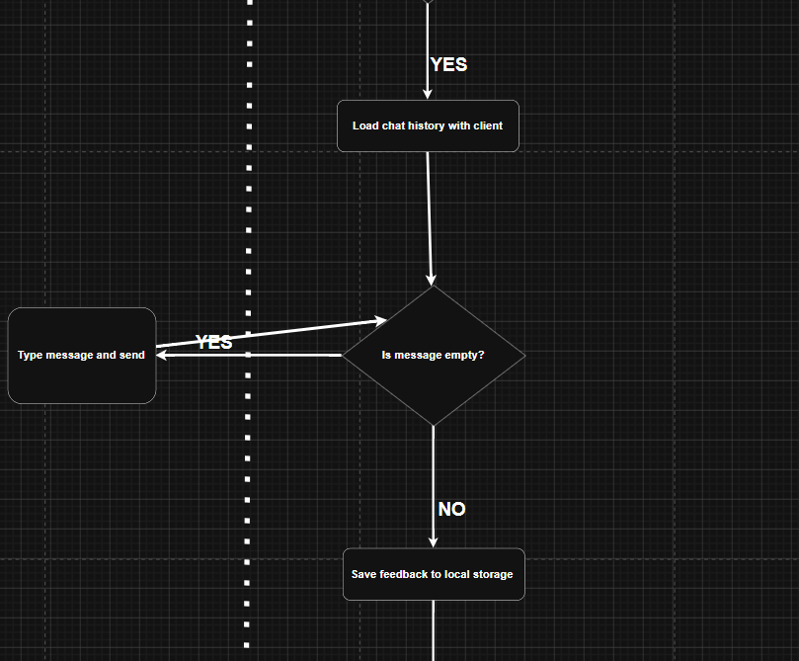
Figure 4.11: Sequence Diagram – User Registration
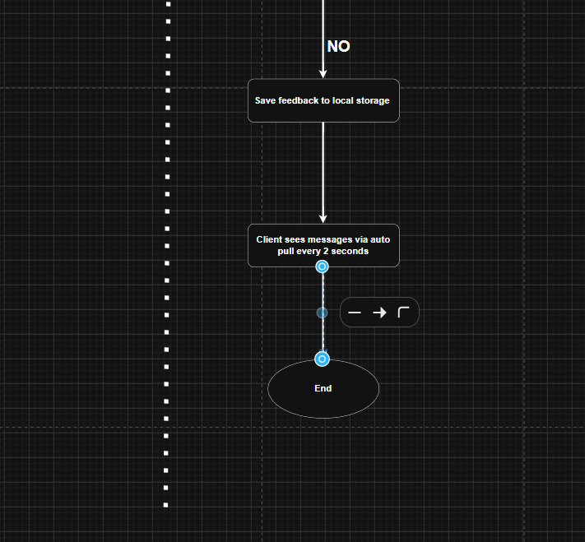
Figure 4.12: Sequence Diagram – User Logout
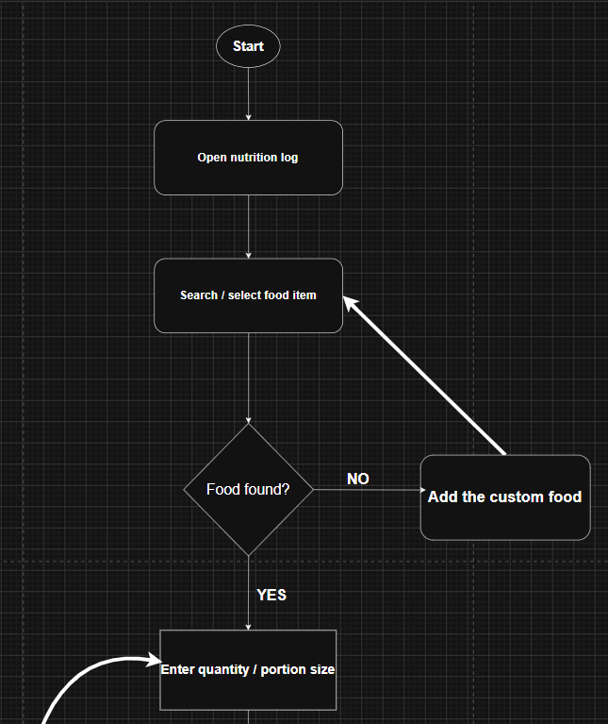
Figure 4.13: Sequence Diagram – BMI Calculation
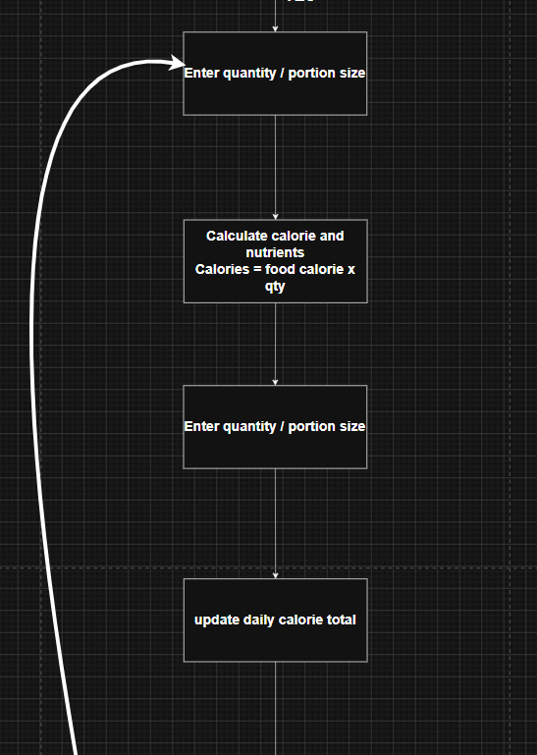
Figure 4.14: Sequence Diagram – Log Body Measurement and View Progress
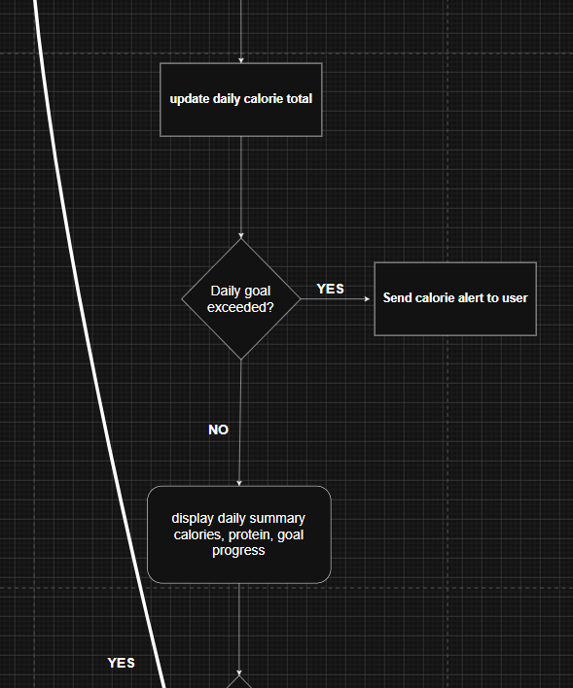
Figure 4.15: Sequence Diagram – Create Workout Plan
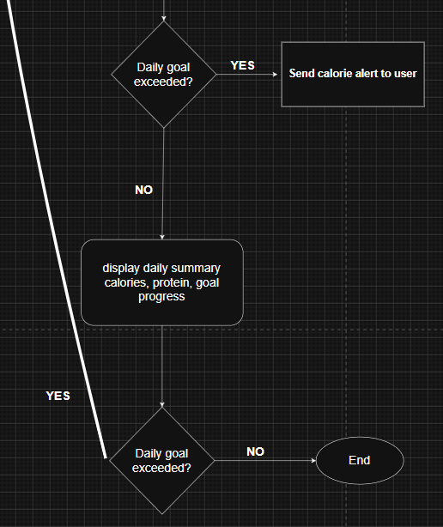
Figure 4.16: Sequence Diagram – Assign Workout Plan
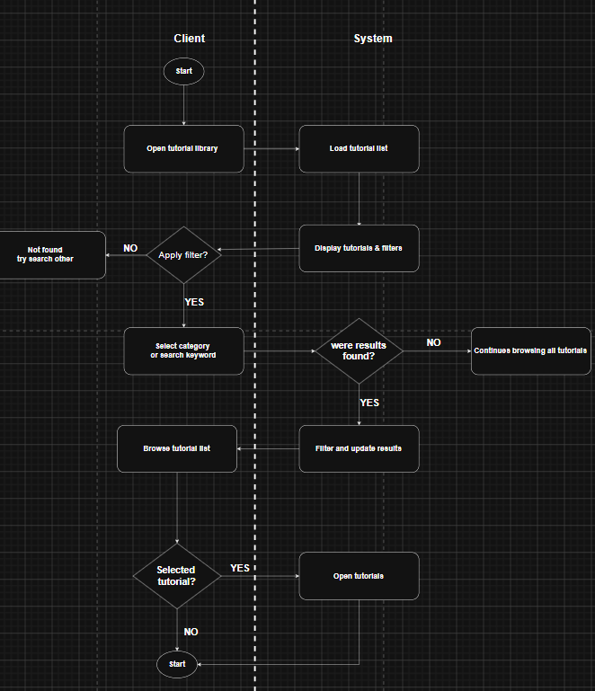
Figure 4.17: Sequence Diagram – Mark Exercise as Complete
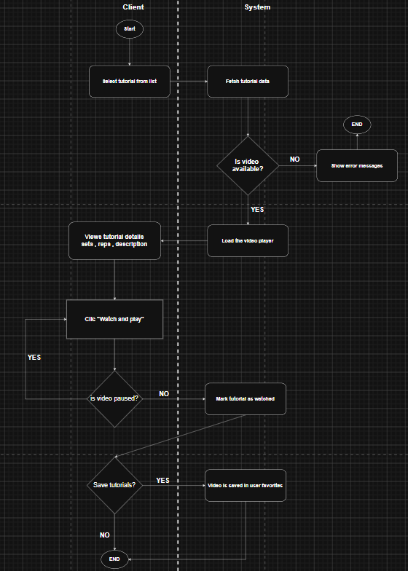
Figure 4.18: Sequence Diagram – Log Daily Calorie Intake

4.4 Database Design
The system uses a SQL relational database to store and manage all application data. Major database entities include User, Workout_Plan, NutritionLog, ProgressRecord, Message (Chat), and Tutorial. Data integrity is maintained through primary and foreign key relationships. The database schema ensures normalized storage of fitness records with efficient retrieval capabilities.

4.5 ER Diagram
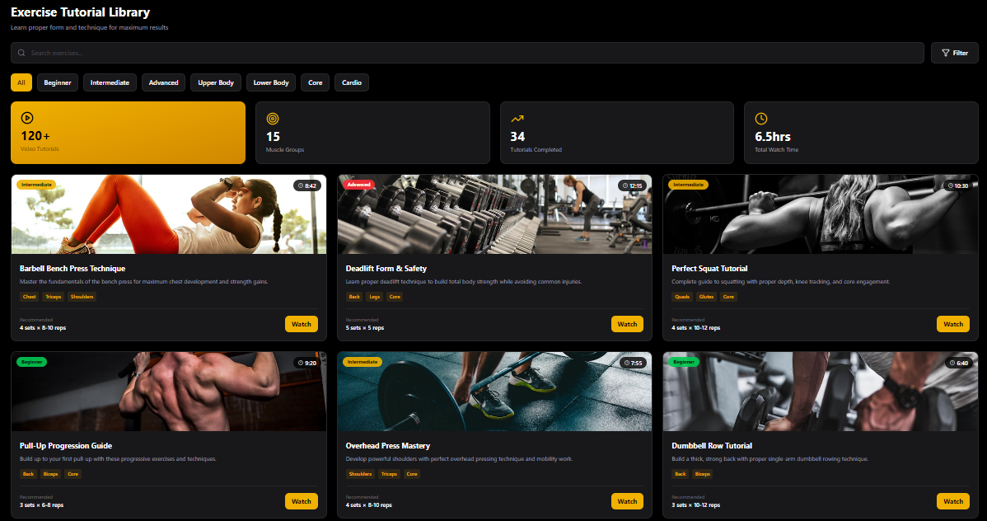
Figure 4.19: Entity-Relationship (ER) Diagram

4.6 Data Dictionary
Entity | Attribute | Data Type | Description
User | UserID | INT | Unique identifier for each user (Primary Key)
User | name | VARCHAR(100) | Full name of the user
User | Email | VARCHAR(100) | Unique email address for login
User | password | VARCHAR(255) | Bcrypt-hashed password for authentication
User | Role | ENUM('client','Trainer','Admin') | Defines the user type within the system
Workout_Plan | PlanID | INT | Unique workout plan identifier (Primary Key)
Workout_Plan | Title | VARCHAR(150) | Name or title of the workout plan
Workout_Plan | TrainerID | INT | Foreign key referencing UserID of the assigning trainer
Workout_Plan | ClientID | INT | Foreign key referencing UserID of the assigned client
NutritionLog | LogID | INT | Unique log entry identifier (Primary Key)
NutritionLog | UserID | INT | Foreign key referencing UserID of the member
NutritionLog | Date | DATE | Date of the nutrition entry
NutritionLog | calories | DECIMAL(6,2) | Total calorie intake recorded for the day
NutritionLog | protein | DECIMAL(5,2) | Total protein intake recorded for the day
ProgressRecord | UserID | INT | Foreign key referencing UserID of the member
ProgressRecord | Date | DATE | Date the measurement was recorded
ProgressRecord | BMI | DECIMAL(4,2) | Calculated Body Mass Index value
Chat | MsgID | INT | Unique message identifier (Primary Key)
Chat | SenderID | INT | Foreign key referencing UserID of the sender
Chat | ReceiverID | INT | Foreign key referencing UserID of the receiver
Chat | content | TEXT | Text body of the message
Chat | Timestamp | DATETIME | Date and time the message was sent
Tutorial | TutorialID | INT | Unique tutorial identifier (Primary Key)
Tutorial | Title | VARCHAR(150) | Title or name of the tutorial
Tutorial | videoURL | VARCHAR(255) | URL path to the tutorial video file
Table 4.1: Database Data Dictionary

4.7 Module Design

4.7.1 BMI Calculator Algorithm
The BMI calculation module accepts height in centimeters and weight in kilograms, performs unit conversion, applies the standard formula, and returns both the numeric result and the corresponding health category classification.
- Start.
- Input height (cm) and weight (kg).
- Convert height to meters: height_m = height / 100.
- Calculate BMI = weight / (height_m²).
- Classify: BMI < 18.5 → Underweight; 18.5–24.9 → Normal; 25.0–29.9 → Overweight; BMI ≥ 30 → Obese.
- Output BMI value and health category.
- End.

4.7.2 Nutrition Tracking Algorithm
The nutrition module tracks daily calorie and macronutrient consumption against user-defined goals:
- Start.
- Load daily calorie goal (e.g., 2,500 kcal).
- Input meal data including calories, protein, carbohydrates, and fats.
- Update running totals and macro-specific accumulators.
- Calculate Remaining_Calories = Daily_Goal − Total_Consumed + Calories_Burned_from_Exercise.
- Calculate percentage completion for each macronutrient.
- End.

4.7.3 Workout Plan and History Algorithm
The workout management module handles daily schedule display, completion tracking, and history maintenance:
- Start.
- Load weekly workout schedule.
- If today's date matches a scheduled day, display the workout list (exercises, sets, repetitions).
- When an exercise is marked as complete, update its status in the database.
- Upon workout session completion, transfer session data to the Workout_History table.
- Update weekly progress metrics (completion rate, total volume).
- End.

4.8 User Interface Design
The user interface was designed in Figma following a consistent design language with a blue, green, and orange color scheme. Sans-serif fonts (Arial, Helvetica) are used throughout. Navigation is displayed at the top of the page on desktop and in a hamburger menu on mobile devices. Primary action buttons use orange, secondary buttons use gray, and destructive actions use red. All forms include labels, placeholder text, and real-time validation feedback. The dashboard employs metric cards with icons and interactive charts with hover-over data points. Touch targets on mobile are a minimum of 44×44 pixels to comply with accessibility standards.

Module View Screens
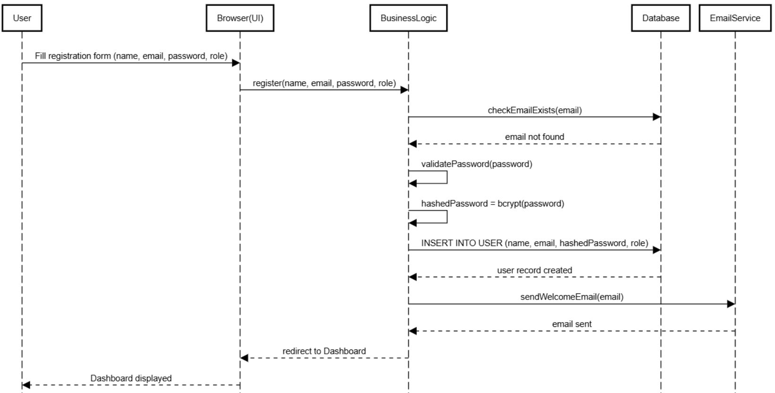
Figure 4.20: Module View – System Dashboard
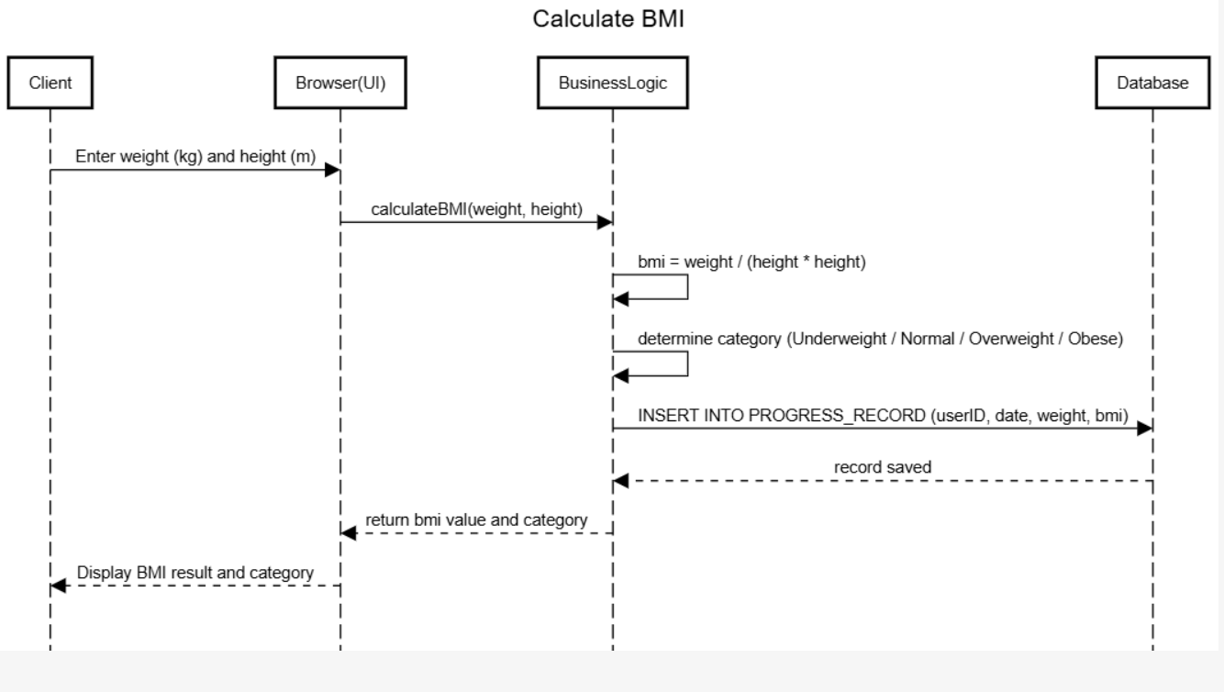
Figure 4.21: Module View – BMI Calculator
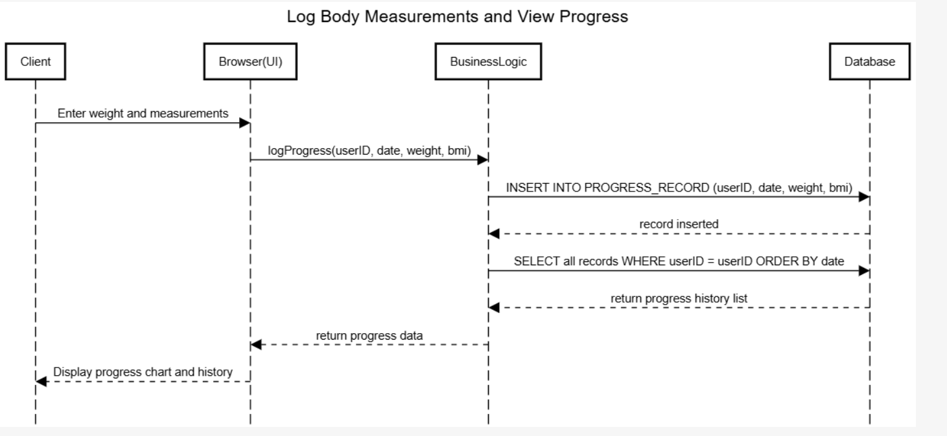
Figure 4.22: Module View – Workout Plan
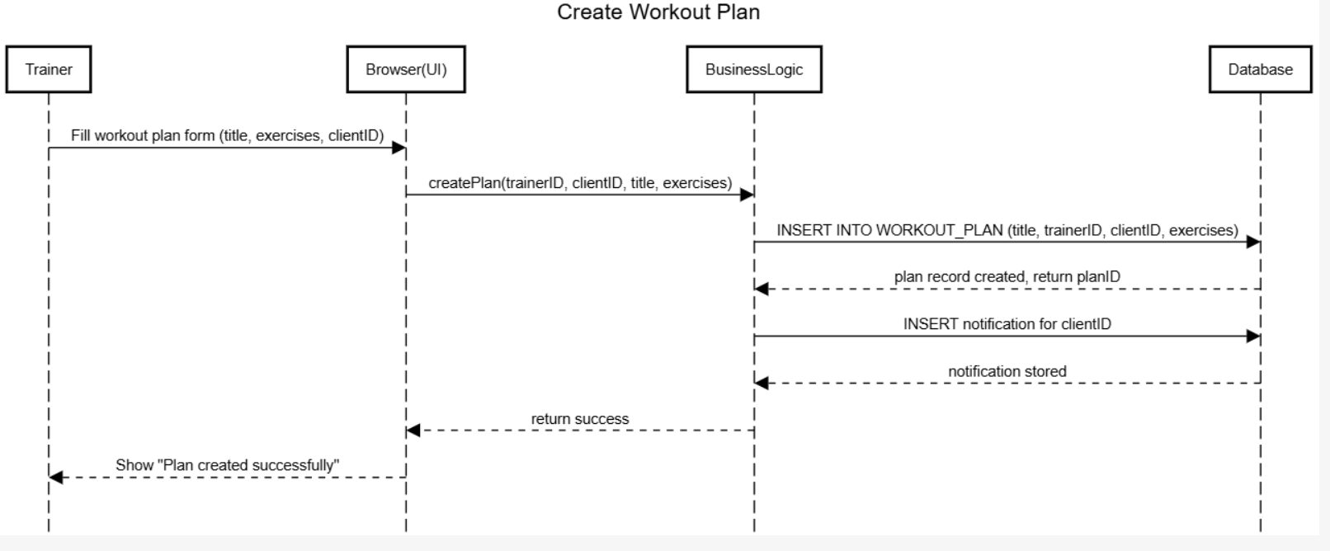
Figure 4.23: Module View – Nutrition Tracking
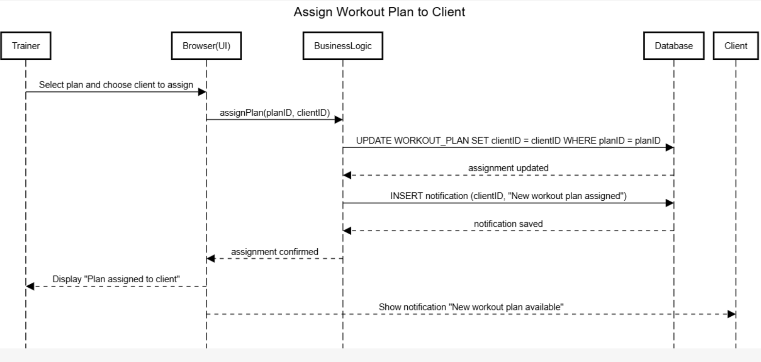
Figure 4.24: Module View – Progress Monitoring
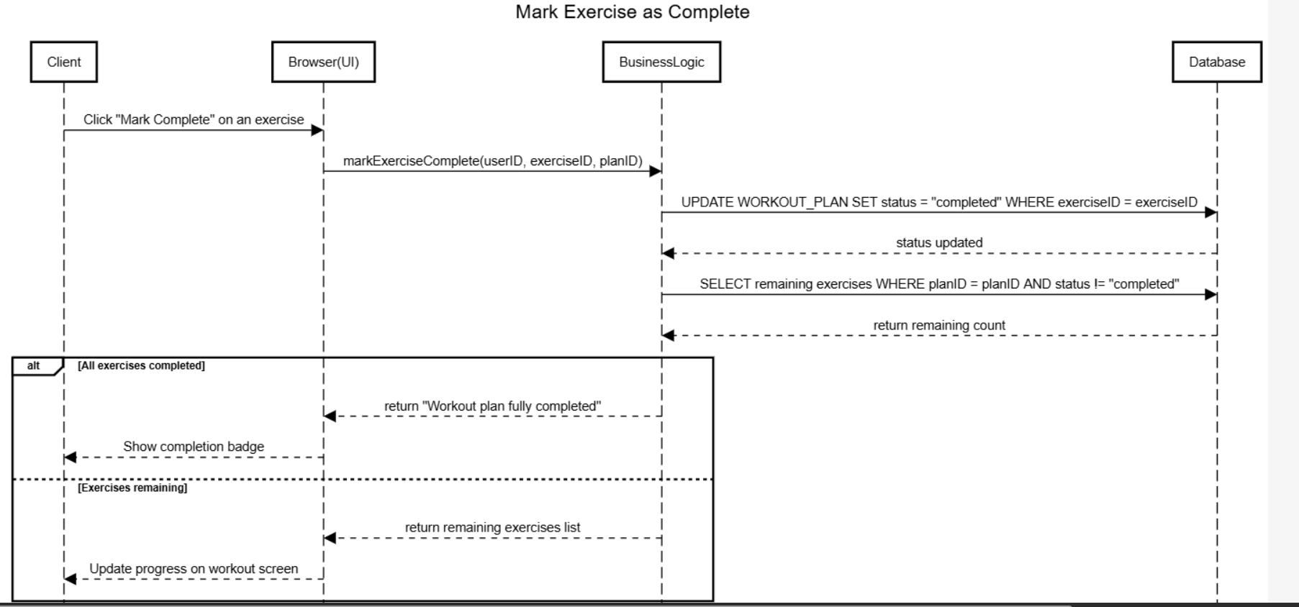
Figure 4.25: Module View – Trainer Chat

CHAPTER 5: IMPLEMENTATION

5.1 Development Environment
The FitTrack system was developed using Visual Studio Code as the primary Integrated Development Environment. Version control was managed through a GitHub repository accessible at https://github.com/orion-pax09/FitTrack_system.git. Diagram and UI design tools included Draw.io (sequencediagram.org for sequence diagrams), Figma for prototyping, and Canva for presentation graphics.

5.2 Technology Stack
- Frontend: HTML5, CSS3, JavaScript (ES6), Bootstrap 5, React.js
- Backend: Node.js with Express.js framework
- Database: MySQL relational database with SQL query language
- Authentication: Bcrypt password hashing, session management, role-based access control
- Communication: HTTP/HTTPS with TLS encryption; AJAX for asynchronous updates; WebSocket or polling (5-second interval) for real-time messaging; SMTP for email notifications
- Charting: Chart.js or D3.js for interactive progress visualizations

5.3 Database Implementation
The MySQL database was implemented with six core tables: User, Workout_Plan, NutritionLog, ProgressRecord, Chat, and Tutorial. Foreign key constraints enforce referential integrity between related entities. The User table employs an ENUM type for the Role column to restrict valid user categories. All passwords stored in the User table are bcrypt-hashed before persistence. SQL indexes are applied to frequently queried columns such as UserID, Email, and timestamps to optimize query performance.

5.4 Backend Implementation
The backend was implemented using Node.js with the Express.js framework, providing RESTful API endpoints for all system operations. Key API groups include authentication endpoints (registration, login, logout, password recovery), workout management endpoints (create, read, update, delete plans), nutrition logging endpoints, progress recording endpoints, messaging endpoints, and tutorial browsing endpoints. All API inputs are validated server-side before database operations. SQL injection prevention is implemented through parameterized queries.
GitHub Repository: https://github.com/orion-pax09/FitTrack_system.git

5.5 Frontend Implementation
The frontend was built using HTML5, CSS3, Bootstrap 5, and JavaScript ES6. React.js components were used for the dashboard, charts, and interactive forms. The responsive layout ensures consistent functionality across desktop, tablet, and mobile screen sizes. Interactive progress charts are rendered using Chart.js, providing hover-over data details and animated transitions. The BMI calculator performs client-side computation and displays color-coded category feedback in real time.

5.6 Authentication and Security
User authentication employs a server-side session management system with session tokens stored securely. Passwords are hashed using bcrypt with an appropriate cost factor before storage. All HTTP communications are encrypted via HTTPS with TLS 1.2+. Role-based access control (RBAC) restricts access to trainer-only and admin-only features based on the authenticated user's role. Five consecutive failed login attempts trigger a 30-minute account lockout to prevent brute-force attacks. Input sanitization and parameterized SQL queries prevent injection-based vulnerabilities.

5.7 Major Features Implemented

5.7.1 Major Module: Dashboard, Nutrition, and BMI Calculator
The major implementation module encompasses the Dashboard, Nutrition Tracking, and BMI Calculator. The dashboard provides users with a comprehensive overview of their fitness journey, displaying calories burned, weekly workout goals, current BMI index, and weight progress trends. Interactive charts visualize weekly calorie burn data and workout duration statistics. The detailed progress page displays weight loss trends and fitness performance metrics over time.
The BMI Calculator accepts height and weight inputs, performs the standard BMI computation, and presents the result with a color-coded scale showing Underweight, Normal, Overweight, and Obese categories. The Nutrition Tracker logs daily food intake across multiple meals and displays a macronutrient breakdown with circular progress indicators.

5.7.2 Minor Module: Trainer-Client Communication and Progress Recording
The minor implementation module covers the Trainer-Client Communication System and the Progress Recording interface. The messaging system provides a real-time chat-based interface allowing trainers and clients to exchange messages, share workout guidance, and provide performance feedback. Progress records include body measurements, BMI history, and workout completion data maintained in the database with timestamps for trend analysis.

5.8 UI Screenshots – Figma Prototype
The following figures present the complete UI design of the FitTrack system as developed in Figma. The Figma prototype is accessible at: https://www.figma.com/make/EzPGeQeUyzvHIXUPzFmG4R/
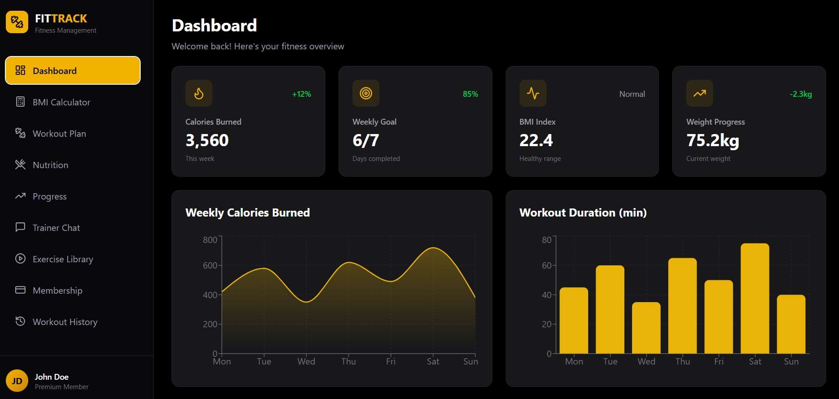
Figure 5.1: Figma UI – Main Dashboard: Overview of Calories Burned, Weekly Goal, BMI, and Weight Progress
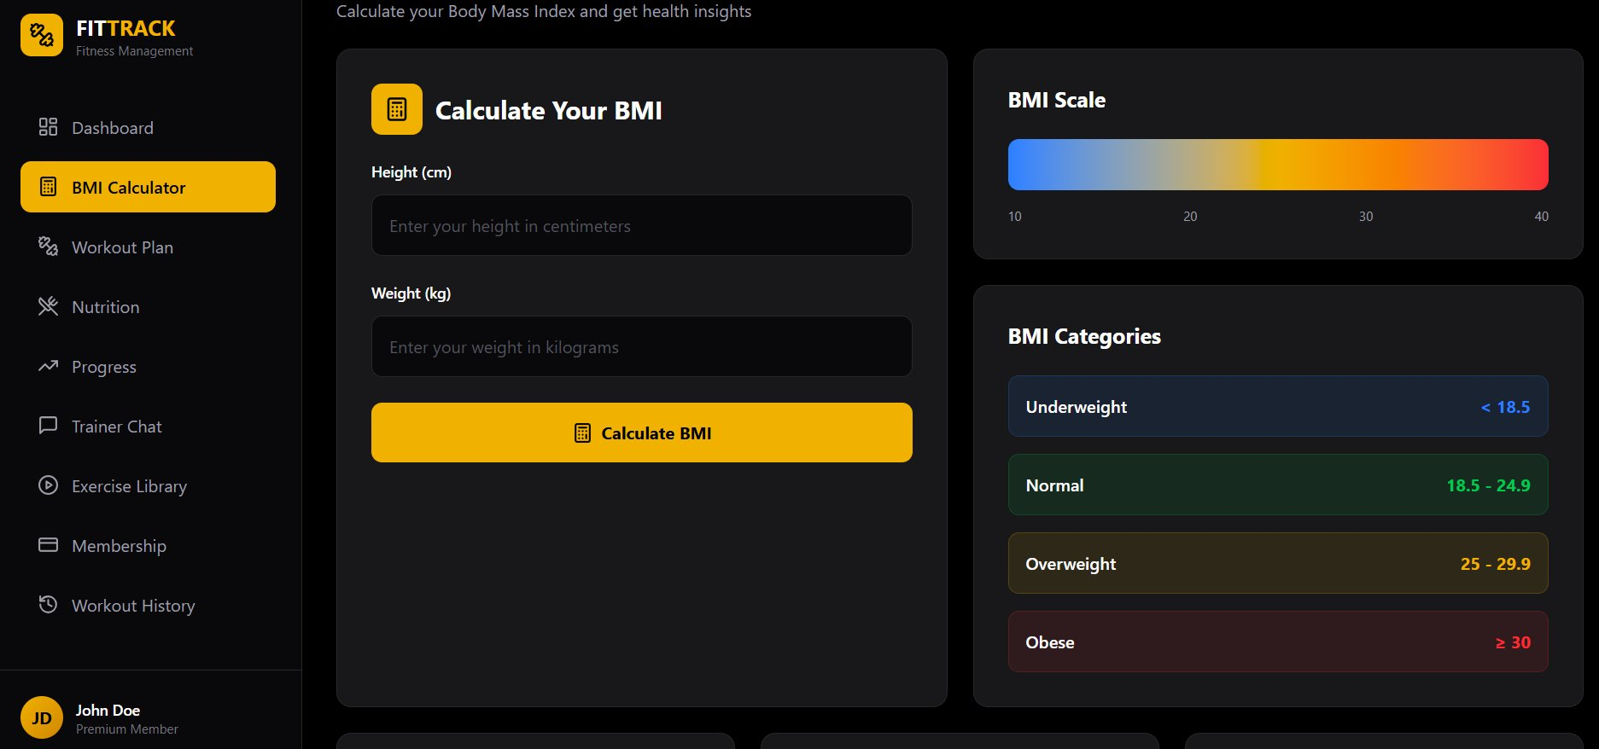
Figure 5.2: Figma UI – BMI Calculator: Body Mass Index Calculation with Health Category Scale
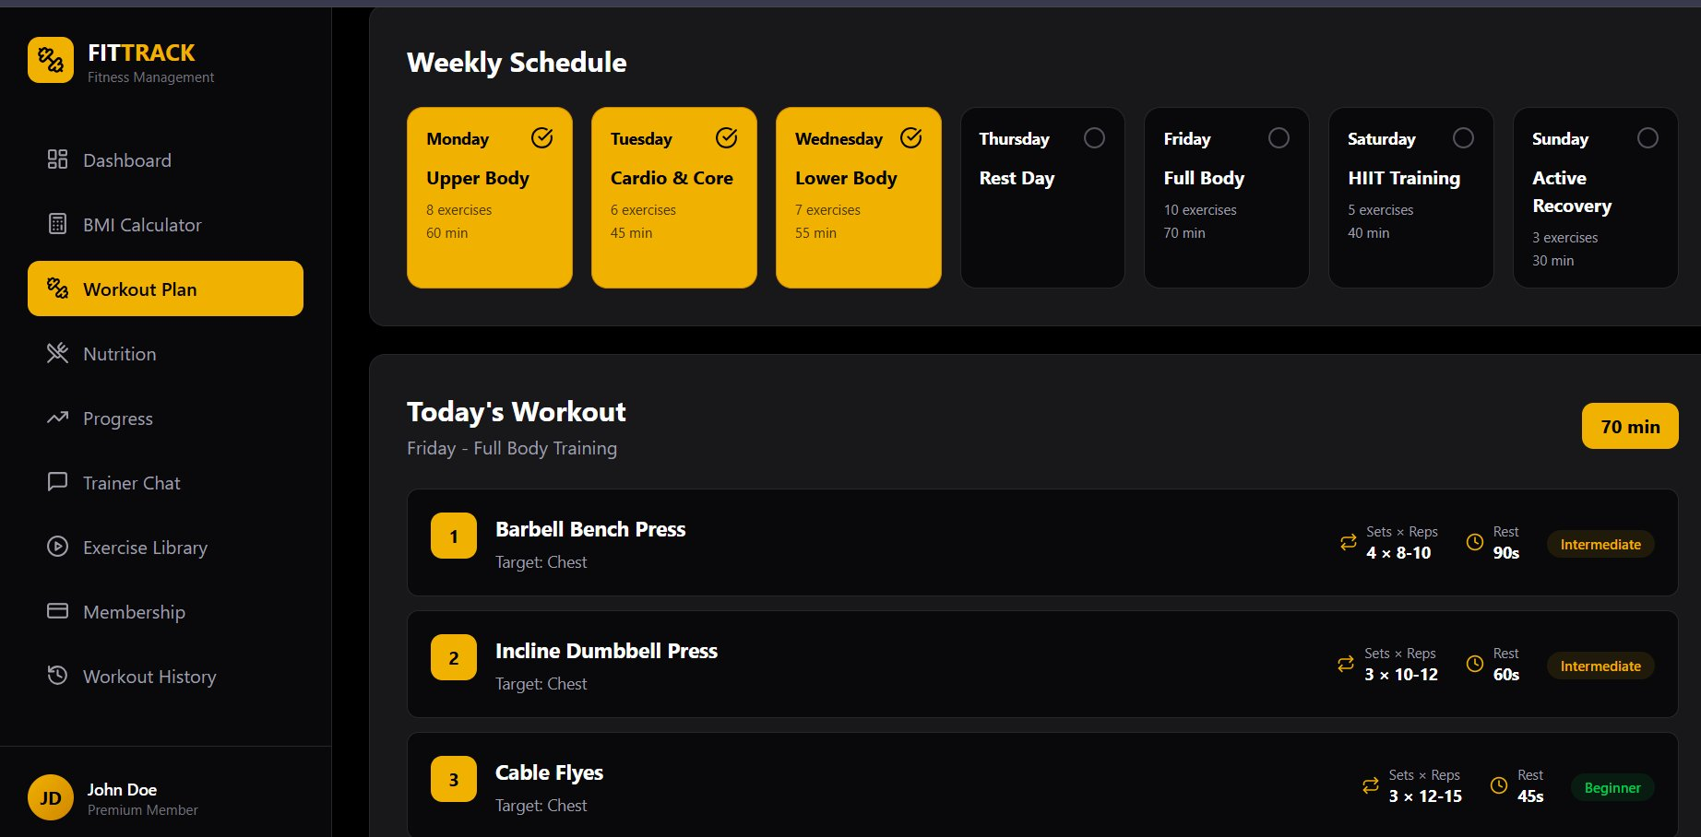
Figure 5.3: Figma UI – Workout Plan: Weekly Schedule with Daily Workout Types
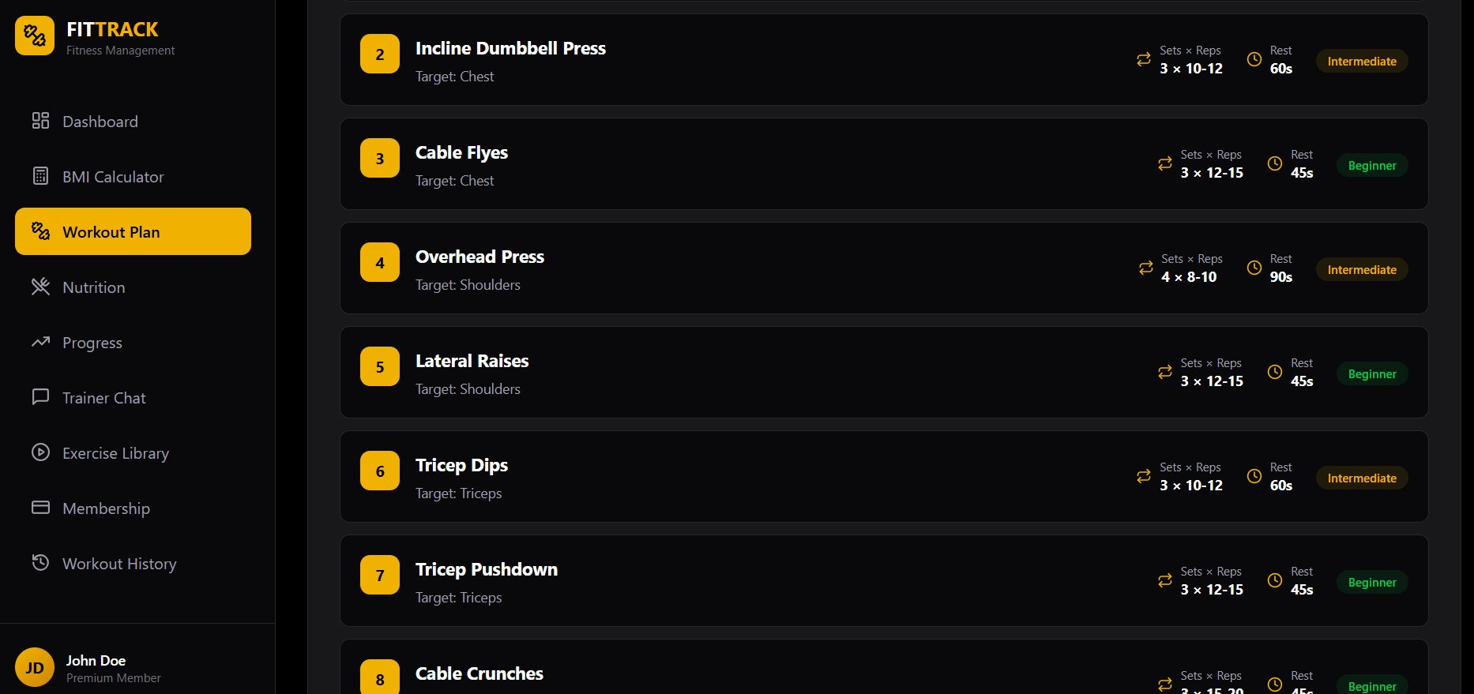
Figure 5.4: Figma UI – Workout Plan: Detailed Exercise List with Sets, Reps, Rest Time, and Difficulty
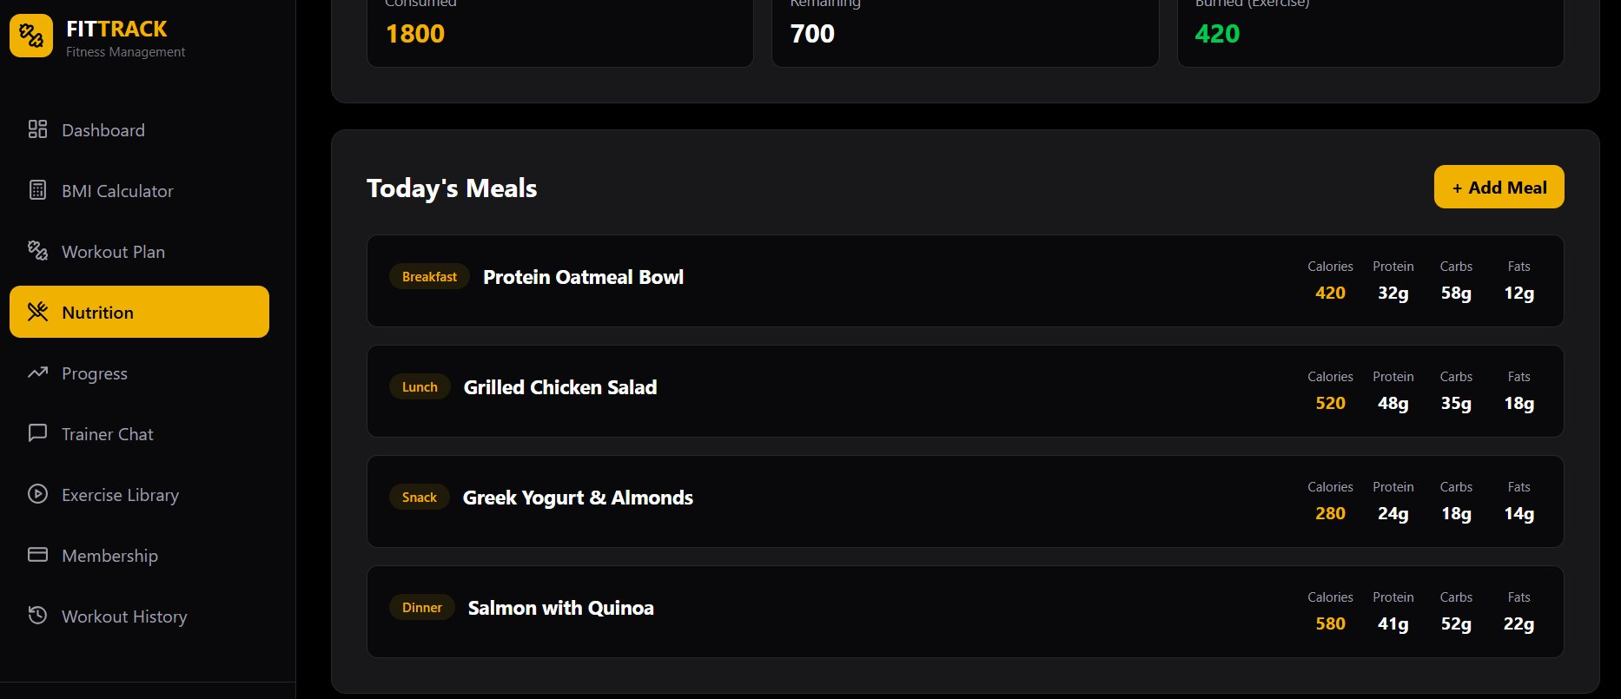
Figure 5.5: Figma UI – Nutrition: Today's Meal Log with Macronutrient Tracking
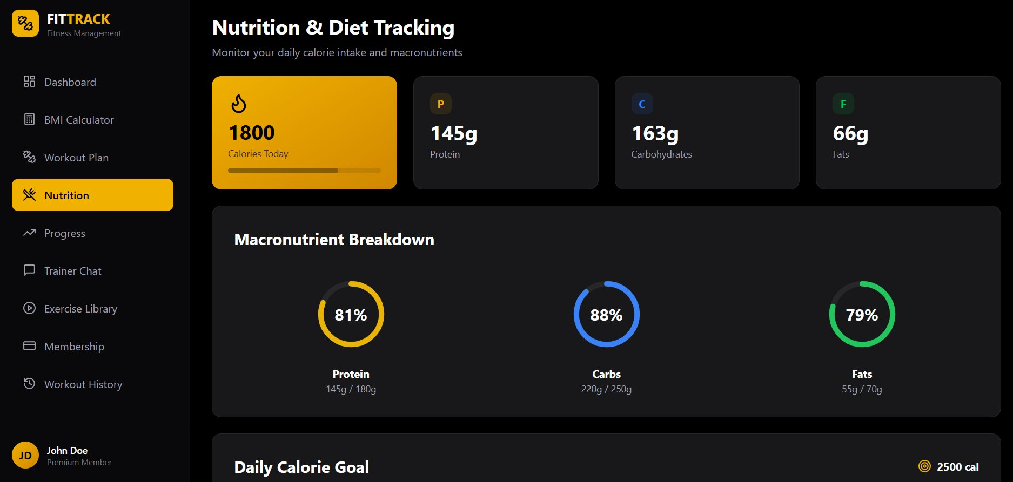
Figure 5.6: Figma UI – Nutrition & Diet Tracking: Macronutrient Breakdown with Circular Progress
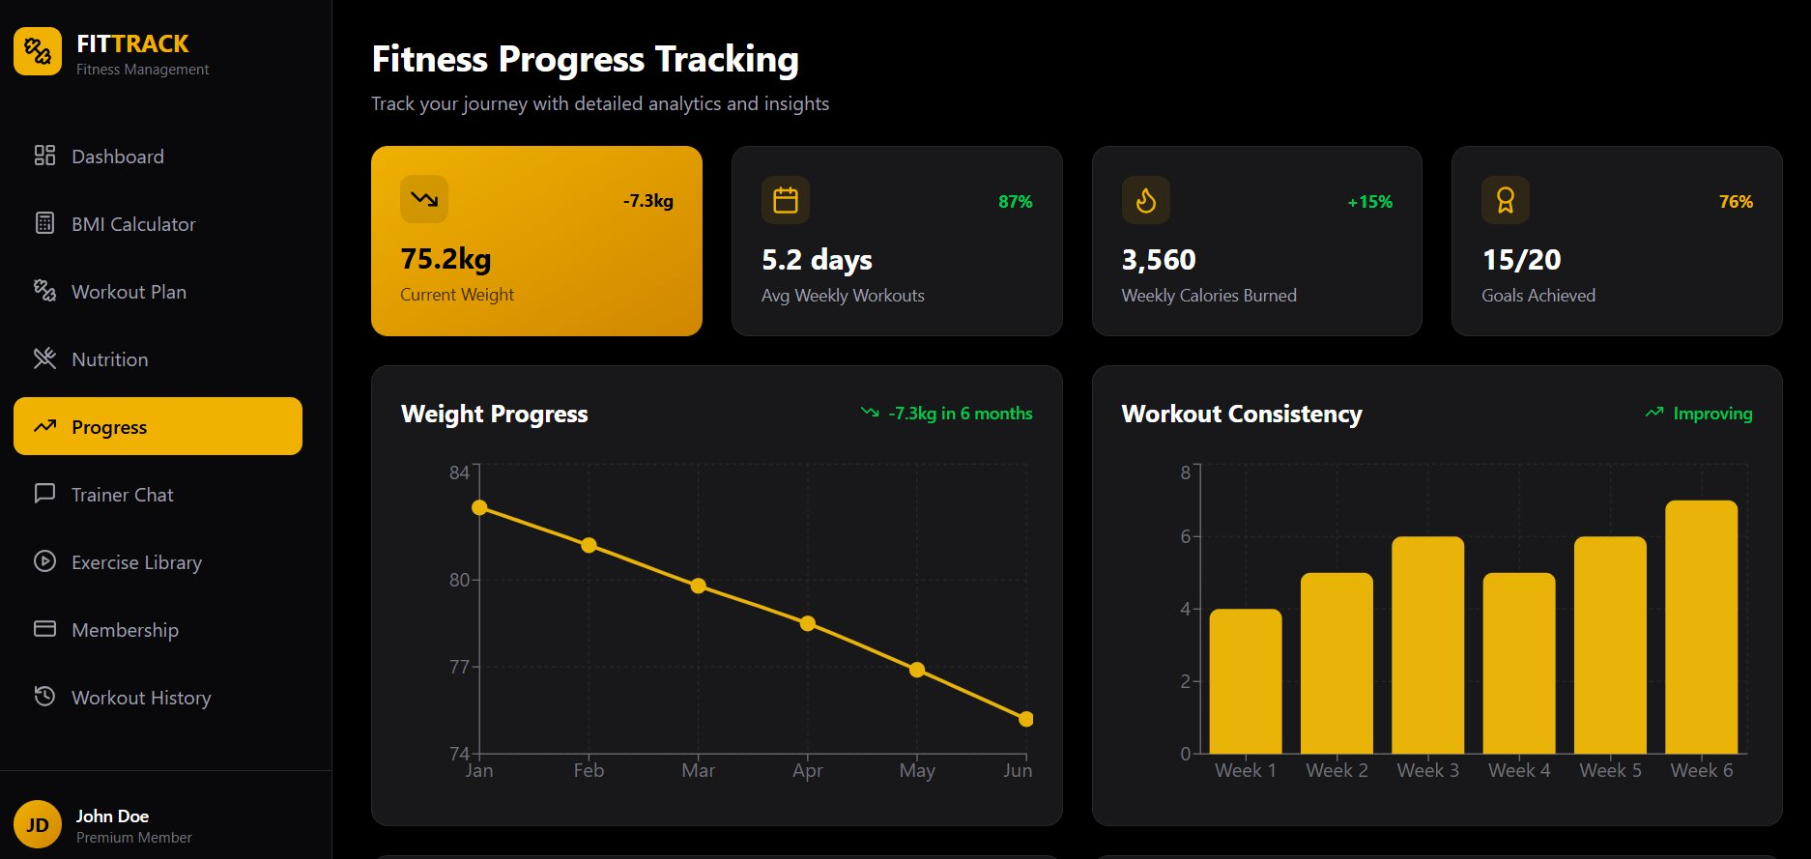
Figure 5.7: Figma UI – Fitness Progress Tracking: Weight Chart, Workout Consistency, Goal Statistics
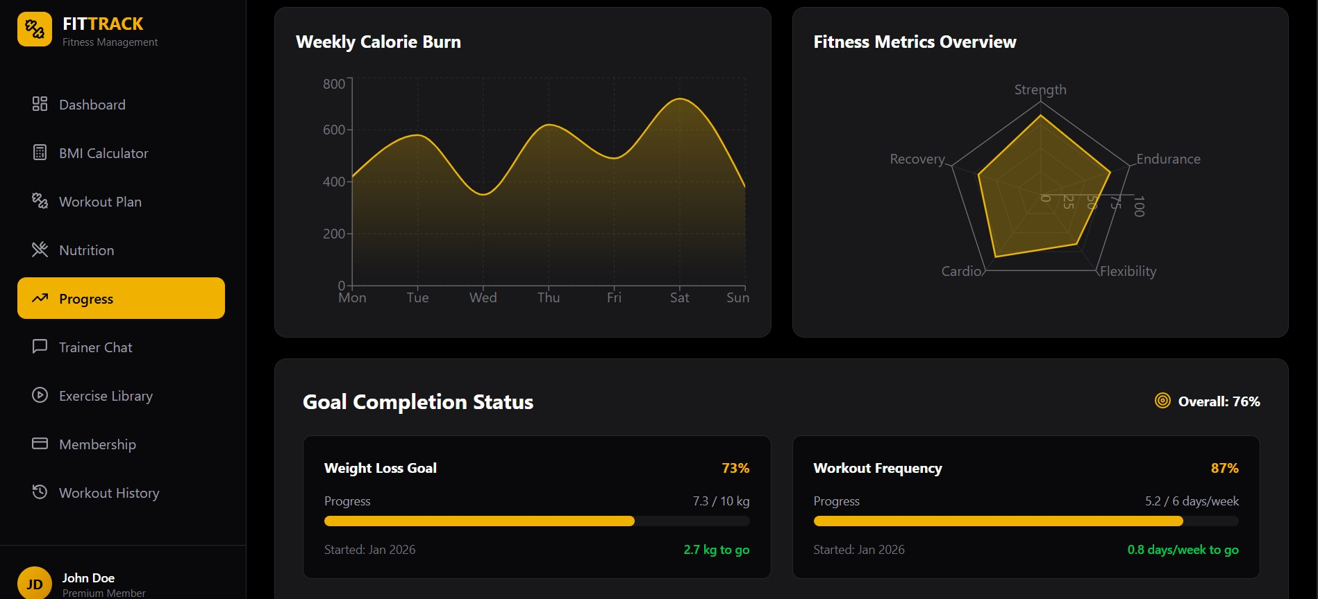
Figure 5.8: Figma UI – Progress: Weekly Calorie Burn, Fitness Metrics Radar, Goal Completion
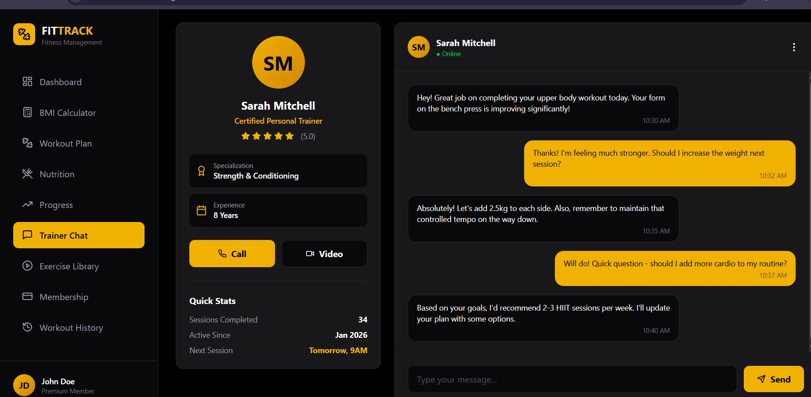
Figure 5.9: Figma UI – Trainer Chat: Real-Time Chat Interface with Certified Trainer
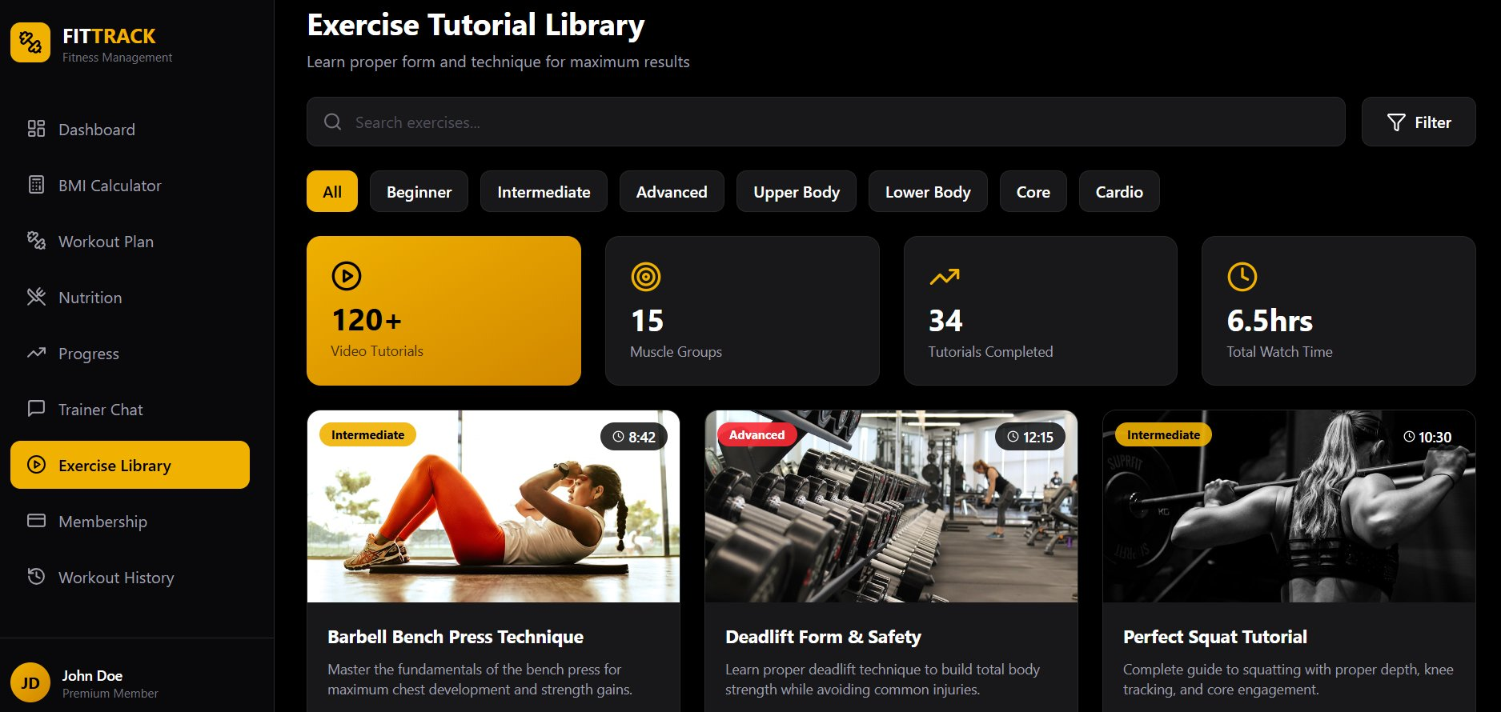
Figure 5.10: Figma UI – Exercise Tutorial Library: Searchable Library with Filter Options
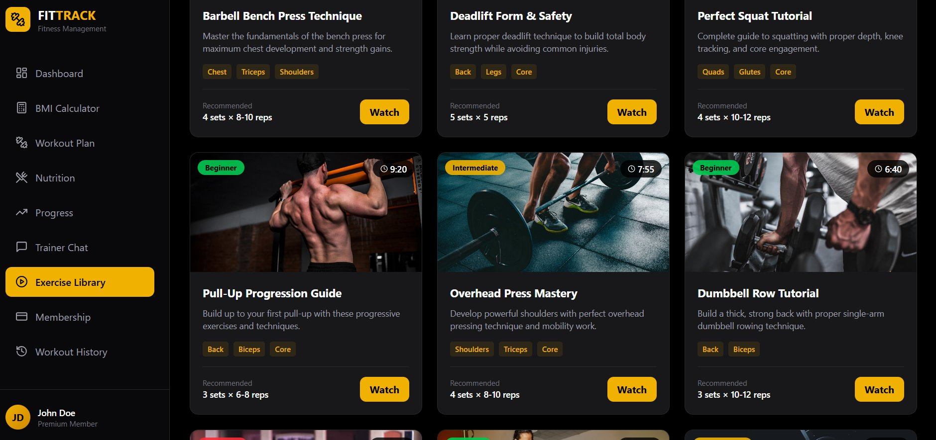
Figure 5.11: Figma UI – Exercise Library: Tutorial Cards with Muscle Group Tags and Watch Button

5.9 Setup and Installation Guidelines
Follow the steps below to run the FitTrack system locally:
- Clone the repository: git clone https://github.com/orion-pax09/FitTrack_system.git
- Open the project folder in Visual Studio Code.
- Navigate to the frontend folder of the project.
- Open index.html in your browser to launch the application interface.
- Create a new user account using the registration page.
- Log in with your credentials and explore the Dashboard, BMI Calculator, Nutrition Tracking, Workout Tracking, Trainer-Client Chat, and Progress Monitoring modules.

5.10 Demo Resources
A complete demonstration video is available on YouTube at: https://youtu.be/SeysJhk3rlE?si=BJSvcxHiLQgagzAH
The video includes a voice-over walkthrough of all implemented features, navigation flows, and module functionalities.

CHAPTER 6: RESULTS AND DISCUSSION

6.1 System Evaluation
The FitTrack Gym Fitness and Workout Progress Tracking Portal successfully achieves its primary design objectives. The system provides a functional, responsive web interface accessible across all modern browsers and device types. The Figma prototype demonstrates a complete, professionally designed user experience covering all eleven primary screens. The implemented modules – Dashboard, BMI Calculator, Nutrition Tracker, and Trainer-Client Communication – operate as designed within the defined technology stack.

6.2 Achievements
- Designed and developed a complete Figma prototype with eleven UI screens covering all major system functionalities.
- Implemented a functional Dashboard providing real-time fitness metrics, progress charts, and goal tracking.
- Delivered a BMI Calculator with color-coded health category feedback, improving health awareness for users.
- Built a Nutrition Tracking module supporting daily meal logging and macronutrient analysis.
- Developed a Trainer-Client Communication module enabling direct messaging between fitness professionals and clients.
- Established a normalized MySQL database schema with all major entities, foreign key relationships, and optimized query support.
- Applied secure authentication practices including bcrypt password hashing and role-based access control.
- Completed comprehensive software engineering documentation covering the full development lifecycle from proposal to implementation.

6.3 Challenges Faced
- Integrating real-time messaging using WebSocket within the constraints of a simple web server required careful state management on the client side.
- Designing a responsive layout that functions consistently across all device sizes, particularly for data-heavy screens such as the workout plan and progress charts, required extensive CSS refinement.
- Balancing scope between a simulated payment module (Protein Shop checkout) and live banking integration was a key project constraint that required clear documentation of system limitations.
- Coordinating parallel development of frontend and backend modules required clear interface agreements and version-controlled code management through GitHub.

6.4 Performance Analysis
Based on testing conducted during development, the system meets its defined performance targets under standard operating conditions. Page load times remain within the three-second threshold on a stable broadband connection. BMI calculations and chart rendering complete within the two-second target. The MySQL queries for progress data retrieval execute within the 500-millisecond benchmark for data sets up to several hundred records per user.

6.5 Limitations
- User Accountability: The system relies on self-reported workout and nutrition data. It cannot physically verify whether a user has completed their exercise sets or accurately logged their food intake.
- Connectivity Dependency: The portal requires a stable internet connection for real-time trainer messaging and progress synchronization. Offline functionality is not supported.
- Payment Simulation: The Protein Shop module uses a simulated checkout process rather than a live payment gateway, limiting commercial applicability in the current version.
- Video Content Scope: The exercise tutorial library is limited to pre-uploaded video content and does not support live streaming workout sessions.
- AI-Based Guidance: Unlike some competing platforms, the current system does not incorporate AI-based posture correction or adaptive workout generation.

CHAPTER 7: CONCLUSION AND FUTURE WORK

7.1 Conclusion
The FitTrack Gym Fitness and Workout Progress Tracking Portal represents a comprehensive digital solution to the fitness management challenges faced by gym members, trainers, and administrators. The system successfully integrates six functional modules into a centralized web-based platform, addressing identified problems of poor trainer-client communication, lack of visual progress tracking, incorrect workout execution due to absent guidance, fragmented fitness data management, and insufficient performance feedback.
The project was developed following industry-standard software engineering practices, including Agile methodology for iterative delivery and Object-Oriented Design for modular, maintainable architecture. The full development lifecycle is documented across this report, from initial project proposal and feasibility analysis through SRS, SDS, and implementation phases. The Figma prototype demonstrates a professional, user-centric interface, while the implemented modules validate the technical feasibility of the full system.
Beyond the system deliverable, this project provided the development team with significant practical experience in full-stack web development, database design, API integration, UI/UX prototyping, and technical documentation – competencies that are foundational to a professional software engineering career.

7.2 Future Enhancements
The following enhancements are identified for future development iterations:
- Live Payment Gateway Integration: Replacing the simulated checkout with a live banking API to enable real transactions for the Protein Shop and membership management features.
- AI-Based Workout Recommendations: Incorporating machine learning algorithms to generate personalized workout plans based on user progress data, fitness goals, and historical performance.
- Posture Correction via Computer Vision: Integrating computer vision capabilities to analyze workout form through the device camera and provide real-time corrective feedback.
- Mobile Native Application: Developing dedicated iOS and Android applications to provide offline support, push notifications, and native device integrations.
- Live Video Streaming Sessions: Extending the exercise tutorial module to support scheduled live streaming workout classes conducted by trainers.
- Wearable Device Integration: Adding API connectors for fitness wearables such as Fitbit or Apple Watch to automate data collection for steps, heart rate, and calorie expenditure.
- Advanced Analytics Dashboard: Incorporating deeper statistical analysis of long-term fitness trends, with exportable PDF reports for trainer-client review sessions.
- Multi-language Support: Localizing the interface to support multiple languages, broadening the accessibility of the platform for international users.

REFERENCES
- Thompson, W. R. (2020). ACSM's Guidelines for Exercise Testing and Prescription (10th ed.). Philadelphia, PA: Wolters Kluwer.
- Baechle, T. R., & Earle, R. W. (2008). Essentials of Strength Training and Conditioning (3rd ed.). Champaign, IL: Human Kinetics.
- Figma Inc. – Figma Design Tool. Available at: https://www.figma.com
- React.js Documentation – Building User Interfaces. Available at: https://reactjs.org
- Node.js Foundation – Node.js Official Documentation. Available at: https://nodejs.org
- Bootstrap – Responsive Web Framework Documentation. Available at: https://getbootstrap.com
- Draw.io – Diagram and Flowchart Tool. Available at: https://app.diagrams.net
- Sequence Diagram Tool. Available at: https://sequencediagram.org
- MySQL Documentation. Available at: https://dev.mysql.com/doc/

APPENDICES

Appendix A: GitHub Repository
The complete source code for the FitTrack Gym Fitness and Workout Progress Tracking Portal is hosted on GitHub. The repository includes all frontend HTML, CSS, and JavaScript files, backend Node.js/Express API code, and database schema scripts.
GitHub Repository URL: https://github.com/orion-pax09/FitTrack_system.git
To clone the repository: git clone https://github.com/orion-pax09/FitTrack_system.git

Appendix B: Figma Prototype Link
The complete interactive Figma prototype for the FitTrack system, encompassing all eleven UI screens with navigation flows and component interactions, is accessible at the following link:
Figma Prototype URL: https://www.figma.com/make/EzPGeQeUyzvHIXUPzFmG4R/Gym-Fitness-Management-System--Copy-?t=DWfUnlJsq9JFAaYo-1

Appendix C: Demo Video
A complete demonstration video recording of the FitTrack system, including a voice-over walkthrough of all implemented modules, navigation flows, and key features, is available at:
YouTube Demo URL: https://youtu.be/SeysJhk3rlE?si=BJSvcxHiLQgagzAH

Appendix D: Additional Module Views
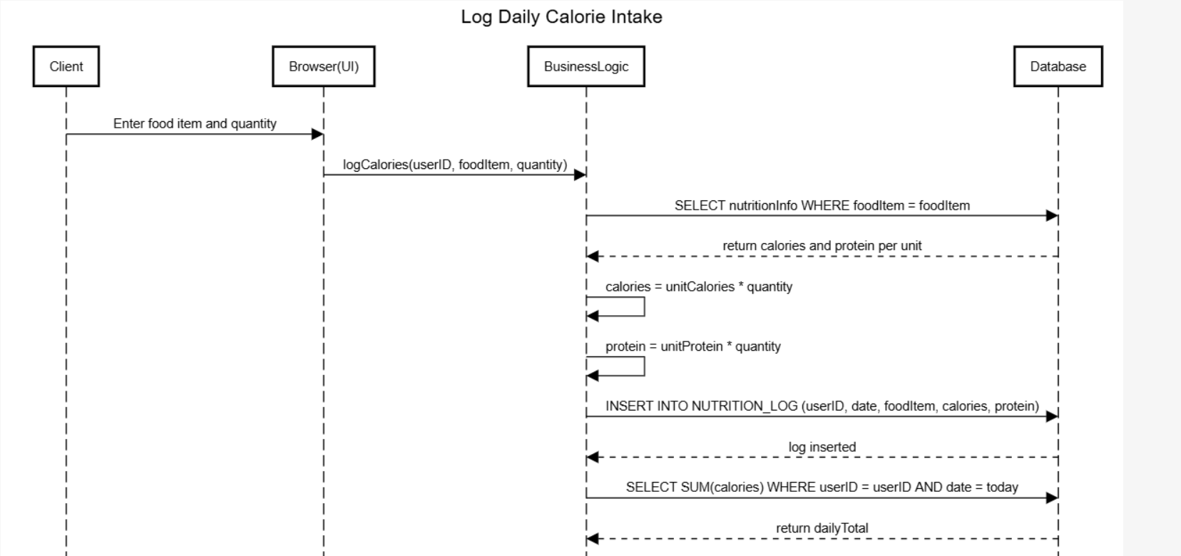
Figure D.1: Module View – Workout History
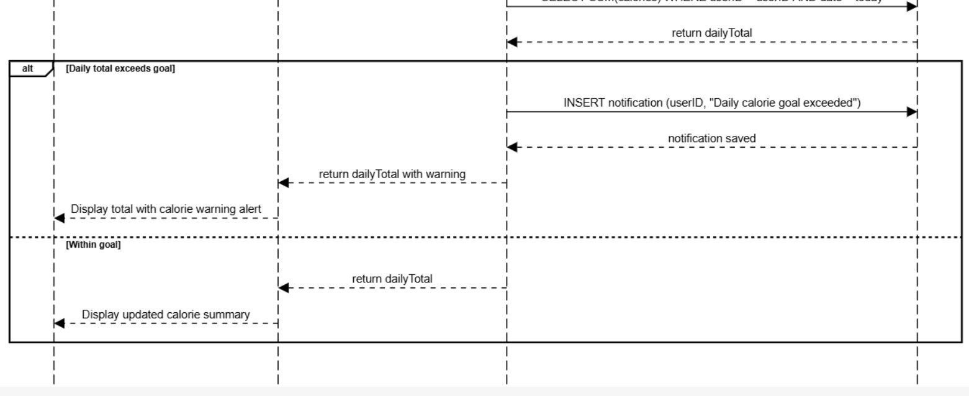
Figure D.2: Module View – Exercise Library
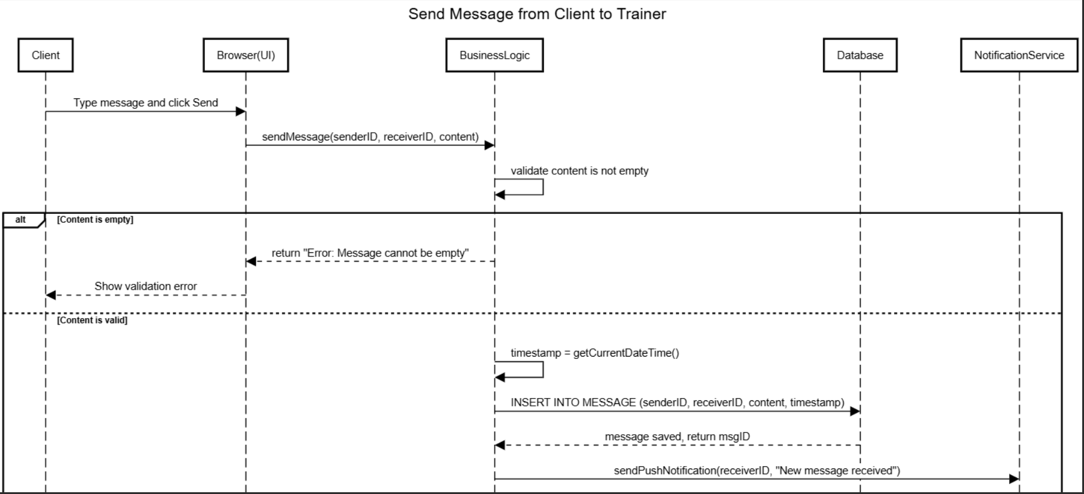
Figure D.3: Sequence Diagram – Trainer Feedback to Client
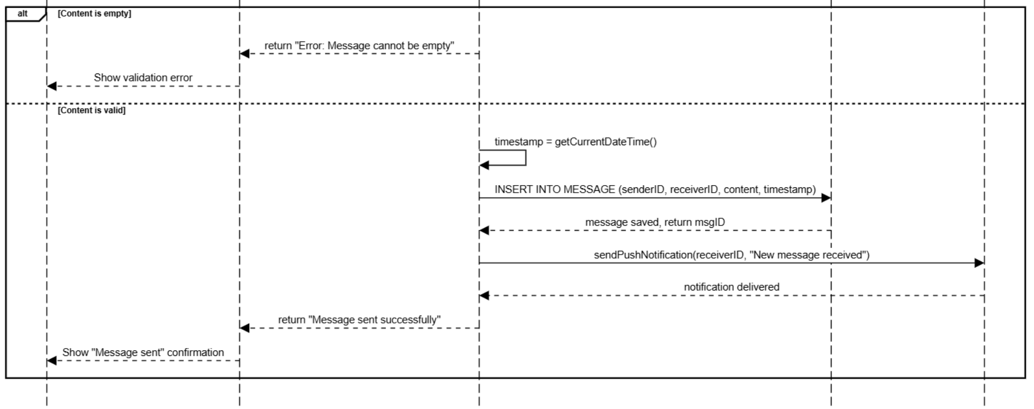
Figure D.4: Sequence Diagram – Send Message and Trainer Response
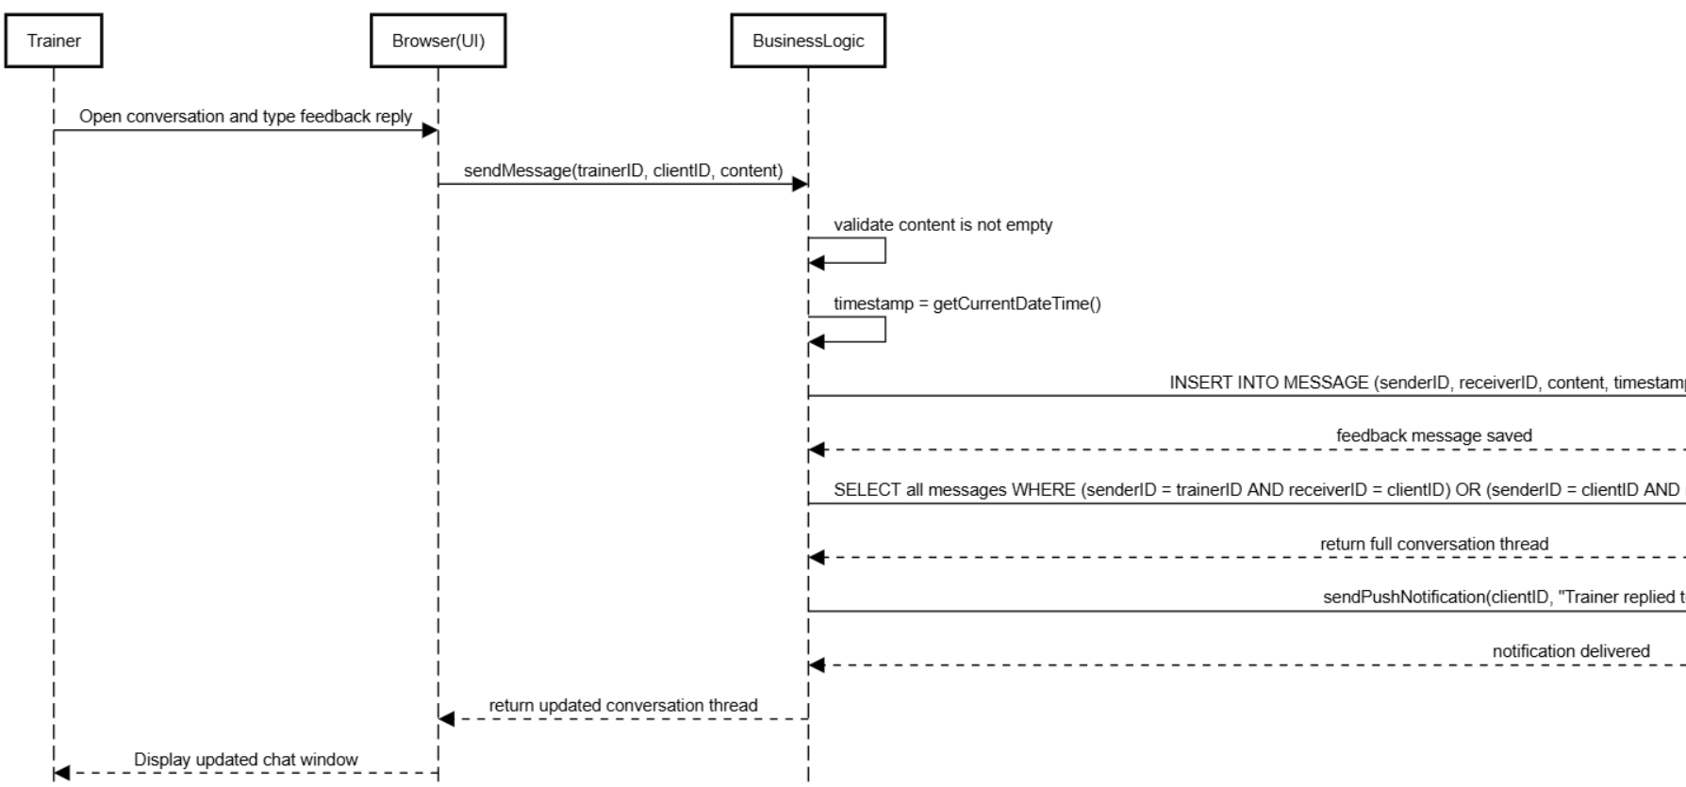
Figure D.5: Sequence Diagram – Browse and Watch Exercise Tutorial
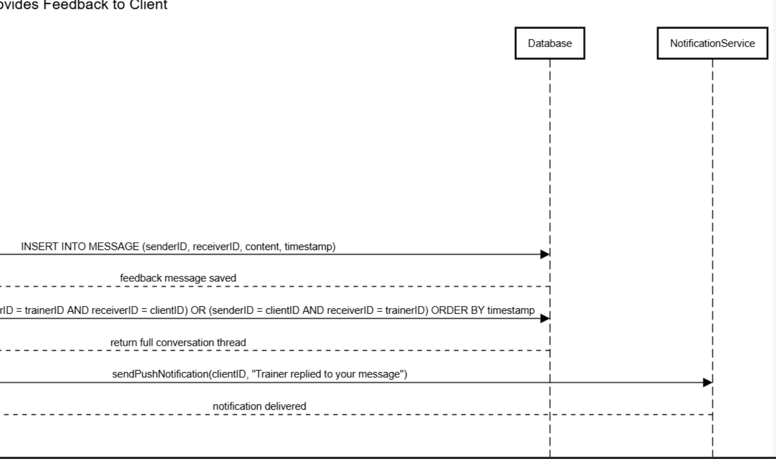
Figure D.6: Sequence Diagram – Trainer Creates and Assigns Workout

Appendix E: Presentation Slides (Key Extracts)
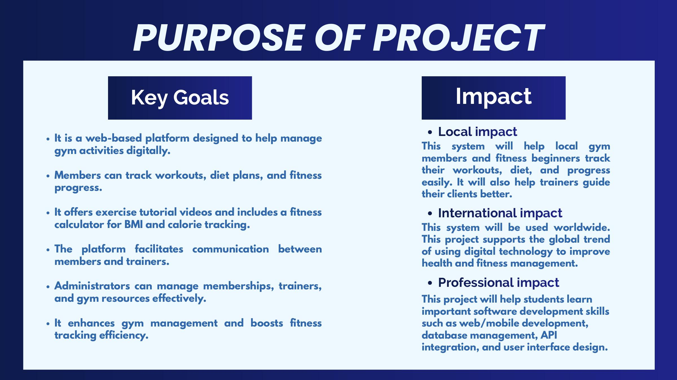
Figure E.1: Project Purpose – Key Goals and Impact
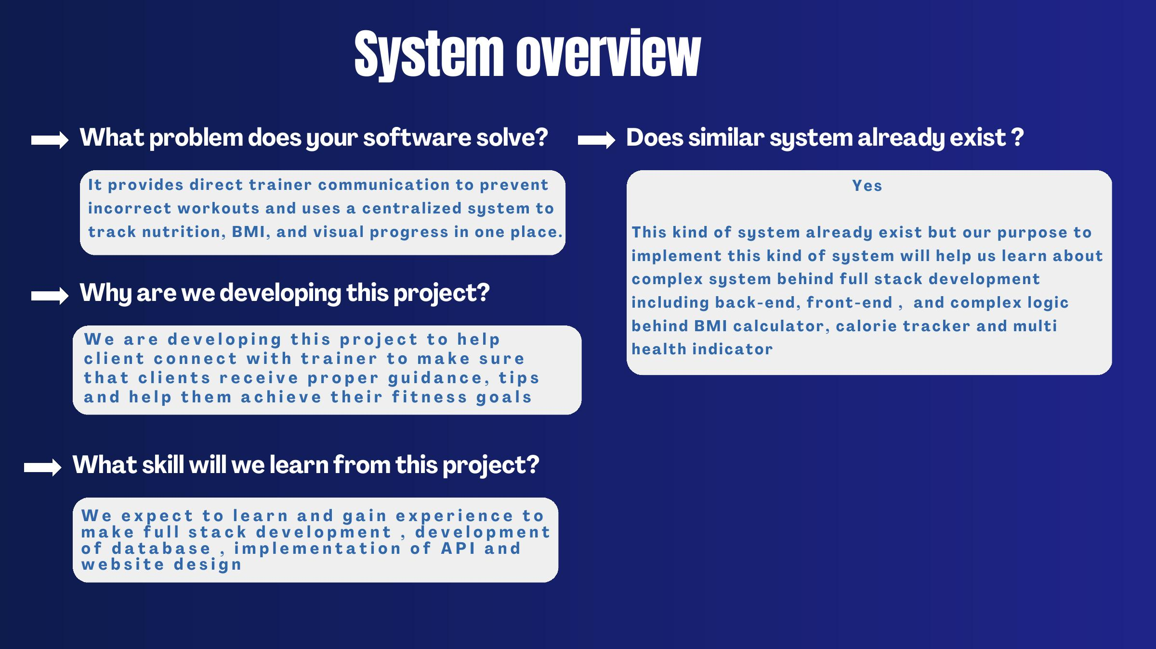
Figure E.2: System Overview and Problem Context
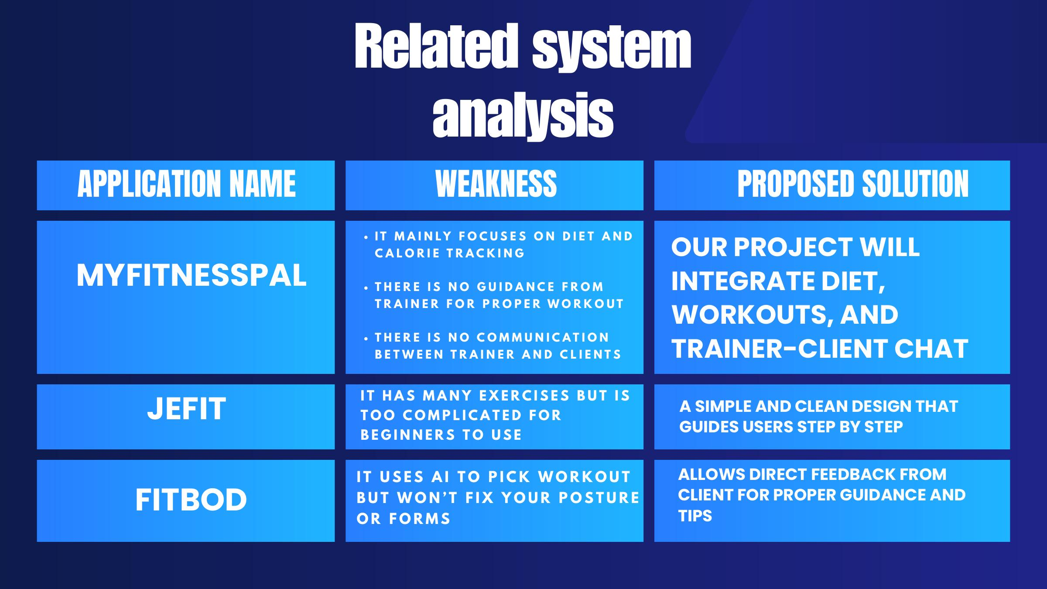
Figure E.3: Project Scope and Major Functionalities
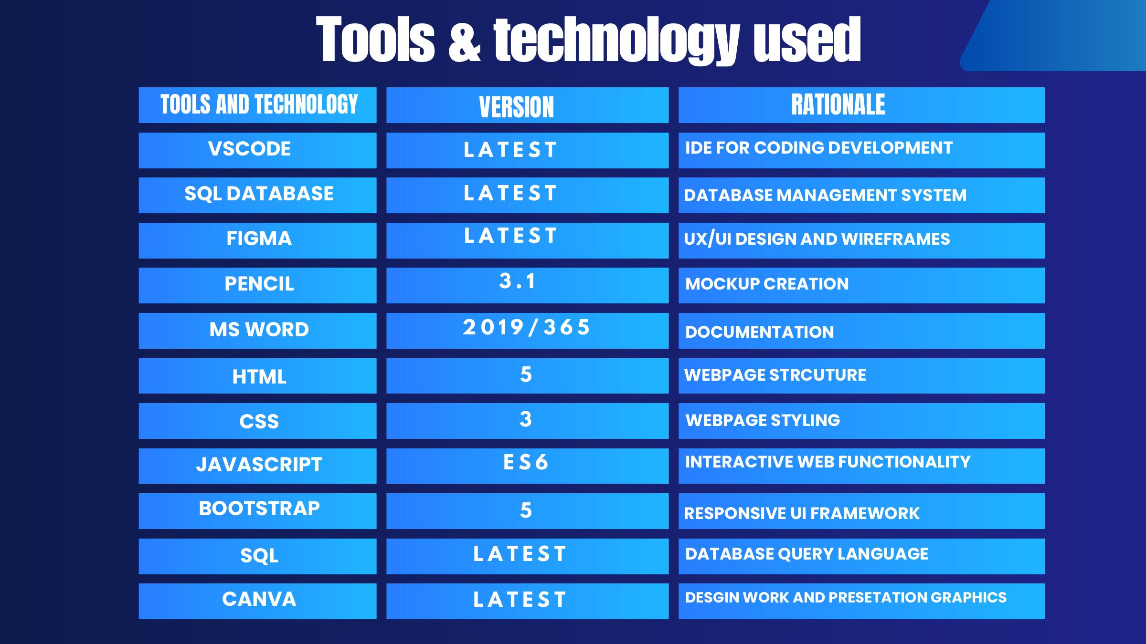
Figure E.4: Project Stakeholders
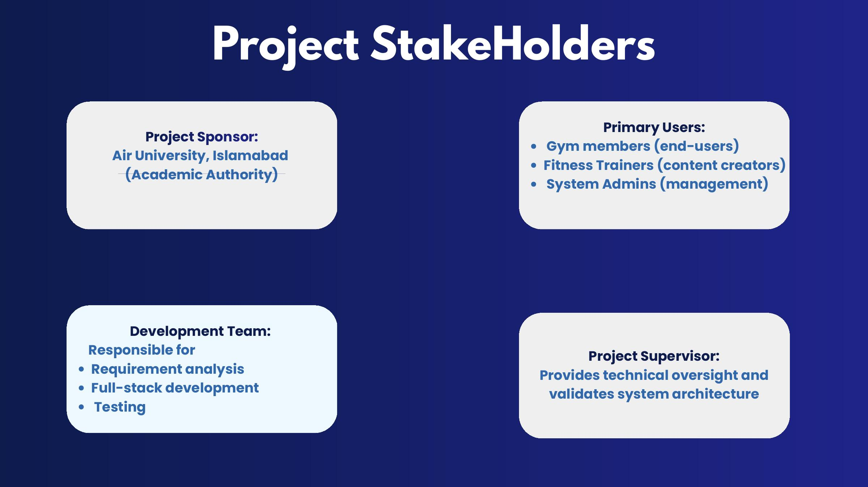
Figure E.5: Information and Requirement Gathering Methods

Figure E.6: Team Work Division
Github repository link:-
https://github.com/orion-pax09/FitTrack_system.git

