Nick Jordy

Is475

Final Project

Due: 12-16-2019

Part 1:

Revised ERD

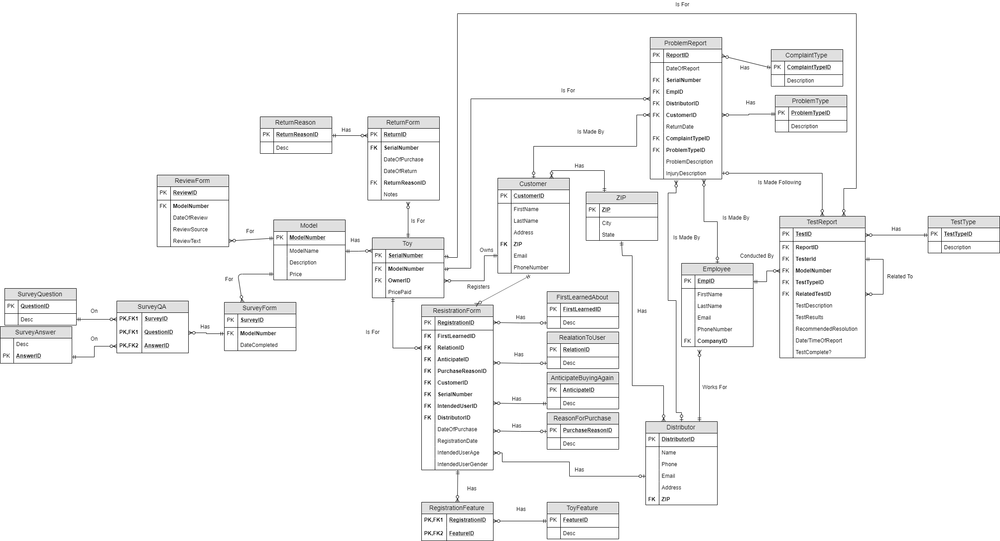

Part 2:

Original ERD

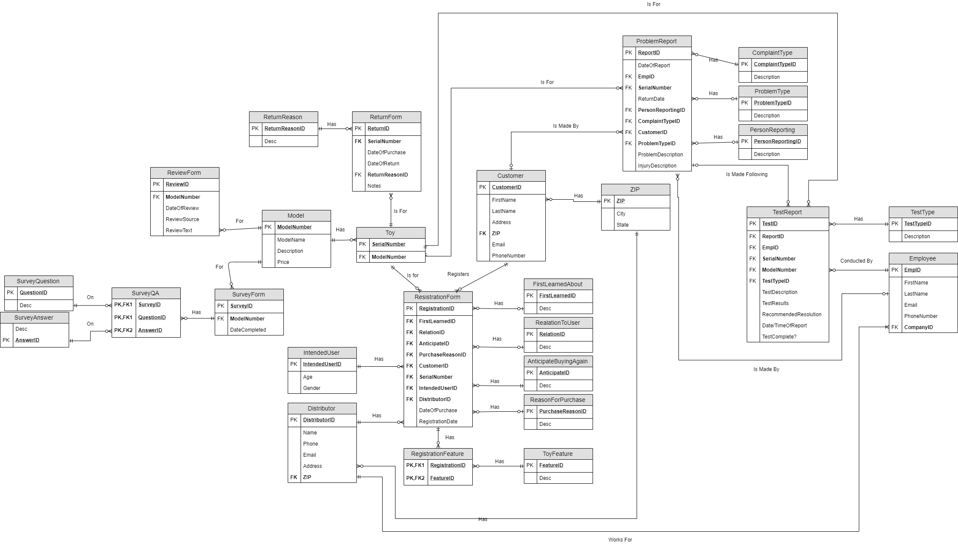

Part 3:

Prototype ERD

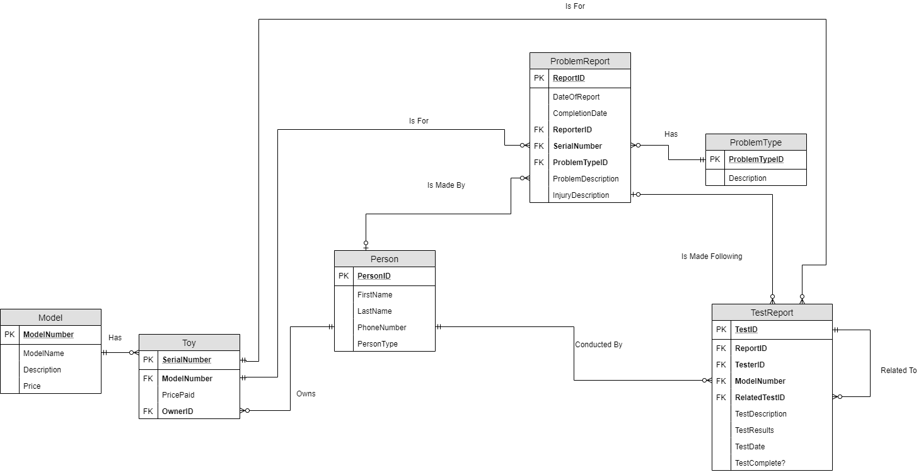

Part 4:

Prototype Database

| Create Table proj_Model  (ModelNumber char(6) Primary Key,  ModelName varchar(100) Not Null,  ModelDescription varchar(100),  ModelPrice money); |
| --- |
| Create Table proj_Person  (PersonID int identity(1,1) Primary Key,  PersonLastName varchar(100) Not Null,  PersonFirstName varchar(100) Not Null,  PersonPhone varchar(100) Not Null,  PersonType char(1) Not Null); |
| Create Table proj_Toy  (ToySerialNumber char(10) Primary Key,  ToyModelNumber char(6) Not Null,  ToyOwnerID int,  ToyPricePaid money,  Foreign Key (ToyModelNumber) References proj_Model (ModelNumber),  Foreign Key (ToyOwnerId) References proj_Person (PersonID)); |
| Create Table proj_ProblemType  (ProblemTypeID int Primary Key,  ProblemTypeDesc varchar(100)); |
| Create Table proj_ProblemReport  (ProblemReportID int Primary Key,  ProblemReportDateOfReport datetime Not Null,  ProblemReportCompletionDate datetime,  ProblemReportProblemDesc varchar(100) Not Null,  ProblemReportInjuryDesc varchar(100),  ProblemReportSerialNumber char(10) Not Null,  ProblemReportProblemTypeID int Not Null,  ProblemReportReporterID int Not Null,  Foreign Key (ProblemReportSerialNumber) References proj_Toy (ToySerialNumber),  Foreign Key (ProblemReportProblemTypeID) References proj_ProblemType (ProblemTypeID),  Foreign Key (ProblemReportReporterID) References proj_Person (PersonID)); |
| Create Table proj_Test  (TestID int Primary Key,  TestDate datetime Not Null,  TestDesc varchar(200) Not Null,  TestResults varchar(200),  TestComplete char(1) Not Null,  TestTesterID int Not Null,  TestReportID int Not Null,  TestRelatedTestID int,  Foreign Key (TestTesterID) References proj_Person (PersonID),  Foreign Key (TestReportID) References proj_ProblemReport (ProblemReportID),  Foreign Key (TestRelatedTestID) References proj_Test (TestID),  Constraint checkCompletion Check (TestComplete IN('Y', 'N'))); |

| **proj_Model** |
| --- |
| **proj_Person** |
| **proj_Toy** |
| **proj_ProblemType** |
| **proj_ProblemReport** |
| **proj_Test** |

Part 5:

SQL Queries

1. **Query 1**

Select pr.ProblemReportID,

Convert(varchar, pr.ProblemReportDateOfReport, 7) as ReportDate,

Convert(varchar, pr.ProblemReportCompletionDate, 7) as ReportCompletionDate,

pr.ProblemReportProblemDesc,

ts.TestID,

Convert(varchar, ts.TestDate, 7) as TestDate

From proj_ProblemReport pr

Inner Join proj_Test ts

On pr.ProblemReportID = ts.TestReportID

Where ts.TestDate < pr.ProblemReportDateOfReport;

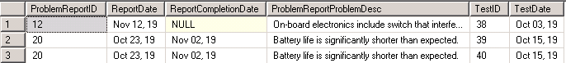

1. **Query 2**

With cte_CountProblemType as

(Select Count(*) NumberPerType,

ProblemReportProblemTypeID

From proj_ProblemReport

Group By ProblemReportProblemTypeID),

cte_CountInjuryReport as

(Select Count(*) NumberPerType,

ProblemReportProblemTypeID

From proj_ProblemReport

Where ProblemReportInjuryDesc is not null

Group By ProblemReportProblemTypeID)

Select pt.ProblemTypeID,

pt.ProblemTypeDesc,

Case

When cpt.NumberPerType is null

Then '0'

Else

cpt.NumberPerType

End CountOfReports,

Case

When cir.NumberPerType is null

Then '0'

Else

cir.NumberPerType

End CountOfInjuryReports

From proj_ProblemType pt

Left Outer Join cte_CountProblemType cpt

On cpt.ProblemReportProblemTypeID = pt.ProblemTypeID

Left Outer Join cte_CountInjuryReport cir

On cir.ProblemReportProblemTypeID = pt.ProblemTypeID;

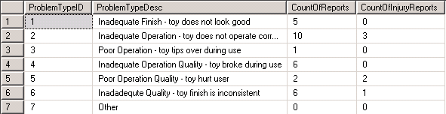

1. **Query 3**

Select Convert(varchar, pr.ProblemReportDateOfReport, 7) as DateOfReport,

pr.ProblemReportID,

pr.ProblemReportSerialNumber,

Case

When pr.ProblemReportCompletionDate is null

Then 'Not Complete'

Else

Convert(varchar, pr.ProblemReportCompletionDate, 7)

End DateCompleted,

Case

When pr.ProblemReportCompletionDate is null

Then Abs(DateDiff(Day, GetDate(), pr.ProblemReportDateOfReport))

Else

Abs(DateDiff(Day, pr.ProblemReportCompletionDate, pr.ProblemReportDateOfReport))

End DaysInSystem,

ty.ToyModelNumber,

md.ModelName,

Concat(ps.PersonLastName, ', ', Left(ps.PersonFirstName, 1), '.') as ReporterName,

Case

When ps.PersonType = 'C'

Then 'Customer'

When ps.PersonType = 'E'

Then 'Employee'

When ps.PersonType = 'D'

Then 'Distributor'

Else

'No Person Type'

End ReporterType,

pt.ProblemTypeDesc

From proj_ProblemReport pr

Inner Join proj_Toy ty

On ty.ToySerialNumber = pr.ProblemReportSerialNumber

Inner Join proj_Model md

On md.ModelNumber = ty.ToyModelNumber

Inner Join proj_Person ps

On ps.PersonID = pr.ProblemReportReporterID

Inner Join proj_ProblemType pt

On pt.ProblemTypeID = pr.ProblemReportProblemTypeID

Where Month(pr.ProblemReportDateOfReport) = '10'

and Year(pr.ProblemReportDateOfReport) = Year(GetDate())

Order By pr.ProblemReportDateOfReport;

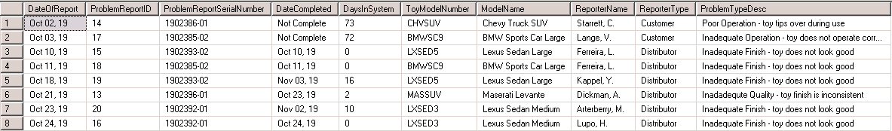

1. **Query 4**

Select Convert(varchar, pr.ProblemReportDateOfReport, 7) as DateOfReport,

pr.ProblemReportID,

pr.ProblemReportSerialNumber,

Case

When pr.ProblemReportCompletionDate is null

Then 'Not Complete'

Else

Convert(varchar, pr.ProblemReportCompletionDate, 7)

End DateCompleted,

Case

When pr.ProblemReportCompletionDate is null

Then Abs(DateDiff(Day, GetDate(), pr.ProblemReportDateOfReport))

Else

Abs(DateDiff(Day, pr.ProblemReportCompletionDate, pr.ProblemReportDateOfReport))

End DaysInSystem,

ty.ToyModelNumber,

md.ModelName,

Concat(ps.PersonLastName, ', ', Left(ps.PersonFirstName, 1), '.') as ReporterName,

Case

When ps.PersonType = 'C'

Then 'Customer'

When ps.PersonType = 'E'

Then 'Employee'

When ps.PersonType = 'D'

Then 'Distributor'

Else

'No Person Type'

End ReporterType,

Convert(varchar, ts.TestDate, 7) as TestDate,

ts.TestDesc,

Case

When tester.PersonLastName is null

Then NULL

Else

Concat(tester.PersonLastName, ', ', Left(tester.PersonFirstName, 1), '.')

End TesterName,

ts.TestComplete

From proj_ProblemReport pr

Inner Join proj_Toy ty

On ty.ToySerialNumber = pr.ProblemReportSerialNumber

Inner Join proj_Model md

On md.ModelNumber = ty.ToyModelNumber

Inner Join proj_Person ps

On ps.PersonID = pr.ProblemReportReporterID

Left Outer Join proj_Test ts

On ts.TestReportID = pr.ProblemReportID

Left Outer Join proj_Person tester

On tester.PersonID = ts.TestTesterID

Where Month(pr.ProblemReportDateOfReport) = '10'

and Year(pr.ProblemReportDateOfReport) = Year(GetDate())

Order By pr.ProblemReportDateOfReport;

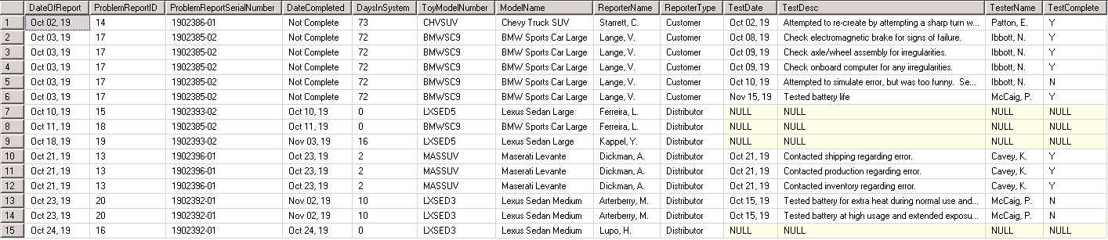

1. **Query 5**

Create View proj_VCountTestsPerProblemReport as

(Select Count(*) as NumberPerPR,

TestReportID

From proj_Test

Group By TestReportID)

Select Convert(varchar, pr.ProblemReportDateOfReport, 7) as DateOfReport,

pr.ProblemReportID,

pr.ProblemReportSerialNumber,

Case

When pr.ProblemReportCompletionDate is null

Then 'Not Complete'

Else

Convert(varchar, pr.ProblemReportCompletionDate, 7)

End DateCompleted,

Case

When pr.ProblemReportCompletionDate is null

Then Abs(DateDiff(Day, GetDate(), pr.ProblemReportDateOfReport))

Else

Abs(DateDiff(Day, pr.ProblemReportCompletionDate, pr.ProblemReportDateOfReport))

End DaysInSystem,

ty.ToyModelNumber,

md.ModelName,

Concat(ps.PersonLastName, ', ', Left(ps.PersonFirstName, 1), '.') as ReporterName,

Case

When ps.PersonType = 'C'

Then 'Customer'

When ps.PersonType = 'E'

Then 'Employee'

When ps.PersonType = 'D'

Then 'Distributor'

Else

'No Person Type'

End ReporterType,

Case

When ctpr.NumberPerPR is null

Then '0'

Else

ctpr.NumberPerPR

End CountOfTests

From proj_ProblemReport pr

Inner Join proj_Toy ty

On ty.ToySerialNumber = pr.ProblemReportSerialNumber

Inner Join proj_Model md

On md.ModelNumber = ty.ToyModelNumber

Inner Join proj_Person ps

On ps.PersonID = pr.ProblemReportReporterID

Left Outer Join proj_VCountTestsPerProblemReport ctpr

On ctpr.TestReportID = pr.ProblemReportID

Order By pr.ProblemReportDateOfReport;

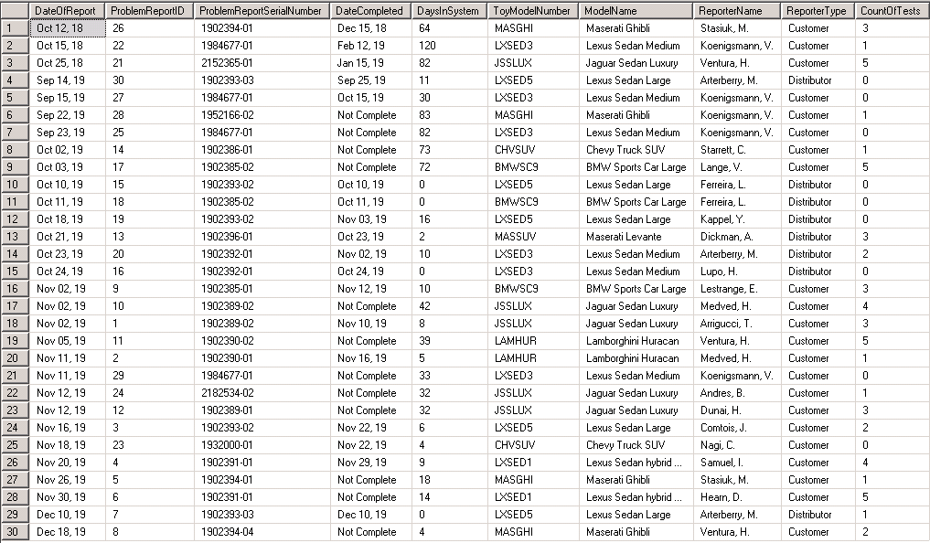

1. **Query 6**

/*Using View from Number 5*/

Select Convert(varchar, pr.ProblemReportDateOfReport, 7) as DateOfReport,

pr.ProblemReportID,

pr.ProblemReportSerialNumber,

Case

When pr.ProblemReportCompletionDate is null

Then 'Not Complete'

Else

Convert(varchar, pr.ProblemReportCompletionDate, 7)

End DateCompleted,

Case

When pr.ProblemReportCompletionDate is null

Then Abs(DateDiff(Day, GetDate(), pr.ProblemReportDateOfReport))

Else

Abs(DateDiff(Day, pr.ProblemReportCompletionDate, pr.ProblemReportDateOfReport))

End DaysInSystem,

ty.ToyModelNumber,

md.ModelName,

Concat(ps.PersonLastName, ', ', Left(ps.PersonFirstName, 1), '.') as ReporterName,

Case

When ps.PersonType = 'C'

Then 'Customer'

When ps.PersonType = 'E'

Then 'Employee'

When ps.PersonType = 'D'

Then 'Distributor'

Else

'No Person Type'

End ReporterType,

Case

When ctpr.NumberPerPR is null

Then '0'

Else

ctpr.NumberPerPR

End CountOfTests

From proj_ProblemReport pr

Inner Join proj_Toy ty

On ty.ToySerialNumber = pr.ProblemReportSerialNumber

Inner Join proj_Model md

On md.ModelNumber = ty.ToyModelNumber

Inner Join proj_Person ps

On ps.PersonID = pr.ProblemReportReporterID

Left Outer Join proj_VCountTestsPerProblemReport ctpr

On ctpr.TestReportID = pr.ProblemReportID

Where pr.ProblemReportCompletionDate is null

and ctpr.NumberPerPR in (Select Max(NumberPerPR) From proj_VCountTestsPerProblemReport)

Order By pr.ProblemReportDateOfReport;



1. **Query 7**

Create View proj_vCountOfReportsPerModel as

(Select Count(*) as TotalPerModel,

md.ModelNumber

From proj_ProblemReport pr

Inner Join proj_Toy ty

On ty.ToySerialNumber = pr.ProblemReportSerialNumber

Inner Join proj_Model md

On md.ModelNumber = ty.ToyModelNumber

Group By md.ModelNumber);

Create View proj_vCountOfInjuryReportsPerModel as

(Select Count(*) as TotalPerModel,

md.ModelNumber

From proj_ProblemReport pr

Inner Join proj_Toy ty

On ty.ToySerialNumber = pr.ProblemReportSerialNumber

Inner Join proj_Model md

On md.ModelNumber = ty.ToyModelNumber

Where pr.ProblemReportInjuryDesc is not null

Group By md.ModelNumber);

Create View proj_vMostRecentModelReport as

(Select Max(pr.ProblemReportDateOfReport) as MostRecentDate,

md.ModelNumber

From proj_ProblemReport pr

Inner Join proj_Toy ty

On ty.ToySerialNumber = pr.ProblemReportSerialNumber

Inner Join proj_Model md

On md.ModelNumber = ty.ToyModelNumber

Group By md.ModelNumber);

Create View proj_vEarliestModelReport as

(Select Min(pr.ProblemReportDateOfReport) as EarliestDate,

md.ModelNumber

From proj_ProblemReport pr

Inner Join proj_Toy ty

On ty.ToySerialNumber = pr.ProblemReportSerialNumber

Inner Join proj_Model md

On md.ModelNumber = ty.ToyModelNumber

Group By md.ModelNumber);

Create View proj_vTestsPerModel as

(Select Count(*) TotalPerModel,

md.ModelNumber

From proj_Test tst

Inner Join proj_ProblemReport pr

On tst.TestReportID = pr.ProblemReportID

Inner Join proj_Toy ty

On ty.ToySerialNumber = pr.ProblemReportSerialNumber

Inner Join proj_Model md

On md.ModelNumber = ty.ToyModelNumber

Group By md.ModelNumber);

Create View proj_vMostRecentModelTest as

(Select Max(tst.TestDate) MostRecentDate,

md.ModelNumber

From proj_Test tst

Inner Join proj_ProblemReport pr

On tst.TestReportID = pr.ProblemReportID

Inner Join proj_Toy ty

On ty.ToySerialNumber = pr.ProblemReportSerialNumber

Inner Join proj_Model md

On md.ModelNumber = ty.ToyModelNumber

Group By md.ModelNumber);

Create View proj_vEarliestModelTest as

(Select Min(tst.TestDate) EarliestDate,

md.ModelNumber

From proj_Test tst

Inner Join proj_ProblemReport pr

On tst.TestReportID = pr.ProblemReportID

Inner Join proj_Toy ty

On ty.ToySerialNumber = pr.ProblemReportSerialNumber

Inner Join proj_Model md

On md.ModelNumber = ty.ToyModelNumber

Group By md.ModelNumber);

Select md.ModelNumber,

md.ModelDescription,

Case

When crm.TotalPerModel is null

Then '0'

Else

crm.TotalPerModel

End CountOfReports,

Case

When cim.TotalPerModel is null

Then '0'

Else

cim.TotalPerModel

End CountOfInjuryReports,

Case

When mrmr.MostRecentDate is null

Then 'n/a'

Else

convert(varchar, mrmr.MostRecentDate, 7)

End MostRecentReportDate,

Case

When emr.EarliestDate is null

Then 'n/a'

Else

convert(varchar, emr.EarliestDate, 7)

End EarliestReportDate,

Case

When tpm.TotalPerModel is null

Then '0'

Else

tpm.TotalPerModel

End CountOfTests,

Case

When mrmt.MostRecentDate is null

Then 'n/a'

Else

convert(varchar, mrmt.MostRecentDate, 7)

End MostRecentTest,

Case

When emt.EarliestDate is null

Then 'n/a'

Else

Convert(varchar, emt.EarliestDate, 7)

End EarliestTest

From proj_Model md

Left Outer Join proj_vCountOfReportsPerModel crm

On crm.ModelNumber = md.ModelNumber

Left Outer Join proj_vCountOfInjuryReportsPerModel cim

On cim.ModelNumber = md.ModelNumber

Left Outer Join proj_vMostRecentModelReport mrmr

On mrmr.ModelNumber = md.ModelNumber

Left Outer Join proj_vEarliestModelReport emr

On emr.ModelNumber = md.ModelNumber

Left Outer Join proj_vTestsPerModel tpm

On tpm.ModelNumber = md.ModelNumber

Left Outer Join proj_vMostRecentModelTest mrmt

On mrmt.ModelNumber = md.ModelNumber

Left Outer Join proj_vEarliestModelTest emt

On emt.ModelNumber = md.ModelNumber;

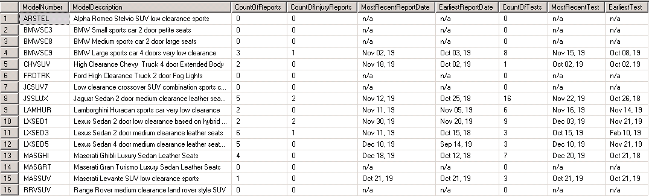

1. **Query 8**

/*Using the views from Seven*/

Select md.ModelNumber,

md.ModelDescription,

Case

When crm.TotalPerModel is null

Then '0'

Else

crm.TotalPerModel

End CountOfReports,

Case

When cim.TotalPerModel is null

Then '0'

Else

cim.TotalPerModel

End CountOfInjuryReports,

Case

When mrmr.MostRecentDate is null

Then 'n/a'

Else

convert(varchar, mrmr.MostRecentDate, 7)

End MostRecentReportDate,

Case

When emr.EarliestDate is null

Then 'n/a'

Else

convert(varchar, emr.EarliestDate, 7)

End EarliestReportDate,

Case

When tpm.TotalPerModel is null

Then '0'

Else

tpm.TotalPerModel

End CountOfTests,

Case

When mrmt.MostRecentDate is null

Then 'n/a'

Else

convert(varchar, mrmt.MostRecentDate, 7)

End MostRecentTest,

Case

When emt.EarliestDate is null

Then 'n/a'

Else

Convert(varchar, emt.EarliestDate, 7)

End EarliestTest

From proj_Model md

Left Outer Join proj_vCountOfReportsPerModel crm

On crm.ModelNumber = md.ModelNumber

Left Outer Join proj_vCountOfInjuryReportsPerModel cim

On cim.ModelNumber = md.ModelNumber

Left Outer Join proj_vMostRecentModelReport mrmr

On mrmr.ModelNumber = md.ModelNumber

Left Outer Join proj_vEarliestModelReport emr

On emr.ModelNumber = md.ModelNumber

Left Outer Join proj_vTestsPerModel tpm

On tpm.ModelNumber = md.ModelNumber

Left Outer Join proj_vMostRecentModelTest mrmt

On mrmt.ModelNumber = md.ModelNumber

Left Outer Join proj_vEarliestModelTest emt

On emt.ModelNumber = md.ModelNumber

Where crm.TotalPerModel in (Select Max(TotalPerModel) From proj_vCountOfReportsPerModel);



1. **Query 9**

Select pr.ProblemReportID,

md.ModelNumber,

md.ModelName,

Convert(varchar, pr.ProblemReportDateOfReport, 7) as ReportDate,

pr.ProblemReportProblemDesc,

pt.ProblemTypeDesc,

Concat(rper.PersonLastName, ', ', Left(rper.PersonFirstName, 1), '.') as ReportingPerson,

tst.TestID,

Convert(varchar, tst.TestDate, 7) as TestDate,

tst.TestDesc,

Concat(tper.PersonLastName, ', ', Left(tper.PersonFirstName, 1), '.') as TestingPerson,

pr.ProblemReportInjuryDesc

From proj_Test tst

Inner Join proj_ProblemReport pr

On pr.ProblemReportID = tst.TestReportID

Inner Join proj_Toy ty

On ty.ToySerialNumber = pr.ProblemReportSerialNumber

Inner Join proj_Model md

On md.ModelNumber = ty.ToyModelNumber

Inner Join proj_ProblemType pt

On pt.ProblemTypeID = pr.ProblemReportProblemTypeID

Inner Join proj_Person rper

On rper.PersonID = pr.ProblemReportReporterID

Inner Join proj_Person tper

On tper.PersonID = tst.TestTesterID

Where pr.ProblemReportProblemDesc Like '%battery%' and pr.ProblemReportInjuryDesc is not null

Order By pr.ProblemReportID;

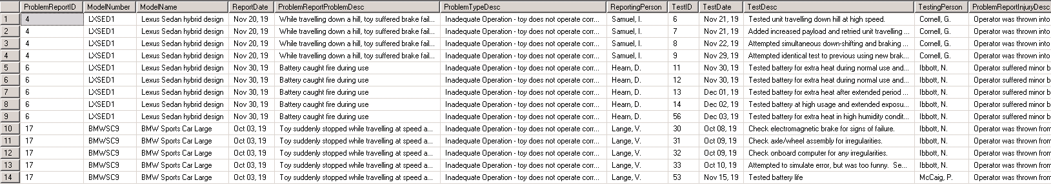

1. **Query 10**

/*Using view "proj_vCountOfReportsPerModel"*/

Select md.ModelNumber,

md.ModelName,

md.ModelDescription,

md.ModelPrice

From proj_Model md

Where md.ModelNumber not in (Select ModelNumber From proj_vCountOfReportsPerModel);

