k_main():start
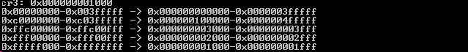

initialize_paging():*VIRT_TO_PDE_ADDR(0x0) = NULL;

initialize_paging():end
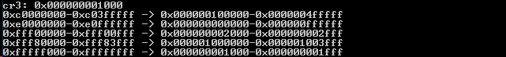

kmalloc_initialize():end
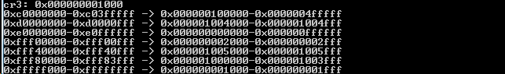

initialize_DMA():dma_free_frames = (u32int *)kmalloc….
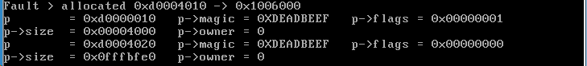

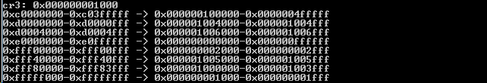

initialize_DMA():end

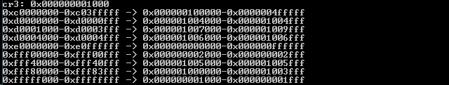

initialize_multitasking()→create_process…:end
