**Front end fixes**

For Rewrite Script, Steps:

* git clone https://github.com/orionkepler/augur
* cd augur/

**Currently Finished:**

* Installation script rewrite
* Make the input more detailed
* Clearly differentiate between similar-looking inputs
* Provide more feedback on possible options
* Reduce the amount of manual configuration post-install
* Clearly define the back-end/front-end running commands
* Clearly define stop conditions
* Make the default decisions Unix compliant
* Default options are CAPITALIZED
  + - * + Current options are reversed
* Metrics For A Repo
* Add routing to the metrics page. URL Path: /metrics
* Home Page / Show All Repo Groups
* There is a basic container for the repo group
* Repos List
* Design the user interface of the repo list component
* Header Bar
* Design the header bar for repo so that it can be easy for users to search

**Installation script rewrite:**

When you run “make install” for installing Augur, you may feel what those option means or what does it asked people to do. Therefore, to solve this problem, I add more detail to the installing scripts, to give more information and try to provide a more easier installing process.

When you get into “Setting up database credentials”, it may feel confused when you choose option 1” initialize a new database AND install the schema?” Since choose this option’s people are most first attach to Augur, I add more information to help them to get understand what this option means. Showing like this.

It can give more detail to people and help them to understand what they need to do.

For generate an API key part, I think it will be helpful for people if just provide the link and instruction they need, showing like following picture.

And I also make it more clear for people who first use Augur about what they need to do next. Showing like this.

This could be helpful for people to understand what the absolute path is using for.

And since I also create a new frontend, I also put a hint who may want to experience.

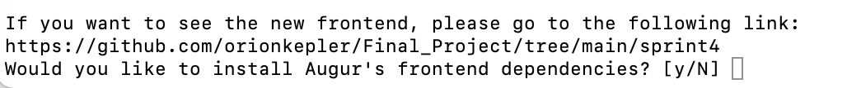

And a little improvement that I made is change the capitalize for choice, I change Y to y, and n to N, which will be more in line with the habits of UNIX users



And there is also an update in script when the program checks there is an Augur API key already. It will provide more information about the Augur API key. Showing like this.

**Re-design Frontend:**

For re-design frontend, I create a new home page, and this frontend is support by Angular, I re-design the Header bar, and it shows like this.



The “Link” button will redirect to the Augur document and I think this will be helpful for people when they encounter to a problem. And I add an aside page, to display the history that the previous repos that the user used. It shows like this.

And It will show more directly regarding to the metrics, and it will also directly display the repo’s list. But due to the Firewall, I am unable to connect to those data, and unable to collect those data, therefore, this is a just a demo to shows what it will include.

The total overview about this frontend is looking like this.

And this is video demo’s link.

<https://youtu.be/5OyH_1bH-70>

Future work

I will try my best to connect to the data and try to collect the data. And I will also try to implement the History function for my frontend.