Continual Experience - Map Calibration
Home interview exercise
by Lorin-Dan Mizrahi

Environment and Tools
For developing this project the following environment and dev tools were used :
- Windows 10, v.10.0, x86_64 / win32
- Eclipse IDE for Enterprise Java Developers,Version: 2019-03 (4.11.0)
- Java version: 1.8.0_202
- NoSQLBooster ,Version 5.2.12
- Postman v7.24.0
- Maven 3.6.1

Preconditions
- Use a registered user at Docker Hub - if not create user at https://hub.docker.com/
- Docker is already installed and running -if not download and install from https://hub.docker.com/editions/community/docker-ce-desktop-windows/

MongoDB installation and initialization
- Pull MongoDb image using command

docker pull mongo

- Start Mongo DB using command

docker run -d -p 27017-27019:27017-27019 --name mongodb mongo:latest

- Run NoSQLBooster and connect to Mongo db , using the following menu commands :
Connect > From uri (mongodb://localhost:27017) .
Press button “Connect”.
- Create user root as following :
Double click admin database ( equivalent to “use admin” from command line)
Run script :
db.createUser(
{
user: "root",
pwd: "root",
roles: [ { role: "userAdminAnyDatabase", db: "admin" } ]
}
)

Import predefined request definitions in Postman
- Open Postman
- On menu click File>Import>File>Upload Files
- Select file “Continual.postman_collection.json” in directory “Spring-MongoDB-Continual “ and press “Open”
- In the right menu you will get request collection “Continual”

Running Spring boot application
- In command terminal ,go to directory ..\Continual\Spring-MongoDB-Continual
- Run command :
mvn spring-boot:run

Using application

Generate data

  - In Postman select request “generate” in collection “Continual”
This operation will generate the collection “NetworkTrafficData” in database Continual in MongoDB (i.e. raw data)

Request type: POST
Parameters :
- roads (optional , default 10)
- days (optional,default 7 )
- documents (optional ,default 1000)
- drilldown (optional , default false) – will display statistics for each road on completion

Example:
{
"roads" : 10,
"days": 7,
"documents":1000,
"drilldown":true
}

NetworkTrafficData collection

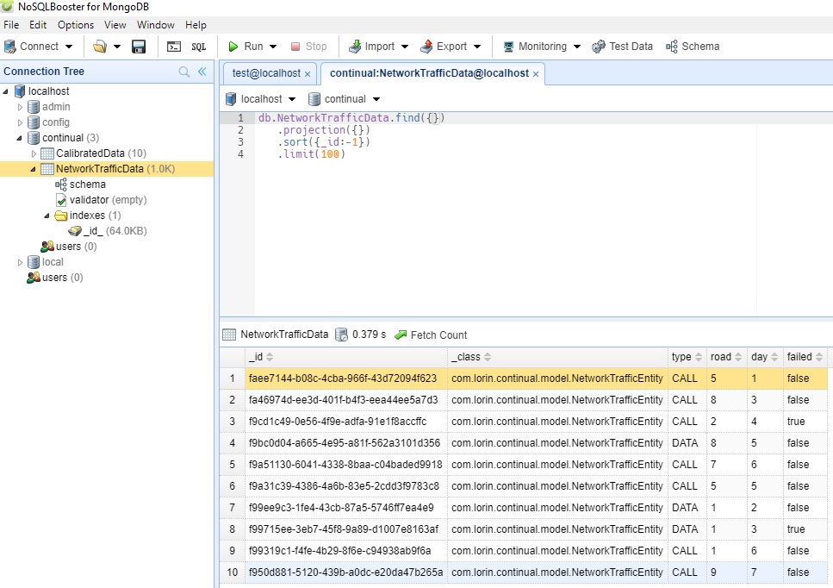

Calibrate data
  - In Postman select request “generate” in collection “Continual”
This operation will generate the collection “CalibrationData” in database Continual in MongoDB
The calibration is performed for all days related to a road

CalibratedData collection
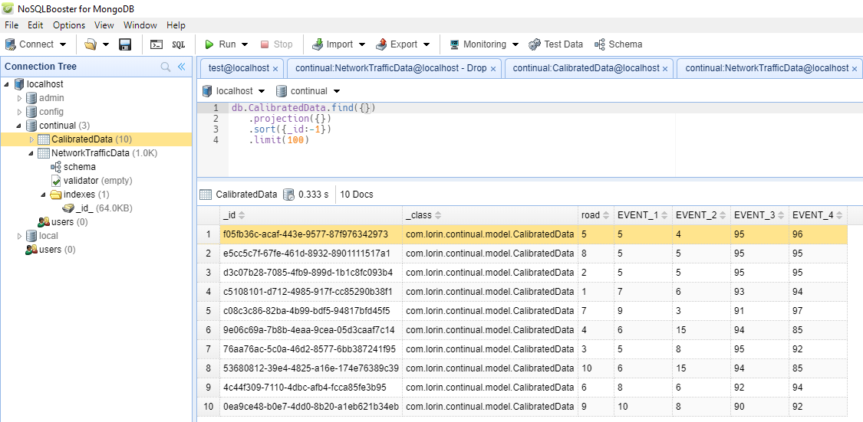

Clear data
  - In Postman select request “clear” in collection “Continual”
Use this only to clear data created with request 1 and 2 and to start a new cycle

Rank Road
  - In Postman select request “rankRoad” in collection “Continual”
Display the ranks for each event in
Example
http://localhost:8102/traffic/rankRoad/9

Additional useful requests

The default values for the rank steps are
80th, 90th, 95th
as requested by exercise .

Get Rank Definition
Display current rank definition
Example
http://localhost:8102/traffic/getRankDefinition

Set Rank Definition

Nevertheless , you can change the rank values

Example:
http://localhost:8102/traffic/setRankDefinition
with parameters as following:

{
"ranks":"86,50,68,10"
}

(Do not have to be sorted)

Reset Rank Definition
Will reset ranks to default values

Calibrated Data for road

Will display calibrated data details for road
http://localhost:8102/traffic/calibratedDataForRoad/9

Class diagrams

Models
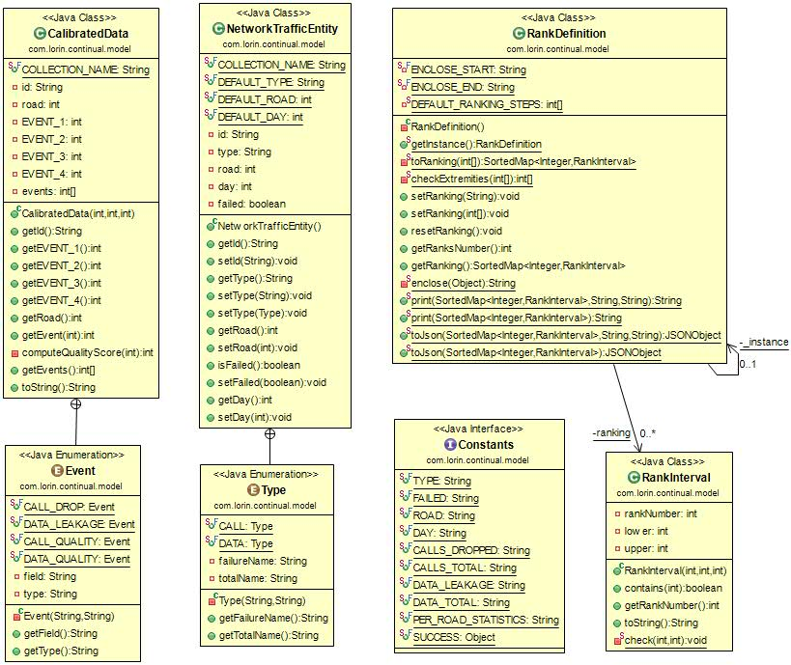

DAO and Utilities
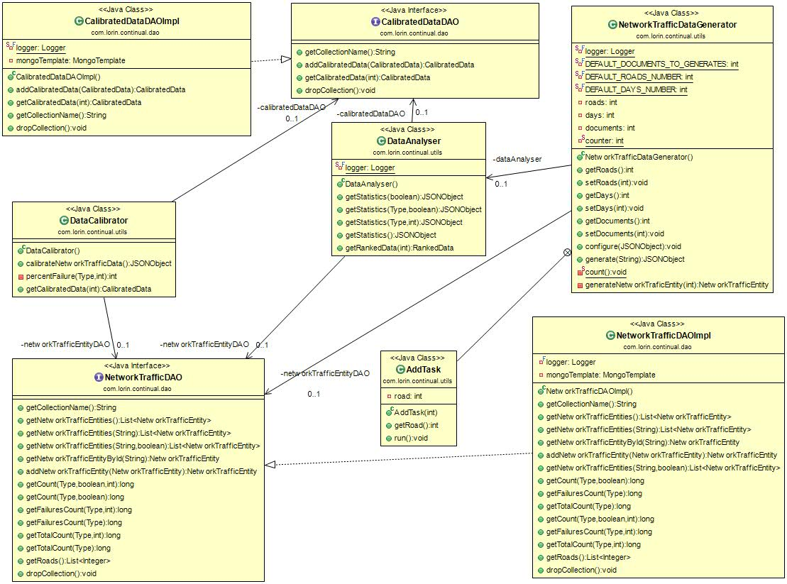

Controller

