2020-05-10 order ori

* biscuits 0.5kg amount=4

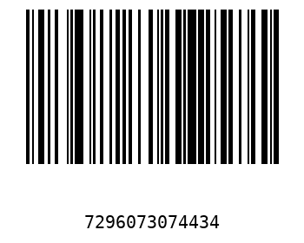

* popeyes amount=3

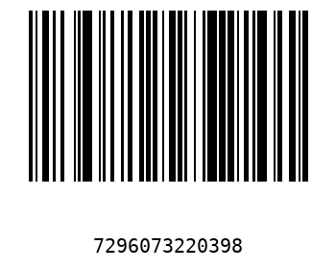

* coffee cookies amount=3

