“The Wishing Well” Site Plan

Beck Johansen

WDD 130

Overview
Note to the developers:
I wanted to make a site that was a little more interesting than a general information site, so I thought of a simple game that could be built using HTML and CSS. Those old “choose your own adventure” books came to mind, and so I decided that’s what my site would be. However, I did not expect this to become a team project, much less that I would be the client as opposed to the developer! I have greatly simplified the concept and will be providing the code needed to make the game run so that the remaining tasks will only consist of HTML and CSS concepts we learned in class. Have no fear and have fun!

Purpose
The goal of this project is to turn a traditional "choose your own adventure" story into a modern, web-based game. It accomplishes this by using a clean, responsive interface and lightweight script to track things like inventory and player stats in real-time. Instead of using a heavy game engine, it proves you can build an immersive, atmospheric experience using just standard web tools that work flawlessly on any device.

Audience
This project is built for anyone who loves a good story, regardless of their gaming experience or what device they’re using. By focusing on a clean, responsive design, the game stays fun and easy to navigate on everything from a high-end PC to an older smartphone. It’s all about removing the technical barriers of modern gaming so anyone can jump in and start shaping their own journey with just a few clicks.

Branding

Website Logo

Note: designed for a dark background

Style Guide

Color Palette
Primary | Secondary | Accent 1 | Accent 2
#808080 | #002C5C | #FFFF00 | #00EDED
Note: I am not very decided on these colors, and if you find something that works better based on the context, I’m all for it.

Typography

Heading Font: Times New Roman

Paragraph Font: Georgia

Navigation
Home Game High Scores
Note: The game child page will need to open in a new tab

Content

Home page:
Title: The Wishing Well
Wishing well home page photo:
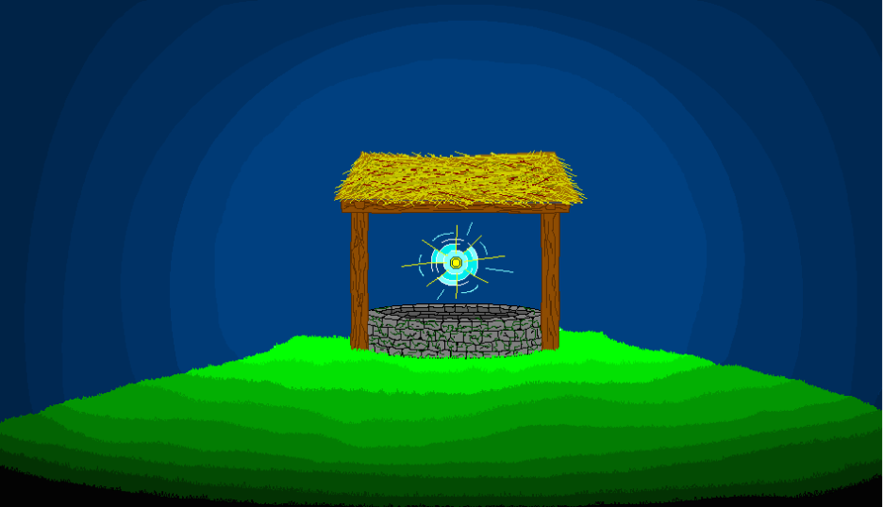
Intro blurb: (created by ai)
‘’’
Be careful what you wish for…
There’s more to the old stone well than might seem. One moment you were casting a coin into the dark; the next, the darkness cast you into a sprawling, subterranean gauntlet! You are now a prisoner of the stone, lost in a winding maze of cold rock and ancient magic that feeds on the desires of those who fall in.
The exit is hidden somewhere in the labyrinth, but the well doesn't let go easily. To escape, you must navigate its shifting passages and face the weight of the very wish that pulled you under.
The well has taken your wish. Now, try to take back your freedom.
‘’’
Play game button: (links to gameplay child page in a new window)


More body text:
‘’’
Escape the Labyrinth, Claim Your Legacy
Your journey through the well is more than a struggle for survival—it’s a race against the dark. Every choice you make, item you find, and room you clear adds to your Final Score, reflecting your cunning and efficiency in navigating the subterranean gauntlet. Whether you find the exit or succumb to the stone, your progress is tracked in real-time.
Only the swiftest and most resourceful prisoners will see their names etched into the High Scores page. Do you have what it takes to top the leaderboard, or will you become just another forgotten echo in the deep?
‘’’

Note: Hyperlink will take you to the high scores child page.

Footer:
‘’’
Web Design:
[Name] - Lead Developer [Name] – Jr. Developer [Name] – Jr. Developer

Game Design:
Beck Johansen

Game Child Page:

This page is going to be the most pre-structured. It will need certain HTML elements with specific id tags to function correctly, but otherwise is fairly simple HTML and CSS on your end. I will be providing a few python files that have the working game code this weekend. Due to time constraints, I do not have all of the important information yet, but will get it to you as soon as possible. For now, here is what the page will mostly consist of:

An empty img tag that will be filled by the game code.

An empty text tag of some sort (<p>,<h3>, etc.), also to be filled by the game.

One text entry element

4 empty button elements

See wireframe for more info.

High Scores Child Page:

If the home page is the most traditional to what we have been doing in this class, and the game page is the most empty due to the script control, than the high scores page is the happy medium.

It will require 10 empty text elements with specific ids (5 names with their 5 scores), but otherwise is like any other ICE challenge assignment.

Text:

HIGH SCORES:

#1 ________ _____ points
#2 … points
#3 … points
#4 … points
#5 … points

Note: I was thinking of swapping out the #’s for small images. If so I will get them to you soon.

Wireframes next page: 