Week 2-4: Unix, Git, Containers & Scientific Python
Chapter 2: The Unix Operating System
What is Unix?
- Fundamental operating system used to control how computers execute programs
- Originated in the 60s
- Important for data analysis, programming and system management
- Designed to produce output that can be used as input to other programs
- Enables the creation of pipelines using small tools
The Shell
- A command line interface (CLI)
- Allows users to:
  - Run programs
  - Control files and folders
  - Receive output in text form
- Operated as a RELP
  - Read Evaluate Print Loop
- Common in modern system (macOS, Linux, Windows via Git Bash)
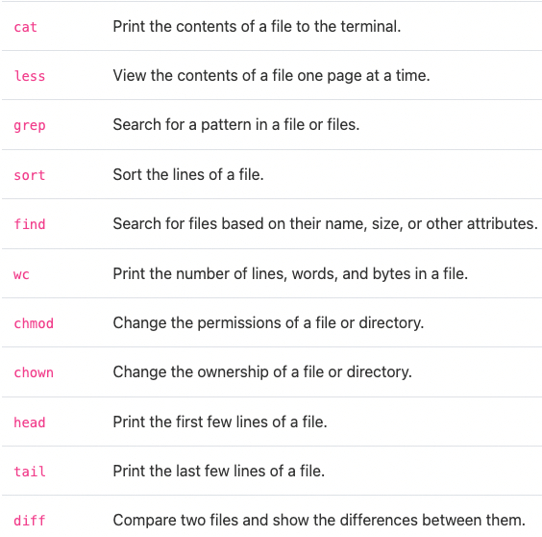
Basic Commands
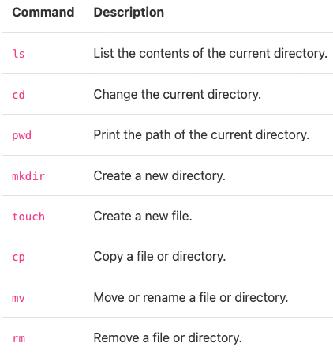

Exploring the Filesystem
- When shell starts, it begins in home directory
- Adding flags changes command behavior
  - Example: ls -F adds / to folders
- Absolute path:
  - Always starts from root /
  - Example: cd /Users/arokem
- Relative path:
  - Depends on current directory
  - Example: cd Documents
Path Shortcuts
- .. – parent directory
  - Example: cd .. goes up one level
- ~ - home directory
  - Example: cd ~
  - Example: cd ~/Documents
Pipe Operator (|)
- Connects commands so output of one becomes input of another
Why Unix Matters
- Provides powerful control over:
  - Files and folders
  - Program execution
  - Automation through pipelines
- Becoming comfortable with Unix makes data work faster and more efficient

Chapter 3: Version Control (Git)
What is Git?
- A widely-used version control tool
- Works via a command line

Initialize a Repository
- Creating a Project
  - Mkdir my_project
  - Cd my_project
  - Get init
- Add a file
  - Touch my_file.txt.
  - Git add my_file.txt
- Check status
  - Git status
- Commit Changes
  - Git commit -m “Statement here”
- Check commit history
  - Git log
- Important concepts
  - Commit: saves a snapshot of your project
  - SHA: unique identifier for each commit
  - HEAD: current state of the repository
Tracking Changes
- Stages
  - Unstaged
  - Stages
  - Committed changes
- View changes
  - Git diff
- Workflow
  - Make changes
  - Git add
  - Git commit
- Undoing changes
  - To revert a file to a previous commit
    - Git checkout <SHA> myfile.txt
Branching and Merging
- Enables experimenting without affecting main code
- Keep main branch stable
- Merge only when readu
- Create and switch branches
  - Git branch feature_x
  - Git checkout feature_x
- Merge branch into main
  - Git checnkout main
  - Git merge feature_x
- Delete branch
  - Git branch -d feature_x
Collaborating with Github
- Remote repository
  - A copy of your respo stored online
  - GitHub is the most common remote
- Add remote and push
  - Git remote add origin <URL>
  - Git push -u origin main
- Authentication
  - GitHub requires
    - Personal Access Token (PAT) OR
    - SSH Keys
Collaborating Workflow
- Cloning

