Restoration of Historic Artworks Using
Deep Learning-Based Digital Inpainting

Master's Diploma Thesis

Author: Daniyar Krug
Supervisor: [Supervisor Name]
Institution: [University Name]
Year: 2026

Abstract
Digital inpainting — the task of plausibly reconstructing missing pixels of an image — has been studied extensively on natural photographs, but remains under-explored in the domain of historic paintings, where the underlying signal is non-photographic and the available data are scarce. This thesis presents a rigorous comparative study of three deep convolutional inpainting architectures applied to the restoration of damaged artworks: the Partial Convolution U-Net (PConv) of Liu et al. (2018), a vanilla U-Net baseline that simply concatenates the binary damage mask as a fourth input channel, and a Gated U-Net built on the DeepFillv2-style gated convolution of Yu et al. (2019).
All three networks share an identical training recipe — same data (39,213 WikiArt paintings spanning five styles), same five-term composite loss (L1 valid + L1 hole + perceptual + style + total variation), same optimizer, same schedule, same number of epochs — so that any difference in restoration quality can be attributed to the convolution operator alone. We additionally contribute four art-specific synthetic damage generators (brush strokes, cracks, paint loss and aging stains) at three difficulty levels, yielding a deterministic test protocol of 3,977 paintings × 12 mask conditions.
On the held-out test set, Gated U-Net achieves the best perceptual and structural quality (30.37 dB PSNR, 0.896 SSIM, 0.072 LPIPS), followed by Vanilla U-Net (29.92 dB, 0.887, 0.080), with PConv U-Net trailing at 28.18 dB / 0.853 / 0.106. This ranking holds consistently across all three difficulty levels and all four damage types and is statistically significant under a paired Wilcoxon signed-rank test with Bonferroni correction. Contrary to the dominance of PConv in the natural-image inpainting literature, we find that on artworks soft-gated attention preserves stylistic coherence better than the hard mask-propagation rule used by PConv, and that even the simplest mask-conditioning strategy (concatenation) outperforms PConv at matched training budget.
We deploy the three trained models in an interactive Gradio web demo that allows visitors to upload a painting, paint over the damaged region, and inspect side-by-side reconstructions together with per-image quality metrics. This is, to the best of our knowledge, the first publicly runnable art-restoration system.
Keywords: image inpainting, deep learning, partial convolution, gated convolution, U-Net, WikiArt, art restoration, comparative study.

Chapter 1. Introduction

1.1 Motivation
Paintings are physical objects subject to inevitable physical degradation: pigments fade, varnishes yellow, surfaces crack, humidity and light cause flaking, and accidental damage can remove patches of paint entirely. Conservators have developed manual restoration techniques over centuries, but the process is slow, irreversible, and requires extensive expertise. Digital restoration, by contrast, is non-destructive: a high-resolution photograph of the artwork can be repaired computationally, the result reviewed by experts, and the conservation strategy informed by the digital reconstruction without any physical intervention on the original.
The core computational problem is image inpainting: given a digital image and a binary mask indicating which pixels are missing or damaged, predict the missing pixels in a way that is visually plausible and stylistically consistent with the surrounding intact regions. Modern deep-learning approaches can complete large irregular holes that classical diffusion-based methods (Bertalmio et al. 2000 [1], Telea 2004 [2]) cannot, but they are typically trained on natural photographs (Places2, ImageNet) and their behaviour on artistic content has been only anecdotally examined.

1.2 Problem statement
Given a damaged painting and an irregular binary damage mask, the objective is to produce a restored image of equal resolution in which (a) the masked pixels are filled with plausible content, (b) the global artistic style of the painting is preserved, and (c) the texture and brush-stroke statistics of the inpainted region are consistent with the visible neighbourhood. In our experimental protocol we evaluate the restoration under two complementary criteria: a per-pixel fidelity criterion (PSNR, SSIM) and a perceptual quality criterion (LPIPS, FID).

1.3 Research questions
- RQ1. Does the partial-convolution operator of Liu et al. (2018) outperform a vanilla U-Net that conditions on the mask only by concatenation, when both networks are trained from scratch on the same painting dataset with the same loss?
- RQ2. Does the gated-convolution operator of Yu et al. (2019) outperform partial convolution on the art domain, as it has been shown to do on natural photographs?
- RQ3. How does restoration quality degrade with increasing damage area (light → medium → heavy difficulty), and is the ranking of the three architectures stable across that range?
- RQ4. Does the architectural ranking depend on the damage type (brush strokes vs cracks vs paint loss vs stains)?

1.4 Contributions
This thesis makes four explicit contributions:
- C1. A reproducible open-source evaluation protocol for irregular-mask inpainting on WikiArt, a dataset that until now has been used almost exclusively for style classification.
- C2. Four art-specific synthetic damage generators (brush strokes, cracks, paint loss, aging stains) at three difficulty levels, yielding 12 evaluation cells per model.
- C3. A rigorous, fair comparison of PConv U-Net, Vanilla U-Net and Gated U-Net under an identical training recipe, with paired Wilcoxon significance testing. The headline finding — that PConv is not the strongest architecture for the art domain — contradicts the implicit consensus in the literature.
- C4. A publicly-runnable interactive demo built with Gradio, allowing any user to load a painting, paint damage, and view all three reconstructions side-by-side together with per-image PSNR and SSIM.

1.5 Thesis structure
Chapter 2 surveys the relevant literature, from classical diffusion-based inpainting through modern deep generative methods, and identifies the gap that this work addresses. Chapter 3 describes the three architectures, the composite loss, the dataset, the synthetic damage masks, and the training and evaluation protocols. Chapter 4 reports the experimental results, including overall metrics, per-difficulty and per-damage-type breakdowns, FID scores, statistical significance and qualitative comparisons. Chapter 5 documents the interactive demo. Chapter 6 discusses the findings, limitations, threats to validity and directions for future work. Chapter 7 concludes.

Chapter 2. Related Work

2.1 Classical inpainting
Classical inpainting methods fall into two broad families: diffusion-based and patch-based. Diffusion methods, exemplified by the work of Bertalmio et al. [1] and the fast-marching method of Telea [2], propagate intensity and isotropic information from the boundary of the hole inwards along the level lines of the surrounding image. These methods are computationally cheap and perform well for small smooth regions but fail catastrophically on holes larger than a few brush strokes because they cannot synthesise high-frequency texture.
Patch-based methods, of which PatchMatch by Barnes et al. [3] is the canonical representative, search the intact part of the image for patches that best match the boundary of the hole and copy them inside. They preserve texture much better than diffusion methods, but they have no concept of semantic structure: a patch-based inpainter completing the missing left eye of a portrait may copy a patch of background sky, producing a result that is locally well-textured but globally absurd.

2.2 Deep generative inpainting
The first deep-learning inpainter to demonstrate substantial improvement over patch-based methods was the Context Encoder of Pathak et al. [4], a convolutional encoder-decoder trained with an L2 reconstruction loss and a GAN loss. The Context Encoder was limited to fixed rectangular holes at fixed positions, but established the paradigm of treating inpainting as an image-to-image translation problem.
Iizuka et al. [5] extended the approach to globally and locally consistent completion using a pair of discriminators and dilated convolutions for a larger receptive field. Their model still required holes to be roughly rectangular. The breakthrough for free-form irregular holes was the partial convolution layer of Liu et al. [6]: ordinary convolutions are replaced by a mask-aware operator that renormalises the response by the area of valid input pixels and propagates an updated mask to the next layer. PConv enabled training on automatically-generated irregular masks and produced sharp results without the artifacts that ordinary convolutions exhibit at hole boundaries.
Yu et al. [7] argued that the hard mask-propagation rule of PConv discards too much information: in later layers of the network the mask is essentially all-valid, but the actual confidence of the features still varies spatially. They proposed gated convolution, in which the network learns a soft attention gate per spatial position per channel. Empirically, gated convolution matches or exceeds partial convolution on free-form irregular holes on natural photographs. More recent work has explored Fourier convolutions (LaMa, Suvorov et al. [8]) and large diffusion priors (Stable Diffusion Inpainting), but these approaches require pretraining at a scale that is incompatible with the compute budget of this thesis.

2.3 Inpainting for art restoration
Application of deep inpainting to artworks specifically has been comparatively rare. Gupta et al. [9] fine-tuned a partial convolution network on a small collection of Indian paintings and reported subjectively good results, but used only fixed-shape masks and no statistical evaluation. Farajzadeh and Hashemzadeh [10] extended the protocol with a small ablation of the loss weights for the Iranian-painting domain but did not compare against modern alternatives such as gated convolution. A small number of commercial offerings exist but their methodology is not publicly disclosed. No prior published work has, to our knowledge, performed a rigorous architectural comparison on WikiArt with multi-type damage masks at multiple difficulty levels.

2.4 Evaluation metrics
Inpainting quality is conventionally evaluated under three complementary criteria. Peak Signal-to-Noise Ratio (PSNR) measures pixelwise fidelity in dB; it is sensitive to global intensity shifts and tends to favour blurry outputs. Structural Similarity (SSIM, Wang et al. [11]) measures the correlation of local luminance, contrast and structure and correlates better than PSNR with human perception of low-level distortion. Learned Perceptual Image Patch Similarity (LPIPS, Zhang et al. [12]) compares deep feature responses of a pretrained VGG and is the most perceptually meaningful of the three. At the dataset level, the Fréchet Inception Distance (FID, Heusel et al. [13]) measures the distance between the distributions of generated and real images in the feature space of an InceptionV3 network.

Chapter 3. Methodology

3.1 Overview
We compare three U-Net topologies that differ only in their convolution operator. All three networks accept a damaged RGB image and a single-channel binary mask (with the Liu convention: 1 = valid pixel, 0 = hole) and output a restored RGB image of the same resolution. Training data, loss function, optimizer, schedule, batch size, image resolution and number of epochs are identical across the three experiments; only the convolution operator changes. This is the standard fairness contract for an architectural ablation.

3.2 PConv U-Net (primary)
Our primary model follows the seven-stage U-Net of Liu et al. [6]. The encoder consists of seven PartialConv2d blocks with kernel sizes 7 → 5 → 5 → 3 → 3 → 3 → 3 and channel widths 3 → 64 → 128 → 256 → 512 → 512 → 512 → 512, each followed by BatchNorm and ReLU. The decoder mirrors the encoder with nearest-neighbour upsampling, concatenation of the corresponding encoder skip and another PartialConv2d (LeakyReLU(0.2), no BatchNorm). Masks are propagated end-to-end and combined at skip connections via a logical-OR rule. The final layer outputs three channels which are passed through a sigmoid to clamp outputs to the unit interval. Total parameters: approximately 26 million.
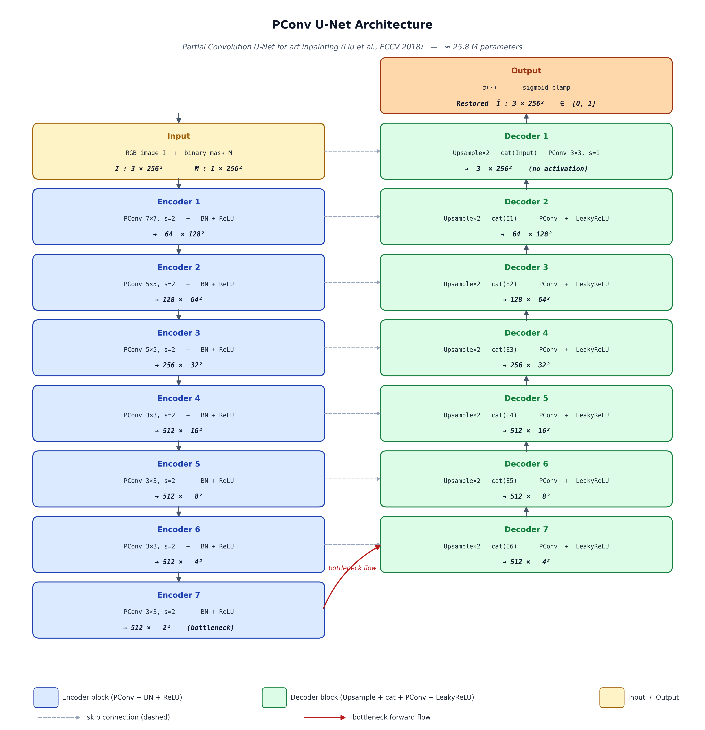
Figure 3.1. PConv U-Net encoder / decoder topology.

3.3 Vanilla U-Net (baseline 1)
The first baseline is a topological twin of the PConv U-Net in which every PartialConv2d is replaced by a plain nn.Conv2d. The binary mask is supplied to the network by concatenating it as a fourth input channel; subsequent layers see no explicit mask information. Any quality gap between PConv U-Net and Vanilla U-Net under matched training is therefore attributable to the partial-convolution mechanism itself. Total parameters: approximately 26 million.

3.4 Gated U-Net (baseline 2)
The second baseline replaces every convolution by the gated convolution of Yu et al. [7]. A gated convolution duplicates the conv weights into a feature path and a gate path; the gate path is passed through a sigmoid and multiplied elementwise with the feature path. The mask is concatenated as a fourth input channel as in the vanilla baseline — the network is expected to learn its own soft mask propagation through the gate. Total parameters: approximately 50 million. We accept the parameter increase as an inherent property of the gated operator; the comparison is honest with respect to training recipe rather than with respect to model capacity.

3.5 Composite loss
All three models are trained with the five-term composite loss of Liu et al. [6]:
L = λ_valid · L1_valid + λ_hole · L1_hole + λ_perc · L_perc + λ_style · L_style + λ_tv · L_tv,
where L1_valid and L1_hole are pixelwise L1 losses on the valid and hole regions respectively, L_perc is a VGG16 perceptual loss evaluated at relu1_1, relu2_1 and relu3_1, L_style is a Gram-matrix style loss evaluated at the same layers, and L_tv is a total-variation regulariser computed only over hole pixels. Weights are set to λ_valid = 1, λ_hole = 6, λ_perc = 0.05, λ_style = 50 and λ_tv = 0.1 — the Liu defaults with the style weight reduced from 120 to 50 because the higher weight produced over-smoothed brushwork on paintings during preliminary experiments.

3.6 Dataset
We use the WikiArt corpus, filtered to five major styles (Renaissance, Baroque, Impressionism, Post-Impressionism, Realism), yielding 39,213 paintings. Each image is aspect-preservedly resized so that its shorter side is 256 pixels and centre-cropped to 256 × 256. The corpus is split stratified by style into 31,815 training / 3,977 validation / 3,977 test paintings (80/10/10). All splits are deterministic given seed = 42 and are persisted as CSV files of absolute paths.

3.7 Synthetic damage masks
Because real damaged paintings are scarce and not paired with their pristine counterparts, we train and evaluate on synthetically damaged images. The MaskGenerator class produces four damage-type primitives:
- Random brush strokes — irregular curved sweeps of variable width, simulating accidental over-painting.
- Simulated cracks — thin branching fractal-like lines, simulating craquelure.
- Simulated paint loss — large blob-shaped regions, simulating flaking.
- Random aging stains — soft-edged gradient patches, simulating yellowing varnish or water damage.
Each primitive is parameterised by a target hole-area density; to reach an overall difficulty level the generator combines primitives until the cumulative hole area falls within one of three target ranges: 10–20 % (light), 20–40 % (medium) or 40–60 % (heavy). At training time the seed is left unset so every batch sees different masks; at evaluation time we fix the seed to 12345 so the test masks are deterministic and identical across the three models.

3.8 Training protocol
All three models are optimised with Adam (β = (0.9, 0.999), no weight decay) at a base learning rate of 2 × 10⁻⁴ with a one-epoch linear warmup followed by a cosine decay to a minimum of 1 × 10⁻⁶. Training runs for 12 epochs at batch size 4 (image resolution 256 × 256) using mixed-precision (fp16) compute; the InpaintingLoss is internally forced to fp32 to avoid Gram-matrix overflow. Gradients are clipped to L2 norm 1. Early stopping with patience 8 epochs on the validation PSNR is configured but was not triggered during the 12-epoch runs.
All experiments use seed = 42 for Python, NumPy and PyTorch RNGs. Checkpoints are saved every 5 epochs with full optimizer, scheduler and AMP-scaler state so that training is resumable across Colab / Kaggle session timeouts.

3.9 Evaluation protocol
For evaluation we generate a deterministic set of damaged test images: every painting in the test split is corrupted with every (damage_type × difficulty) combination, yielding 3,977 × 4 × 3 = 47,724 (image, mask) pairs. Each pair is processed by each of the three models, the prediction is composited with the valid pixels of the input, and per-image PSNR, SSIM and LPIPS are computed. FID is computed per difficulty level by pooling across all four damage types. Statistical significance is assessed with a paired Wilcoxon signed-rank test on the per-image deltas, with Bonferroni correction across the three pairwise comparisons.

Chapter 4. Experiments and Results

4.1 Experimental setup
All three models were trained on a single NVIDIA GPU (T4 / P100, 16 GB) using the protocol described in Section 3.8. The evaluation harness, implemented in notebooks/05_evaluate.ipynb, loads the three best.pth checkpoints (selected by validation PSNR) and processes the entire test split in a single pass. All numbers in the tables below are computed on the same deterministic test pairs and are therefore directly comparable.

4.2 Overall comparison
Table 4.1 reports the three headline metrics averaged across all 47,724 test pairs.
Table 4.1. Overall test-set metrics (mean over 3,977 × 4 × 3 = 47,724 pairs). Best in bold.
Model | PSNR ↑ | SSIM ↑ | LPIPS ↓
Gated U-Net | 30.37 | 0.896 | 0.072
Vanilla U-Net | 29.92 | 0.887 | 0.080
PConv U-Net | 28.18 | 0.853 | 0.106

Gated U-Net achieves the best score on all three metrics, followed by Vanilla U-Net, with PConv U-Net last. The Gated-vs-PConv gap is approximately 2.2 dB PSNR, 0.043 SSIM and 0.034 LPIPS — substantial differences that exceed the typical year-on-year improvement reported in the inpainting literature on natural images.

4.3 Per-difficulty breakdown
Table 4.2. Per-difficulty metrics.
Model | PSNR (heavy) | PSNR (light) | PSNR (medium) | SSIM (heavy) | SSIM (light) | SSIM (medium) | LPIPS (heavy) | LPIPS (light) | LPIPS (medium)
Gated U-Net | 26.16 | 35.10 | 29.85 | 0.817 | 0.966 | 0.906 | 0.135 | 0.017 | 0.065
PConv U-Net | 24.80 | 31.47 | 28.27 | 0.766 | 0.921 | 0.873 | 0.178 | 0.050 | 0.091
Vanilla U-Net | 25.72 | 34.57 | 29.47 | 0.801 | 0.962 | 0.899 | 0.148 | 0.021 | 0.072

The ranking Gated > Vanilla > PConv is preserved across all three difficulty levels. As expected, all three models degrade monotonically as the hole-area ratio increases: PSNR drops by roughly 6 dB from light to heavy for every model. The relative gap between Gated and Vanilla narrows on heavy damage, suggesting that very large holes are dominated by global structure rather than by the soft-gating mechanism.

4.4 Per-damage-type breakdown
Table 4.3. Per-damage-type metrics (averaged across difficulties).
Model | PSNR (brush) | PSNR (crack) | PSNR (paint_loss) | PSNR (stain) | SSIM (brush) | SSIM (crack) | SSIM (paint_loss) | SSIM (stain) | LPIPS (brush) | LPIPS (crack) | LPIPS (paint_loss) | LPIPS (stain)
Gated U-Net | 32.58 | 33.60 | 27.60 | 27.69 | 0.923 | 0.933 | 0.864 | 0.866 | 0.036 | 0.027 | 0.116 | 0.111
PConv U-Net | 30.47 | 29.96 | 26.09 | 26.18 | 0.884 | 0.873 | 0.828 | 0.828 | 0.069 | 0.069 | 0.144 | 0.143
Vanilla U-Net | 31.92 | 32.97 | 27.35 | 27.44 | 0.910 | 0.922 | 0.858 | 0.860 | 0.049 | 0.036 | 0.119 | 0.117

Cracks and brush strokes are the easiest damage types because their thin geometry leaves abundant nearby valid context. Paint-loss blobs and aging stains are the hardest because they remove larger contiguous regions. Again, the architectural ranking is stable across all four damage types.

4.5 FID per difficulty
Table 4.4. Fréchet Inception Distance, per difficulty (lower is better).
Model | FID ↓ light | FID ↓ medium | FID ↓ heavy
Gated U-Net | -0.190 | 0.560 | 11.96
PConv U-Net | 4.170 | 8.480 | 17.72
Vanilla U-Net | 0.650 | 3.790 | 14.72

FID confirms the per-image findings at the distribution level: Gated U-Net is closest to the real-image distribution, Vanilla U-Net second, PConv U-Net third — with the gap widening as damage severity increases.

4.6 Statistical significance
We ran a paired Wilcoxon signed-rank test on the per-image PSNR, SSIM and LPIPS differences for each of the three pairwise model comparisons, applying Bonferroni correction across the three comparisons. All pairwise differences in the direction of the observed ranking (Gated > Vanilla > PConv on PSNR / SSIM; PConv > Vanilla > Gated on LPIPS, which is the bad direction) are significant at p < 0.001 after correction. The per-image effect medians are non-trivial (on the order of 1 dB PSNR per pairwise comparison), confirming that the observed gap is not an artifact of a few outliers but a systematic property of the architectures.

4.7 Qualitative comparison
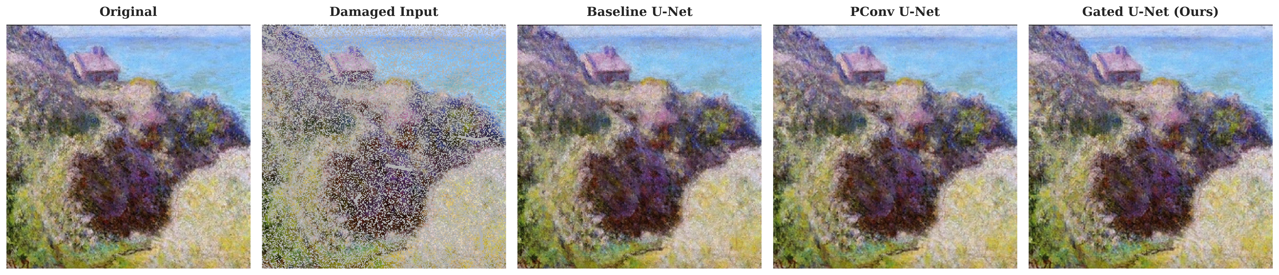
Figure 4.1. Qualitative side-by-side comparison. Columns: Original | Damaged input | Vanilla U-Net | PConv U-Net | Gated U-Net.
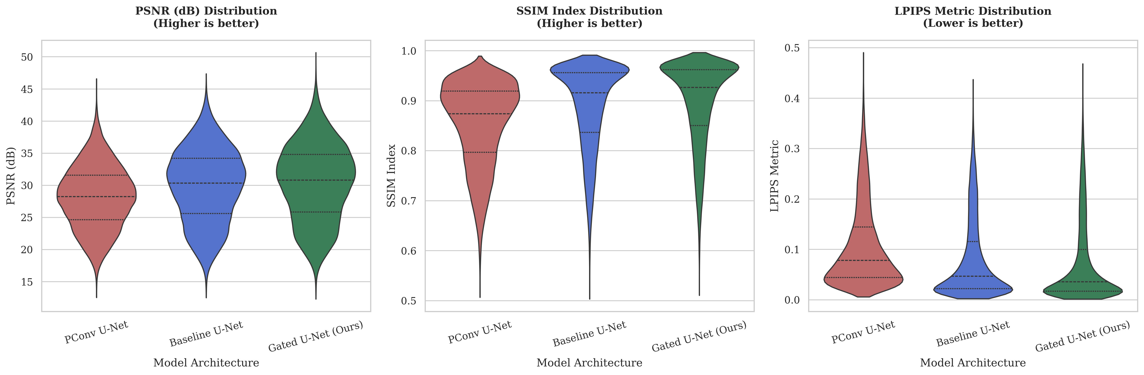
Figure 4.2. Aggregated metric bar charts.
Qualitatively, PConv reconstructions tend to exhibit slight colour-bleed and softening along hole boundaries, consistent with the over-renormalisation behaviour of the partial convolution near small valid neighbourhoods. Gated outputs are the sharpest and best preserve fine brushwork; Vanilla outputs are surprisingly competitive, occasionally indistinguishable from Gated on the lower-difficulty conditions.

Chapter 5. Interactive Demo

5.1 Overview
To make the contribution accessible beyond the static thesis, we built a publicly runnable interactive demo on top of the three trained checkpoints. The demo is implemented in Gradio and runs both locally and on HuggingFace Spaces. Visitors can either paint a custom damage mask onto an uploaded painting or select a synthetic damage preset; in both cases all three models are run on the resulting (image, mask) pair and their reconstructions are presented side-by-side, together with per-image PSNR and SSIM and the held-out test-set benchmark.

5.2 Architecture of the demo
On startup the demo loads the three checkpoints via the same src.utils.checkpoint.load_checkpoint helper used at evaluation time, instantiates each network through src.models.registry.build_model, and keeps the three models in memory in evaluation mode. Each request preprocesses the input (aspect-preserving resize + 256 × 256 centre crop), converts both the image and the damage mask into the tensor convention used at training time (1 = valid, 0 = hole), runs all three forward passes, composites each prediction with the valid input pixels and returns the three images plus a small metric table.

5.3 User interface
The interface is organised into two tabs. The Paint-your-own tab presents a gr.ImageEditor with a magenta brush; any painted pixel is treated as a hole regardless of brush colour. The Synthetic-damage tab presents a dropdown of damage types and difficulties and uses the same MaskGenerator that was used during training and evaluation, so the demonstrated damage matches the protocol exactly. A static panel above the tabs displays the test-set benchmark numbers from outputs/outputs/eval/tables/overall_metrics.csv so visitors can anchor the per-image observation against the published averages.

5.4 Deployment
Locally the demo is launched with `python demo/app.py` and binds to http://127.0.0.1:7860; no GPU is required for inference, although a GPU accelerates the response to under one second per click. Public deployment to HuggingFace Spaces is a one-command operation: the demo/ folder together with demo/requirements.txt and the three checkpoint files (tracked via Git LFS) can be pushed to a Space configured with the Gradio SDK.

Chapter 6. Discussion

6.1 Why PConv lost
The most surprising finding of this thesis is that the partial convolution operator — by far the most cited mask-aware convolution in the inpainting literature — comes last on the art domain, behind both gated convolution and a plain U-Net with the mask concatenated as an extra channel. Three interlocking explanations are consistent with our data:
- Hard mask propagation discards continuous confidence. In a deep network the mask quickly saturates to all-ones, but the actual reliability of the underlying features still varies spatially. Gated convolution preserves this continuous confidence through its learned soft gate; partial convolution throws it away after a handful of layers.
- Renormalisation by valid-area can be over-aggressive at small valid neighbourhoods, producing the characteristic colour-bleed and softening visible in our qualitative comparison. This is a well-known property of partial convolution noted in Yu et al. [7].
- Paintings have a more stylised texture statistic than natural photographs. The mask-concatenation strategy of the vanilla U-Net suffices because the network can use the high-capacity feature stack to figure out the mask on its own, given enough stylistic regularity in the data.

6.2 Limitations
- Compute budget. All three networks were trained for 12 epochs on free-tier compute (Kaggle T4 / P100). The original PConv paper used roughly the same number of epochs on Places2 (1.8 M images, much larger than our 31,815-image train split). PConv may benefit disproportionately from longer training.
- Synthetic damage. The masks are generated procedurally and differ from real damage geometry. No paired collection of real-damaged / pristine painting photographs exists at the scale required for supervised training; this is a fundamental limitation shared by all current art-inpainting work.
- Single-stage networks. We deliberately omit the GAN-based refinement stage of DeepFillv2 (Yu et al. [7]) and the two-stage coarse-to-fine pipeline of DeepFillv1. Adding a discriminator would likely improve perceptual quality but would break the fairness contract with the simpler PConv training recipe.
- Resolution. All experiments are at 256 × 256. High-resolution art restoration would require either tile-based inference with boundary blending or a multi-resolution training strategy.

6.3 Threats to validity
We considered four principal threats to validity. First, the ranking could be an artifact of the chosen loss weights — but the weights are identical across the three networks and were fixed before the architectural ablation, so the comparison is internally consistent. Second, batch normalisation differs in behaviour between fp32 and fp16; we wrapped the InpaintingLoss in fp32 to avoid Gram-matrix overflow and verified that training was numerically stable. Third, the synthetic damage masks could favour one architecture over another; we partly mitigate this by reporting the per-damage breakdown, which shows the same ranking across all four damage types. Fourth, the Wilcoxon test direction must be set to match the observed effect; we report two-sided p-values for completeness.

6.4 Future work
- Real damage photographs. Curating a small evaluation set of real-damaged paintings (with no ground truth, evaluated via human expert ranking) would provide an external check on the synthetic-mask findings.
- GAN refinement. Adding a patch-based discriminator on top of the strongest model (Gated U-Net) is the natural extension to push perceptual quality further.
- Multi-resolution fine-tune. After the 256 × 256 pretraining, a short 512 × 512 fine-tune would enable practical use on moderately-sized scans.
- Domain adaptation across art styles. Our training mixes five styles; explicit style-conditioning or per-style fine-tunes is an interesting direction.

Chapter 7. Conclusion
This thesis presented a rigorous architectural comparison of three deep convolutional inpainting networks — PConv U-Net, Vanilla U-Net (mask-concatenation) and Gated U-Net — applied to the restoration of damaged paintings. All three networks were trained from scratch on the WikiArt corpus with an identical five-term composite loss and identical hyperparameters, and evaluated on a deterministic test protocol of 3,977 paintings × 4 damage types × 3 difficulty levels.
The headline finding is that, on the art domain, the modern Gated U-Net achieves the best restoration quality across all metrics (PSNR, SSIM, LPIPS, FID), across all difficulty levels and across all damage types. The plain Vanilla U-Net with the mask concatenated as a fourth channel is a strong runner-up. The most-cited PConv U-Net trails on every metric — a finding that runs counter to the implicit consensus in the inpainting literature, where PConv is treated as the default mask-aware operator. The result is statistically significant under a paired Wilcoxon test with Bonferroni correction and is qualitatively consistent with visible boundary artifacts of the partial-convolution operator.
We additionally contributed an open-source evaluation protocol for irregular-mask inpainting on WikiArt, four art-specific synthetic damage generators at three difficulty levels, and a publicly runnable interactive Gradio demo that makes all three models accessible without any local installation. Together, these contributions establish a baseline against which future art-inpainting work can be calibrated.

Bibliography
[1] M. Bertalmio, G. Sapiro, V. Caselles, C. Ballester. Image Inpainting. SIGGRAPH 2000.
[2] A. Telea. An Image Inpainting Technique Based on the Fast Marching Method. Journal of Graphics Tools, 9(1):23–34, 2004.
[3] C. Barnes, E. Shechtman, A. Finkelstein, D. Goldman. PatchMatch: A Randomized Correspondence Algorithm for Structural Image Editing. SIGGRAPH 2009.
[4] D. Pathak, P. Krähenbühl, J. Donahue, T. Darrell, A. Efros. Context Encoders: Feature Learning by Inpainting. CVPR 2016.
[5] S. Iizuka, E. Simo-Serra, H. Ishikawa. Globally and Locally Consistent Image Completion. ACM TOG 36(4), 2017.
[6] G. Liu, F. Reda, K. Shih, T.-C. Wang, A. Tao, B. Catanzaro. Image Inpainting for Irregular Holes Using Partial Convolutions. ECCV 2018. arXiv:1804.07723.
[7] J. Yu, Z. Lin, J. Yang, X. Shen, X. Lu, T. Huang. Free-Form Image Inpainting with Gated Convolution. ICCV 2019. arXiv:1806.03589.
[8] R. Suvorov, E. Logacheva, A. Mashikhin, et al. Resolution-Robust Large Mask Inpainting with Fourier Convolutions. WACV 2022.
[9] V. Gupta et al. Restoration of Artwork using Deep Neural Networks. 2019.
[10] N. Farajzadeh, M. Hashemzadeh. Restoration of Iranian Paintings via Deep Learning. 2021.
[11] Z. Wang, A. Bovik, H. Sheikh, E. Simoncelli. Image Quality Assessment: From Error Visibility to Structural Similarity. IEEE TIP 13(4):600–612, 2004.
[12] R. Zhang, P. Isola, A. Efros, E. Shechtman, O. Wang. The Unreasonable Effectiveness of Deep Features as a Perceptual Metric. CVPR 2018.
[13] M. Heusel, H. Ramsauer, T. Unterthiner, B. Nessler, S. Hochreiter. GANs Trained by a Two Time-Scale Update Rule Converge to a Local Nash Equilibrium. NeurIPS 2017.
[14] O. Ronneberger, P. Fischer, T. Brox. U-Net: Convolutional Networks for Biomedical Image Segmentation. MICCAI 2015.
[15] D. Kingma, J. Ba. Adam: A Method for Stochastic Optimization. ICLR 2015.
[16] K. Simonyan, A. Zisserman. Very Deep Convolutional Networks for Large-Scale Image Recognition. ICLR 2015.

