Orix/Twilighte Manual

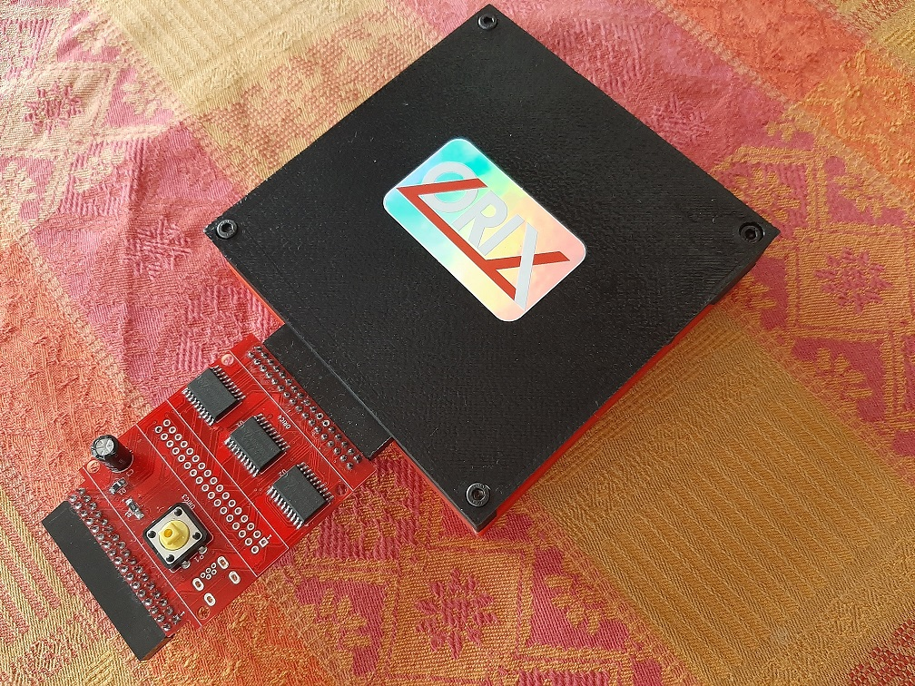

v2021.1

Version of this manual : rev 16/12/2020
Table des matières
Introduction 4
Content 6
Initialize the storage 6
First step : type a command 7
SHELL 8
Usages 9
Flush the current command line 9
BASIC11 10
Basic11 : load .tap file 11
Launch a .tape file 11
Downloaded file 11
Known tape file from oric.org 11
Load a tap file from command line 11
Save your program : CSAVE 12
ORIXCFG 13
Update kernel, shell : orixcfg 14
Load a ROM into a ram slot 14
Load a set of ROM into ROM slot 14
DSK-UTIL 15
BANK 16
CUMULUS COMPATIBILITY 17
How to connect a cumulus 18
Firmware upgrade 20
First method : For those who have programmers and some hardware tool 20
Second method : send the card to the author of the card (me) 20

INTRODUCTION

Introduction

This documentation must be use when you are with the orix version 2021.1. Or if you want to upgrade the 2020.4 version.
On http://orix.oric.org, you will have some link to video which will show how to use some functionnality.
The board has a firmware version. This firmware can be upgarded see « Hardware and firmware upgrade » section.
The board can be upgarded too but you have to send it to upgrade the board see « Hardware and firmware upgrade » section » too.

GETTING STARTED

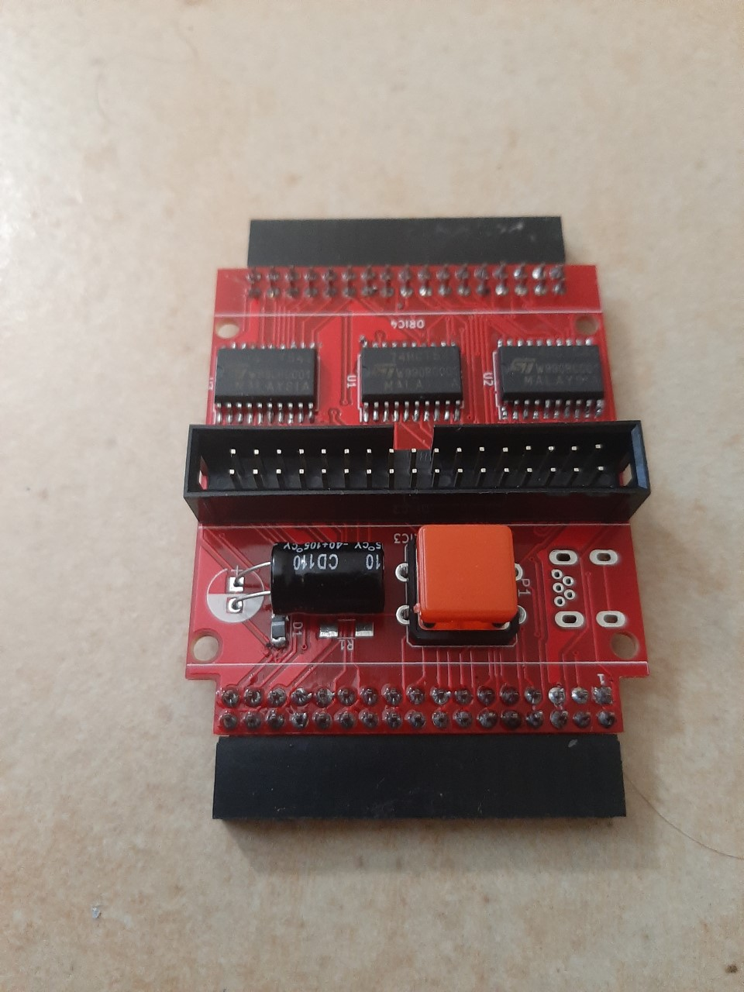
Content

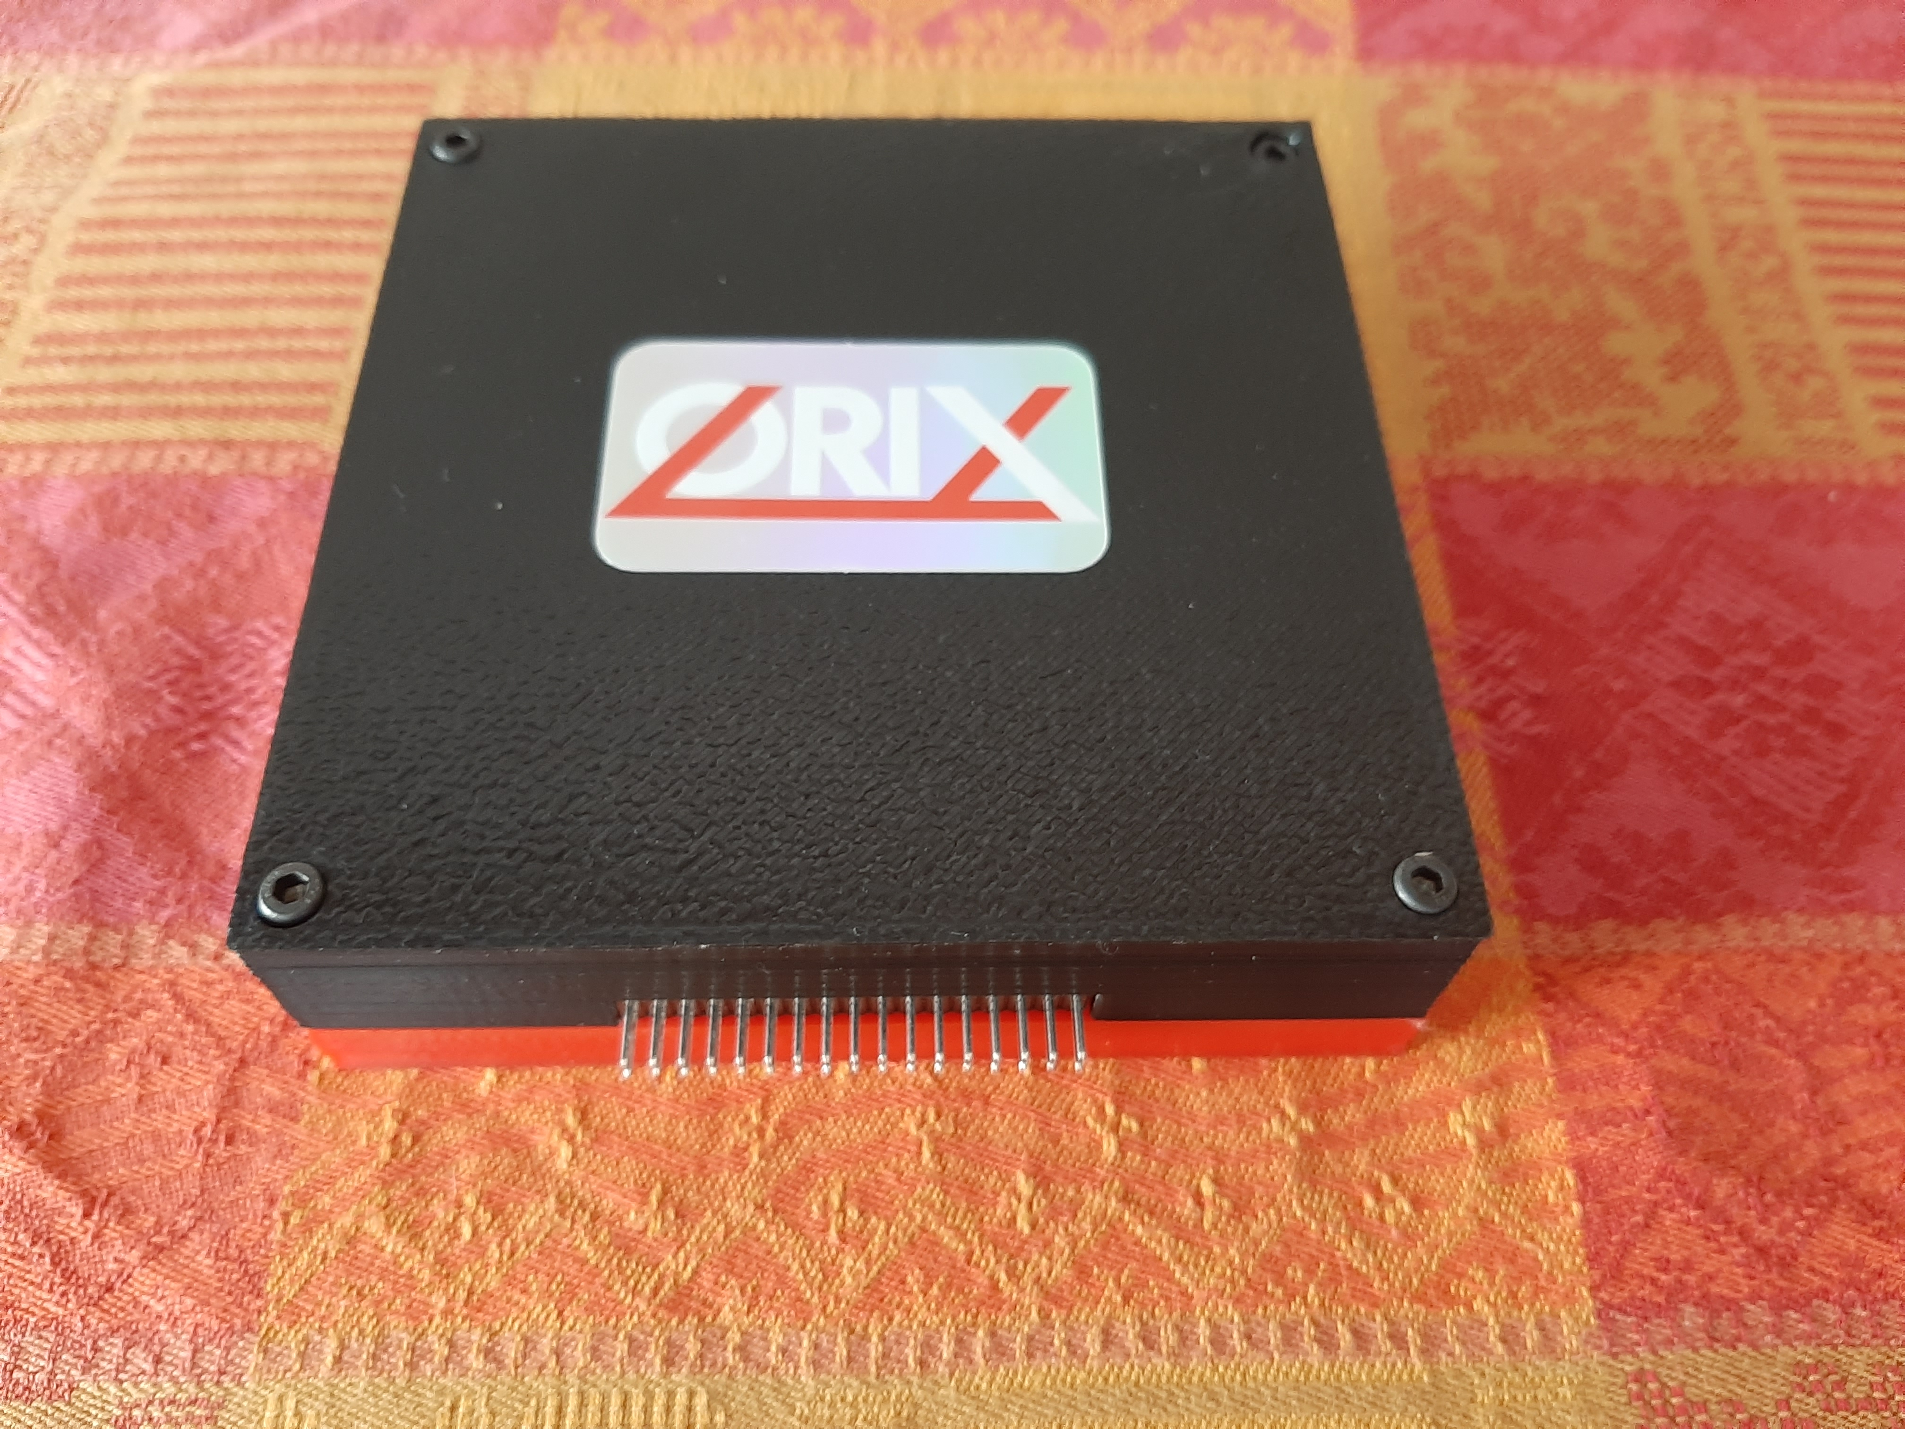

Initialize the storage
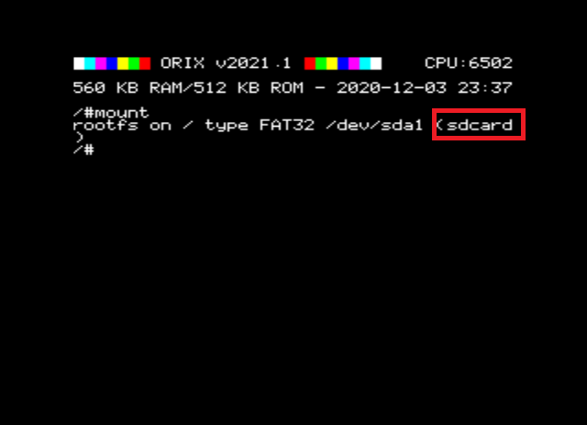
When the card is sent, kernel is built with a default storage. In order to know which device is the default one, you can type « mount ».
If you see « sdcard », then sdcard will be read by default. You can change it, with a command : « twil -u », it will switch to usbdrive. If you want to have usb drive by default, you can program kernel with the tool « orixcfg ». See Orixcfg section.
Now, if you know which device you will use by default, you can install all software on it.
Plug the device on the PC (sdcard or usbkey), if you have a pi zero w, you can do this with drag and drop solution from the PC.
Download sdcard.tgz from this : http://repo.orix.oric.org/dists/official/tgz/6502/
It contains all software for orix there is others which are not available in this tgz.
Now, use 7zip on your PC (or tar/gzip under linux), and unzip all files from this sdcard.tgz. Put all theses new file in the device root folder.
Now, you can insert the device in the twilighte board and play

First step : type a command
You can access to available command from many ways :
- From /bin folders,

SHELL

Usages

Flush the current command line
Ctrl+c

BASIC11

Basic11 : load .tap file

Launch a .tape file

There is two cases.

Downloaded file

You have downloaded a .tap file, and want to use it. Then, you can create a folder /home/basic11/
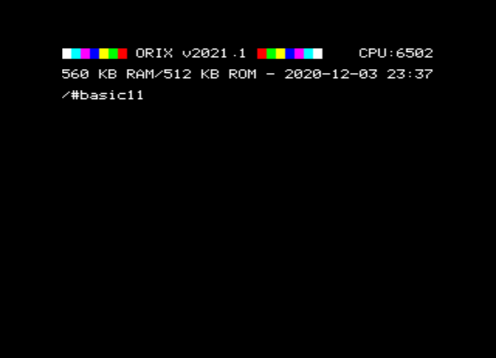
Under Orix
# mkdir home
# cd home
# mkdir basic11
# cd basic11
Put you file in this folder from your PC, and start basic11 (you don’t need to be in the home/basic11 folder to start basic11 with no parameter. By default, basic11 starts in homebasic11/

Known tape file from oric.org

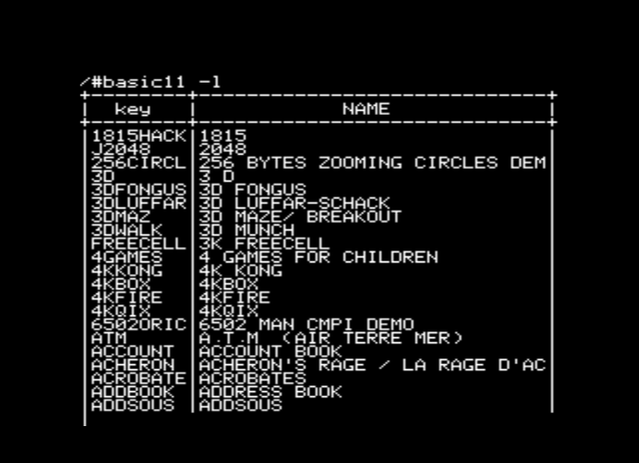
Basic11 has also many.tap files inserted in sdcard.tgz
Try to find the software with option -l
# basic11 -l
If you find your software, you can do perform ctrl+c.
You can type space to do a pause

Load a tap file from command line

Note that MYFILE must be in UPPERCASE
# basic11 « MYFILE
If MYFILE is in the oric.org database, it will launch the software with the filename MYFILE.
If basic11 command does not find MYFILE in the oric.org database, it will try to load it from /home/basic11/ folder.

Save your program : CSAVE

ORIXCFG

Update kernel, shell : orixcfg

When a new released is done, you can update the eeprom with the new kernel and new roms.
If you want to know if you need to update the kernel, you can compare your current version, and the last release version. You can go to http://orix.oric.org You need to have a look to this release below :
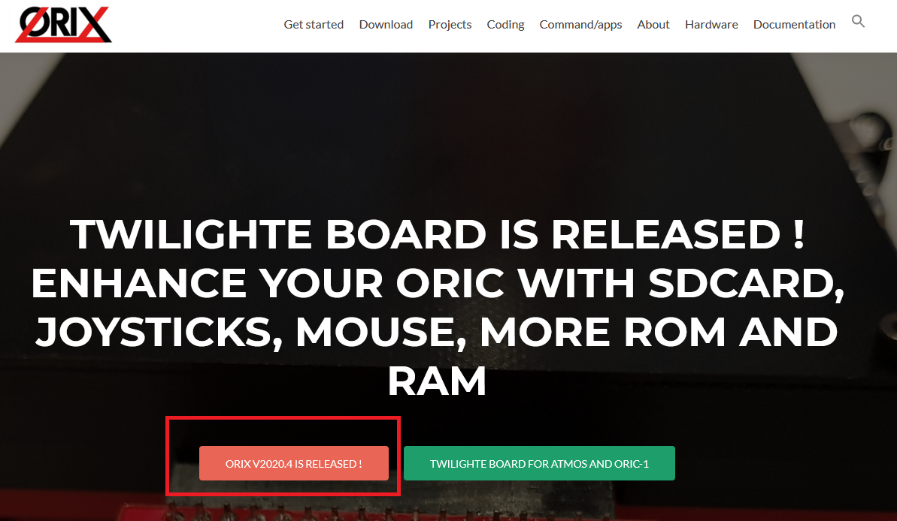
If on your Oric screen, it’s not the same value, you can update it. The sequence of the Orix release is Year.X. There is 4 releases a year, and each one must be done until you reach the final one, in order to avoid some case. If your version is v2020.3 and the last available version is v2021.4. You need to update to v2020.4, then v2021.1, v2021.2, v2021.3, v2021.4.
It’s maybe possible to jump to version v2021.4, but it’s at your own risk because there is a « chance » that some kernel calls changed.

Load a ROM into a ram slot

Load a set of ROM into ROM slot

DSK-UTIL

BANK

Bank command

Bank command is command line tool to see which bank are loaded into EEPROM bank and RAM bank. Each bank has a « signature ». Bank allows to see theses banks
Bank can also starts a ROM with his id. In that case, you don’t need to have a rom « orix friendly » and you can start it from command line. In the current bank version, there is restriction to launch a command.

CUMULUS COMPATIBILITY

How to connect a cumulus

On the current (firmware 1 : check it with command « twil -f ») , and current hardware (board version v0.65), we have to do some hacks to have cumulus working. But, you will only launch two diskfile. Anyway, you can access to drive with no restriction, except bank switching. See « Hardware and firmware upgrade », if you want to avoid theses modifications
In firmware 1, and with board modification, there is only two working disk : Blake’s 7 and VIP2015.
If you want to use cumulus, you have to :
1) cut 4 pins on daughter card
2) remove eeprom from cumulus
3) add a another amplibus befire twilighte daughter board

Hardware and firmware upgrade

Firmware upgrade

There is only one firmware available. The version 2 is in development.

First method : For those who have programmers and some hardware tool

But, when it will be released, you could update the firmware with :
1) a plcc extractor
2) altera software (Quartys v13)
3) a Jtag programmer
4) solder the jtag connector
5) get .pof file

Second method : send the card to the author of the card (me)

In that case, fimware upgrade will be done, and you could ask to upgrade to new board version to add (sometimes new functionnality)

TROUBLE SHOOTING

‘ls’ displays garbage on screen
Insert your sdcard or your usb drive into your PC. You should have strange « file » on the sdcard : remove theses files.

