Orix/Twilighte Manual

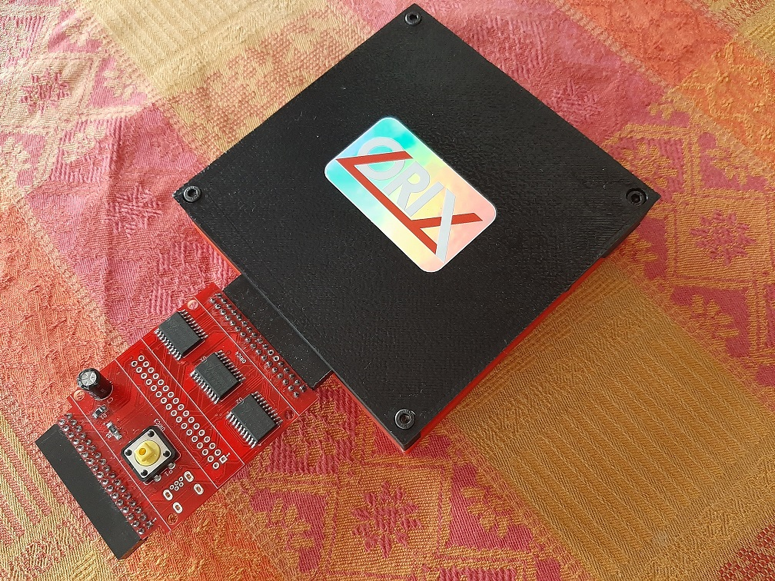

v2021.3

(rev 10/06/2021)
Table des matières
INTRODUCTION 5
What is new (v2021.3) ? 6
SHELL 6
cc65 6
Orixcfg 6
Oricutron 6
Twil lib 6
Kernel 6
Known bug 6
General informations 7
Features 7
GETTING STARTED 8
Content 9
Physicals ports 9
Hardware limits 9
Software limits 10
Information about joysticks part 10
First boot : Initialize the storage 10
Upgrade from v2021.2 to v2021.3 11
Optionnal step for upgrade 11
First step : type a command 11
BANK 13
Usage 14
List all bank (when ROM signature is valid) 14
Displays all signature even when ROM is not valid 14
List all commands from a bank 14
Start a specific bank 14
SHELL 15
Flush the current command line 16
Available commands 16
Known bugs 16
BASIC11 17
Load a personal .tap file 18
Oric.org tape file 18
Oric.org tape file update 18
Search a tape file from command line 18
Load a tap file from command line 19
Save your program 19
Start basic11 menu 19
Quit basic11 20
How the .tap file starts 20
Not working tapes (for instance) 20
Tape with altered charset 20
Joysticks issues 21
Software update changelog 21
BOOTFD 22
Introduction 23
CKSUM 24
Usage 25
DF 26
Usage 27
DSK-UTIL 28
Introduction 29
List files from .dsk (sedoric) 29
Extract a file from sedoric .dsk file 29
Extract only .hrs files from sedoric .dsk file 29
FORTH 30
Use forth 31
HEXDUMP 32
Introduction 33
IOPORTS 34
Introduction 35
LS 36
Introduction 37
list all the files in the current folder 37
List all *.tap files 37
List size and datetime of the file 37
LSCPU 38
Introduction 39
MONITOR 40
Usage 41
ORIXCFG 42
Update kernel, shell : orixcfg 43
Update kernel, shell 43
Load a ROM into a ram slot 44
Load a set of ROM into ROM slot 44
Clear bank ram or initialize it 44
Flush all ram bank 44
OSID MUSIC 45
How to play osid music ? 46
PWD 47
Introduction 48
SHA1 49
Usage 50
STORMLORD 51
Introduction 52
Only one joystick port is working on this version 52
SYSTEMD 53
TWIL 55
Introduction 56
Displays Twilighte board firmware 56
Swap to sdcard for root file system 56
Swap to usb key for root file system 56
PI ZERO connection for DRAG AND DROP 57
Drag and drop or file copy to the pi zero 58
CUMULUS COMPATIBILITY 59
How to connect a cumulus 60
Twilighte board firmware compatibility 64
Hardware and firmware upgrade 65
Firmware upgrade 66
First method : For those who have programmers and some hardware tool 66
Second method : send the card to the author of the card (me) 66
TROUBLE SHOOTING 67
‘ls’ displays garbage on screen 68
Impossible to mount a usb key or a sdcard 68
Screen garbage when i use bank 68
Pi zero always reboots 68
When i start Orix, filesytem is unstable or displays usb controler not found 68
« I/O Error » is displayed 68
The oric does not work : black screen 69
Kernel panic 69
A folder is displayed on my PC but not under my Oric 69
I have strange behavior when un do csave or cload on basic ROM : It’s always the same file event i cload another content 69
Q&A 70
I want to change the current directory 71
I want to see which bank are loaded into ROM and RAM 71
I want to read a .dsk file 71
ANNEXES 72
Firmware version 73
Upgrade from older version 73
Upgrade from v2021.1 to v2021.2 73
From 2020.4 to 2021.1 73

INTRODUCTION

What is new (v2021.3) ?

SHELL
- Twil message changed when we swap to usb drive or sdcard : /dev/usb1 and /dev/sda1 for sdcard
- mount displays now /dev/usb1 for usbdrive
- bank can start every rom (it reads $fffa/b)
- Fix bug when we reach the end of line and when we hit “del” on the first colunm of the next line
- fix bug with df : an instable state on usb chip occurs when df was executed.

cc65
- kbhit() is now working
- Fix conio lib in telestrat target (many bugs fixed)
- add chdir() in telestrat target
- add clock() in telestrat target
- bug fix in joysticks mask : left and right are inverted.

Orixcfg
- Now -c flag initialize ram with new ROM format

Oricutron
- Bug fix in oricutron for time for files under linux. (ls -l is now working)

Twil lib
- New lib to work with banking

Kernel
- Now « XOPEN » primitive manages file opened (File pointer are set correctly)

Known bug
- Some binary file can’t open files because there is a kernel bug

General informations
This documentation must be use when you have installed orix version 2021.2 (see at the top of the banner).
On http://orix.oric.org, you will have some youtube videos links showiint how to use some functionnality.
The board has a firmware version. This firmware can be upgarded see « Hardware and firmware upgrade » section.
The board can be upgarded too but you have to send it to upgrade the board see « Hardware and firmware upgrade » section » too.
The card has a 512KB of eeprom, and 512KB of RAM. This RAM is saved with a battery. For instance, only bank 4, 3, 2 and 1 can be switched to see others sets. It’s a software limit. In the future, you will be able to displays all bank and starts any binary from theses banks. If you wants to change the set, you can use twil command. This command can switch to eeprom bank or ram bank and can switch to any set.
Some extra devices (TOM2, logitech joypad) are explained a bit in this manual, but it’s not adverts, we don’t ear anything:) It explains some ways to use joystick, others hardware exists in the same way)

Features
- .tap file fast loading (with multitap files)
  - Joysticks support for a lot of games on atmos mode
  - the hobbit, defence-force (and others games) works without any patch for loading
- in system : kernel update, roms and ram update (with orixcfg binary)
- 2 DB9 Joysticks (atari)
- 512KB of EEPROM (banking mode)
- 512KB of RAM (banking mode)
- read from sdcard or usb drive (mass storage)
- ram saved with a battery
- drag and drop from the PC to the oric : It will be available on the oric (with WIFI connexion) : It requires extra hardware with a raspberry pi zero
- fast loading : 46KB per second. A game require less than one second to load and start
- cumulus compatible with the help of an other amplibus board (not provided)

GETTING STARTED

Content
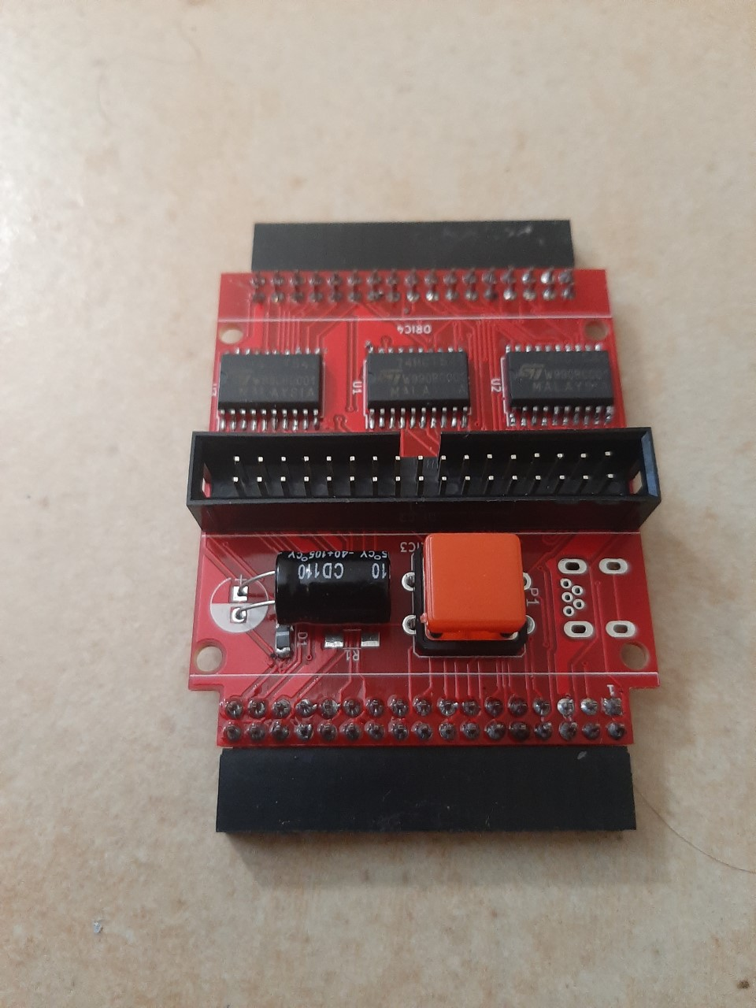Figure1 : Expansion board and reset button
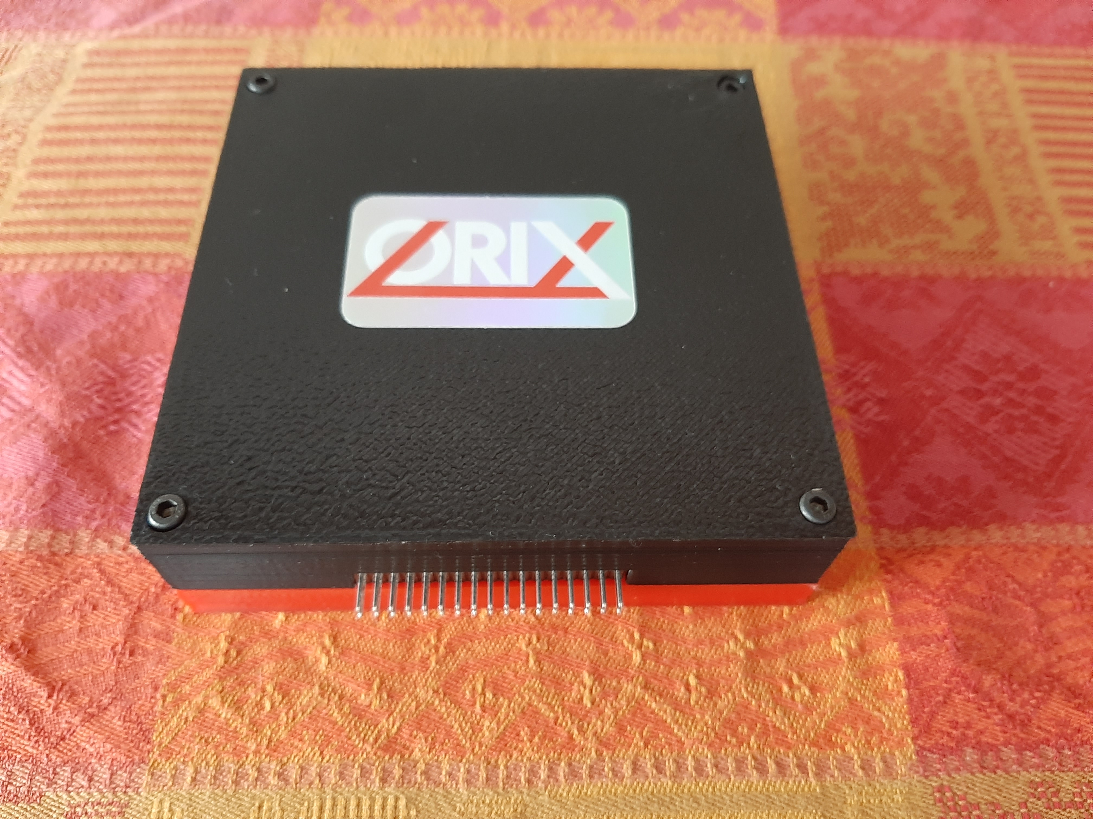Figure 2: Twilighte board

Physicals ports
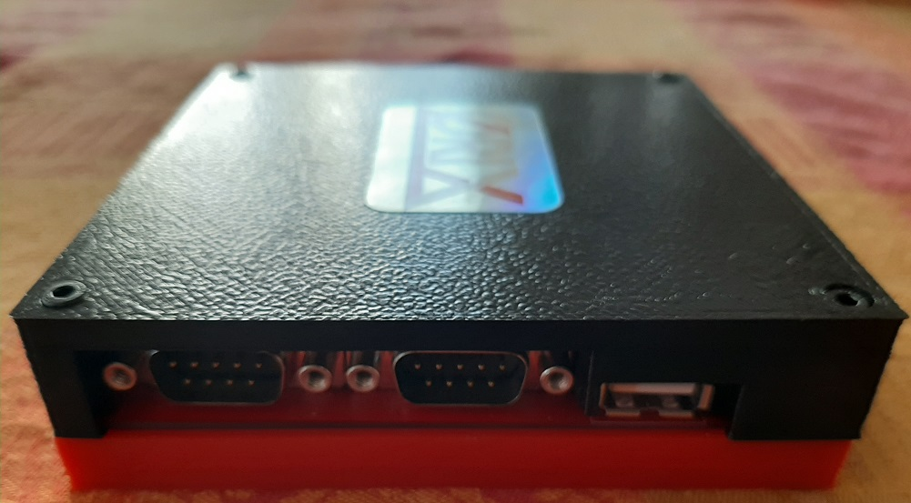Figure 1: 2 joysticks port : left port and right port, 1 usb port
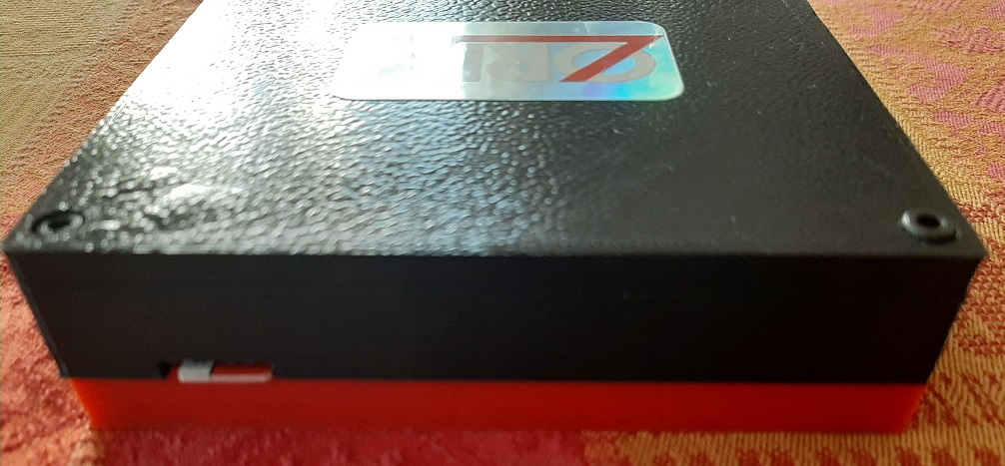Figure 2: sdcard port

Hardware limits
The usb controler manage FAT32 only. Sdcard and usb key must be formatted with FAT32 filesystem. If you want to use pi zero gadget trick, you need to do a mkfs to FAT32 file system.
All tests had been done with samsung evo sdcard and sandisk usb key. A lot of sdcard works, and we did not see incompatibility with sdcard.
Sdcard controler and usb key controler can work with 32GB storage Max. But it can handle 64 GB sdcard (tested). It can handle larger sdcard/usb key reader, but only 32 and 64 GB devices was used.

Software limits
The sdcard/usb controler can handle long filename, but Orix handles 8+3 filename only.

Information about joysticks part
The left port has only 1 button. The right port has 3 buttons. The joystick pinout is atari pinout. You can use standard DB9 joystick. You can also plug « TOM2 » hardware (not provided), it can connect a usb mouse or usb joypad (wireless) to theses ports. For example, logitech joypad F710 (wireless) works with TOM2.
Please note that TOM2 can only handle 2 buttons. It means that the third button can’t work with TOM2 connected.

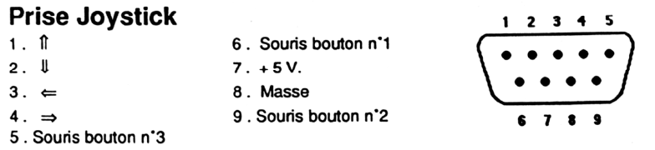

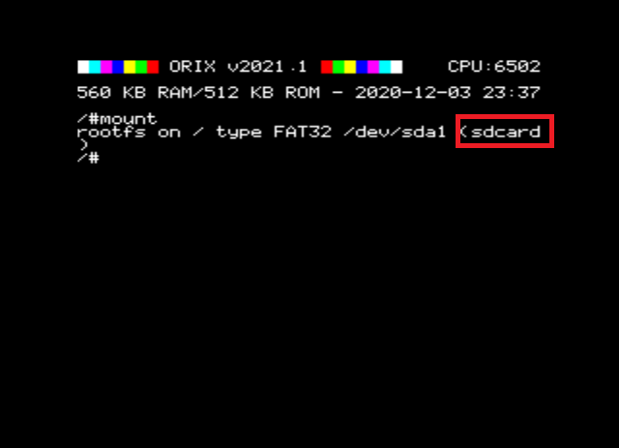
First boot : Initialize the storage
When the card is sent, kernel is built with a default storage. In order to know which device is the default one, you can type « mount ». You can only use one device at the same time, but you can swap easily theses devices from command line.
If you see « sdcard », then sdcard will be read by default. You can change it, with a command : « twil -u », it will switch to usbdrive. If you want to have usb drive by default, you can program kernel with the tool « orixcfg ». See Orixcfg section.
Now, if you know which device you will use by default, you can install all software on it.
Plug the device on your PC (sdcard or usb key). If you have a pi zero w, you can do this with drag and drop solution from the PC.
Download sdcard.tgz from this : http://repo.orix.oric.org/dists/official/tgz/6502/
It contains all software for orix there is others which are not available in this archive.
Now, use 7zip on your PC (or tar/gzip under linux), and unzip all files from this sdcard.tgz. Put all theses new files in your device root folder.
Now, you can insert the device (sdcard or usbkey – or pi zero) in the twilighte board and play.

Upgrade from v2021.2 to v2021.3
If your card is below v2021.2 version, please go to annexes part at the end of this document, before you try to upgrade to v2021.3
- Download http://repo.orix.oric.org/dists/official/tgz/6502/sdcard.tgz
- untar/gunzip sdcard.tgz (use 7zip under windows) on your device usb or sdcard : It could require some time to copy because there is a lot of small files (tap, hlp etc)
- you can start orix on real machine, and type :
/#cd usr
/usr#cd share
/usr/share#cd carts
/usr/share/carts#cd 2021.3
If you want to usr usb drive for default device :
/usr/share/carts/2021.3#orixcfg -r -s 4 kernelus.r64
If you want to use sdcard for default device :
/usr/share/carts/2021.3#orixcfg -r -s 4 kernelsd.r64
- press ‘y’, and wait until Orix reboots
(Don’t switch off the Oric at this step)

Optionnal step for upgrade
Now bank displays all banks from l to 64. It means that you should have some strange bank signature for eeprom. Now an empty set is provided in /usr/share/carts/2021.3 folder. With Orixcfg you can initialize your set with this cart. Don’t use « -s 4 » flag for orixcfg when you want to load emptyset.

First step : type a command
You can access to available command from many ways :
- From /bin folders, there is binary available on current device, ‘ls’ will show you available commands
- From banks : type « help -b5 » you will see available commands

BANK

Usage
Bank command is command line tool to see which bank are loaded into EEPROM bank and RAM bank. Each bank has a « signature ». Bank allows to see theses banks.
Bank can also starts a ROM with his id. In that case, you don’t need to have a rom « orix friendly » and you can start it from command line. In the current bank version, there is restriction to launch a command.

List all bank (when ROM signature is valid)
/#bank
Bank 1 to 32 is eeprom bank and bank 33 to 64 are ram bank

Displays all signature even when ROM is not valid
/#bank

List all commands from a bank
/#help -b5

Start a specific bank
/#bank 1
If you need to load a rom into a bank, you need to have a look to orixcfg binary.

SHELL

Flush the current command line
Ctrl+c

Available commands
You can see available commands with this command :
/#help -b5
The command line is limited in characters. If you reach this limit, you won’t be able to type the complete command line

Known bugs
- If you return to a line when your command line is bigger than 40 columns, if you try to del a chars at the previous line, you can’t.
- « ./ » can not be used to launch a binary

BASIC11

Load a personal .tap file
When you starts basic11 commands, the default path is « /home/basic11/ ». Each action on the basic11 mode will be done in this folder (cload/csave). If you cload a tape file, it must be in « /home/basic11 » folder.
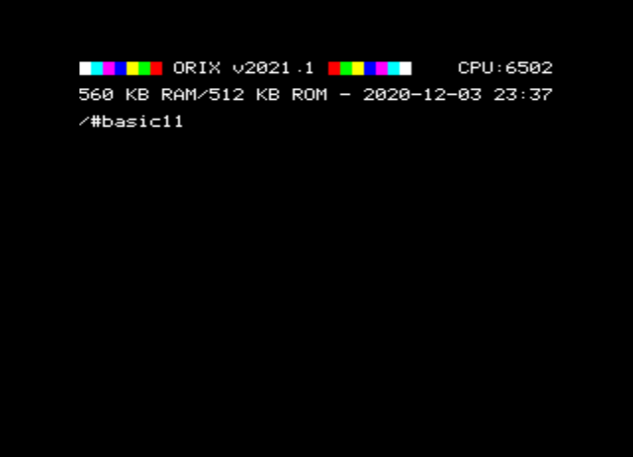
You have downloaded a .tap file, and want to use it. Then, you can create a folder /home/basic11/
Under Orix
/#mkdir home
/#cd home
/home#mkdir basic11
/home#cd basic11
Put you file in this folder from your PC, and start basic11 (you don’t need to be in the «/home/basic11 » folder to start basic11 with no parameter. By default, basic11 starts in « /home/basic11/ »

Oric.org tape file
When you downloaded sdcard.tgz and unzip it into sdcard or usbkey device, there is many tape file included in this archive. You don’t need to move these type file, if you know the key, you can starts it from commands line. In this case, it will load the correct basic1.1 rom to start the tape file (see below), and the correct joystick configuration if it’s correct.

Oric.org tape file update
Each week a new software.tgz is generated. You can download it from « repo » and unzip it on the device. It will generate last tape file and last joysticks configuration.

Search a tape file from command line
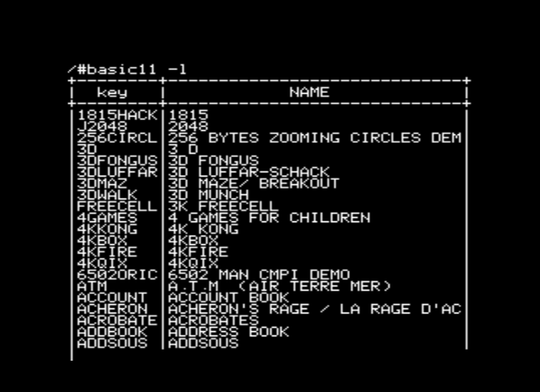
Basic11 has also many.tap files inserted in sdcard.tgz
Try to find the software with option -l
/# basic11 -l
If you find your software, you can do perform ctrl+c.
You can type space to do a pause.
On that case, you can launch the tape file like :
/# basic11 «KEYDISPLAYED
When KEYDISPLAYED is the key displayed in key column. Please note that the key must be in UPPERCASE

Load a tap file from command line
Note that MYFILE must be in UPPERCASE
/# basic11 «MYFILE
If MYFILE is in the oric.org database, it will launch the software with the filename MYFILE.
If basic11 command does not find MYFILE in the oric.org database, it will try to load it from /home/basic11/ folder.

Save your program
If you start « basic11 » with no options, basic rom will starts and each csave (or cload) actions will store files in « /home/basic11 » folder

Start basic11 menu
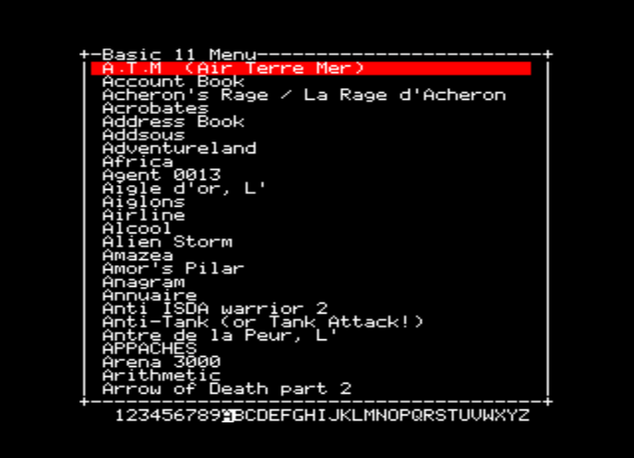
If you type « basic11 -g » on command line, you will have a menu with all software which have a download link on oric.org (only atmos version and when a tape file is available).
/#basic11 -g
You can use left and right letters to change to a new letter. If the letter is empty, it means that there is no available tap file for this letter.
You can use up and down link to navigate into software. If you press enter, the software will starts.
Note that not all games are working yet. Some times, chars are corrupted. If the joysticks does not works, there is two case :
- the game does not call rom routine to manage keyboard
- keyboard mapping is not done yet
You can use arrows to navigate into the menu :
- up and down to select the software
- right and left to switch to the menu letters
Some letters are empty. It means that there is no software with tape file available on oric.org for this letter

Quit basic11
If you want to quit basic11 from interpreter command line, you can type « QUIT ». This will force to reboot to Orix (you can also use reset button)

How the .tap file starts
If you only type « basic11 », this will start bank 6 (normal basic rom). The default folder in that case is «/home/basic11 »
If you type « basic11 » with a tape file as an argument, there is 2 cases
- The tape file (key) is already known in oric.org website, then basic11 try to find it in its databank file (/var/cache/basic11/ folder). If the key is found, it will start the tape file located in «/usr/share/basic11/... »
- If the key is unknown, it will try to find it in «/home/basic11 »
If the tap file is in the oric.org db file, basic11 will load the software configuration from the db software file (as joystick configuration, and the id of the rom). Basic11 load the right rom into ram bank, override the default basic11 path to the tape file folder (« usr/share/basic11/[firstletter software].
It means that if you load this kind of software and you can quit the software, each file action in basic11 rom, will be performed in « usr/share/basic11/[firstletter software]. »

Not working tapes (for instance)
- All Oric-1 games (but it can be fix with a new basic rom )
- Software which does not work (25), but the number can be reduced in the future release.
cobra | Cobra pinball | Damsel in distress
Le diamant de l’ile maudite | Durendal | HU*BERT
Hunchback | Schtroumpfs | Stanley
Them | Titan | Visif
Xenon III | Dig Dog | Elektro Storm
Kilburn Encounter | Le tresor du pirate | L’aigle d’or
Le secret du tombeau | Volcanic demo | Clavidact
Compatible (micropuce) | Contre attaque | CW-Morse
DAO Cobra Soft

Tape with altered charset
Fire flash | Scuba Dive

Joysticks issues
We did keyboard/joystick mapping for a lot of games, but we did not set the keyboard mapping for all software. If you want to help us, contact us.
Some game does not work because they handle their own keyboard routine. It could be handle with hardware tricks but, it’s not done.
Some others games uses special keys (SHIFT, CTRL) for direction or the first button. Theses cases are not handle yet : but it could in the future.

Software update changelog
You need to download software.tgz in the official repo for :
- Mr wimpy added to the archive (takes effect 20/01/2021)
- Airfox added to the archive (takes effect 20/01/2021)
- Atlantid added to the archive (takes effect 20/01/2021)
- Centrale nucléaire added to the archive (takes effect 20/01/2021)
- Cobra invaders added to the archive (takes effect 20/01/2021)
- Coctail Recipies added to the archive (takes effect 20/01/2021)
- Crusher added to the archive (takes effect 20/01/2021)
- Death Driver added to the archive (takes effect 20/01/2021)
- Challenge voile added to the archive (takes effect 20/01/2021)
- Breakout 1K added to the archive (takes effect 20/01/2021)
- DAO added to the archive (takes effect 20/01/2021)
- echecs asn
- dialogue
« added to the archive » means that you need to download softwares.tgz from the repo after the displayed date to get it in the archive

BOOTFD

Introduction
bootfd is a tool to boot the boot sector when a drive is connected. Insert a disk and type :
/#bootfd
The binary is located to bin folder. It will load microdisc rom and start it. If the binary displays that it does not found microdis.rom, then place microdis.rom file in the right folder.
If you have firmware 1, you will be able to load « blake’s 7 ». If you have firmware 2, all sedoric .dsk should start.
For instance, only Space99 does not work, it stops after intro.

CKSUM

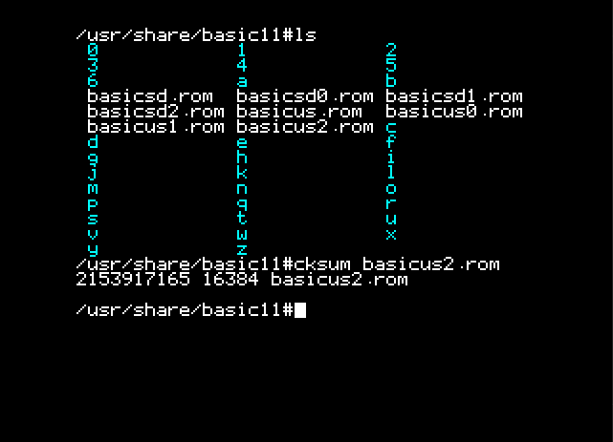
Usage
Cksum is a tool to compute a checksum of a file and displays its size.

DF

Usage
It displays available blocks on current device
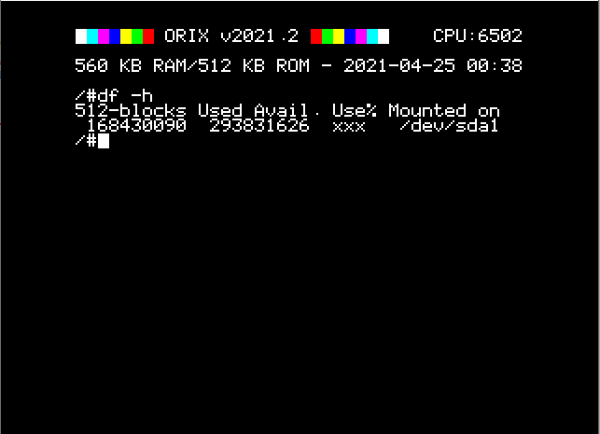

DSK-UTIL

Introduction

This tool is useful to extract files from dsk file. You can extract it, and uses command line tool to use it. For example, if you extract a basic program (.bas in FTDOS .dsk file), you can see it with « list » binary. If it’s a .hrs/.hir file, you can read it with viewhrs file.
You can create a «/home/sedoric/ » folder and adds .dsk sedoric files in this folder
Some .dsk files are imported in sdcard.tgz. For sedoric, you can have a look to «/usr/share/sedoric/ » and for ftdos : « /usr/share/ftdos »

List files from .dsk (sedoric)
/home/sedoric# dsk-util -s ls sed.dsk

Extract a file from sedoric .dsk file
/home/sedoric# dsk-util -s e sed.dsk myfile.hrs

Extract only .hrs files from sedoric .dsk file
/home/sedoric# dsk-util -s e sed.dsk *.hrs

FORTH

Use forth
You can use forth language. It works the same ways than Tele forth (it’s teleforth but it write file on sdcard/usbdrive).
You can download Teleforth langage in order to see how to program in forth.
When you type « forth » forth starts with the current folder directory.
If you were in /, forth will load and save file in this folder.
In others cases, you can create a forth folder in home and goes into it in forth for example :
/#mkdir home
/#cd home
/#mkdir forth
/#forth
if you type « cd forth» in forth environnement, all files actions will be perform in « /home/forth »

HEXDUMP

Introduction
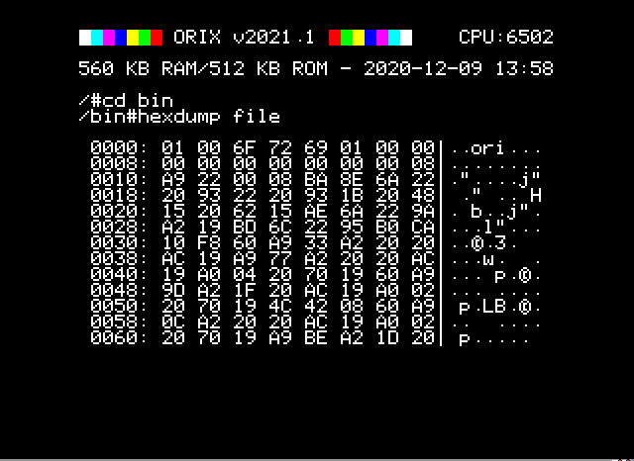
Can dump in hexadecimal and ascii the content of a file. Ctrl+c and space are working

IOPORTS

Introduction
Displays I/O address of the board

LS

Introduction
« ls » list all the file in the current folder. Token are supported (*,?) ex : « ls ?e.tap » will list all files with a ‘e ‘ in the second letter

list all the files in the current folder
/#ls

List all *.tap files
/#ls *.tap

List size and datetime of the file
/#ls -l

LSCPU

Introduction
Displays cpu info. It detects : 6502, 65c02 and 65816

MONITOR

Usage
Monitor is a rom which can displays a monitor. It’s teleass without assembler part.

ORIXCFG

Update kernel, shell : orixcfg

When a new released is done, you can update the eeprom with the new kernel and new roms.
If you want to know if you need to update the kernel, you can compare your current version, and the last release version. You can go to http://orix.oric.org You need to have a look to this release below :
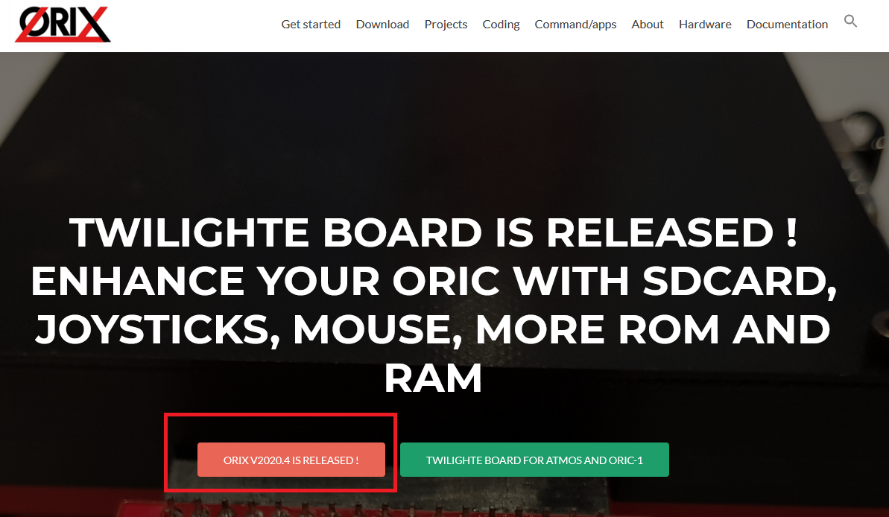
If on your Oric screen, it’s not the same value, you can update it. The sequence of the Orix release is Year.X. There is 4 releases a year, and each one must be done until you reach the final one, in order to avoid some case. If your version is v2020.3 and the last available version is v2021.4. You need to update to v2020.4, then v2021.1, v2021.2, v2021.3, v2021.4.
It’s maybe possible to jump to version v2021.4, but it’s at your own risk because there is a « chance » that some kernel calls changed, and orixcfg could do wrong step.

Update kernel, shell
When you need to update kernel, you can update it with orixcfg. You just need to define set 4 on the command line. This step is very dangerous if you don’t load the right file. There is no verification and any file on the command line will be load in the kernel set. Usually, kernel set file is named kernxxxx.r64.
If you did something wrong on this step, you won’t be able to start orix again. It means that you will need to remove eeprom from the card and program it with a eeprom programmer
This next command will load kernel.r64 to kernel set. Please wait until Orix reboots. If you have a kernel 2020.3 and you need to load a kernel 2021,1, you will need to load previous kernel set before the update of 2021.1.
.r64 extension means that it’s a 64KB set. It’s usually used to define that the file contains 4 roms of 16KB.
Please note that we provide 2 kernels version. One named « kernelsd.r64 » which means that the default device will be sdcard, and the other one « kernelus.r64 » which means that default device will be « usb » (usbkey). If you load the wrong kernel at this step, you can use twil command to switch to the right device, and you can start again kernel update with the right file (kernelsd.r64 or kernelus.r64 depending of your configuration).
/#orixcfg -r -s 4 kernelsd.r64

Load a ROM into a ram slot
Space between values and switches are not optionnal, orixcfg needs theses spaces
/#orixcfg -b XX -l myrom.rom
This command will load myrom.rom (in the current path), in RAM bank XX
Older usage as : orixcfg -r -s X -b Y myrom.rom is no longer included in orixcfg since orixcfg v2021.3

Load a set of ROM into ROM slot
/#orixcfg -r -s 0 myrom.r64
This command will load myrom.r64 (in the current path), in set 0. For instance, you can not load one bank, you need to load 64KB set.

Clear bank ram or initialize it
Ram bank are not initialized when the board is tested. If you have garbage on screen when you uses bank (after you used twil -w). You have to clear all ram bank (ram bank are battery saved).
If you want to clear bank 4 of the set 0, you can do this command. You need to do this command for each bank of each set. For instance, there is no switch to clear all the ram with one command.
/#orixcfg -w -s 0 -b 4 -c

Flush all ram bank
/#orixcfg -w -f

OSID MUSIC

How to play osid music ?
You need to check if you have twilighte board firmware 2 :
/#twil -f
If it returns 2 or greater, you can download some osid files :
https://www.oric.org/software/osid_music-2534.html
Place all .tap files in /home/basic11
And launch :
/#basic11
Load patch to avoid to load sedoric routines (in basic command line)
CLOAD«OSID
And then load the osid file you want :
CLOAD«OSNEVER

PWD

Introduction
Displays current PWD

SHA1

Usage
Sha1 is a tool to displays a string into sha1 encoding

STORMLORD

Introduction
Stormlord is Stormlord game port to Orix. You can use joysticks to plays to this game.

Only one joystick port is working on this version

SYSTEMD
Systemd is a rom which can load another ROM in ram slot. When you type systemd, it will reads /etc/systemd/banks and will load rom declared in this file sequencialy. It means that the first rom will be load in bank id 33, the second one in bank id 34.
This roms can be used in a eeprom bank, you can load it with orixcfg
You can set roms in « /etc/systemd/banks » as :
[MYROMNAME1]
path=/usr/share/rom/my.rom
[MYROMNAME2]
path=/usr/share/rom/my2.rom

TWIL

Introduction
Twil command can displays the current firmware of twilighte card, and can swap root folder to usbkey or sdcard.
Twil command can also swap bank 4, 3, 2 and to eeprom set or ram set.

Displays Twilighte board firmware
/#twil -f

Swap to sdcard for root file system
/#twil -d

Swap to usb key for root file system
/#twil -u

PI ZERO connection for DRAG AND DROP

Drag and drop or file copy to the pi zero
If you have a pi zero, you can use it to simulate a usb key with wifi connectivity for drag and drop.
You need to follow this documentation : http://orix.oric.org/drag-and-drop-files-from-pc-to-the-card/
Please note that you must connect pi to usb twilighte port on his usb port (not the psu port). Also note that pi consumes power and if you use a psu lower than 2 A, you should have some hardware errors
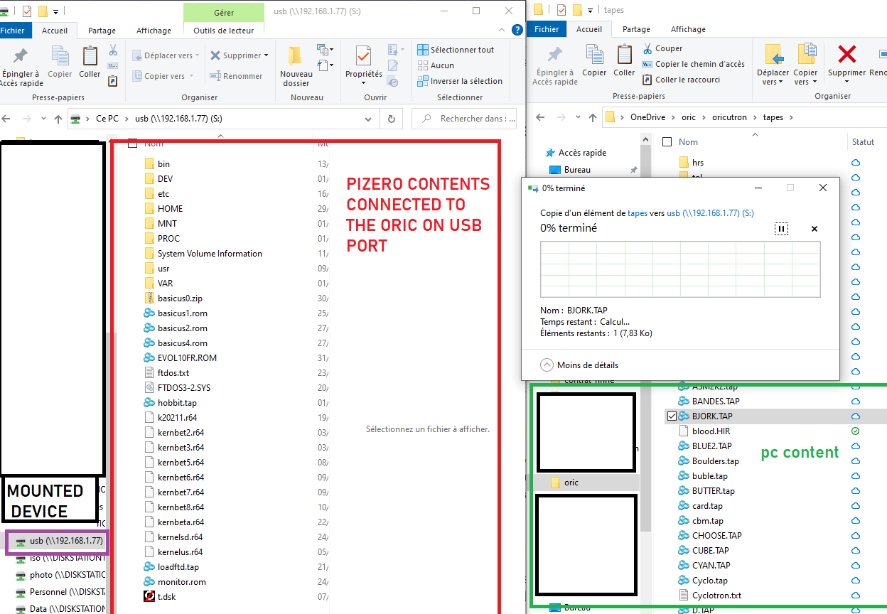
Some usb cable are only for charge, it means that it won’t work with the card and pi zero, because it missed data wires

CUMULUS COMPATIBILITY

How to connect a cumulus

On the current firmware (Firmware 1) : and current hardware (board version v0.65), we have to do some hacks to have cumulus working. But, you will only launch two diskfile. Anyway, you can access to drive with no restriction, except bank switching. See « Hardware and firmware upgrade », if you want to avoid theses modifications
In firmware 1, and with board modification, there is only two working disk : Blake’s 7 and VIP2015.
Please, test your cumulus on the oric connected to the board. If it does not work on your Oric, it won’t work too with card plugged !
If you want to use cumulus, you have to :
1) cut 4 pins on daughter card (ROMDIS, MAP, A14, A15)
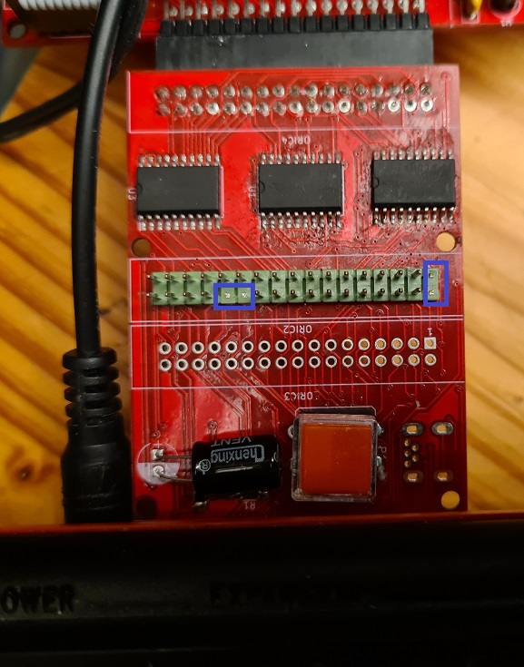

2) remove eprom from cumulus
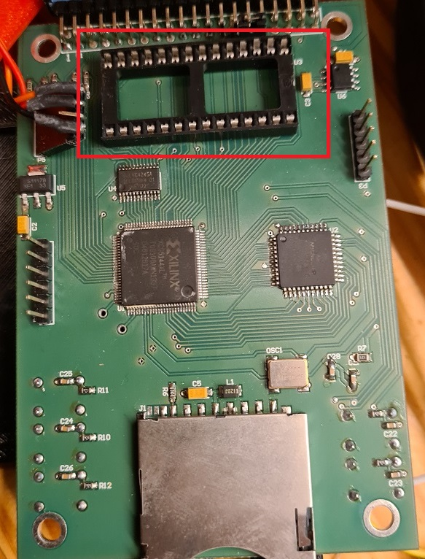

3) add another amplibus before twilighte daughter board
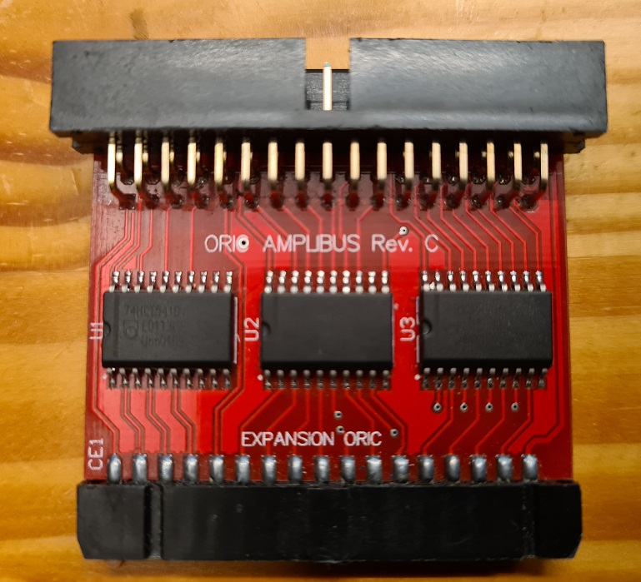

4) Connect all cards to the oric
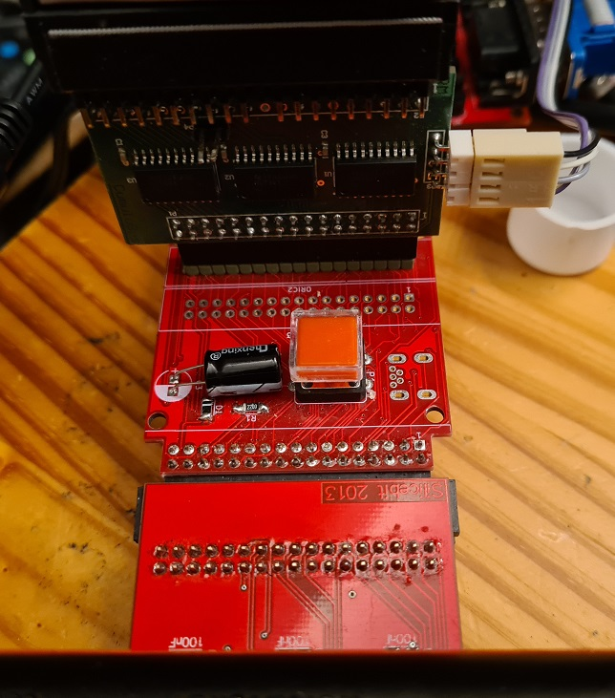

Twilighte board firmware compatibility

Only firmware 2 is available to use boot sector to start Microdisc disk.

Hardware and firmware upgrade

Firmware upgrade
There is only one firmware available. The version 2 is in development.

First method : For those who have programmers and some hardware tool
But, when it will be released, you could update the firmware with :
1) a plcc extractor
2) altera software (Quartys v13)
3) a Jtag programmer
4) solder the jtag connector
5) get .pof file

Second method : send the card to the author of the card (me)
In that case, fimware upgrade will be done, and you could ask to upgrade to new board version to add (sometimes new functionnality)

TROUBLE SHOOTING

‘ls’ displays garbage on screen
Insert your sdcard or your usb drive into your PC. You should have strange « file » on the sdcard : remove theses files.

Impossible to mount a usb key or a sdcard
The sdcard must be in FAT32 format

Screen garbage when i use bank
If you have screen garbage when you switched to ram bank before with « twil -w »
It means that ram bank are not initialized. See orixcfg section to fix it

Pi zero always reboots
Check your PSU. If you have a 2A PSU and you have a pi zero, cumulus and TOM2 connected, you should reach the PSU limits. If you can’t get another PSU, you can disable bluetooth of you pi zero, or you can also downclock from 1Ghz to 700mhz for example.
You can also use a 3A PSU. In the future, it will be possible to add another PSU on the board.

When i start Orix, filesytem is unstable or displays usb controler not found
If you have pi zero connected, it could answer to the controler partial information or could hang the usb controler because controler does not understand usb data when it sends information to usb port.
You have to wait a bit. If you want to verify this, you can switch off the oric (and then the pi zero), switch on the oric with Orix, and type ‘debug’, if you have another value than #AA for ch376 check exists, it’s the problem, if you do ‘debug’ another value will be displayed but not #AA. In fact, when pi zero boot, usb controler is unstable.

« I/O Error » is displayed
You can reach this message in some case :
- device (sdcard or usbdrive is missing)
- after a launch of « df » command : There is an issue, the controler is in incorrect state after this command. It’s a bug
You can usually fix it by launching « ls » twice. Because « ls » handles a reset order to the usb controler when it does not produce the correct answer. It means that if USB controler is not working well, ls displays the error message and will produce a reset command to the controler. If you launch ls again, it will work.

The oric does not work : black screen
If you have a pi zero connected on usb port, unplug it. Boot the oric, and now insert pi zero into usb port

Kernel panic
When kernel can’t solve a « free memory kernel call» in a binary, it could produce a kernel panic. In that case, you need to do a reset. There is a bug in kernel 2021.1 which could produce this error. It will be corrected as soon as possible.

A folder is displayed on my PC but not under my Oric
Sometimes sdcard or usbkey has bad format for the usb controler and it can reads some content. Format the usb key or sdcard and install again all files. Or try another usb key/sdcard

I have strange behavior when un do csave or cload on basic ROM : It’s always the same file event i cload another content
Sometimes sdcard or usbkey has bad format for the usb controler and it can reads some content. Format the usb key or sdcard and install again all files. Or try another usb key/sdcard

Q&A

I want to change the current directory
See « cd » command

I want to see which bank are loaded into ROM and RAM
See «bank» section

I want to read a .dsk file
You can only extract files from a .dsk file (see « dsk-util »)
If you have a cumulus board, you can use « bootfd » and connect your cumulus on expansion board « see how to connect a cumulus section »

ANNEXES

Firmware version
Version | Features | Known bugs
1 | RAM/ROM switch, ROM programmation, joysticks, usb controler | N/A
2 | Start all sedoric disks from cumulus | N/A

Upgrade from older version

Upgrade from v2021.1 to v2021.2
If your card is below v2021.1 version, please go to annexes part at the end of this document, before you try to upgrade to v2021.2
- Download http://repo.orix.oric.org/dists/official/tgz/6502/sdcard.tgz
- untar/gunzip sdcard.tgz (use 7zip under windows) on your device usb or sdcard : It could require some time to copy because there is a lot of small files (tap, hlp etc)
- you can start orix on real machine, and type :
/#cd usr
/usr#cd share
/usr/share#cd carts
/usr/share/carts#cd 2021.2
If you want to usr usb drive for default device :
/usr/share/carts/2021.2#orixcfg -r -s 4 kernelus.r64
If you want to use sdcard for default device :
/usr/share/carts/2021.2#orixcfg -r -s 4 kernelsd.r64
- press ‘y’, and wait until Orix reboots
(Don’t switch off the Oric at this step)

From 2020.4 to 2021.1
Download : http://repo.orix.oric.org/dists/2021.1/tgz/6502/carts.zip
Unzip it on your device (sdcard/usbkey)
- you can start orix on real machine, and type :
/#cd usr
/usr#cd share
/usr/share#cd carts
/usr/share/carts#cd 2021.1
If you want to usr usb drive for default device :
/usr/share/carts/2021.1#orixcfg -r -s 4 kernelus.r64
If you want to use sdcard for default device :
/usr/share/carts/2021.1#orixcfg -r -s 4 kernelsd.r64
- press ‘y’, and wait until Orix reboots
(Don’t switch off the Oric at this step)

