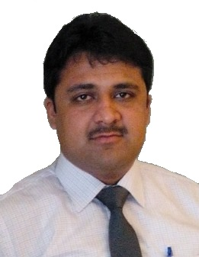
CV
ABBAS KHAN

Mohallah Eid Gah
Village & P.O. Akora Khattak
District Nowshera,KPK,Pakistan.
Mobile No. +92310-9490532

PERSONAL PROFILE

To work in a professional environment where my skills and abilities are of use to the organization and where I can work to the best of my knowledge and experience. To obtain a challenging and career oriented position, to utilize my knowledge and skills in dynamic and progressive organization with an opportunity of career growth.

BIO DATA:
Father’s Name : MUHAMMAD TARIQ
Date of Birth : 24-02-1990
CNIC : 17201-6936133-1
Nationality : Pakistani
Domicile : Nowshera (Khyber pukhtunkhwa)
Religion : Islam
Marital Status : Single
E-mail : abbaskhan2483@yahoo.com
Mobile : 03109490532

EDUCATION:

- 2014 Pharm.D (Doctor of Pharmacy) , Percentage(70 %) , Grade-A

Hazara University

- 2008 F.Sc (Pre-Medical) , Percentage (76%) , Grade-A

BISE Mardan

- 2006 SSC (Science Group) , Percentage(80%) , Grade-A-1

BISE Mardan.

ABILITIES :

- To work under challenging atmosphere.
- Quick Learning.
- Organizational Skills.
- Good Team worker.
- Capable in Administrative matters.
- Co-operative.
- Strong in taking decisions.
- Honest Worker.
COMPUTER EXPERIENCE:

      - Microsoft Word
      - Microsoft Excel
      - Microsoft Power Point

LINGUISTIC SKILLS:
      - English Fluent in both spoken and written

      - Urdu Good in both spoken and written

      - Pashto Fluent in spoken

      - Hindko Fluent in spoken

EXPERIENCE:
- 1 year Sales experience as a Territory Manager at Abbott Laboratories,Pakistan.
From 01-03-2015 till to date.

- Two year experience as a Retail Pharmacist at Shakeel Medical Center opposite to RHC,Havelian,Abbottabad.
From 01-06-2012 to 20-05-2014.

- Four months, Clinical Pharmacist experience as a Clinical Pharmacist Internee at Ayub Medical Complex,abbottabad,
From 01-01-2013 to 01-03-2013 and 01-01-2014 to 01-03-2014.

- Three months Teaching experience as a Science tutor at Hira Tuition academy, Havelian , Abbottobad ,
From 01-03-2012 to 01-06-2012.

- Three months Teaching experience as a Secondary School Science Teacher at The Suffa Model High School ,Akora Khattak , Nowshera.
From 01-03-2011 to 01-06-2011.

REFERENCE:

To be furnished upon request

