Confidence (Can-do attitude), skills, and hardworking are the keys to success.....
COVERING. .Letter.
To,  HR Manager | B.Pharmacy 2nd Division  M.B.A(Management)-1st-Division  Working Areas  Team management, Research on Training & Technical Assistance. Implementation Controlling, Supervision &monitoring of Project. Family Planning & Reproductive Health care Services. Pharmaceutical production, Operation & management.  Email: a.waqar83@gmail.com ,  waqar ahmed5597@yahoo.com

Dear Sir,
I am a Pharmacist by profession and did post-graduation in Human resource Management.
I have an extensive experience in research studies on Family Panning & reproductive health care, safe mother Hood, outreach mobile services in very poor area’s Management, Marketing & production of medicines & hospital pharmacy. I also have good experience in Community development organization, Social mobilization of rural communities, capacity building, and manage different projects of reputable organization.
I worked as a Sr. Production officer in Otsuka Pharma Company of Pakistan Hub.
Currently, I am working as District Coordation Officer in Marie Stopes Society (a Leading Reproductive health care & Family Planning org.) since last three years at District Khairpur Mir’s.
In addition I have attended different trainings of Management, Marketing, Mobilization & survey programmes with support of self capacity building specially organized by various NGOs in Pakistan.
I believe that I have a great deal to offer to your organization my services to lead team members in right direction. I am a team player and an active contributor. With my maturity and skills, I believe that I have the abilities to embark a career in your organization. Please find attached my CV to evaluate my skill and abilities.
I look forward to hear positive response.
Thank you for your consideration.
Sincerely,

Abdul Waqar Khan 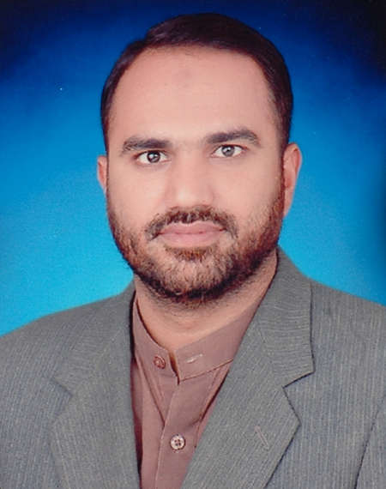
Sociologist/Analyst/Development
Professional/Pharmacist

Résumé
Abdul waqar Khan
(Pharmacist/Administrator)
Cell: +92-333-7104472.
0336-2425613
Phone: +92-0722-570609
Email: a.waqar83@gmail.com, waqar_ahmed5597@yahoo.com

OBJECTIVE:
To be a part of progressive organization of repute that believes in strong and dynamic
Workforce for the key to success of organisation with development

District CO-Ordation Officer Dist (Khairpur Mir’s)
To the date Aug-2011 Marie Stopes Society (A leading Reproductive Health Care
Service provider & Family Planning organization)

Responsibilities:
- Plan, Implementation, Monitoring & Planning of different Project Assignments of district.
- Mobilization, Survey conduction, Research Studies on RH/F.P, Administration, Managing and supervising the office & field team at district Level.
- To arrange, manage & Lead different Survey projects & assignments.
- To train & facilitate the Field team for survey conducting, communication & counselling.
- To facilitate the donors & different visitors in field visits of projected areas.
- To Facilitate team in arranging seminars, Meetings workshops with line department, community stakeholders, social activities on RH/F.P
- To facilitate the team in arranging different community level activities, surveys & sessions.
- Managing & supervising the administrative and project’s financials matters at district Level.

District CO-Ordation Officer Dist: (Kandhkot)
Marie Stopes Society (A leading Reproductive Health Care
Service provider & Family Planning organization)

Responsibilities:
- Plan, Implementation, Monitoring & Planning of different Project Assignments of district.
- Mobilization, Survey conduction, Research Studies on RH/F.P, Administration, Managing and supervising the office & field team at district Level.
- To arrange, manage & Lead different Survey projects & assignments.
- To train & facilitate the Field team for survey conducting, communication & counselling.
- To facilitate the donors & different visitors in field visits of projected areas.
- To Facilitate team in arranging seminars, Meetings workshops with line department, community stakeholders, social activities on RH/F.P
- To facilitate the team in arranging different community level activities, surveys & sessions.
- Managing & supervising the administrative and project’s financials matters at district Level.

March-2009 to March-2010 Sr Production Officer In charge (OTSUKA Pharma: PAK: LTD.) Multinational Pharmaceutical Company

Responsibilities:
- Managing and supervising the teams in the production department.
- To conduct all the activities of production about manpower, material to prepare of product.
- Packaging of a product then transferring to warehouse.
- To meeting, with sub ordinate to quality of a product according to CGMP.

Jan 2008 to March- 2009 Production Officer (OTSUKA Parma: PAK LTD

Responsibilities:
- Working in auto clave department to manage all the activity according to instructions of Immediate Boss.
- Working In packaging department to arrange material from warehouse department, arrange man power
- To packaging of product according to CGMP.
- If any type of issue, in production department to solve them.

July 2006 to Nov 2006 Production supervisor
Multination Business Link (Pharmaceutical companies)

Responsibilities:
- Managing & supervising Tablet section.
- Managing & supervising capsulation section raw material, semi-finished & finished Products.
- Assure the Proper implementation of Standard Operating Practices of quality of all products(Inj.Pills.Capsules,Syrups)
- Organizing progressive pilot projects & policies to ensure quality & facilitating the trainings, seminars, learning tours, develops link with market stake holders and other relevant activities.
- The main objective is to improve the Pharmaceutical production, ensure the implementation of quality protocols & policies & international recommendations of different research laboratories.

Languages (Read, Write, Speak)
English, Urdu, Sindhi, and understanding of Srieki.

Personal Information
Date of Birth : January -15th -1983
Domicile : Sukkur (Urban)
N.I.C : 45504-1076990-5
Religion : Islam
Marital Status : Married
Nationality : Pakistani
Contact # Phone: Cell: +92-0333-7104472, 0336-2425613
Email: a.waqar83@gmail.com

Postal Address: H: NO: 504, Sindh Colony, Shar Muhallah New pind sukkur, Sindh Pakistan.

References:
- Mr Imam Ali
Dist Manager
SRSO
Cell: 0333-7121804

- Mr Faiz Muhammad
Manager Operation PPP NEP-Marie Stopes Society
Sukkur Region office.
Contact: 0333-7177611 email: Faiz.Muhammad@msspk.org

