Curriculum Vitae
ABID ULLAH  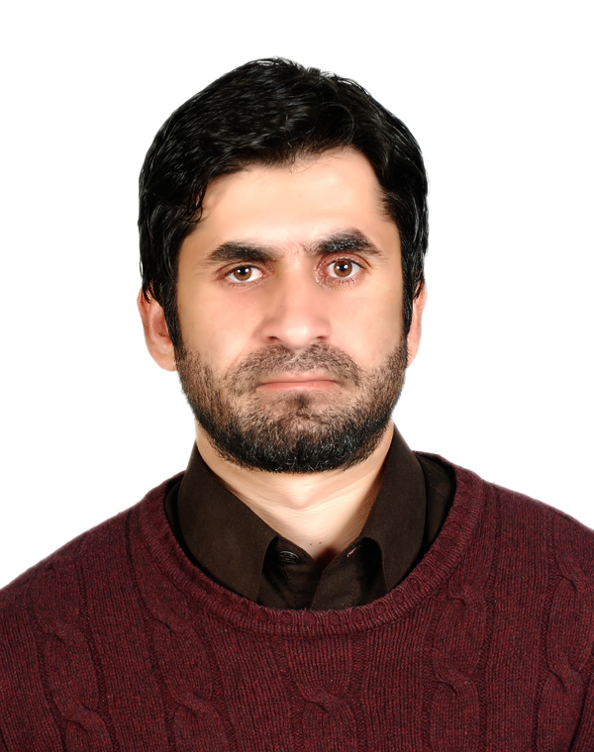  S/O  JANEB-KHAN  C.N.I.C.No:-  17301-4989184-3  D.O.B. 05/01/1990  Marital Status: single  Religion: Islam  Present Address:  House#18c,Street#3,  Gul-Nar Colony Dhode Chaudhrian  Rawalpindi Pakistan.  Permanent Address:  BARA KHYBER AGENCY  Contact:  0092- 3459050718.  E-mail:  Afridi_brother@yahoo.com | objectives:  Looking for a challenging and rewarding future in a healthy and competitive organization and to prove my will-power, resolution and mental make-up both as a team player as well as a leader through shear hard work and dedication is the ambition of my life. I offer my enthusiasm, dynamism and commitment for achieving the goal with the following:  Educational qualification:  main subjects in (b.com). main subjects in (MBA)  EXPERIENCE:  - In PTV Head Quarter Islamabad (admin and personnel dept).  computer skills:  - Having Knowledge of Personal Computer use.  OTHER SKILLS:  - Good Communication and negotiation skills.  - Capacity to carry out complex activities.  - Ability to work independently and sense of initiative.  - Strong sense of responsibility and adaptability.  - Flexibility and availability to work over time when needed.  languages:  - English: - Good command of spoken, writing, and reading.  - Urdu : - Good command of spoken, writing, and reading.  - Pushto: - Good command of spoken, writing, and reading.  hobbies:  - Reading News papers, playing Cricket, travelling, Cooking and net surfing.  References:  Will be provided according to your preference.
  Exam | Year | Board/University
  S.S.C. | 2008 | B.I.S.E. Peshawar
  D.com | 2010 | B.T.E.P Peshawar
  B.com | 2013 | Qurtuba university
  MBA | 2016 | Quaid-i-Azam Uni.
  - Accounting  - Management  - Economics  - Auditing | - Accounting  - H-R-M  - Marketing  - Business Communication

