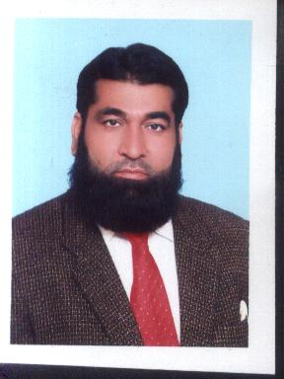
Abrar Hussain
Curriculum Vitae

Objective: -

To be the part of an energetic organization and utilize my knowledge, Skills and expertise to contribute towards organizational and professional brilliance.

Personal Info: -

Name abrar Hussain

Father’s Name Muhammad Hussain

Date of Birth 23-11-1973
Marital Status Married
Religion Islam
Nationality Pakistani
C.N.I.C No. 35201-0685881-1
Cell No. 03224765172

Address House No1a, Street #4, singpura
Ghuray shah road Lahore

Academic Qualification: -

Matric 1986 Lahore Board
F.A 1990 Lahore Board
B.A 1994 Punjab university
Experience: -

  - 4years experience.stal labtry (F.M)
  - 2years experience amson pharma.(F.M)
  - 2 years experience Stand pharma (A.S.M)
2 year experience bion pharma(A.S.M)
Key Strengths: -

- Strong interpersonal and communication skills
- High expertise in problem solving strategies.
- Strong skills in maintaining discipline and decorum.

Languages:-

English, Urdu, Punjabi.

Hobbies:-

Playing Cricket

Reference: -

Will be furnished upon request.

