Absar Ahmed Siddiqui  Lane no 2, Quaid-e-Azam Colony Chakri Road, Rawalpindi  Phone: 03035849988 , 03361917338  Email: smartworker50@yahoo.com | 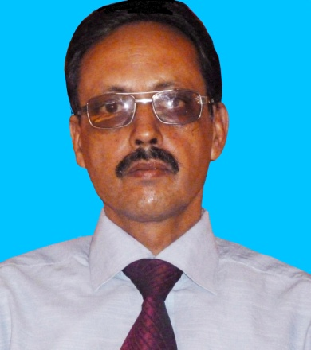

 | Objective
I wish to work in an organization where I can prove my worth as a part of that organization. I also want to learn in a congenial atmosphere which provides chances of making head way.

Professional Experience

Presently working in

DON VALLEY Pharmaceutical (Pvt) Ltd

As AREA SALES MANAGER

Worked as AREA SALES MANAGER in a Karachi based pharma company “Century Pharmaceutical” from January 2009 till Nov 2013.

Goodman International Rawalpindi. | Nov 2005 to Sept 2008
Area Manager (Peshawar)

Olive Pharmaceutical Rawalpindi. | Oct 2000 to Aug 2005
Area Manager Rawalpindi.

Mead Johnson Nutritional, Karachi | Jul 1993 to Sept 2000
Medical Representative Jul 1993 to Aug 1997 Based at Rawalpindi.
Senior Medical Representative Sep 1998 to Jul 1999 Based at Peshawar
Field Manager Aug 1999 to Sept 2000 Based at Rawalpindi

Area Exposure:
Rawalpindi Region: Rawalpindi, Islamabad, Taxila, Wah Cantt, Hassanabdal, Hazro, Ghazi, Attock, Haripur, Abottabad, Mansehra, Battgram, Muzaffarabad, Rawlakot, Bagh, Hajeera, Abbaspur, Mirpur, Kotli, Gujar Khan, Chakwal, Talagang, Jehlum, Gujrat.
Peshawar Region: Peshawar, Charsadda, Nowshera, Mardan, Battkhela, Swat, Kohat, Parachinar, Bannu.

Core Competencies

- Dynamic, result-oriented professional with over 22 years of broad based experience.

- A team player brings enthusiasm and energy into group efforts.

- Focused on quality and productivity.

- Excellent customer relationship management.

- Excellent time management skills.

- Strong follows up on all tasks related to Operations, Sales & trainings at each & every stage of development.

Personal Information

Father’s Name: Masood Akhter Siddiqui (Late)
Marital Status: Married
Children: Four
Education: Graduate
Date of Birth: 14th March 1965
Religion: Islam
Nationality: Pakistani
N.I.C No: 37405-0395674-5

Academics
BA | Dec 1986
Jamia Karachi, Karachi, Pakistan, with (Grade/GPA) A

Skills
Computer | Level: Intermediate
with 10 year(s) of experience, Currently used

Languages
English | Conversational - Advanced

Punjabi | Fluent - Full Knowledge

Urdu | Fluent - Full Knowledge

References
Nadeem Siddiqui 03072223259 | Professional
Ferozsons Pharmaceutical Rawalpindi.

Shoaib Ahmed Khan 03345443096 | Professional

Werrick Pharmaceutical Rawalpindi

