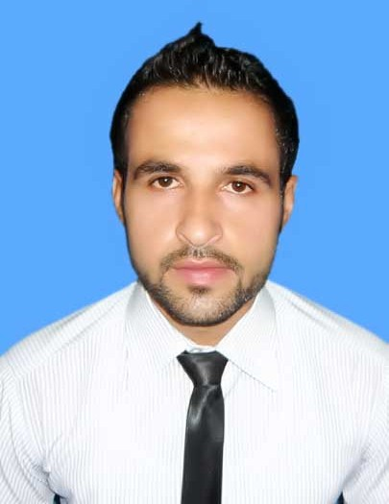
ADIL KHAN
House # 693 Inside Asia Gate Illqa Dabgari Peshawar Pakistan
Email: Adilakbar72@yahoo.com
Cell #: +92313-9772364

Objective
- To work with an organization that could utilize my skills and Knowledge and provide me an environment that could polish my abilities.

- I have adaptability to adjust myself in all types of environment and societies and having strong communication and personality enhancement aptitude, self-motivated person and believe in only hardworking.
Personal Profile

Father’s Name : : Haji Lal Akbar
Date of Birth : 01-04-1991
Domicile : Peshawar Kpk
Religion : Islam
Nationality : Pakistani
Marital Status : Unmarried
Postal Address : 693 Inside Asia Gate Illqa Dabgari Peshawar
Pakistan
Academic Qualification
Pakistan Degree / Certificate | Board / University | Session
BA | University of  Peshawar, Pakistan | 2012
FA | Board of Intermediate & Secondary Education Peshawar | 2010
SSC | Board of Intermediate & Secondary Education Peshawar | 2008

Professional Experience
- 1 Years working experience as HCR at Ferozsons Laboratries in District Peshawar .
- 1 Year experience as F.E Amarant PHARMA
Summary
- Excellent interpersonal skills, team player and ability to work well with all level of an organization. Effective presentation, verbal and communication skills.
- Ability to handle sensitive and confidential information with absolute discretion is mandatory to the position, able to work in a cross-cultural environment.
Individual strength
- Enjoy the challenges of fast paced work environment, meet the demand of heavy work load have flexible attitude and work with diverse responsibilities.
Future Planning
- To work in Web Hosting.
- To create new ideas.
- To develop short long term goals and target
- To improve efficiency and effectiveness of organization

Communication/computer Skill
Reading Writing Speaking listening
English Excellent Excellent Good Excellent
Urdu Excellent Excellent Excellent Excellent
Pashto Excellent Excellent Excellent Excellent
Local Languages Good Fair Excellent Excellent

- Typing
- Microsoft Word.
- Microsoft Excel.
- Microsoft Power point.
- Internet Surfing.

- Adobe Photo Shop
- Photo and video Editing
- Make this ID’s all Internet Companies.
- Net image
- Software’s Installation
- Windows Installation Window-7, Window-8 ,2007, 2006, 98.
- Good communication, analytical and interpersonal skills.
Willing to improve professional knowledge through constant hard work

Hobbies
- Social Working
- Reading
- Traveling
- Read Islamic books
- Internet Searching
- Listing Quran pak
- Listing Ahadees mubarka
- New Software’s learn

