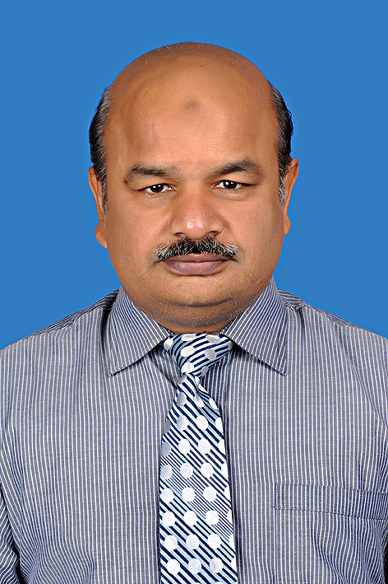
AHMAD NADEEM

nadeemshafi323@gmail.com
nadeemshafigsk@yahoo.co.in

323. DIII. WAPDA TOWN LAHORE.
Mobile: 0331 4239842
0300 4275939

- Dedicated Senior Medical Service Executive with years pharmaceutical sales experience both in local and MNC (GlaxoSmithKline/Wilson pharmaceutical ) in Pakistan. Highly motivated and result oriented sales professional aspiring to establish career with reputed organization offering challenging and rewarding assignments in sales and marketing. Consistently ensure high performance with growth and turnaround of underperforming areas.
- Respected builder and leader of customer-focused teams; Instill a shared, enthusiastic commitment to customer service as a key driver of company goal attainment. Lead by example and ensure the execution of all organizational policies for the achievements long term business goals.

Personal Expertise

- Co-operates well with others; shares knowledge, experience and information; supports others in the pursuit of team goals.
- Experience of promoting top brands of industry related to therapy areas like gastroenterology, pediatrics, gynecology, pulmonology, surgery, medicine, and GP sector.
- Identifies and seizes business opportunities and has a strong positive impact on sales growth and profitability.
- Customer Service Management.
- Focus on personal development.
- Experience of promoting antibiotics, antiulcerants, analgesics, inhalers, vitamins etc. in leading pharmaceutical company (glaxosmithkline).
- Expert in relationship building.
- Quick learner and focus on acquiring new information about diseases and products.
- Ability to develop KOLs for company brands for long term business support to the company.
- Passed multiple courses on Presentation/selling skills (WSFE.REP).

Managerial expertise

- Ability to develop business strategy and appropriate action plans for self and team.
- Sales data and trend analysis. Focusing on key performance indicators to monitor performance for best results.
- Experience and understanding of complete health care professional environment and its dynamics.
- Coaching and development skills.
- Coach in house and on job to the sales team to ensure 100% achievement of assigned sales targets.
- Good communication, leadership and analytical thinking and ability to adapt well in new environment.
- Ability to handle multiple tasks at one time through proper planning and management.
- Well versed with basic computer applications combining sound knowledge of MS office and internet.
- Teambuilding & Training

Professional Experience/Rewards

- Territory manager 1993-1994 Wilson pharmaceuticals.
- Senior Medical Service executive GlaxoSmithKline Pakistan, 12-2-1994 to date.
- Promoted to senior grade in 2009, during this period work in different areas of Lahore and its peripheries and Involved in variety of tasks.
- Won “Star Awards” for achieving highest sales growth not only in region but also at national level.
- Remain top scorer in quiz competition five times at national level.
- Winning detailing competitions more than 15 times in my career
- Officially declared BRAND AMBASSADORR for ZANTAC in LHR zone and delivering presentations in different areas and institutes almost 3 times in a month since the start of this program from 2007.
- Also remain involved in organizing different training workshops conferences for health care professionals.
- Being the senior member of my team arranged different in house session for the training of new team members.
- Whenever my first line manager is on leave I have been given managerial assignment repeatedly to manage team performance and co-ordinate with higher management.

- In order to develop myself as true professional I have been selected in different courses training programs relating to communication and interpersonal skills which are organized by leading HR development companies of Pakistan(nerajo,navitus etc).

Education and Training

- BSc. (premedical) from Govt. College Lahore.

- Computer course from Punjab University.

- IELTS. 2006 from British council.

- Diploma in Business management 2008 from skills development council Punjab.

