H.No 356 C, Officer Colony 2, Madina Town Faisalabad ,
Cell # 0334 4108428
Aiman Ashfaq 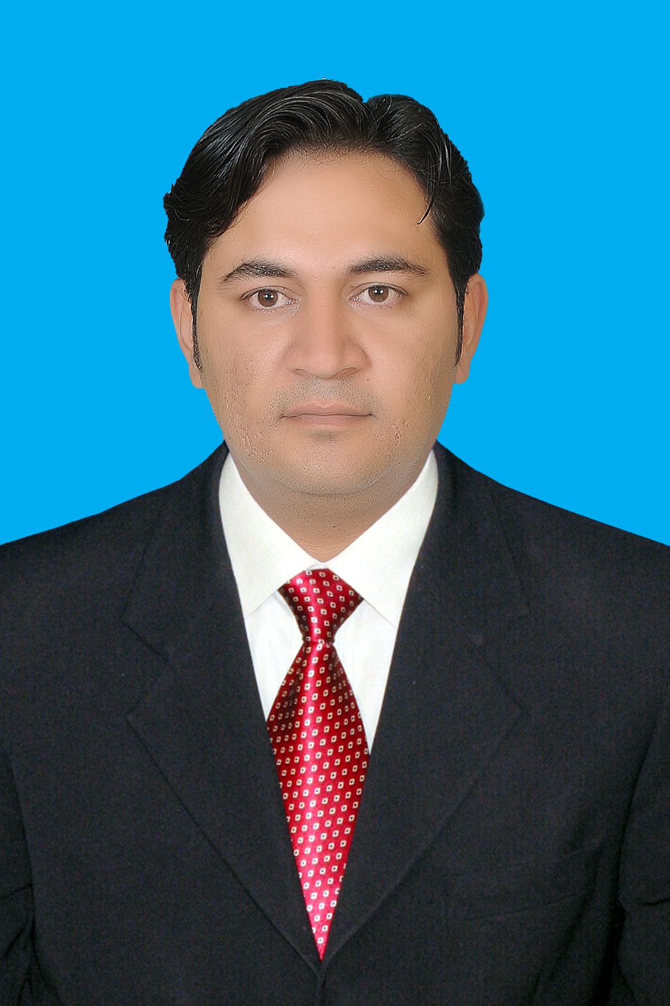
Objective | Want to play an active role in the success of an organization having challenging job and growth opportunities.
Experience | 2005 till Now  Sales Manager (From Sep 2014 till Now)  Got promotion as Sales Manager In Sep 2014  Based at Faisalabad  In Reporting: 1 Zonal Sales Manager  5 Managers  21 Tm’s  Area Coverage:  Faisalabad, Jhang, TT Singh, Sargodah, Multan, Vehari,  Khanewal, DGK , Layyah, Bhakker, Bahawalpur, Bahawalnagar,  Mianwali  Distribution Coverage : 13  Also Office incharge at Faisalabad  Zonal Sales Manager ( From Jan 2014 – Sep 2014)  Join Wilson Pharmaceuticals as  ZSM based at Okara  In Reporting: 4 Managers  12 TM’s  Area Coverage:  Okara, Shaiwal,. Kasur  Distribution Coverage : 3  Area Sales Manager (From 2010 – Dec 2013)  Join Himont Pharmaceuticals as  DSM (2012 – Dec 2013)  In Reporting: 10 Tm’s  Area Coverage:  Lahore, Sahiwal, Okara.  Join Macter International based at  Lahore in Respiratory Group From July (2009 to 2010)  Got Internal promotion in Macter Pharmaceuticals as  RSM( 2010-2012)  Specialty Group (Respiratory Group)  In reporting : 5 PA’s  Area Coverage:  Lahore, Sahiwal, Okara, Gujranwala, Sialkot, Gujrat, Jehlum,  Mirpur Khas  Distribution Coverage: 6  Transfer to North Region As RSM in Same Group  In reporting 3 PA’s  Area Coverage:  Mardan, Sawabi, Charsadah, Swat, Temelgarah, Dir, Chitral  Pharma Associate/Sales Promotion officer  (From 2005 till 2010)  Responsible for visiting doctors' offices, hospitals, clinics,  pharmacists and other healthcare facilities with the goal of selling  prescription drugs.  Working as Pharma Associate in Macter International based at  Lahore in Respiratory Group From July (2009 to 2010).  Working as Territory Manager in Atco Laboratories Based at  Children Hospital Lahore From (Jan 2008 to June 2009).  Working as Sales Promotion Officer in Martin Dow Pharmaceutical  Based Lahore Pakistan From Feb (2005 to Jan 2008).
Event Management
- Planning and organizing stall activities at different events.
- Develop and implement annual, quarterly, monthly event management plans for maximum output.
- Managing brand promotion activities at operational level

Sales Management

- Managing sales operations for achieving increased growth &
bottom-line profitability and initiating market development
efforts.
- Conceptualizing & implementing sales activities as a part of market
development and brand building effort
- Can do approach and self driven.

Team Management

- Recruiting, training & monitoring the performance of team members to ensure efficiency in event management, operations and meeting
individual & group targets.
- Conducting meetings for setting up sales objectives and designing or streamlining processes to ensure smooth functioning of sales and
operations.
- Creating and sustaining an environment that fosters development
- Opportunities and motivates high performance.

Education | 2001-2003 BCS (Bachelor of Computer Sciences)  Nasreen Kiyani Foundation College (pvt) Lahore, Pakistan  1999-2001 F.S c (Computer Sciences)  Pakistan Air Force Degree College Risalpur. Pakistan  1998-1999 Metric / 10th (Science)  Federal Govt Public High School Mardan Cantt, Pakistan
Interests | Fond of outdoor physical activities, cricket, long Drive, Computer  Games, Surfing
Personal Information
Father’s Name: Ashfaq Ahmed (Late)
Religion: Islam
Nationality: Pakistani
Date of Birth: 19th Feb, 1983
Marital Status: Married
Languages: English, Urdu & Punjabi, Pashto

