CURRICULUM VITAE

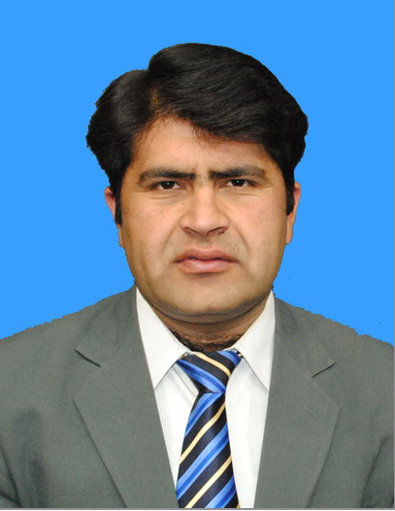
Arif Ullah

Mob 03009363905 Email. Arifullah.danone@gmail.com
Banaras Khan Town Duran Pur Ring Road Peshawar

_____________________________________________________________

Vision:
To increase the shareholder value and maximize profit by improving the operational efficiencies and maximum utilization for the available resources.

Keys for Success:
- Integrity
- Ethics
- Leadership
- Teamwork
- Training
- Recognition
- Communication
- Continuous Improvement

CAREER OBJECTIVE

To find a challenging position to meet my competencies, capabilities, skills, education and experience

PERSONAL INFORMATION

F/Name | Shah Nawaz Khan
D.O.B | 11-02-1984
Domicile | Charsadda
NIC # | 17101-6568484-7
Marital Status | Married
Nationality | Pakistani
Religion | Islam

EDUCATION

2009- 2011 | Virtual University Lahore Pakistan  MBA Marketing
2002- 2004 | University of Peshawar  B.Sc
2000-2002 | B.I.S.E Peshawar  F.Sc
1998-2000 | B.I.S.E.Peshawar  S.S.C

.

PROFESSIONAL EXPERIENCE

May 2013 to Present | Medical Representative  DANONE NUTRICIA  Karachi Pakistan
Dec 2008 to May 2013 | Professional Services Representative  WYETH NUTRITION  Karachi Pakistan
Jan 2008 to Dec 2008 | Sale Promotion Officer  Global Pharmaceutical Pvt Limited  Islamabad Pakistan
Jan 2007 to Dec 2007 | Sales Promotion Officer  Arco Pharmaceutical Pvt Limited  Karachi Pakistan
June 2005 to Jan 2007 | Sale Promotion Officer  Global Pharmaceutical Pvt Limited  Islamabad Pakistan

EXPERTISE:
- Achieving organization objective with maximum utilization of available resources
- Supervises and Motivate the subordinate while achieving company goals,
- Prepares Monthly and Quarterly plan to achieve the targets
- Coordinates with Business Unit Managers and Fied Manager to:
- Develop Strategy according to yearly sales projections.
- Monitor Stock vs Sales.
- Coaches and trains subordinate on job training programs
- Help with immediate boss in setting annual team objectives and training of collogues.
- Ability to take initiatives and accept challenges
- Flexible in any environment
- Worked as a acting District Field Manager form Feb 2011 to Feb 2012

COMPUTER SKILLS:

- Ms Office
- Internet

LANGUAGE:
Urdu, English, Pashto

HOBBIES:
Using internet

