Asif Jalal Siddiqui
FLAT NO.A-15, 4th FLOOR, ALLIANCE PERADISE PHASE.2
SECTOR 11-C/1. NAGAN CHOWRANGI
NORTH KARACHI. KARACHI-75850
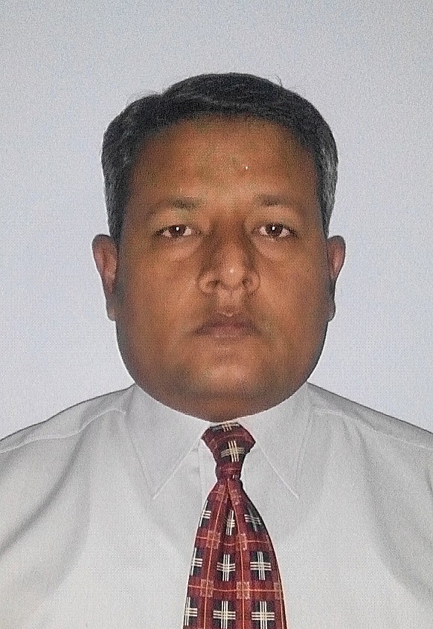
Cell : 0300-212-4141
Email: asifjalal56@gmail.com

CAREER OBJECTIVE

To become a successful sales person in an esteemed organization where by utilizing my skills and experience, I can contribute to achieve the corporate objective

PROFESSIONAL EXPERIENCE

- MANGROVE PHARMACEUTICALS.

 Sales Manager (south) March’15 to till to date.

- Building the team achievers.
- Hiring to appropriate person.
- Training the field force for current job.
- Development the field force for future job.
- Achievement of monthly quarterly and yearly targets by F.Ms by units by products.
- To develop key opinion leaders to build company’s image and bet their support in sales achievement.
- Implementing marketing strategies.
- To retain professional relation with distributors in macro and micro towns.

- AMARANT PHARMACEUTICALS.

 Sales Manager (south) Feb’13 to March’15.

- CCL PHARMACEUTICALS.

 Asst. Sales Manager (Aug’11 to Feb’13)
 District Sales Manager (June’09 to April’11)

AGP (Pvt.) Ltd
.
 Regional Sales Manager (Aug’08 to Mar’09)
✶ Asst. Regional Sales Manager (Sep’06 to July’08)
✶ Sr. Territory Manager (Jan’05 to Aug’06)
✶ Sales Promotion Officer (Aug’02 to Dec’05

ACHIEVEMENTS

- Throughout my career in AMARANT PHARMA my team stood second & sometimes first on national basis.

- Got the highest sales achievement (122%) award of Third quarter of 2014.

- Got the highest sales achievement (158%) of YTD history of Mass Pharma.

- Got the highest achievements (115%) year to date history of Mass Pharma in respective team.

- Got the highest YTD achievement award continuously four years in AGP pharmaceuticals.

- Got best participation awards in all kind of training programs in AGP Pharmaceuticals.

- Generated good business from KPT, KDLB, PNS Shifa, Baqai Hospital, Abbasi Shaheed Hospital, PMTF, HOPE, Sindh Govt. New Karachi, Airport security force, Attock cement factory, Civil Hospital, PTCL, PIA etc.

ACTIVITIES

- Conducted in house training programs for field force and Business Unit Manager on Cycle meeting occasions.

- Having vast experience of conducting Doctors Program, RTDs, Scientific sessions, Social events with doctor’s families, arranging stalls on conferences etc.

- Developed highly professional relations with Trend Setters and Leading Consultants to conduct trials on company products in order to conduct them involved for prescriptions.

- Developed opinion leaders to speak out in favor of products in front of their pears, doctors of other specialties, general practitioners etc. in scientific programs.

- Created an excellent image of company and its products in the mind of both primary and secondary customers.

PERSONAL

Father’s Name : Jalaluddin Siddiqui (Late)
Date of Birth : 28th Nov 1976
NIC # : 42101-5204451-9
Marital Status : Married

QUALIFICATION

- B.Sc in 1998 from Karachi University.

REFERENCES
Can be furnished upon request.

