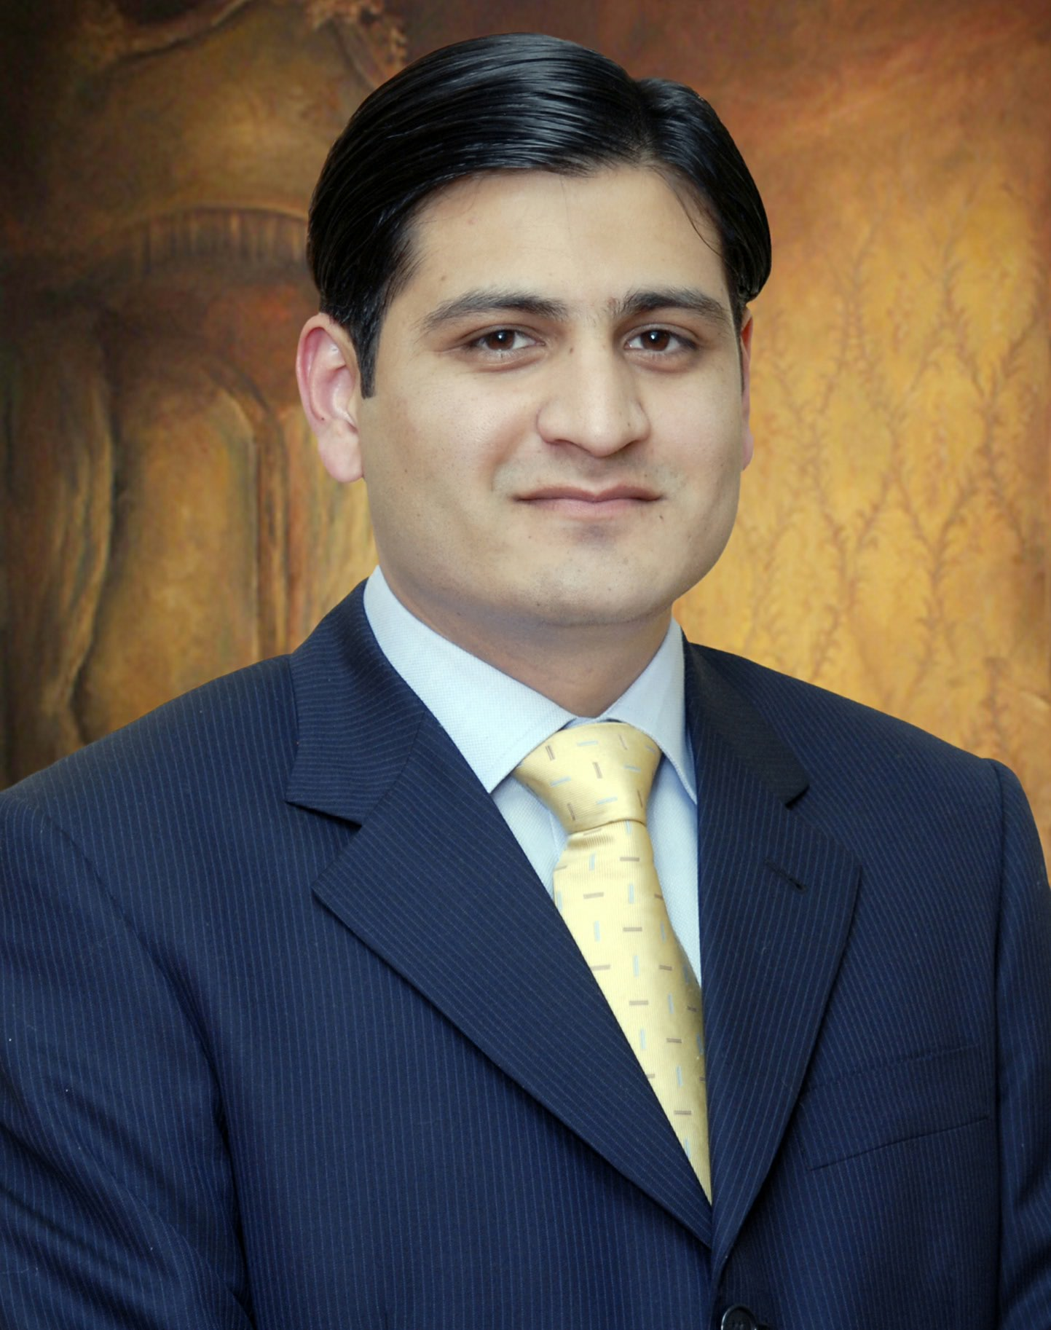
Atif Gulraiz Butt
378, D-3, Wapda Town, Lahore
Cell: (+92 321) 4242625
atif.gulraiz@gmail.com

Personal Statement

My name is Atif Gulraiz Butt belongs to Pakistan having Sales Management & Business Development, Management experience of Pakistan market from last 8 years. Since 2009 I have been working as Regional Sales Manager (North) at Mitchell’s Fruit Farm Limited a leading FMCG which produces Jams, Jellies, Marmlades, Ketchup, Sauces, Pickles, Ready to Eat Food, Squashes, Chocolates & Confectionary products.

My current portfolio is as under;

- Pakistan General Trade market sales.
- HORECA business development experience & exposure which is business to business dealing.
- Retail distributor handling management.
- General Trade retail outlets handling.
- General Trade whole sale outlets handling.
- Third party sole distribution network for managing supplies for sub distributors.

I am a keen learner and devour any opportunity to enhance my skills. I have a firm belief in seizing opportunities, possess excellent problem solving skills and engineer my efforts to pro-actively meet and exceed customer requirements, consistently in line with tactical and strategic initiatives. I am also flexible and a hardworking individual with the ability to plan effectively across multiple work streams, meeting and managing aggressive deadlines.

Although all businesses are challenging, my experience and education enable me to deliver beyond expectations. With my desire, motivation, and dedication I am convinced that I can make a positive contribution to any company.

I hope the above mentioned details would give you a general idea of my abilities and interests in order to give me a chance to serve your esteemed organization and prove myself. It is my strong belief that this will help me build on my existing knowledge and experience benefitting both myself and my future employer.

Enclosed please find my résumé for your kind perusal.

Objective:

To gain a position in a dynamic and well reputed organization which offers good career opportunities and a challenging working environment.

Career Highlights

Regional Sales Manager @ Mitchell’s Fruit Farms Limited
Regional Office - (North) (April 2010 – Present)

“Mitchell’s Fruit Farm Limited produces Jams, Jellies, Marmlade’s, Ketchup, Sauces, Pickle, Ready to eat Foods, Squashes, Chocolates & Confectionary products”.

- Assisting Head Of Sales in day-to-day official work by managing the team of 17 operational staff & liaison with 07 Warehouses, 1 ASM, & 65 Distributors.
- Custodian of north region (Sales & Distribution Management System) implementation.
- Responsible for smooth sales operations and distribution north region by implementing Company policies/ procedures.
- Taking initiatives and made strategic decisions to improve service level.
- Liaison with supply chain & production for demand management, sales forecast, Production planning & budgeting.
- Field force, warehouses & distributors’ monthly claims & expenses controlling/monitoring/authorizing.
- Monitoring daily sales achievement (volume/ value) against targets, primaries vs. secondaries.
- Independently hired & developed sales team & distribution structure from the scratch.
- Initializing training sessions for sales staff on regional level.
- Designed & monitored BTL & other trade activities to improve the availability/ visibility of all SKUs.
- Made trade & consumer offers with the help of field force suggestions.
- Evaluated team performance through appraisals.
- Evaluating sales force performance via customer survey & taking corrective actions.

Sales Promotion Executive @ Mitchell’s Fruit Farms Limited
Head Office – Lahore (25th February 2010 – April 2010)

“Mitchell’s Fruit Farm Limited produces Jams, Jellies, Marmlade’s, Ketchup, Sauces, Pickle, Ready to eat Foods, Squashes, Chocolates & Confectionary products”.

- Reported to NSM directly regarding Mitchell’s sku’s presence in market.
- Independently hired & developed sales team & distribution structure from the scratch.
- Geographical expansion of business.
- Taken initiatives and made strategic decisions to improve the sales, achieved highest sales.
- Controlled/ monitored/ authorized all field force & distributors’ monthly claims/ expenses.
- Monitored daily sales achievement (volume/ value) against targets, primaries vs. secondaries & distributor’s ROI.
- Successfully launched new SKUs on regional scale.
- Made trade & consumer offers with the help of sales & marketing team’s suggestions.
- Designed & monitored BTL & other trade activities to improve the availability/ visibility of all SKUs.
- Coordinating with marketing department for ATL/ BTL & participating in agencies meetings.
- Monitored primaries/ secondaries/ minimum inventories at warehouses, distributors & trade level.

Channel Development Manager @ Tech Pecific – (Canyon Tech Pakistan)
Head Office – Lahore (7th December 2009 – 20th February 2010)

“Canyon is one of the world’s fastest growing brands in IT related customers electronics in Asia & EMEA (Europe-Middle East-Asia) region. Taiwan based company has an established network of sales offices in more than 50 countries”.

- Reported to MD/CEO regarding the performance of sales team.
- Responsible for smooth sales operations and implementing Company policies/ procedures.
- Taken initiatives and made strategic decisions to improve service level.
- Monitored daily sales achievement (volume/ value) against targets, credit limits.
- Initialized training sessions for sales staff on regional level.
- Made trade & consumer offers with the help of field force suggestions.
- Evaluated sales force performance via customer survey & taking corrective actions.
Business Development Manager @ Classical Office Products
Lahore – Head Office (2nd December 2008 – December 2009)

“Classic Office Products is the largest supplier of printing solutions services offered the customers government & private sector”.

- Reported to CEO directly.
- Managed the team of 25 area managers nationwide.
- Taken initiatives and made strategic decisions to improve the sales, achieved highest sales.
- Strong implementation of Sales and Marketing activities.
- Investigated and evaluated complaints and recommended solutions.
- Managed day to day business issues at the trade.
- Exercise administrative as well as functional authority over the sales staff.
- Assisted sales staff in their territories by training through meetings, on-job guidance and helping in making sales and developing new channels.

Corporate Account Manager @ Yaqoob Group of Companies - (O&A Business Machines)
Lahore – Regional Office (10th June 2008 – 28th November 2008)

“Yaqoob Group Of Companies since 1949, presence in 9 major cities.”
“O&A Business Machines are the exclusive/authorized distributor for such multinational companies as TOSHIBA & RISO. They sell products as well as services having 8 independent offices different regions”.

- Reported to Regional Sales Manager.
- Daily targets Monitoring at Region/ Areas/ Territories.
- Prepare the cost benefit analysis vs competitors brands.
- Planned with the help of RSM and in line with the E-mail’s receiving from Head Office about the roll out of Launches, Re-launches, Consumer Promotions, Trade Offers.
- Coordinated in all IT related affairs of the Region and followed-up with team members.
- Resolved consumer and trader’s complaints through follow up with field force.
- Coordination with government & Private departments.

Product Manager @ Computer Marketing Company
Lahore – Head Office (4th April 2007 – 30th May 2008)

“Computer Marketing Company is the authorized distributor of SAMSUNG printers in Pakistan. They sell IT related products Servers, Printers, Cash Counter Machines & offer after sales and services facilities with all over the Pakistan having regional offices in different areas.

- Reported to Director Marketing (DM).
- Responsible for providing the feedback and proper guidance to field force.
- Promoted distributor retention by settling their claims in a timely manner.
- Targets split and monitoring and Monthly Meetings preparation.
- Actively involved in re-organization of distribution nation wide
- Developed assorted sales presentations on Microsoft Power Point.
- Data consistency checking after getting the data from field force & distributors.

Interships

- Industrial Development Bank Of Pakistan (Karachi) – (4th August 2003 - 4th October 2003)
- Commercial Banking, Deposit Banking, Forex Dept.

- AD Sells Publicity Services Private Limited (Lahore) – (02 October 2006 – 09 December 2006)
- Market Survey, Customer Relationship, Print Media Section, Accounts.

Academic

- Master in Business Administration (MBA) in 2006.
- Graduation from Lahore Board in 2003.
- Matric Certificate from Lahore Board in 1999.

Courses

- Seven Habits of Highly Effective People “Franklin Covey” – Mitchell’s Fruit Farm Limited
- Un-leashing creativity to deliver Strategic Excellence “Sunail Gupta” – Mitchell’s Fruit Farm Limited
- Companies Vision Preparation Workshop “AR Mir” – Mitchell’s Fruit Farm Limited

Skills

- Diploma information Technology (DIT)
- Strong negotiation and interpersonal skills
- Business Development
- Sales Operation

Attributes

* Leadership Skills * Management by Objectives
* Strategic Thinker * Result oriented
* Strong Motivator * Strong & Careful planner
* Quick Learner * Problem solver
* Dedication & Commitment * Work well with others

Awards

- Highest sales volume & value growth Award 2010-2011 “North Region”
- Highest sales volume & value growth Award 2011-2012 “North Region”
- Best Regional Sales Manager Award 2012-2013 “North Region”

Interests

- Sales & Marketing
- Operations & Administration
- Playing and watching cricket
- Badminton

Personal

Date of Birth: April 15th, 1981 Marital Status: Married
Languages: English/ Urdu/ Punjabi Travelled: UK

References

Available on request.

