MR. MUHAMMAD NISAR AFRIDI

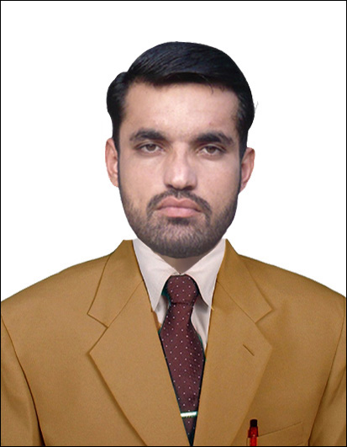
PERSONAL BIODATA
Father’s Name: Badshah Khan
Date of Birth: 15-03-1990
NIC# 17301-1060634-7
Domicile: F.R Peshawar (FATA)
Religion: Islam
Marital Status: Married
Nationality: Pakistani
Cell No: Other contact No:
Email: m.nisar998@gmail.com
Postal Address: Post Office Sherkera Tehsil and District Peshawar,
Permanent Address: Jabba Musaly Sherkera Tehsil and District Peshawar.

CONTACT NO: +92-301-8904068 +92-345-4994081

OBJECTIVE:
To join an esteemed organization where I can practically explore my skill and abilities and to add success & growth to that organization and my carrier as well.

QUALIFICATIONS:

Career | School/College  University | Date of declaration result | Total Marks | Obtain Marks | Grade/Division
SSC(Science) | G.H.S Sherkera Peshawar | 22-06-2005 | 1050 | 498 | D/2nd
F.A | G.D.C Dara Adam Khel F.R Kohat | 10-08-2007 | 1100 | 606 | C/2nd
B.A | G.D.C Dara Adam Khel F.R Kohat | 27-11-2013 | 550 | 262 | C/2nd
Shorthand | Al-Farooque Institute | 17-07-2013

PROFESSIONAL EXPERIENCE:

- TEACHING EXPERIENCE:
Two years teaching experience at Mohmand Public High School Passani Peshawar as English Teacher.
- Marketing Experience:
One year of marketing experience of promoting lubricants in Peshawar of BEST company.
- COMPUTER SKILLS:
6-months certificate in office automation from Hitec Collage Peshawar.
MS Word, Ms Excel, Power point.
Designing and other program.
Corel Draw, Adobe photo shop, Ulead Video studio.
LANGUAGES:
Pashto (Read, Write, Speak)
Urdu (Read, Write, Speak)
English (Read, Write, Speak)

