M. Asif Khan
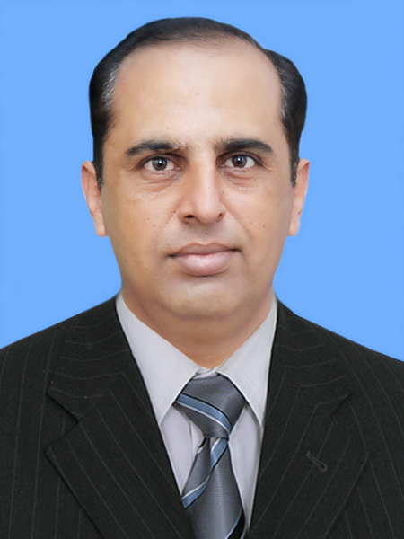
Mobile: 0312-5851256.

Objectives:

To join a highly skilled team of professionals, where I can prove my abilities, and try to groom up myself for career development.

Personal Information:

Name: M.Asif Khan.
Father's name: Mir Afzal Khan.
Religion: Islam.
Marital status: Married.
Children: Three.
E-Mail: masifasm@hotmail.com.
Address: H # 161, Lane # 9, Ali Town, Adyala Road Rawalpindi.

Academic Qualifications:

B.Com from Punjab University.
I.Com from Rawalpindi College of Commerce.
Matriculation from Rawalpindi Board.

Job Experience:

April 2000 to March 2002:

I started my career in Pharmaceuticals industry from “GETZ” Pharma at the post of Sales Promotion Officer.
April 2002 to 30th June 2009:

I worked in “SAMI” Pharmaceuticals as “Medical Information Officer.
Achievements:

During my stay in “SAMI” Pharma, I remained a regular incentive
winner.
In the year 2006, my overall achievement (sales vs targets) was
161%.
In the year 2008, I got promoted as Product Specialist.

July 2009 to April 2013:

I joined Bio Angel Pharmaceuticals as “Area Sales Manager”.
In Aug 2010, on the basis of performance I got promoted as
“Sales Manager”

April 2013 to Jan 2015:

I worked in Al-Khowais Group of companies Dubai.

April 2015 to July 2016:

I worked as “Area Sales Manager” in Shaigan Pharmaceuticals.

August 2016 till Date:

I worked as “Area Sales Manager” in Cirin Pharmaceuticals.

Other Qualifications:

Medical Transcription.
Computer basics course.
Language Proficiency:

English, Urdu, Pushtu, Kashmiri, Punjabi and Pothohari.
Interpersonal Skills:

Ability to work in a challenging environment, with minimal
supervision.
Excellent organizer in team Management.
Excellent communication skills.

M.Asif Khan

