FARHAN SHAIKH  Add: House No. A-30 Thamsabad, Mirpurkhas – Sindh.  Cell # +92 345 3166 322  Email: farhan.shaikh@gmail.com | 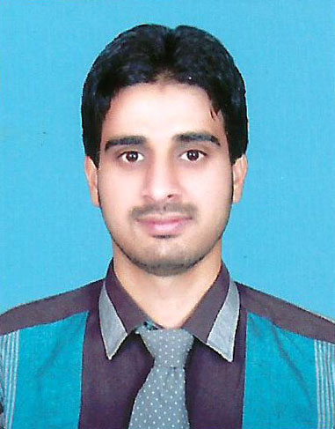
OBJECTIVE  I have gained significant knowledge in the field of LAN & Wireless Networking. And Web-Design & Develop skills. With this knowledge, I foresee a better, self-sufficient and aspiring IT future. I would like to improve upon my skills while in turn benefiting the organization for which I work, working cross functionality with others and prioritizing responsibilities. Responsible, reliable, able to work quickly, optimistic and hardworking.  EXPERIENCE  Assistant to Director of Admission office worked as a DATA ENTRY/MULTIMEDIA OPERATOR and FILE MANTANANCE to January 2010 – still continue.  Company Name, Muhammad Medical College, Mirpurkhas – Sindh is a leading and growing department in Rural Area of Sindh.  A brief synopsis of my job description is attached herewith for your kind perusal.  - I manage all the work related to the Admissions and Students file Mantance as well.  - Install, setup, monitor local area network (LAN). Perform a variety of maintenance, evaluation installation, and training tasks to ensure LAN performance meets department and user requirements.  - Install, configure, and maintain personal computers, file servers, Ethernet networks, network cabling, and other related equipment, devices, and systems; adds or upgrades and configures modems, disk drives, CD ROM units, printers, and related equipment.  - Investigate user problems, identify their source, determine possible solutions, test and implement solutions.  - Install, configure, and maintain personal computers, switches and others networking devices and related equipment.  - Troubleshoot networks, systems and application to identify and correct malfunctions and other operational difficulties.  - Establish and perform maintain programs department.  - Evaluate and/or recommended purchase of computers, network hardware, peripheral equipment.  - Establish user profiles, user environment, directories, and security for networks being installed.  - Interview the new comers/employee in Computer Department.  - Willingness to work different shifts.  - I have also been working as Network Administrator at Hatf Research Projects and Technologies, Mirpurkhas – Sindh, Pakistan.  - Teaching Experience in Muhammad Institute of Science & Technology in the program of (BBSYDP) course named: Web-Designed & Development.  - Teaching Experience of the University Candidates regarding their projects, course named: Web-Designed & Development.  - Cisco Certified Network Associate (CCNA) Routing and Switching is a certification program.  Worked as a DATA ENTRY OPERATOR and Record MANTANANCE to January 2009 – 2010.  Company Name, TCS OFFICE, Mirpurkhas – Sindh is a leading and growing department in Rural Area of Sindh.  - Established good and professional relationship with the customers and provide them better services as per the company policies.  - Were passion to accept challenges and targets?  - Receive and respond to customer complaints.  - Verify customer and order information for correctness, checking it against previously obtained information as necessary.  EDUCATION  Masters in Computer Science -MCS (Continue)  Virtual University of Pakistan.  Master of Business Administration – MBA (Marketing)  University of Sindh, Jamshoro, Pakistan.  Bachelor of Science (Bcome)  University of Sindh, Jamshoro, Pakistan.  Pre-Engerning, Intermediate  S.A.L College B.I.S.E Mirpurkhas  General Science, Matriculation  Govt High School, B.I.S.E Hyderabad  CERTIFICATIN / COURSE / INTERNSHIP / WORKSHOP  - Cisco Certified Network Associate (CCNA) Routing and Switching is a (Continue)  - SPSS, Data Analyzer, Muhammad Medical College, Mirpurkhas.  - Diploma in Computer Science from Board of Technical Education, Karachi, Pakistan.  - Short Course in Computer Science, From Paras Computers, Mirpurkhas – Sindh, Pakistan.  DESCRIPTION OF ACTIVITIES  - Hard working and committed  - Honest and reliable  - Eager to learn, able to think deeply & analyze the work assignment.  - Language - Posses excellent oral, reading and written English & Urdu  PERSONAL INFORMATION  Father Name: Muhammad Ashfaque  Date of Birth: March 01,1989  Nationality: Pakistani  Religion: Islam  CNIC #: 44103-1575995-1  Passport #: AU8949951 |  | Expertise:  Windows XP Professional.  Windows Server 2003.  Networking Cable Infrastructure.  Set Up and Configure Local Area Networks and Wireless Networks.  MS Office Automation.  CorelDraw  Projects:  Designed and developed my University Project, Its Web-based application at Virtual University of Pakistan.  &  Seeking a challenging career within a dynamic and progressive environment where enthusiasm, dedication and the ability to manage tasks effectively are prerequisite in driving the organization forwarding.  Make marketing decisions in the context of general management.  Design effective organizations and change them to achieve superior performance.

