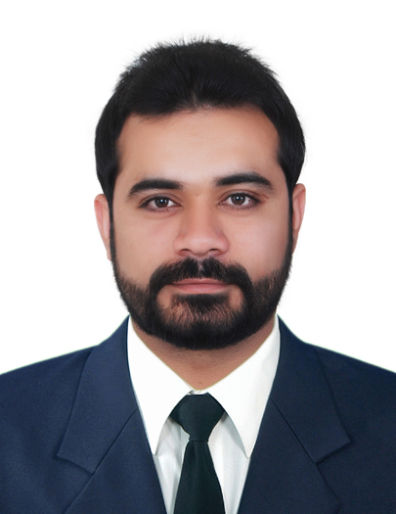
FAYYAZ HUSSAIN
House No. 115/23, CAA Colony
Airport Karachi, Pakistan
Mobile # 0092-321-8783650
E-mail: fayyaz589@gmail.com
Skype ID: fayyaz589

Objective:

A Creative, highly organized and flexible individual, able to coordinate effectively to accomplish tasks with positive attitude and strong work ethic. An Enthusiastic team player and a dedicated learner, always ready to take challenges and achieve them in an effective manner.

Experience:

Professional experience  Appointment  May-2015 to  till date | Alkaram Textile Mills Private Limited Unit-II  Working as an Executive HR & System Development
Professional experience  Appointment  May-2015 to  till date | My key responsibilities are:  - Processing Complete Payroll of almost 1000 employees, for new hires including Absence, Deductions, separations, pay changes, Incentives, Special Allowances, Final Settlements  - Prepare all necessary information’s data for promotions/increment, salary reviews, Medical benefits, Group life Insurance as per company policy  - Prepare EOBI & Social Security Payments (including SESSI issues of employees)  - Maintain records and compile statistical reports concerning wages, salaries and benefits  - Maintain record of employee’s Annual, Casual, Sick and Short Leaves  - Issue charge sheets, conduct inquires, issue warning letters or refer employees to management for further action if required  - Conducting exit interviews and make turn over reports for Management & Labour Staff  - Prepare letters such as offer and confirmation  - Establish, implement and maintain Social Compliance System in line with land laws and customers codes of ethical conduct  - Promote good health, safety, and environmental practices throughout organizational activities  - Conduct regular site safety inspection and follow up actions  - Apply local laws as per as industrial act in Pakistan  - Conducting Work Council, Environment Health & Safety, Fire Safety, Security and Canteen committee meetings  - Conducting different training for workers like safe waste handling (Hazardous/Non Hazardous), Company Policies, Job Awareness, usage of PPEs  - Conduct internal Audit in coordination with Manager for improving Quality Systems  - Conduct compliance, Environmental trainings and meetings  - Reporting directly to the Head of Department
October-2013  to  Apr-2015 | Cresox (Pvt) Ltd (formerly Renfro Crescent (Pvt.) Ltd, SITE Karachi   Worked as an Executive HR/Payroll in Human Resource Department
October-2013  to  Apr-2015 | My key responsibilities were:  - Processing Complete Payroll of almost 1200 employees, for new hires including Absence, Deductions, separations, pay changes, Incentives, Special Allowances, Final Settlements  - Implement and monitor HR Policies and Procedures  - Assist in recruitment and selection process.( Job posting, Short listing, Plan Interviews, Interview calls, offer letters, confirmation letters)  - Handling matters of Loans, Final Settlement, Attendance  - Maintain records and compile statistical reports concerning wages, salaries and benefits  - Issue charge sheets, conduct inquires, issue warning letters or refer employees to management for further action if required  - Maintain record of every employee’s Annual, Casual, Sick and Short Leaves.  - Handle and resolve employees issues related with the monthly salaries and deductions  - Making EOBI & SESSI Payments (including SESSI issues of employees)  - Prepare all necessary information’s data for promotions/increment, salary reviews, Medical benefits, Group life as per company policy  - Orientation of new hired employees  - Conducting exit interviews and make turn over reports for Management & Labour Staff  - Reporting directly to the Head of Department
April 2009 to  September 2013 | Bahria College Karsaz, Habib Rehmatullah Road Karsaz, Karachi  Worked as an Admin Assistant
Academic Qualification | MHRM | 2013 | Human Resource Management | Karachi University | Karachi
Academic Qualification | Graduation | 2010 | Physics, Statistics & Mathematics | Karachi University | Karachi
Academic Qualification | Intermediate | 2007 | Pre-Engineering | HSC Board | Karachi
Academic Qualification | Matric | 2004 | Science | S.S.C Board | Karachi
I.T Skills | Description | Level | Description of skills
I.T Skills | DOS/WinXP/Win7 | Excellent | Command over advance functions including Installation & configurations.
I.T Skills | MS-Office | Excellent | Command over advance functions, VBA, macros, filters, Pivot tables, presentations, documents, projects & etc.
Professional Certificates & Courses | - Fire Fighter & First Aid training course from Civil Defence conducted by organization.  - Employee of the month award 3 times.  - Certification Course in Labor Laws conducted by Organization.

