Syed Imran Haider ZAidi 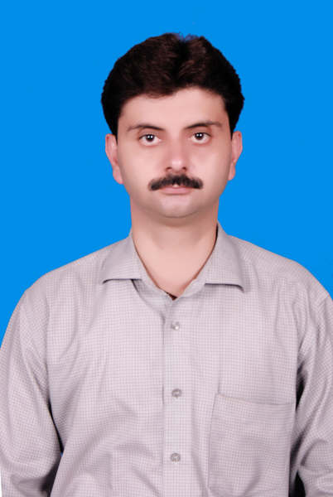
Present/Postal Address: House no. 7

Street 71 Islam Pura Lahore.

PERSONAL:

Father’s Name: Syed Razi Haider Zaidi.
Martial Status: MARRIED
Date of Birth: 25th of Mar-76.
Qualification: B.com MBA.
NIC No: 17301-7082414-3.
Cell no: +92-300-959-5627.
Residence no: +92-423-724-85-85.
Religion: Islam.
E-mail: sihz.leo@gmail.com

Permanent Address. Zaidi’s Gulbahar #5 Near Ring Road Peshawar City.
OBJECTIVE:
In order to utilize my knowledge & the related experience, I am seeking a responsible position in reputable organization where I can contribute beneficially to my prospective employer & myself. I am looking forward to work in challenging environments where I could use all my current professional skills and could learn something new.
WORK EXPERIENCE:
Recent Job:
DESIGNATION,
SALES MANAGER (NORTH/CENTRAL ZONE)
Worked for Six Months All Over Pakistan for AKSON.

COMPANY:
AKSON PHARMACUTICALS (MIRPUR/KKARACHI)
Job Duration: Mar 2015 till date.
Previous Jobs:
i) DESIGNATION,

SALES MANAGER (CENTRAL ZONE/NORTH).
COMPANY:

MATRIX PHARMA. (ALL GROUPS)
Job Duration: Feb 14th 2011 till Feb 2015.

ii) DESIGNATION,

ZONAL SALES MANAGER (CENTRAL ZONE/NORTH).
COMPANY:

LEO PHARMACUTICALS. (Derma & Orthro)
Job Duration: JULY-9th 09 till Feb 14th 2011.

iii) DESIGNATION,
Product Specialists Eli Lilly Pakistan (MARCH 2005 TILL JUNE 2009)

iv) Medical Representative in NOVARTIS Pharma Peshawar (JAN 2000 TILL 2005).

Qualification Detail:
Certificate / Degree | Board / University | Division / Grade
MBA | PRESTON UNIVERSITY | A+
B.COM | PESHAWAR UNIVERSITY | 1ST Div
B.Sc | PESHAWAR UNIVERSITY | 2nd Div

COMPUTER SKILLS:
Office: MS Windows, MS Word, MS Excel.
Software: Installation of Windows (98, XP, 7).
Hardware: Installation of all Drivers, Cards, Assembling & Dissembling.

Professional / Expert In:
Communication Skills, Product Related Knowledge,
Information Technology, Elementary Course,
Training Courses, Office Automation,
Windows 98, XP, 2000 Service (Professional) and 7.
EXTRA CERTIFICATES:
DIBATOR OF COLLAGE. FATMID DONNER.
COMPUTER HARDWARE & SOFTWARE CERTIFICATES.
INSIGHT AND BEHAVIOUR LERNING, TRANING CERTIFICATES.

POTENTIALS:
- I can work for field, visiting customers who can make the difference (KOL’s).
- Keep Interests in research program & seminars.
- Keeping all the records regarding the sales and agreements.
- Have the ability of performing all the official works.
- Maintaining of files, reports and official documents.
- Keeping the records of all correspondence etc.
- I can proof my abilities in Customer services Support.
8. Can handle sales & marketing teams.
ABOUT ME:
I am quick learner, self-starter, eager personality, strong analytical, interpersonal & communication skills. I am friendly, honest, reliable, responsible person with “can do” attitude; believe in leading by example & appreciating good work & efforts.

INTERESTS:
I would like to step into field of research, study about new techniques/technologies and able to conceptualize the basics to that it can better help me in making the right resolution what to learning for my bright future.
LANGUAGES:
Urdu, Persian, Pashto, Punjabi, English, and Hinko.
References:

WILL BE PRVIDED ON REQUEST.

Aun Arts: 0300-581-7-582

