Curriculums Vitae

Imran Hakim  House No.E-84/1 peer colony No. 2 near Gul shadia mosques Walton road cantt Lahore - Pakistan.  Cell No: 0321-7173176  0345-4085271  E-mail:  emran_hakim@yahoo.com  emranhakim80@gmail.com | 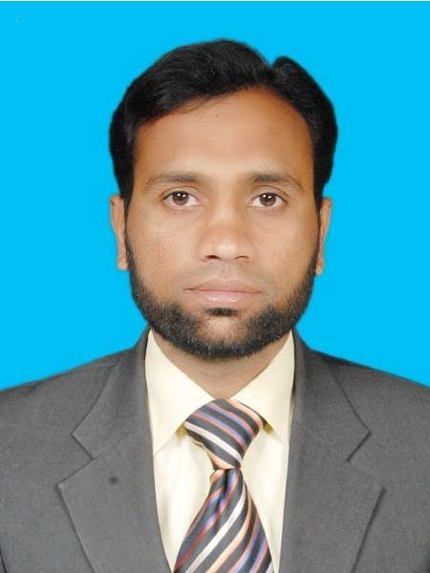

Objective

I want to become a part of an organization where I can utilize my professional knowledge, skills and abilities optimally to achieve the corporate as well as personal objectives.

Education
- Master in Business & Administration
(MBA) Marketing (2011)
Virtual University Lahore Pakistan.
- Graduation (2004)
University of the Punjab
Lahore, Pakistan.
- Intermediate (1999)
Govt Islamia College for Boys
Sadder Cantt Lahore Pakistan.
- Matriculation (1997)
F G Abid Majeed High School
R A Bazaar Lahore Cantt Pakistan

Work experience

- Working as a Assistant Field Manager in La-Vie (Pvt) Ltd.
(From Aug 2014 to Till)
- Worked as a Field Executive in Sanofi Aventis Pakistan Limited.
(Dec 2007 to Jul 2014)
- Worked as an Associate Medical Representative in Bristol Myers Squibb Pakistan Limited.
(Dec 2006 to Nov 2007)
- Worked as s Pharma Associate in Macter International (Pvt) Ltd.
( Nov 2005 to Dec 2006).

Professional Education

- Initial Sales & Product Training (ISTP)
One week training & Workshop on sales and Products
Sanofi Aventis Pakistan Limited
- Sales Certification Training
Two Days Workshop on Product Detailing Process
Sanofi Aventis Pakistan Limited
- License to Sell
Two Days Workshop on selling skills.
Sanofi Aventis Pakistan Limited

Job Responsibilities
- Develop and Lead the Team
- Achievement Sales Targets within time frame
- Implementation of Marketing Strategies
- Ensure return on investment
- Having good contacts with Key Opinion Leaders
- Promoting Diversify Portfolio (CV Drugs, CNS, Antibiotics, General Products, urology etc.)
Computer Skills

- Microsoft Windows HTML Language
- Microsoft Office Word, Excel, PowerPoint,
- Internet and Email

Personal Details

Bate of Birth 11-May-1980

Gender Male
Father’s Name Hakim-Ud-Din (Late)
Family Name Rajput (Rana)
Nationality Pakistani
Domicile Lahore
Marital Status Married
NIC # 35201-1267223-1

Interests activities

- Surfing on internet:
Searching and exploring through internet search medicine and body system on different fields especially anti biotic and many more and share informative knowledge and sites to my friends.

- Sports:
Badminton, Cricket.

Languages

Fluent in Urdu and Punjabi, Good in English.

References

They can be made available on request.
It is hereby stated that all the above–mentioned information is true and correct to the best of my knowledge and belief.

Imran Hakim

