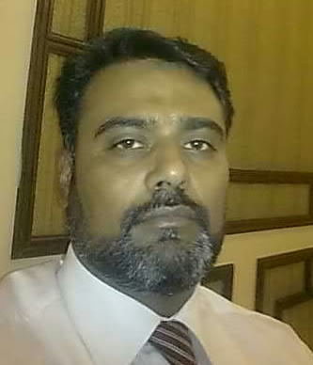

House # BB164-B ST#06
Mohallah Imam Bara Rawalpindi
Ph # 051-5541412, Cell-03458473975
E-mail: shehzad__imran@yahoo.com

Imran Shehzad

Career Objective:
To find a challenging position in a well reputed Company to meet my competencies, capabilities, skills, education and experience.

Qualification: | MBA, Marketing

Personal Information ▼
Experience | 04 years in Searle Pakistan Pvt. Ltd.  04 years in Lundbeck Pakistan Pvt.Ltd
Present Job | working With Highnoon Labs  4 years as District Manager and from last 3 years  Working as Sales Manager North
Professional Skills | - Got successful “Selling skill course” by Searle Pakistan.  - Got successful “Basic Training course” by Searle Pakistan.  - Got successful Training course on “Objection Handling” by Searle Pakistan.  - Got successful Training course on “How to present a Clinical Trail Report” by Searle Pakistan.  - Got successful “Basic CNS Training course” by Lundbeckpakistan Pvt Ltd  - Got successful Training course on “Social Style” by Lundbeck Pakistan Pvt Ltd  - Got successful Training course on “TDP” by Lundbeck Pakistan Pvt Ltd  - Got successful Training course on “Effective sales Call” by Lundbeckpakistan Pvt Ltd  - Got successful Training course on “Magic of Team Work” by Highnoon Labs  - Got successful Training course on “Star Performer”  By Highnoon Labs  Got successful Training course on “Field Coaching from IBA” arranged by Highnoon Labs

Father’s Name: Gustasif Hussain

Date of Birth 01-09-1972

Marital Status: Married

Area Coverage Experience ▼
Rawalpindi, Islamabad,Peshawar,Kohat,Bannu,DIK,Swat,Mardan,Temergara,Sargodha,Mianwali,
Faisalabad,Jhang,Gujranwala,Sialkot and Mandibahuddin.

Specialties :Physicians ,GPs,Ortho,ENT, Cardiology, Gastro. Psychiatry

Achievements ▼

- Got 2nd position in Basic Training program of Searl Pakistan
- Have honour to launch successful products “Susscard buccal, Seronil, Alprox” in Searl Pakistan.
- Have honour get highest seller position of Calan range, Spiromide, Sustac
- Have honour get 2nd position in CNS Training program of Searl Pakistan as Product Specialist
- Have honour be a part of M.D. trophy winner in Searal Pakistan.
- Have honour to won best performer prize in Spiroline
- Have honour to include new products in leading Institutions in Searle Pakistan
- Have honour to arrange successful roundtable meetings among Psychiatrist & Physician
- Have honour to achieve highest growth 80% of Cipralex all over the Pakistan
- Have honour to achieve 1st position as REP of the year 2004, celebrated in Singapore
- Have honour to achieve 3rd position as REP of the year 2005, celebrated in Beijing
- Have honour get 2nd position as “REP” of the year in 2006, celebrated in DUBAI
- Have honour to conduct successful symposium about Cipralex and Ebixa among all the Physicians / Psychiatrist
- Have honour to get the best prize on individual presentation “Prospecting “
- Best District Manager of 2011.

Computer Skills: ▼

One year Diploma from Central London College.

Reference:

Mr.Aamir Zafar Director Highnoon Labs cell # 0345-8439550
Mr.Shahnawaz Baig Director Highnoon Labs cell # 0345-8446601

