IQRA JAVED |  | Address: Roza Park, Mansoorabad, Faisalabad, Pakistan  Email Address: iqrajaveed.16@gmail.com
 |  | Cell: +92-323-7755090
Objective:

To venture into the professional life and practically apply my skills, in a highly professional environment, that best utilizes my qualifications, ability and competence and where my education and exposure can contribute towards achieving organizational objectives as well as for betterment of my country.

Personal Data

Father’s Name : Javed iqbal
Gender : Female
Nationality : Pakistani
Domicile : Faisalabad
Date of Birth : 15 November 1992
Marital Status : Single
Religion : Islam
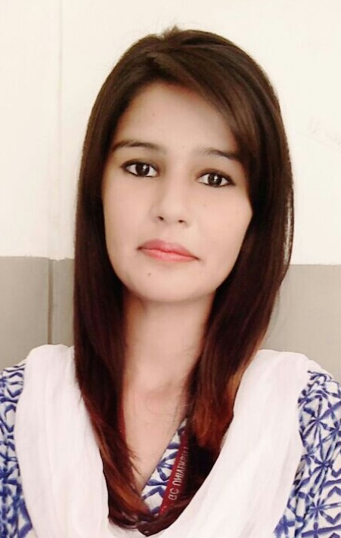

Work Experience

Three Month internship in “Shifa International Hospital:
Islamabad, Pakistan.

      - Extemporaneous preparation.
      - Intravenous preparation.
      - Patients counseling.
      - Invoices entry in computer.
      - Other duties as assigned.

Three month work experience in IVF (InVitro fertilization) centre:

      - Handling of Apparatuses & Maintenance of equipments.
      - Maintenance of Lab (Embryology & Andrology).
      - Patients Data & Record keeping.
      - Patients Counseling.

Education

Government College University Faisalabad.
2010 - 2015
Degree: Pharm-D
CGPA: 3.01

Punjab College Faisalabad.
2007 – 2009
Degree: FSc Pre-Medical
Percentage: 909/1100; 82.6%

Comprehensive Girls High School, Faisalabad.
2005 – 2007
Percentage: 744/850, 87.5%
Matriculation in Science, BISE Faisalabad.

Projects

- Formation of Nanoparticles

Certificates
- Research of pharmacy practice in Pakistan.
- Career Counseling.
- Pharmacy industry contribution for Diabetes Management & Career Development.
- Participation in 1st National Pharmacy Symposium.
- Hospital and Clinical Pharmacy Practice at Department of Pharmacy Shifa International.
- Comparing in the workshop on Research Physiology & Pharmacology.

Skills

- Possess strong leadership skills as well as a team member.
- Problem solving.
- Good planning skills with execution abilities.
- Good presentation and interpersonal skills.
- MS Office (Microsoft Word, Excel & Power point).
- Encouraging and motivating others.
- Able to work as team member and independently.
- Target Achiever.

Interests & Activities

- Interested in Creative Projects
- Social Networking
- Internet Browsing & Listening Music

Languages

- English
- Urdu
- Punjabi

References

- Will be furnished on demand.

