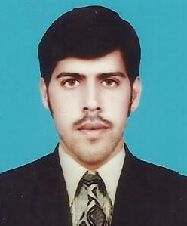
Curriculum Vitae

KAMRAN SHAH

Objective:

Well Educated individual with cultural and professional background re-inferred with multi-disciplinary skills work experience. A team player with a positive attitude and rational approach to problem solving quick learner and flexible personality, people oriented, responsible, work well in group as well as individual situations self reliant, results oriented and quality conscious. .

Personal Profile:
Father Name : Ahmad Shah
Date of birth : 13-03-1990
Gender : Male
Marital Status : Single
Religion : Islam
Domicile : Kohat (KPK)
Nationality : Pakistani
National ID No. : 14301-5632951-3
Address : House No.110, Mohallah Charbagh Jungle Khel Kohat.
Contact No : 03337702743 Email Add : beboooshah@yahoo.com
Passport No : CJ5159511
Academic Profile:

SSC (Science) 2007 B.I.S.E Kohat
F.S.c (General Science) 2009 B.I.S.E Kohat
BA 2011 Kust OSHA30hr 2014 PSTC

Skill:
- Problem solving skills and ability to work under pressure.
- Training development and delivery skills.
- Quality oriented

Experience:
- Three Year Experience as a Medical Representative In Pharmaceuticals’ To Till Date.

Languages:
- English
- Urdu
- Pashto

Personal References:
- Reference would be provided on demand.

