CURRICULIM VITAE

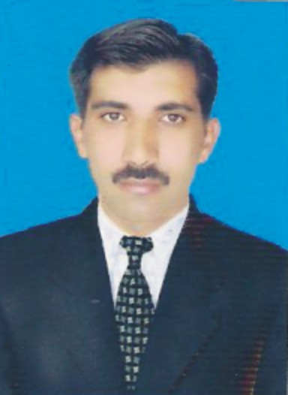
NAME : KHALIQ DAD KHAN
FATHER’S NAME : HAJI UMER ZAD
RELIGION : ISLAM
Gender : MALE
MARITIAL STATUS : MARRIED
N.I.C. NO. : 11101-1981602-1
DOMICILE : BANNU
NATIONALITY : PAKISTANI
DATE OF BIRTH : 20-03-1979
PH NO. : 03219637765 / 0928-624775
POSTAL ADDRESS : Out side new Kachery Gate House No: 264/27
Bannu City.

PERSONAL OBJECTIVE
I am confident and enthusiastic person with ability to learn and adapt quickly to new challenges and difficult situation under pressure have an organized approach with good communication skills which me enable to work effectively either on my own or as a part of the team.

S# | PARTICULAR | Subject | Year | DIV: | BOARD/UNIVERSITY
1 | MSc | BOTONY | 2012 | A+ | UST Bannu
2 | BSc | Medical | 2000 | 1st Good | G.U.D.I.Khan
3 | FSc | Medical | 1998 | 2nd | BANNU BOARD
ACADEMIC RECORD
4 SSC Science 1995 2nd BANNU BOARD

Experience:
- 3 yrs experience in himont pharmaceuticals
- 4 years experience SEARLE Pakistan Limted as a PS From 2003 to July 2007.
- 4 years experience as Field Manger in Stand PHARMA from
20th july 2007 to 30th June 2011.
- From 1st July 2011 Mass Pharma to 22/5/2014
23/05/1014 joined Highnoon lab as a Distt Field Manager at Bannu Base covering d.i.khan and kohat till to date

Languages:

Language | Speaking ability | Writing Ability
English | Excellent | Excellent
Urdu | Excellent | Excellent
Pashto | Excellent | Excellent
Sarayki | Excellent | Excellent

Courses:.
- Selling Skill summit 2005 by Searle Pakistan.

- Basic Selling Skill Course by Himont Pharmacitical.

Convince
CAR

Awards:
I M CERTIFIED FROM IBA (INSTITUTE OF BESNESS ADMINISTRATION) WORK SHOP IN ISLAMABAD IN JANUARY, 2016
- Gold Medalist on Supper Achiever 2006 in Searle Pak
- Man of Levoxn , ventek and Tramal.
- Champion of 3rd and 4th Quarter 2006 in Searle Pak
- 3 yrs connectivity Top achiever in Searle Pak National Levels
- 1st Position in National Level 2009 in stand pharm
- I was certified as best DFM on Bonnisan
- Special gift on prospan and Tres o Rex forte.

