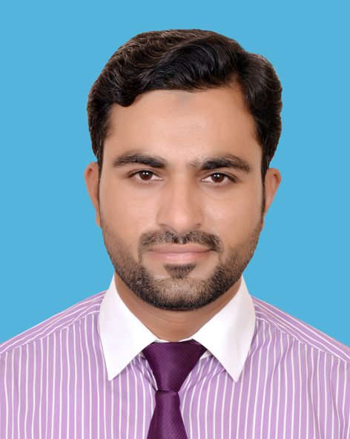

LUQMAN BUTT
Mohalla Syed Pak, Street Hameed Shaheen,
Dhullay; Gujranwala
Email: luqman055@gmail.com
Cell. +923216434348

Objective:

To obtain a good position in a pharmaceutical organization to apply my accumulated knowledge & best services as a good individual & team player in the practical field. I want to be at the peak of my profession.

Personal Profile:
Father’s Name : Faqeer Ullah Butt
Date of Birth : 30/03/1981
Religion : Islam
N.I.C No. : 34101-2459009-7
Domicile : District Gujranwala (Punjab)
Marital Status : Married

Educational Background

- Matriculation from Govt. School Gujranwala
- F.Sc. from Govt. College Gujranwala
- B.Sc from Govt. College Gujranwala.
- MBA Executive from AIOU (common wealth MBA)

Educational Record:

Course / Degree | Obtained Marks | Total Marks | Division
MBA ( Executive) | 966 | 1500 | 1st
B.Sc.(Bot.Zoo.Chem | 364 | 800 | 2nd
F.Sc. (Pre-medical) | 630 | 1100 | 2nd
Matriculation | 638 | 850 | 1st

Professional Skills Profile

- Basic Sales Training Course
- Techniques of persuasive selling.(TOPS)
- Certificate in selling skills.
- Certificate in Computer Techniques.
- Complete M.S. Office.
- Focus on selling course.(FOS)
- Focus on social style course.(FOSS)
- Portfolio selling skills (PSS)

Experience

Ethical Marketing Executive in Recket Benckizer from 2004 to 2005
Territory manager at Abbott Laboratories (Pak) Ltd.
Since 21-Nov-2005 ……… to Sep 2015
Professional Services Representative at Pfizer Pakistan

From Nov 2015 to present

Achievements

- Consecutive 7 years 100% sales achievements.
- Top achiever from central zone in field force “E” for year 2007 & 2008.
- Winner of Incentive Thailand tour 2010
- Highest achiever among Gujranwala district in 2014
- Best presentation award in 2013

