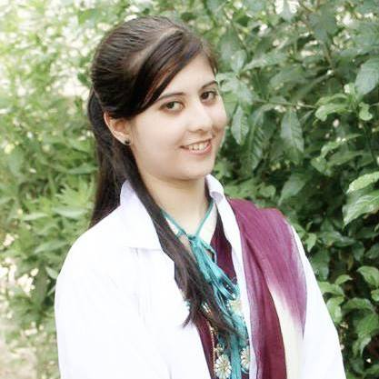
SYEDA MALIHA ALI

Address: N65 Block 15 Gulistan E Johar ,Karachi
Mobile No# 0346-2745578
Email: pharmacist.maliha@gmail.com

OBJECTIVE;-

To augment my skills and knowledge in an organization that is conducive to learning, in order to build myself as a strong professional who is mutually beneficial to the organization and society. To be an asset of an organization where I enhance my professional and qualification skill and grow with growth of that organization.

EXPERIENCES;-

Internships:

✔ Abbasi Shaheed Hospital , Nazimabad , KMC (2012)

✔ Atco Pharmaceutical, Quality and Production (2014)

✔ National Institute of Blood Disease and Bone Marrow Transplantation (N.I.B.D )
(2014-2015)

Management Training:

✔ Atco Pharmaceutical (2015)

PERSONAL DETAILS;-

Date of birth | 14th August 1991
Fathers Name | S.M Ali Haider
Gender | Female
Nationality | Pakistani
Marital status | Single
Religion | Islam

EDUCATION ;-

QUALIFICATION | YEAR | INSTITUTION | GRADE
PHARM-D | 2014 | UNIVERSITY OF KARACHI | 3.6 3CGPA
HSC | 2009 | S.T JOSEPH COLLEGE | 74.64%
SSC | 2007 | KARACHI PUBLIC SCHOOL | 84.65 %

PROFESSIONAL EXPERIENCE ;-

Responsibilities as a pharmacist:
- Discuss case history of patients.
- Study and investigate drug interactions and therapeutic uses.
- Independently seek information or training to improve evaluation and treatment skills, and evidence for practice.
- Seminar on business strategies .

VALUE ADDED SEMINARS AND ACTIVITIES ;-

- Seminar on essential of pharmaceutical industries
- Seminar on lymphoma awareness
- Seminar on thalasemia awareness
- Seminar on challenges and opportunities in U.K
- Seminar on business strategies
- Volunteer work in reasearch project (Pharmacoeconomic studies of Diabetes
- Mellitus in Pakistan )
- Participation in Seminar and one day dialogue on  Current trends in hospital pharmacy  ( Practise and role of pharmacists )
- Participated in research workshop and attended a session conducted by GlaxoSmithKline (GSK) .

COMPUTER SKILLS ;-

Ms Office
Graphics
Adobe Photoshop

PERSONALITY STRENGTHS ;-

Good team player
Aspire to win
Accept challenges
Self motivated
Interpersonal, communication and language skills

EXTRA CURRICULAR ACTIVITIES ;-

Participated in various seminars
Participated and organized various functions

