CURRICULUM VITAE

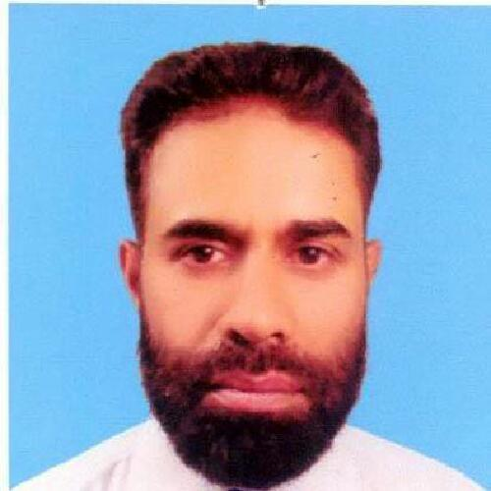

- Name Maqbool Ahmed

- Father’s name Mahmood Bin Noor

- Date of Birth 02-Jan-1969

- Qualification

      - MBA (Marketing) Philippines Christian University Manila
      - B.Sc. (Zoology, Chemistry) Peshawar University Pakistan.

- Experience

      - 20 years+ experience in Marketing & Sales.
      - 3 year as National Training & Sales Manager in Stanley Pharmaceuticals (Pvt) Ltd Pak.
      - 18 years as Medical Service Executive in GlaxoSmithKline Pak Ltd
      - 1 year as Territory Manager in Wyeth Lab Pak Ltd
      - 6 months as Sales Promotion Officer in Siza International (Pvt) Ltd

- Worked in the following Areas

      - Sindh: Karachi, Sukkur, Ghotki, Shikarpur, Jacobabad, Larkana, Dadu.

      - KPK: Peshawar, Attock, Nowshera, Charsadda, Mardan, Batkhela, Timergara, Mingora, Kohat, Bannu, D.I.Khan.

      - Azad Kashmir: Muzaffarabad, Bagh, Rawalakot, Abbottabad.

      - Punjab: Sargodha, Mianwali, Khushab, Sahiwal & Okara.

      - Balochistan: Quetta, Zhob.

- Sales Responsibilities

.
      - Sales forecast and sales planning.
      - Developing strategies for business development and sales growth.
      - Presentations to Doctors.
      - Have a sound knowledge of Dermatology, Gynecology, Antibiotics & more..
      - Lead sales/operations team of the assigned region to meet the business objectives. Review, propose and organize staff training as per requirement.
      - Manage teams for organizational objectives & personal development of staff. Actively participate in hiring of staff as per requirement.
      - Assign specific goals, objectives, and targets to staff. Evaluate performance on periodic basis. Take corrective measures to improve business performance.
      - Review coverage of areas and develop strategies to increase & maximize coverage. Continuously expand distribution network for assigned product portfolio.
      - Ensure portfolio management of fast & slow moving products. Develop & propose strategies to improve sales of slow moving products/liquidation where required.
      - Active relationship management with Customers. Take steps & propose activities to manage & improve company's & team's relationship with the Doctors/Customers.
      - Review after-sales service periodically and propose actions for improvement.

- Training Responsibilities

- Develop, implement, and monitor training programs within an organization.
- Supervise technical training for staff.
- Conduct orientation sessions.
- Create brochures and training materials.
- Develop multimedia visual aids and presentations.
- Create testing and evaluation processes.
- Prepare and implement training budget.
- Evaluate needs of company and plan training programs accordingly.
- Conduct performance evaluations.
- Provide companies with classroom training, demonstrations, on-the-job training, meetings, conferences, and workshops.
- Manage staff of classroom facilitators.
- Provide performance feedback.
- Conduct continuing education training.
- Provide leadership development education.
- Build solid cross-functional relationships.
- Provide logistical support, course development, delivery, evaluation, process measurements, and cost management.
- Plan the implementation and facilitation of activities and events, budget spending, material production and distribution, and other resources to ensure that operations are managed within authorized budgets.
- Assist with the development of strategic plans.

- Languages Urdu (Mother Tongue), English, Pashto.

- Address Islamabad

- Contact # +92-3229042770

- Email ubaidu01@gmail.com

