MEHBOOB UR REHMAN KASHIF (KASHIF KAMBOH)
S/O SAFDAR ALI ASIF

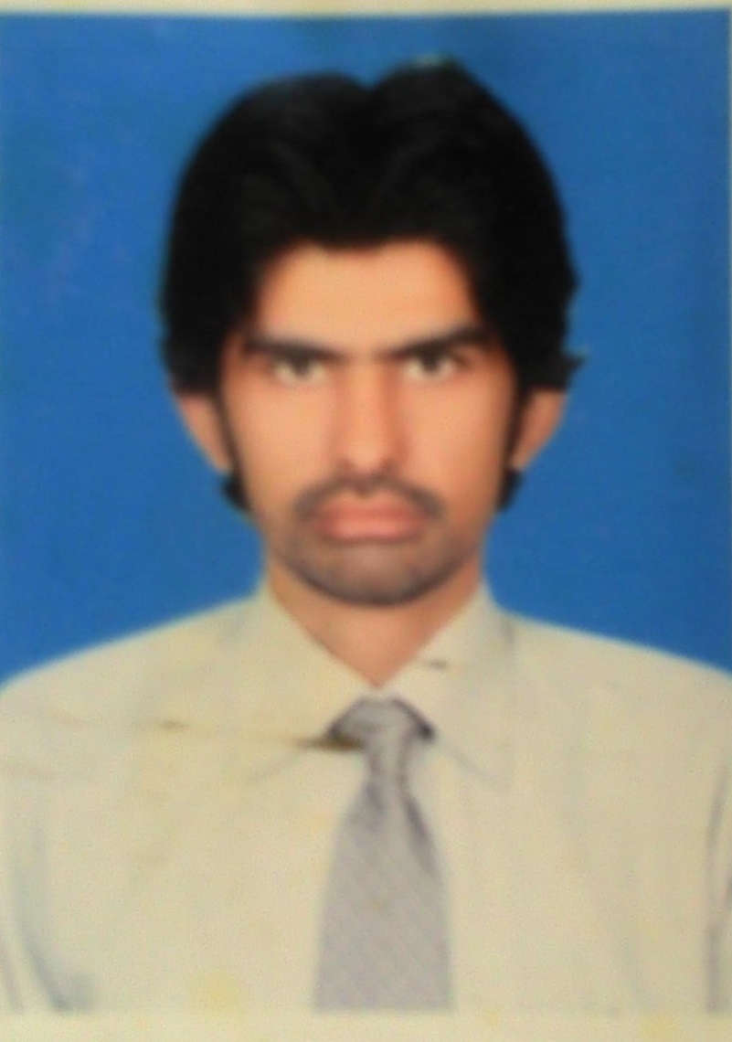

Adress: House No. D/22 Agri. Staff Colony
Bahauddin Zakariya University, Multan

Mobile: 0333-6078189
0316-6319911

Email: Drkashif.kamboh@gmail.com

Profile

An intelligent, well presented and adaptable graduate with solid qualifications and a comprehensive skill set underpinned by work experience in environment demanding self-motivations and focused approach. Capable of working without supervision and willing to assume additional responsibility. A committed team player, with leadership ability who use high standard of communications ability to establish positive interpersonal relationships. Quick and willing to assimilate and apply new work procedures .Familiar with wide range of IT applications with high standard of numeracy and literacy.

Areas of interests

- Pharmacy and pharmaceuticals | - Medical science and Medicines | - Oral mucosal drug delivery system
- MS Office | - International Affairs | - In page
- Networking | - Hardwearing | - Sports and games
- Arts and photography | - Marketing and management

Professional Development

Degree (institute) | Major Subjects |  | Session
M.Phil.  (Pharmaceutics) | pharmaceutical technology, clinical pharmacy, pharmaceutical biotechnology, pharmaceutical marketing and management |  | 2012-14
Pharm-D (5 years)  (B.Z .University Multan) | Physiology, Anatomy, Biochemistry, Medicines Chemistry, Pharmacognosy(herbal Medicines),Pharmacology (Actions of Medicines on human) |  | 2005-10
F.Sc (intermediate)  Govt. College Bosan Road Multan) | Physics, Chemistry, Biology |  | 2003-05
Matriculation  (Govt. Comprehensive School Multan) | Physics, Chemistry, Biology, Mathematics |  | 2002-03 |  |  | physics, Chemistry, Biology | 2003-05
Experience in pharmaceutical

- Working in Pfizer parke-davis since of APRIL 2011 to MAY 2012 as PSR (pharmaceutical sales Representative).

Key Responsibilities in Pfizer parke-davis Pakistan
1: To communicate with doctors, physicians, pharmacists and other health service providers for the promotion of Pfizer’s products.
2: Maintain the sales and achievements of targets given by the Pfizer.
3: Conduct meetings and seminars for the promotions of my products.

teaching Experience
- VISITING LECTURER in Department of psychology in ISLAMIA UNIVERSITY BAHAWALPUR (for a semester)

- LECTURER of PHARMACEUTICS I (physical pharmacy and Dispensing)
PHARMACEUTICS II (Industrial pharmacy and quality control)
In Multan College of Pharmacy And Management Sciences Multan from JULY 2012 till August 2014.

Key responsibilities in Multan college of pharmacy and Management Sciences Multan

1: Beside my teaching responsibility I was given an extra charge of administrator of the college due to my professionalism and hard work.
As administrator I was responsible for maintaining the discipline in the college.
2: I was the college’s representative in various managerial level meetings on different occasions and forums.
3: As administrator I was also responsible for audits, salaries of the employees, purchasing and maintenance of lab equipment, sports and all co-curricular activities for the students.
4: I was also responsible good teacher parents relationship to magnify the performance of students

- 2 years’ experience of teaching F.Sc level (biology) in ASIAN ACADAMY Gulgasht colony Multan.
- 1 year experience of home tuitions during my academic studies.
my research project IN M.PHIL

- Formulation and In-vitro evaluation of Chlorpheniramine maleate medicated chewing and its In-vivo studies in human

- The Chlorpheniramine maleate belongs to the first generation alkyl amine antihistamine. It is widely used in the treatment of the allergic diseases like rhinitis and urticaria. So the major objective to formulate a medicated chewing gum of CPM is to provide a better and convenient dosage form and compliance for the patients having problems with solid oral dosage form (tablets).

conferences and training seminars

- Capacity building of pharmacists in public and private sector held on 20th December 2014.
Organized by Pakistan pharmacist association Multan and Southern Punjab.

- International conference for MALNUTRITION IN SOUTH ASIA THE PERIL PERSISTS.
Held on February 23-24, 2015 organized by department of food science and technology BZ University Multan.

co-curricular activities

- Executive member of Pakistan Pharmacist Association (Multan and southern Punjab).
- Organizing sports and debate festivals in BZU Multan.
- Organized first mini marathon in the history of BZU as an organizer.
- Organized job festival 2010 in collaboration with career development centre BZU Multan as an organizer.
- Ex. member Zakariyan literary forum BZU Multan.
- Ex. Member Zakariyan dramatic club BZU Multan.

Extra Skills, languages, interests and pastimes

- Presentation Skills
- Communications Skills

Languages: Urdu, English, Punjabi

Interests and Pastimes: surfing internet, reading Urdu poetry,
Great lover of sports as I was also a sportsman
During my academics. I played table tennis
For BZU Multan. Snooker and badminton are also good pastime sports for me.

Personal details: I believe in professionalism and hard work and my sole aim of life is the fearless pursuit for truth.

Reference

- Prof Dr. Syed Nisar Hussain Shah – Associate Professor Department of Pharmacy, B.Z. University Multan
0322-615104
- Dr Sohail Arshad – Assistant professor Department of pharmacy B.Z. University Multan
0333-4363634

