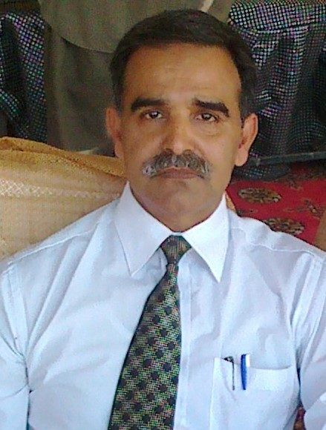

CURRICULUM VITAE

MUHAMMAD IRFAN ANSARI

HOUSE NO A/895 ANSARI MOHALLA ROHRI DISTRICT SUKKUR

CELL PHONE: 03009312740/03333159710

Email: irfanlibra2003@gmail.com

OBJECTIVE:

To obtain a Professional career in an organization that offer a competitive environment, demands excellence in performance and provides opportunities to attune professional growth based on the individual’s merit, performance and capabilities.

Education: B.Sc (Microbiology), MBA (Marketing)

Computer Skills: Known M.S Office

PERSONAL DATA:

Father’s Name: (Late) Muhammad Bux Ansari

Date of Birth: 29.12.1965

Religion: Islam

Marital status: Married

EXPERIENCE

12 YEARS WORKING WITH GSK AS SR MSE BASED AT SUKKUR

3.1/4 YEARS WORKING WITH SGJ AS AREA MANAGER BASED AT SUKKUR

2 YEARS WORKING WITH STANDPHARM AS AREA MANAGER AT SUKKUR.

3.1/4 YEARS WOKING WITH NABIQASIM INDUSTRIES AS AREA MANAGER.

CURRENTLY WORKING WITH WERRICK PHARMA AS CITY MANAGER SUKKUR (CONTINUE)

WORKING EXPERIENCE IN GASTROENTROLOGY, CARDIOLOGY, ORHTOPEDICS, PSYCHIATRY, CNS, PEDIATRICIAN, GYNAE ETC.

ACHIEVMENTS:

Successfully launch several products’ (CARA, DRATE, VETINIL, ACENAC, PLANTCAL, ANTI ALLERGIC, PAIN KILLER, ANTI BIOTICS, PPI’S, and NUTRACEUTICAL PRODUCT OF WERRICK)

Passed GSK academy in 2003.

Regional star in GSK in 2003.

Highest per rep sales in all Pakistan bases in Standpharm.

First time include SJG products in Mari Gas com Daharki.

Achieve several gifts in training and developments.

Got several trainings in sales and Marketing.

Give training of product and field to newly hire field force in Werrick and other companies also.

TERRITORY KNOWLEDGE:

Sukkur-Larkana-Jacobabad-Dadu and Quetta Along with Their out Station’s

INTEREST & HOBBIES:

Reading Books & Quotation’s

REFERENCE.

Nasir Ali Khan

DSM EX GSK Karachi (03008208572)

Nadeem Hameed Khan

EX NSM STANDPHARM (03459477720)

Mohammad Amir Kakar (03204444010)

Marketing Manager SWISS

