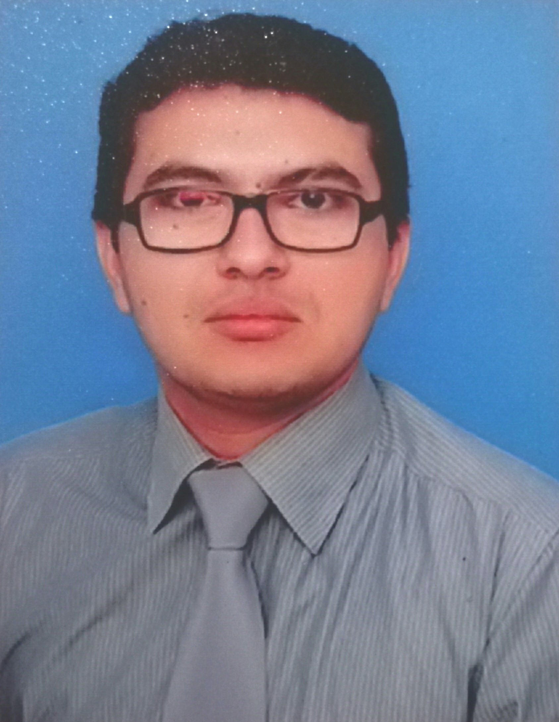
DR.MOHAMMAD KHALID
CONTACT#0333_7334157
EMAIL#Dr.khalid3478@gmail.com
To be at a Business Leadership position in a reputable Organization where, I could contribute effectively in Organizational Growth, through the Strategic Approach, Brands’ Development, Market Intelligence, Targeting Effectiveness, Customer Centricity, Organizing Team, Internal & External Collaborations, and Accountability with the monitoring & improving the performance & Brands’ Up gradation that results in timely results delivering with high ethical standards.

PERSONAL

Father’s Name - Mohammad Yaqoob
Date of Birth: - 05- 04 -1986
Domicile/PRC - Sindh
Marital Status - Single
Religion - ISLAM
Nationality - Pakistani
CNIC - 43102-0173012-3
Passport - TU-4110121

ACADEMIC QUALIFICATION

MBA (2015)
College of Business Management


Pharm-D (2009)  University Of Sindh Jamshoro

PROFESSIONAL SKILLS

MS Word, Excel, PowerPoint, Outlook
Windows Operating Versions (2000, Me, XP, Vista 7, 8)
Computer operation /Hardware / Installation Skills
Typing skills/Peach tree accounting software
Very efficient in Internet, social media / skilled in advance searching + professional emails.
Ability to handle multiple tasks in high pressure environment & proactive working style.
Persuasive Communication Skills
Extremely goal oriented
Customer relationship Building
Professional Presentations
Marketing Skills
Medical Terminology
BusinessManagement
Polite and humble attitude

INTERESTS AND HOBBIES

Photography
Music
Marshal Arts
Cricket
Long drive
Current Affairs & TV Talk Shows

EXPERIENCE

- PFIZER PHARMACEAUTICALS INTERNATIONAL

Period - February 2010 to January 2012 
Position held - Professional Sales Representative (PSR)

- Responsible to maintain daily Intimation of team and inform to department of Sales via email.
- Best COSTUMER RESEARCH AWARD 2011 in PFIZER.

- Address all operational queries like Detailing / handling objection / competitor activities.

- Control & generate all monthly activities records & send to NSM.

- Maintain all operational data and receiving documents & provide to supervisor when require

- Systematically maintain all team Daily Transfer Notes, monthly expanse sheets and camp planning Notes.

- Conduct meeting of sales team in absence of supervisor time to time.

- Continuously Assisting & Supporting Manager in District’s Business Development Plan.
- Initiated & arranged workshops and Patient Case Scenarios at health institutes.
- Planned & Conducted Public Awareness Programs on different Diseases & General Health Issues.
- Member of Departmental Magazine.
- Member of Departmental Seminar Organizing Committee.

- SANOFI PHARMACEAUTICALS LIMITED

Period - February 2012 to Date 
Position held - FIELD EXECUTIVE

- Successfully completed Sanofi Initial Classroom Training, Training Program.
- Attended training on “Business Presentation Skills” conducted by sanofi Training Department..
- Successfully completed ‘Global Compliance & Integrity Awareness’ Training.
- Successfully completed ‘Sanofi Compliance & Foreign Corrupt Policies’.
- Prepare the monthly expanse of all team members.

- Winner of BEST IDEA proposal competition 2014.

- Made and present motivational and academic presentation on power point on weekly basis.

- Cross check the resources from resource sheets & cartons.

- Allocate resources equally to all team members and maintain record.

- Maintain the coordination of team among training department, distribution and toll free.

- Any other job assigned by the management time to time.
- Achieved NATIONAL SALES CHAMPION Award in SANOFI 2013.
- Add sanofi products for first time at SESSI, HUNDRED BED and CHINIOT.
- Very good doctor’s management & relation record.
- Best in quiz and sales certification numbers.

