CURRICULUM VITAE

PERSONAL

Name  Father Name  Date of Birth  NIC No.  Address  Phone No.  Mobile No. |  |  | 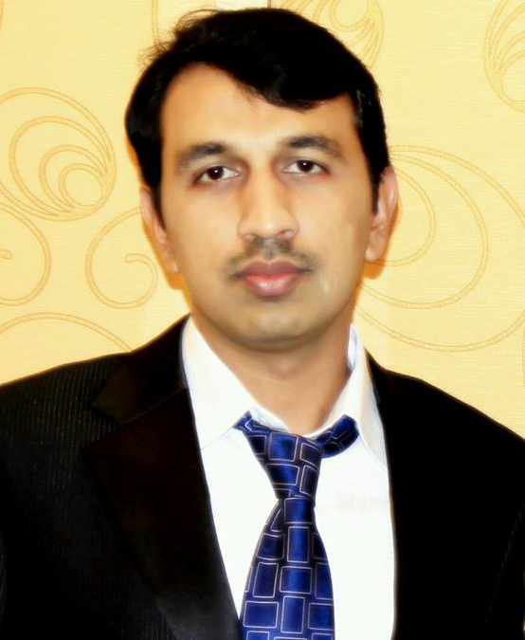  Muhammad Shakeel Akhtar  Sanaullah Cheema  27-05-1985  35202-9435240-7  House No. 289, Block No. D-III, Wapda Town, Lahore, Pakistan  042-5180004  0332-4148289

QUALIFICATION

Graduation |  | SESSION Jan 2004-Jan 2009  PHARM- D (Doctor of Pharmacy) |  |  |  | University of Lahore  Lahore, PAKISTAN
Intermediate |  | SESSION 2001-2003 |  |  |  | Government College of Science, Wahdat Road Lahore
Matriculation |  | SESSION 1998-2000 |  |  |  | The Punjab School,  Lahore
TECHNICAL EXPERTISE/SKILLS
Internship  Experience |  | - MEGA PHARMACEUTICALS LIMITED  Worked as an Internee and has attended the following Departments and practically observed operations, processes and procedures thoroughly.  - Quality Control Deptt  - Production Deptt  - Material Control Deptt  - Accounts Deptt  - Sales / Marketing Deptt  - AHMED MEDICOS(RETAIL PHARMACY)
Computer Skills |  | Worked as a pharmacist and core study related public health problems, involve in direct councelling of patients related to their medical issues and supervise dispensing according to prescription.  - MS Word  - MS Excel  - MS Power Point

JOB EXPERIENCE

Industry  Industry | ENGLISH PHARMACEUTICAL  LAHORE  LAHORE CHEMICAL & PHARMACEUTICAL WORKS,LAHORE (HOWARDS) |  |  | Worked as a production pharmacist in sterile area  (March 2009—Dec 2010) in the following departments  - Dry powder injectable section  - Liquid injectable section  - I.V Infusion section  - Packing incharge of injectable area  - Water treatment plant incharge  - In-house printing incharge  Working as a Senior Production pharmacist in Sterile area (Jan 2011---todate) in the following departments  - I.V Infusion section  - Dry powder injectable section  - Liquid injectable section  - I.V Infusion section  - Eye Drop section  - Semisolid section  - Research and development of Injectables
Job Description
- Also member of internal audit team in LCPW, and audit quarterly the different departments according to cGMP(current good manufacturing practice).
- Currently revised all the SOPs(standard operating procedures) and MMDs(master manufacturing documents) of injectables.
- Quarterly arrange and conduct training session of production staff to enhance their working and communication skills.
- Reporting to management regarding daily planning ,daily production in documented form
- Responsible for making monthly tentative production, operational plan and strategies and its implementation.
- Uptodate daily production files and records.
OBJECTIVE
Desire to exhibit my working abilities especially in a globally reputed people-oriented organization where I can get a competitive environment and apply my knowledge to the practical field in a global scenario to achieve a solid initiation to my career.

